**Minutes, Board of Directors Meeting**

**Date:** Sunday, March 02, 2014

**Time:** 7:30 PM

**Location**: 6023 NW 107th PL, Alachua, FL 32615

**Present:** Reza Nabi, President & Secretary

Mohammad AH Miah, Vice President

Tamjidur Choudhury, Treasurer

**Absent:** None

1. **Call to order**: at 7:35 PM by presiding officer Reza Nabi.
2. **Quorum:** three of three Board members present (2 required.)
3. **Reading and Approval of Minutes:** This is the first board meeting after Bestowers Foundation is formed on February 14, 2014. No previous minutes to be approved.
4. **President’s Report**
   1. Application to register “Bestowers Foundation, Inc” in the state of Florida has been filed on February 14, 2014. SS-4 application is submitted to IRS and received EIN, which is: 46-4846664.
   2. Collected logos for Bestowers Foundation from “Bestowers Kids” and adopted circular logo created by Samah Nabi, meaning of the logo is: “Striving to illuminate people's worlds and bringing our world out of the darkness”. For historical evidence, collection of logos will be included with this minute in Appendix-A
   3. Official website for the foundation is adopted as “bestowers.org” unanimously. Website will be developed shortly.
5. **New Business**
   1. Unanimously decided to open bank account at credit union (e.g. IBM CU and CampusUSA) to save cost.
   2. Unanimously decided to file 501c3 application to IRS as soon as possible.
6. **Open Forum**
   1. Next annual meeting tentatively set for April 30th 2014.
7. **Adjournment**
   1. There being no further business, President Reza Nabi declare meeting adjourned by unanimous consent.
   2. Meeting Adjourned at 8:35 PM

|  |  |
| --- | --- |
| Respectfully submitted by,  /Reza Nabi/  Secretary | Adopted by the Board in the meeting  Of March 02, 2014  ____________________________  (Signature of the Presiding Officer) |

**APPENDIX – A**

**LOGOS SUBMITTED BY BESTOWERS KIDS**

**About the Bestowers Foundation**

BESTOWERS FOUNDATION is a non-profit corporation and shall operate exclusively for charitable, educational and religious purposes within the meaning of Section 501 (c)(3) of the Internal Revenue Code, or the corresponding section of any future Federal tax code. Toward said purposes, BESTOWERS FOUNDATION may do the following:

i) Giving relief to the poor, the distressed or the unprivileged or the people who struck by natural disaster.

ii) Giving scholarships and/or grants to students or educational institutions such as schools and colleges for advancement of education or science.

iii) Giving grants/donations to religious institution so that people of their faith have can build a facility to worship or can have better facility to worship and/or to have better environment to increase their religious knowledge.

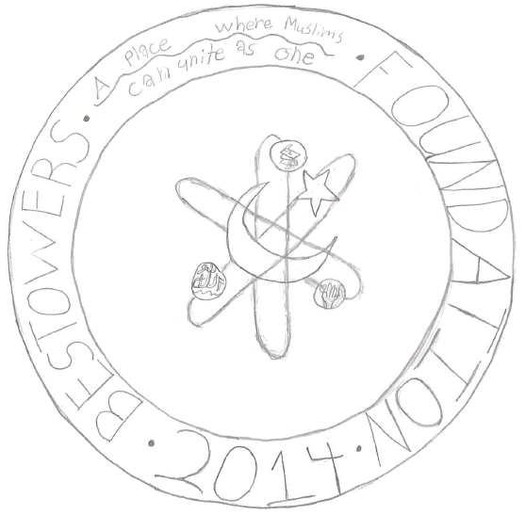

This logo represents the foundation almost like an analogie. It basically is just an analogie in a picture. The logo compares an atom with the foundation in a few ways. The most important is the way they work what I mean by that is the way that they are at work.For example the logo has the rings of an atom and instead of electrons making its outside it has the symbols of the three goals of the foundation. Then the nuecleas,instead of the center being protons and nuetrons it is the islamic symbol,a star and crescent moon.

BY: Tahsin Nabi

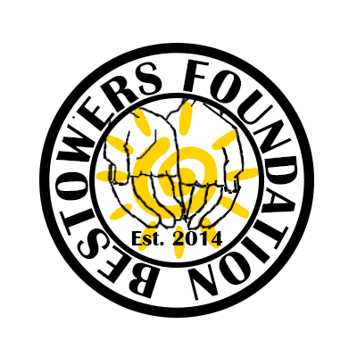

Striving to illuminate people's worlds and bringing our world out of the darkness.

BY: Samah Nabi

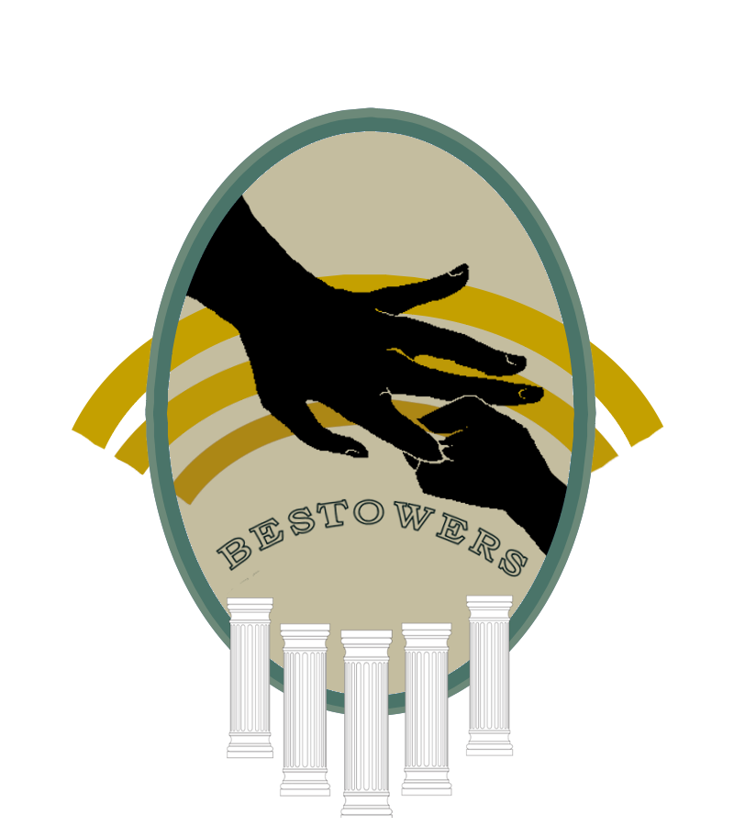

The five pillars in our logo represent the five pillars of Islam, with the center one (the largest) representing zakaat. In the middle is a big hand holding a baby hand, representing how your foundation will guide the youth.

BY: Humaira Halim

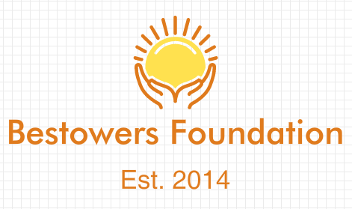

The hands represent out foundation raising people up and helping one another, while the sun represents picking people up and raising them into the light.

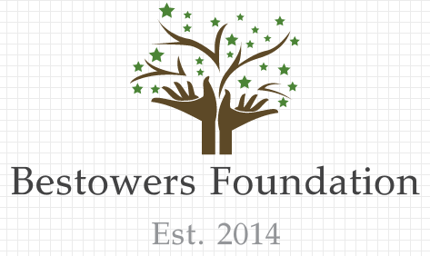

The hands represent the strength and foundation that our foundation bring. The leaves and branches represent how open we are and how we will support many and raise them up.

BY: Wahida Choudhury