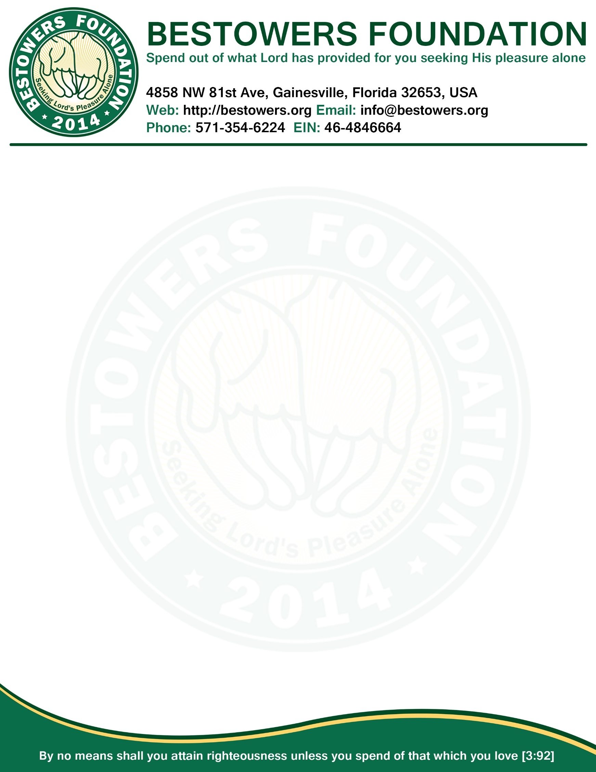

**ANNUAL FINANCIAL REPORT 2015***Date: Jan 1, 2016*

|  |  |
| --- | --- |
| **INCOME – FISCAL YEAR 2015** | |
| **Item** | **Amount** |
| Beginning balance | $1591.00 |
| Gifts, grants, and contributions received | $37,241.11 |
|  |  |
| **Total Income:** | **$38,832.11** |

|  |  |
| --- | --- |
| **EXPENSE – FISCAL YEAR 2015** | |
| **Item** | **Amount** |
| Everlasting Scholarship Tree | $26,400.00 |
| Grant for Educational or Charitable Institution | $5,355.16 |
| Grant for Unprivileged People | $3,486.51 |
| Fundraising Event (Food, Trophies, Awards and Souvenirs) | $1028.00 |
| Scholarship for Bestowers Foundation Scholar | $1,020.95 |
| Services for Local Muslim Community | $827.67 |
| Transaction Fees | $133.93 |
| Legal (IRS, State Annual Report) | $61.25 |
| **Total Expense:** | **$38,312.82** |

|  |  |
| --- | --- |
| **BALANCE – FISCAL YEAR 2015** | |
| **Item** | **Amount** |
| Total Income | $38,832.11 |
| Total Expense | $38,312.82 |
| **Ending Balance End-of-the-Year 2015:** | **$519.29** |



**Secretary**

**Bestowers Foundation**