**3.01 Purpose**

BESTOWERS FOUNDATION is a non-profit corporation and shall operate exclusively for

charitable, educational and religious purposes within the meaning of Section 501 (c)(3) of the Internal Revenue Code, or the corresponding section of any future Federal tax code. Toward said purposes, BESTOWERS FOUNDATION may do the following:

i) Giving relief to the poor, the distressed or the unprivileged or the people who struck by natural disaster.

ii) Giving scholarships and/or grants to students or educational institutions such as schools and colleges for advancement of education or science.

iii) Giving grants/donations to religious institution so that people of their faith have can build a facility to worship or can have better facility to worship and/or to have better environment to increase their religious knowledge.

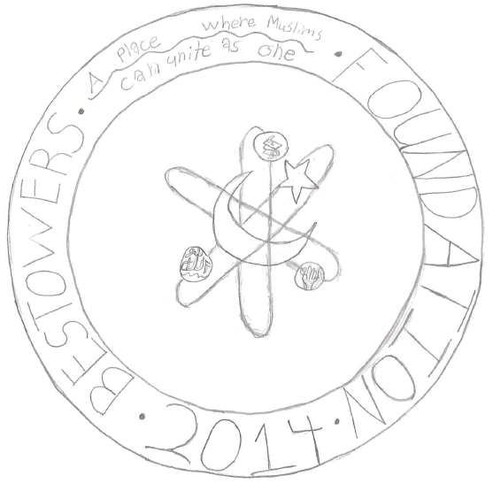

This logo represents the foundation almost like an analogie. It basically is just an analogie in a picture. The logo compares an atom with the foundation in a few ways. The most important is the way they work what I mean by that is the way that they are at work.For example the logo has the rings of an atom and instead of electrons making its outside it has the symbols of the three goals of the foundation. Then the nuecleas,instead of the center being protons and nuetrons it is the islamic symbol,a star and crescent moon.

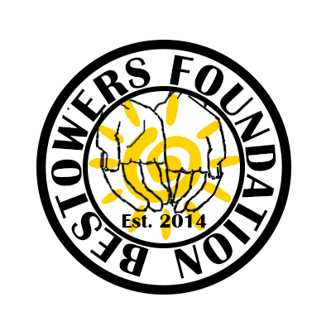

Striving to illuminate people's worlds and bringing our world out of the darkness.

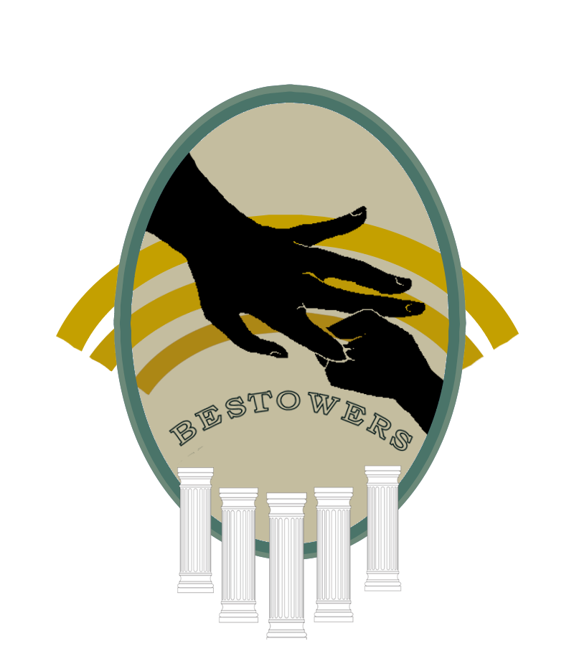

The five pillars in our logo represent the five pillars of Islam, with the center one (the largest) representing zakaat. In the middle is a big hand holding a baby hand, representing how your foundation will guide the youth.

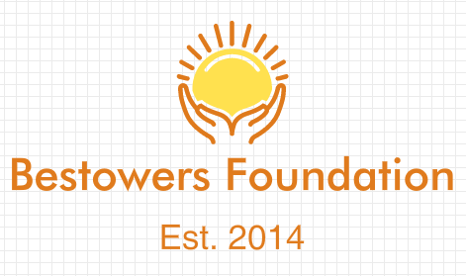

The hands represent out foundation raising people up and helping one another, while the sun represents picking people up and raising them into the light.

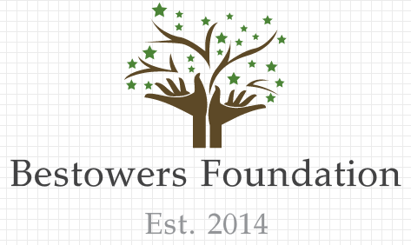

The hands represent the strength and foundation that our foundation bring. The leaves and branches represent how open we are and how we will support many and raise them up.