

**BESTOWERS FOUNDATION, INC.**

A Florida Non-profit Public Benefit Corporation

**ARTICLES OF**

**INCORPORATION**

**ARTICLE I**

**NAME**

* 1. **Name**

The name of this corporation shall be BESTOWERS FOUNDATION, INC. hereinafter referred to as “BESTOWERS FOUNDATION”.

**ARTICLE II**

**DURATION**

**2.01 Duration**

The period of duration of the corporation is perpetual.

**ARTICLE III**

**PURPOSE**

**3.01 Purpose**

BESTOWERS FOUNDATION is a non-profit corporation and shall operate exclusively for

charitable, educational and religious purposes within the meaning of Section 501 (c)(3) of the Internal Revenue Code, or the corresponding section of any future Federal tax code. Toward said purposes, BESTOWERS FOUNDATION may do the following:

i) Giving relief to the poor, the distressed or the unprivileged or the people who have been struck by natural disaster.

ii) Giving scholarships and/or grants for advancement of education or science or arts.

iii) Giving grants and/or services for advancement of religion or community.

**3.02 Public Benefit**

BESTOWERS FOUNDATION is designated as a public benefit corporation.

**ARTICLE IV**

**NON-PROFIT NATURE**

**4.01 Non-profit Nature**

BESTOWERS FOUNDATION is organized exclusively for charitable, educational and religious purposes including, for such purposes, the making of distributions to organizations that qualify as exempt organizations under section 501(c)(3) of the Internal Revenue Code, or corresponding section of any future federal tax code. No part of the net earnings of BESTOWERS FOUNDATION shall inure to the benefit of, or be distributable to its members, trustees, officers, or other private persons, except that the corporation shall be authorized and empowered to pay reasonable compensation for services rendered and to make payments and distributions in furtherance of the purposes set forth in the purpose clause hereof.

Notwithstanding any other provision of this document, the corporation shall not carry on any other activities not permitted to be carried on (a) by any organization exempt from federal income tax under section 501 (c) (3) of the Internal Revenue Code, corresponding section of any future federal tax code, or (b) by an organization, contributions to which are deductible under section 170 (c) (2) of the Internal Revenue Code, or corresponding section of any future federal tax code.

BESTOWERS FOUNDATION is not organized and shall not be operated for the private gain of any person. The property of the corporation is irrevocably dedicated to its charitable, educational and religious purposes. No part of the assets, receipts, or net earnings of the corporation shall inure to the benefit of, or be distributed to any individual. The corporation may, however, pay reasonable compensation for services rendered, and make other payments and distributions consistent with these Articles.

**4.02 Personal Liability**

No officer or director of this corporation shall be personally liable for the debts or obligations of BESTOWERS FOUNDATION of any nature whatsoever, nor shall any of the property or assets of the officers or directors be subject to the payment of the debts or obligations of this corporation.

**4.03 Prohibited Distributions**

No part of the net earnings or properties of this corporation, on dissolution or otherwise, shall inure to the benefit of, or be distributable to, its members, directors, officers or other private person or individual, except that the corporation shall be authorized and empowered to pay reasonable compensation for services rendered and to make payments and distributions in furtherance of the purposes set forth in Article III, Section 3.01.

**4.04 Dissolution**

Upon the dissolution of the corporation, assets shall be distributed for one or more exempt purposes within the meaning of section 501(c)(3) of the Internal Revenue Code, or the corresponding section of any future federal tax code, or shall be distributed to the federal government, or to a state or local government, for a public purpose.

Any such assets not so disposed of shall be disposed of by a Court of Competent Jurisdiction of the county in which the principal office of the corporation is then located, exclusively for such purposes or to such organization or organizations, as said Court shall determine, which are organized and operated exclusively for such purposes.

In the event that the court shall find that this section is applicable but that there is no qualifying organization known to it which has a charitable purpose, which, at least generally, includes a purpose similar to this corporation, then the court shall direct the distribution of its assets lawfully available for distribution to the Treasurer of the State of Florida to be added to the general fund.

**4.05 Restricted Activities**

No substantial part of the corporation’s activities shall be the carrying on of propaganda, or otherwise attempting to influence legislation, and the corporation shall not participate in, or intervene (including the publishing or distribution of statements) in any political campaign on behalf of or in opposition to any candidate for public office.

**4.06** **Prohibited Activities**

Notwithstanding any other provision of these Articles, the corporation shall not carry on any activities not permitted to be carried on (I) by a corporation exempt from federal income tax as an organization described by Section 501(c)(3) of the Internal Revenue Code, or the corresponding section of any future federal tax code, or (II) by a corporation, contributions to which are deductible under Section 170(c)(2) of the Internal Revenue Code, or the corresponding section of any future federal tax code.

**ARTICLE V**

**BOARD OF DIRECTORS**

**5.01 Governance**

BESTOWERS FOUNDATION shall be governed by its board of directors.

**5.02 Initial Directors**

The initial directors of the corporation shall be:

Reza U. Nabi

6023 NW 107th Place

Alachua, FL 32615

Mohammad A. Miah

6736 Mockingbird Woods CT

Lorton, VA 22079

Tamjidur R. Choudhury

2828 NW 42nd Place

Gainesville, FL 32605

**ARTICLE VI**

**MEMBERSHIP**

**6.01 Membership**

BESTOWERS FOUNDATION shall have no members. The management of the affairs of the corporation shall be vested in a board of directors, as defined in the corporation’s bylaws.

**ARTICLE VII**

**AMENDMENTS**

**7.01 Amendments**

Any amendment to the Articles of Incorporation may be adopted by approval of two-thirds (2/3) of the board of directors.

**ARTICLE VIII**

**ADDRESSES OF THE CORPORATION**

**8.01 Corporate Address**

The address of the corporation is:

Bestowers Foundation, Inc.

6023 NW 107th Place

Alachua, FL 32615

The mailing address of the corporation is:

Bestowers Foundation, Inc.

6023 NW 107th Place

Alachua, FL 32615

**ARTICLE IX**

**appointment of registered agent**

**9.01 Registered Agent**

The registered agent of the corporation shall be:

Reza U. Nabi

6023 NW 107th Place

Alachua, FL 32615

**ARTICLE X**

**INCORPORATOR**

The incorporator of the corporation is as follow:

Reza U. Nabi

6023 NW 107th Place

Alachua, FL 32615

**CERTIFICATE OF ADOPTION OF Articles of Incorporation**

We, the undersigned, do hereby certify that the above stated Articles of Incorporation of BESTOWERS FOUNDATION were approved by the board of directors on 04/03/2014 and constitute a complete copy of Articles of Incorporation of the BESTOWERS FOUNDATION.

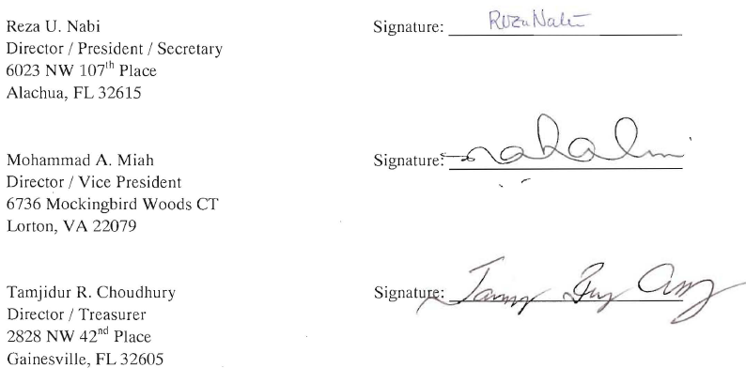

**acknowledgment of conSENT**

**to APPOINTMENT as REGISTERED AGENT**

