**Minutes, Board of Directors Meeting**

**Date:** Saturday, Dec 31, 2016

**Time:** 3:15 PM

**Location**: 1502 Kingfisher Dr, Marietta, GA 200152 (Online)

**Present:**Reza Nabi (Chairman), Tamjid Choudhury, Abdul Halim Miah, Putul, Samah and Tahsin

**Absent:** None

1. **Call to order**: at 7:35 PM by presiding officer Reza Nabi (Chair).
2. **Quorum:**Three of Three Board members present (2 required.)
3. **Reading and Approval of Minutes:** Minutes of the Aug 05, 2016 Board meeting accepted as previously published and posted on foundation website and approved by unanimous consent.
4. **Chairman’s Report**
   1. Presented annual financial report (see below).

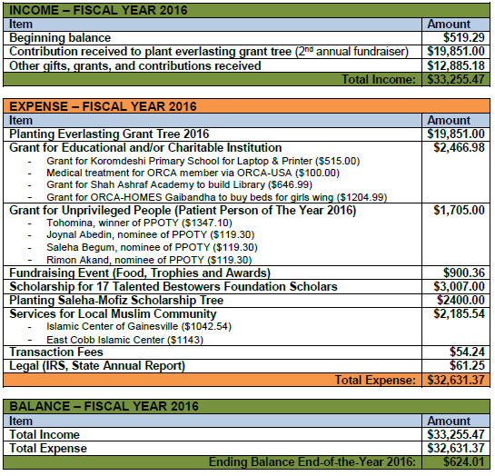

* 1. The actual fund that was raised in 2nd annual fundraiser is: $19851 (15 Lac 88 thousand and 80 TK) which has been successfully transferred to Shahajalal bank. Unanimously decided to plan two grant trees one with 8 lac and other one 7 lac 90 thousand by first week of January.
  2. Unanimously decided that Samah and Putul will be fundraising co-ordinators, to raise fund to plant everlasting scholarship tree for talented student in Bangladesh. Date for 3rd annual fundraiser is set to Feb 18, Saturday, 2017. Based on the response from Gainesville donors, venue will be decided.
  3. Discussed potential renaming of the “Bestower of the Year” to “Philanthrophyst of the year”. Majority liked the “Bestower of the year”. Also unanimously decided to give “Bestower of the year 2016” award to “Sadek Afzal” for his outstanding contribution to Bestowers Foundation. Award will be given in the 3rd annual fundraiser evening, Lord willing.
  4. All monthly bank statements and minutes of the meetings are posted to our website acceible to board members and affiliates by valid login.

1. **New Business**
2. Initiating fundraising activity by Fundraiser coordinators;
3. Reza Nabi will send annual financial report to all donors and assist fundraising co-ordinators any help they need to get access to emails.
4. **Open Forum**
   1. Next annual board meeting tentatively set for Dec 31, 2017.
5. **Adjournment**
   1. There being no further business, Chairman Reza Nabi declare meeting adjourned by unanimous consent.
   2. Meeting Adjourned at 4:15 PM

|  |  |
| --- | --- |
| Respectfully submitted by,  /Reza Nabi/  Chairman | Adopted by the Board in the meeting  Of Dec 31, 2016  ____________________________  (Signature of the Presiding Officer) |