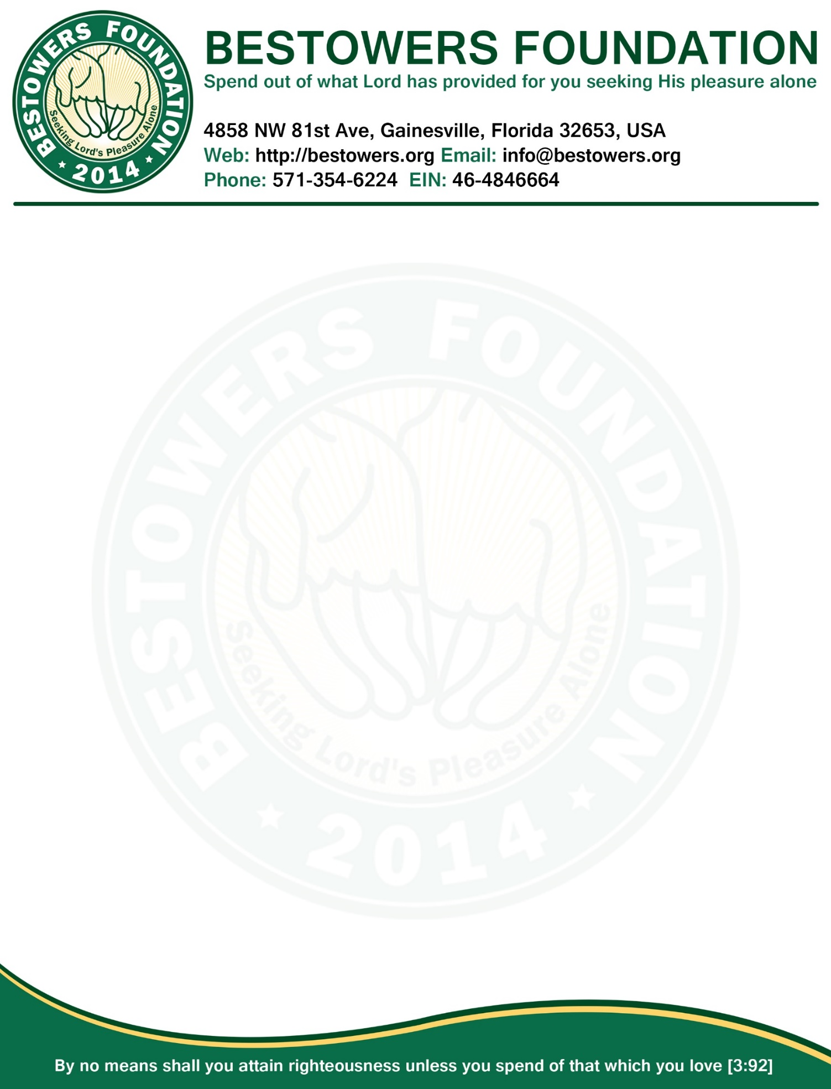

**Minutes, Board of Directors Meeting**

**Date:** Sunday, March 01, 2015

**Time:** 7:30 PM

**Location**: 4858 NW 81st Ave, Gainesville, FL 32653

**Present:** Reza Nabi, President & Secretary

Tamjidur Choudhury, Treasurer

**Absent:** one

1. **Call to order**: at 7:35 PM by presiding officer Reza Nabi.
2. **Quorum:** two of three Board members present (2 required.)
3. **Reading and Approval of Minutes:** Minutes of the December 28, 2014 Board meeting accepted as previously published and posted on foundation website and approved by unanimous consent.
4. **President’s Report**
   1. Based on the application for building Morajanpar Shahi Eidgah, fund (TK 1 Lac) has been sent to our overseas secretary, Mahfuza Khatun.
   2. Application for building library for ORCA-Homes Gaibandha, an orphanage, has been approved unanimously.
   3. Tax for Bestowers Foundation has been filed with IRS and document is archived at our website.
   4. President will file annual report with State of Florida by May 31st, 2015 (due date)
   5. Ms. Meherun who is blind wishes if she could see the world. Bestowers Foundation unanimously agreed to finance her eye-surgery so that she could see the world and her wishes come true.
5. **New Business**
   1. Unanimously decided to plant everlasting scholarship tree in first-come-first-own basis and trees will be planted in 4 batches listed below.

|  |  |  |
| --- | --- | --- |
| **LIST OF BATCHES & DUE DATES TO PLANT EVERLASTING SCHOLARSHIP TREES, INSHA-ALLAH** | | |
| **Batch #** | **Due Date to fulfill the pledge** | **Approx. Date to complete Plantation** |
| 1st Batch | March 15, 2015 | March 31, 2015 |
| 2nd Batch | July 15, 2015 | July 31, 2015 |
| 3rd Batch | September 15, 2015 | September 30, 2015 |
| 4th Batch | Dec 31, 2015 | Jan 15, 2016 |

* 1. For clarity, for each tree, there should be separate transaction of $2400 which would fixed at Shahjalal Islamic Bank as auto-renewable 3-months FDR. For now overseas secretary will do the needful open this account with her name, until we establish legal charitable entity, preferably with same name, in Bangladesh.
  2. President will work with Lawyers in Bangladesh to establish a charitable organization in Bangladesh so that we can perform overseas secretary’s work under the charitable organization.
  3. Since creating legal charitable entity may take longer time, we decided that Director and Treasurer Tamjid Chowdhury should be added as join account holder with overseas secretary, including the Auto-renewable FDR account which will return fruits (scholarship) for Bestowers Foundation’s orphan students.

1. **Open Forum**
   1. Next annual meeting tentatively set for 31st May 2015.
2. **Adjournment**
   1. There being no further business, President Reza Nabi declare meeting adjourned by unanimous consent.
   2. Meeting Adjourned at 8:35 PM

|  |  |
| --- | --- |
| Respectfully submitted by,  /Reza Nabi/  Secretary | Adopted by the Board in the meeting  Of March 01, 2015  ____________________________  (Signature of the Presiding Officer) |