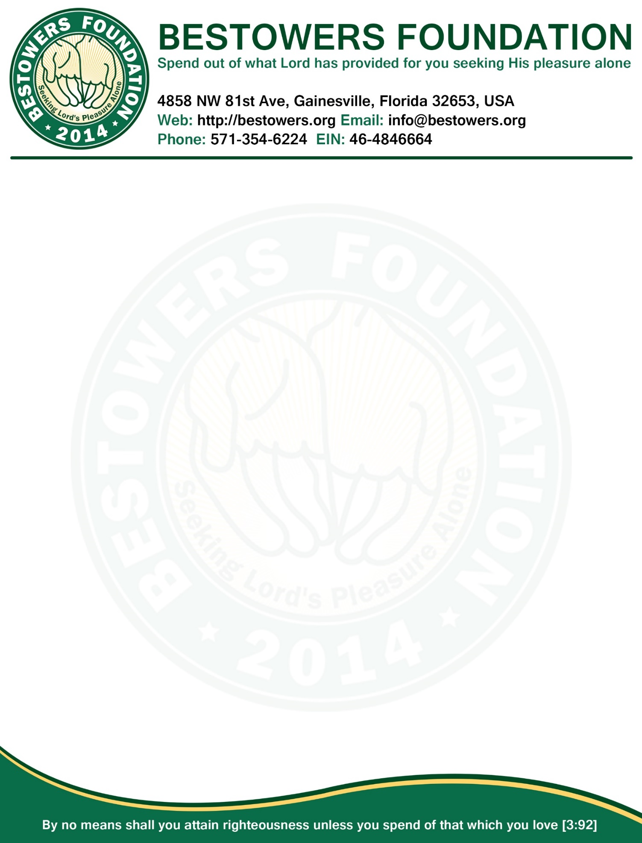

**Minutes, Board of Directors Meeting**

**Date:**Monday, November16, 2015

**Time:** 7:30 PM

**Location**: 4858 NW 81st Ave, Gainesville, FL 32653

**Present:**Reza Nabi, President & Secretary

MA Halim Miah, VP

Tamjid Choudhury, Treasurer

**Absent:** None

1. **Call to order**: at 7:35 PM by presiding officer Reza Nabi.
2. **Quorum:**Three of three Board members present (2 required.)
3. **Reading and Approval of Minutes:** Minutes of the Sep 25, 2015 Board meeting accepted as previously published and posted on foundation website and approved by unanimous consent.
4. **President’s Report**
   1. Unanimously decided that we need to reschedule 2nd annual fundraiser from Jan 17th to March 05, 2016. This is because Zahid Chowdhury’s daughter is getting married on December 2015 and one of the major host (Lokman Chowdhury) of various tournament will have time to host in December. The earliest Lokman Chowdhury can host in in January. Hence, deadline to complete all tournament is set to Jan 31, 2016. Since, most likely, there will be “Ekushe Febuary” cultural program in Gainesville, hence, we, unanimously decided to reschedule fundraiser to March 05, 2016.

|  |  |
| --- | --- |
| **BESTOWERS FOUNDATION’S 2nd ANNUAL COMMUNITY GET-TOGETHER & FUNDRAISER ITINERARY** | |
| **Date** | **Activity** |
| Oct 24, 2015 | Deadline to submit names of all participants and the dedicated volunteer who will be responsible to organize the tournament |
| Nov 21st, 2015 | Foundation publishes final list of tournaments which met the criteria of having a dedicated volunteer and have at least 4 participants |
| Nov 23rd 2015 - Jan 31, 2016 | The dedicated volunteer will communicate with the corresponding participants and organize events/tournaments. |
| Feb 08, 2016 | The dedicated volunteer will submit all winner's name to the Bestowers   Foundation at [info@bestowers.org](mailto:info@bestowers.org) |
| Mar 05, 2016 | Winners will be given personalized Trophies and certificates at Bestowers Foundation's 2nd Annual Community Get-Together and Fundraising Dinner |

* 1. Bestowers Foundation secured one of the gold sponsor plate with “Bestowers Foundation” by donating $500 to Eastside PTSA. Completed the perpetual sponsor plaque for Eastside Media Center and gave that to Principal Mr. Charbonnet. We are able to raise $6300 (where our goal was to raise $5000).
  2. In our community there are many unprivileged people who cannot afford to see the doctor. It is unanimously decided that the Foundation should step forward and help those patients in need by taking them to free clinic, such as "Rahama Mercy Clinic". Having a medical background, Umme Safa Nur volunteered to lead this mission of helping patients who cannot afford see doctors. It was also unanimously decided that we create a new "Executive Member" position in Executive Committee and filled newly opened position by Umme Safa Nur. Reza Nabi will will update the website in contact us page with Umme Safa Nur's name as "Executive Member" under "Executive Committee".

1. **New Business**
2. Reza Nabi will send out the email to all bestowers with list of official tournaments along with updated itinerary. Reza Nabi will also communicate with all volunteers to encourage them to complete all tournaments before January 31, 2016.
3. **Open Forum**
   1. Next annual meeting tentatively set for Dec31,2015.
4. **Adjournment**
   1. There being no further business, President Reza Nabi declare meeting adjourned by unanimous consent.
   2. Meeting Adjourned at 8:15 PM

|  |  |
| --- | --- |
| Respectfully submitted by,  /Reza Nabi/  Secretary | Adopted by the Board in the meeting  Of Nov 16, 2015  ____________________________  (Signature of the Presiding Officer) |