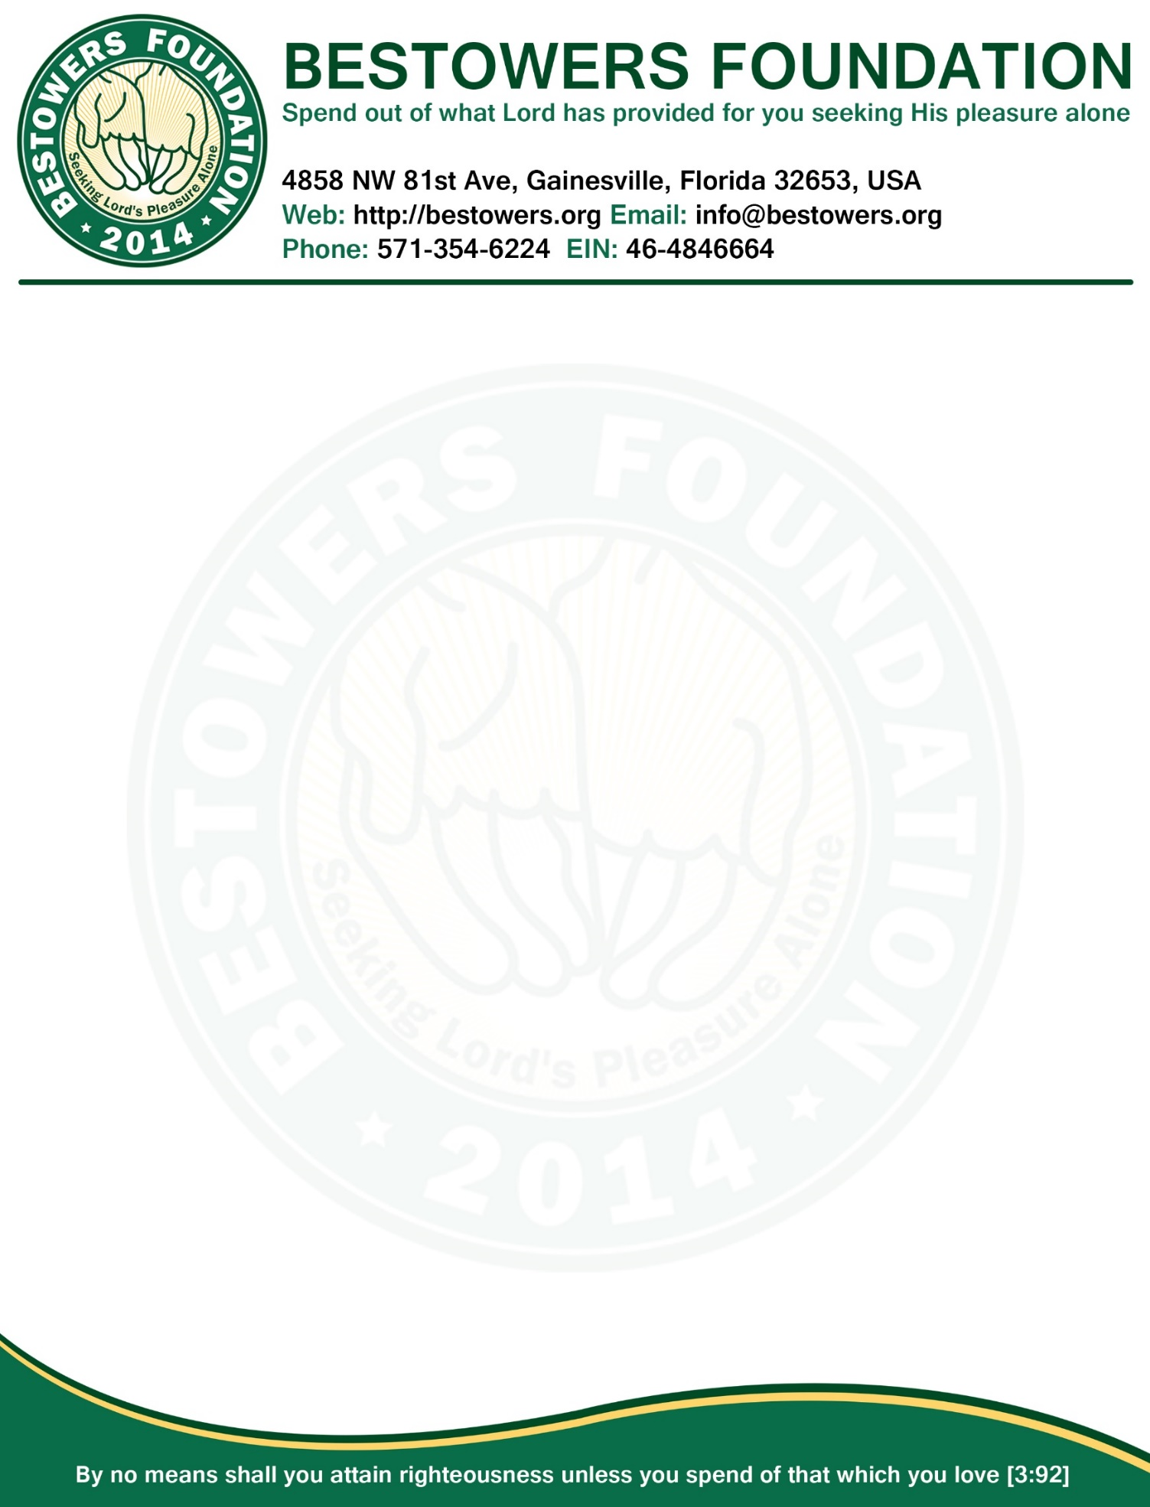

**Minutes, Board of Directors Meeting**

**Date:** Friday, September 25, 2015

**Time:** 7:30 PM

**Location**: 4858 NW 81st Ave, Gainesville, FL 32653

**Present:**Reza Nabi, President & Secretary

MA Halim Miah, VP

Tamjid Choudhury, Treasurer

**Absent:** None

1. **Call to order**: at 7:35 PM by presiding officer Reza Nabi.
2. **Quorum:** Three of three Board members present (2 required.)
3. **Reading and Approval of Minutes:** Minutes of the July 13, 2015 Board meeting accepted as previously published and posted on foundation website and approved by unanimous consent.
4. **President’s Report**
   1. Unanimously decided to start planning to host 2nd annual fundraiser 2016 according to the following itinerary. Reza Nabi will send out invitation to register participants for various tournaments. Deadline to submit names for tournament is: Oct 24, 2015. This year’s registration fee for tournament is set to: $10 / per tournament or $8 / pretournament (for those who participant 3 or more tournaments).

|  |  |
| --- | --- |
| **BESTOWERS FOUNDATION’S 2nd ANNUAL COMMUNITY GET-TOGETHER & FUNDRAISER ITINERARY** | |
| **Date** | **Activity** |
| Oct 24, 2015 | Deadline to submit names of all participants and the dedicated volunteer who will be responsible to organize the tournament |
| Oct 31st, 2015 | Foundation will publish final list of tournaments which met the criteria of having a dedicated volunteer and have at least 4 participants |
| Nov 1st - Dec 31 | The dedicated volunteer will communicate with the corresponding participants and organize events/tournaments. |
| Jan 04, 2016 | The dedicated volunteer will submit all winner's name to the Bestowers   Foundation at [info@bestowers.org](mailto:info@bestowers.org) |
| Jan 17, 2016 | Winners will be given personalized Trophies and certificates at Bestowers Foundation's 2nd Annual Community Get-Together and Fundraising Dinner |

* 1. It was also decided unanimously that Bestowers Foundation will help to organize fundraiser for Eastside High School for upgrading media center. The foundation will help Eastside MSA Club students to sponsor food, plates, napkins etc for the fundraising dinner. Reza Nabi will work with Principal, Eastside and PTSA president to get the total number of confirmed guests and also order a perpetual sponsor plaque.

1. **New Business**
2. Reza Nabi will send out the email to all bestowers with list of tournaments foundation is planning to host and also encourage them to register for the tournament before the due date. if Lord wills.
3. **Open Forum**
   1. Next annual meeting tentatively set for Nov 16, 2015.
4. **Adjournment**
   1. There being no further business, President Reza Nabi declare meeting adjourned by unanimous consent.
   2. Meeting Adjourned at 8:15 PM

|  |  |
| --- | --- |
| Respectfully submitted by,  /Reza Nabi/  Secretary | Adopted by the Board in the meeting  Of Sep 25, 2015  ____________________________  (Signature of the Presiding Officer) |