AI HACKATHON 2026 · DIU CPC × UPAY · TRACK 05: MERCHANT & AGENT INTELLIGENCE
FloatWise
AI agent-liquidity forecaster for upay
Project report: the problem, the solution, the architecture, the technical workflow, the execution and the results.
Model version fw-c078f4bb · Test period 1 January – 30 June 2026 · Demo date 15 March 2026
Repository: github.com/redwanhasan980/DIU_AI_Hackathon
All data in this project is synthetic. Every number in this report is produced by code and read from artifacts/*.json.

Contents

1. Executive summary
Mobile financial services (MFS) agents in Bangladesh run out of cash (so they cannot pay cash-outs) or e-float (so they cannot accept cash-ins) on exactly the days when customers need them most: before Eid, on garment salary days, during remittance surges and on government allowance (G2P) days. The customer hears “cash nai, pore ashen” (“no cash, come back later”). upay loses the fee, the agent loses commission and the customer may switch wallets.
FloatWise forecasts every agent's cash-out and cash-in for the next 7 days, turns the forecast into a stockout risk and an exact top-up amount, plans the field officers' (DSOs') visits within their limits, explains each recommendation in Bangla or English, and leaves every decision to a person. A six-month backtest against today's rule of thumb measures the impact.
−47.5%  stockout agent-days | −53.7%  upay fee revenue lost | −53%  forecast error vs same day last week | Tk 9.3 Cr  upay fees recovered per month at network scale

Headline results
Result | Value | Source
Stockout agent-days, 500 agents, Jan–Jun 2026 | 6,973 → 3,664 (−47.5%) | simulation_default.json
Failed cash-out value | Tk 52.2 crore → Tk 27.8 crore (−46.7%) | simulation_default.json
upay fee revenue lost | Tk 33.81 lakh → Tk 15.64 lakh (−53.7%) | simulation_default.json
Cost: average cash held / DSO trips | +2.3% / +4.1% | simulation_default.json
Cash-out forecast error (WAPE), overall | 18.7% vs 39.8% for same day last week | metrics.json
Cash-out forecast error on Eid and event days | 21.2% vs 58.9% (−64%) | metrics.json
At upay's ~1,54,000 agents, per month | Tk 9.3 crore fee, Tk 6.4 crore commission, 1,68,938 stockout-days avoided, 2,69,962 customers kept | simulation_default.json
Fairness | Every area type and both rural and urban improve on forecast and on stockouts | fairness.json
Quality | 89 automated tests, 21-step browser walk-through, CI on Linux and Windows, deterministic rebuild | repo

Design principle. Machine learning predicts demand. Deterministic, tested code decides amounts. The language model only explains, behind a numeric guardrail. A person approves every action; no money ever moves automatically.

2. The problem

2.1 Context
upay serves customers through a network of roughly 1,54,000 retail agents (end of 2023). Each agent holds a fixed total float split between physical cash in the drawer and e-float in the agent wallet. A cash-out converts the agent's cash into e-float; a cash-in does the opposite. When either side reaches zero, one type of transaction stops.
Failure mode | What happens | Typical trigger
Cash stockout | Agent cannot pay a cash-out; customer is turned away | Pre-Eid remittance arrivals, garment salary days, G2P allowance days
E-float stockout | Agent cannot accept a cash-in; sender goes elsewhere | Urban pre-Eid rush to send money home, market days

2.2 Who loses on a failed cash-out
- The customer cannot withdraw salary or remittance on the day it is needed and may move to another wallet.
- The agent loses the 0.41% commission on every failed cash-in and cash-out, on the busiest days of the year.
- upay loses its cash-out fee (1.0–1.4% by wallet type) net of the 0.51% channel commission, and risks losing the customer.
- The distributor and DSO lose 0.10% distributor commission and spend the day firefighting with unplanned trips.
In the six-month backtest of 500 synthetic agents, today's rule of thumb failed 2,15,101 cash-outs worth Tk 52.2 crore.

2.3 How big and how seasonal
Under today's rule, 30% of agent-days stock out in the week before Eid-ul-Fitr, against 1.6% on a normal day. The pain is concentrated in a few predictable windows, which is exactly what a forecaster can exploit.
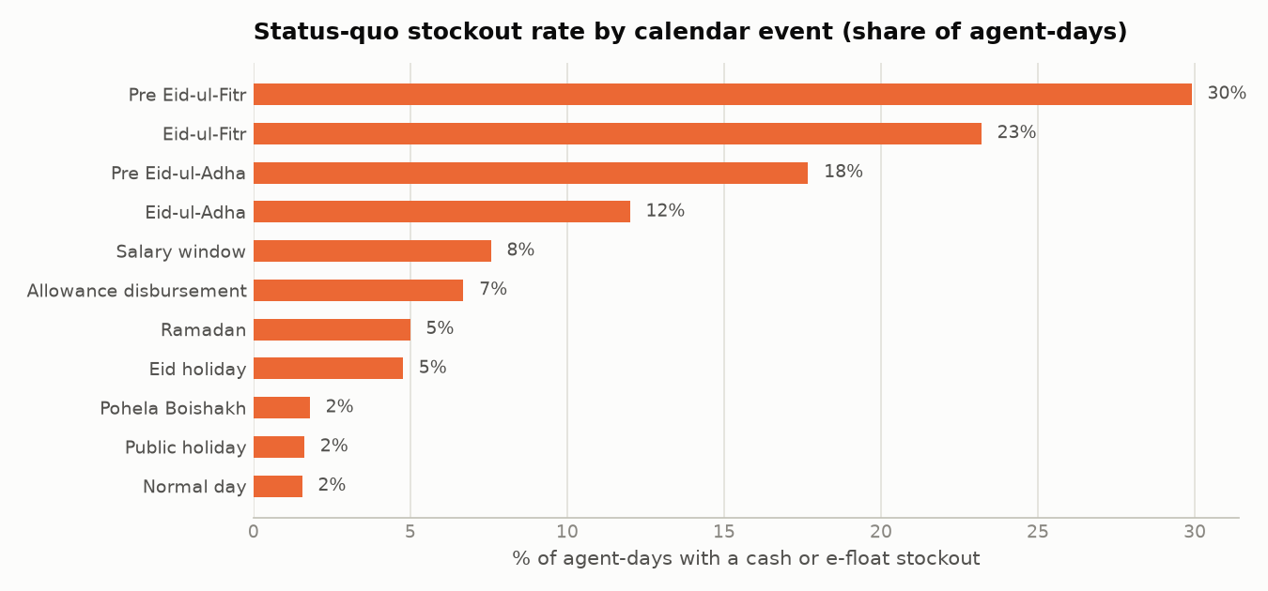
Figure 1. Stockout rate under today's rule by type of day (synthetic network, full dataset).

2.4 Why today's rule of thumb fails
Agents and DSOs top up to about 1.5× the last 7 days' average when the balance falls below 0.6× of that target. An average only sees the past. Eid moves about 11 days earlier every year, and salary and allowance days follow the calendar, not the average. For the demo agent the average keeps climbing during the pre-Eid rush and peaks on Eid day, after demand has already fallen by about three-quarters.
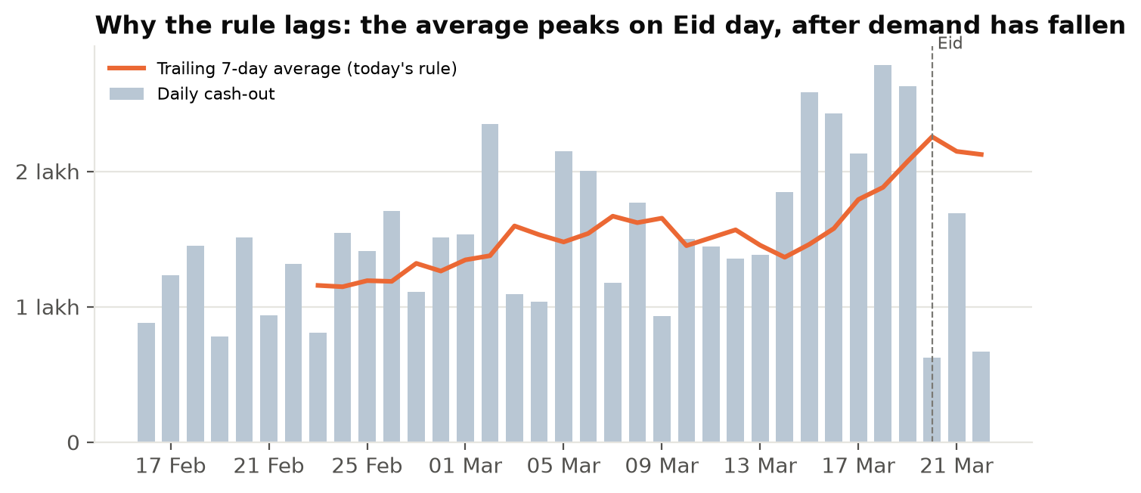
Figure 2. Demo agent AG00471: daily cash-out against the trailing 7-day average used by today's rule.

2.5 Problem statement
For upay operations, distributors, DSOs and agents, who cannot see tomorrow's cash and e-float needs, FloatWise is an AI liquidity forecaster that predicts each agent's 1–7-day demand, sizes the top-up and plans DSO visits, unlike a backward-looking 7-day average, because it learns the Bangladesh calendar (Eid, salary, remittance, allowance days) and reports its uncertainty.

3. The solution

3.1 What FloatWise does
- Forecast. Every agent's cash-out and cash-in for the next 1–7 days as quantiles (P10, P50, P90).
- Assess risk. Convert the forecast into the chance of running out of cash or e-float tomorrow and over the next 7 days.
- Recommend. TOP_UP_CASH, TOP_UP_EFLOAT, NO_ACTION or NEEDS_EXTRA_FLOAT, with an exact amount rounded up to Tk 1,000 and reason codes.
- Plan. Rank DSO visits by taka at risk within the visit limit (10) and the cash bag (Tk 10 lakh); unvisited agents get the advice in the app.
- Explain and approve. SHAP drivers plus a Bangla or English explanation; a person approves, modifies or rejects.
- Prove. Backtest FloatWise against today's rule on six months of true demand, including Eid-ul-Fitr and Eid-ul-Adha 2026.

3.2 Users
Persona | Needs | FloatWise screen
Operations lead (upay / distributor) | Where is the network at risk, how much cash and e-float to move, is it working? | Network map, Impact, Model & fairness
DSO (field officer) | Which agents to visit today with a limited bag | DSO plan
Agent | How much cash to keep tomorrow and why, in Bangla | Agent mobile card
Risk / compliance | Is it fair, explainable and human-controlled? | Model & fairness, Decisions log

3.3 A day with FloatWise
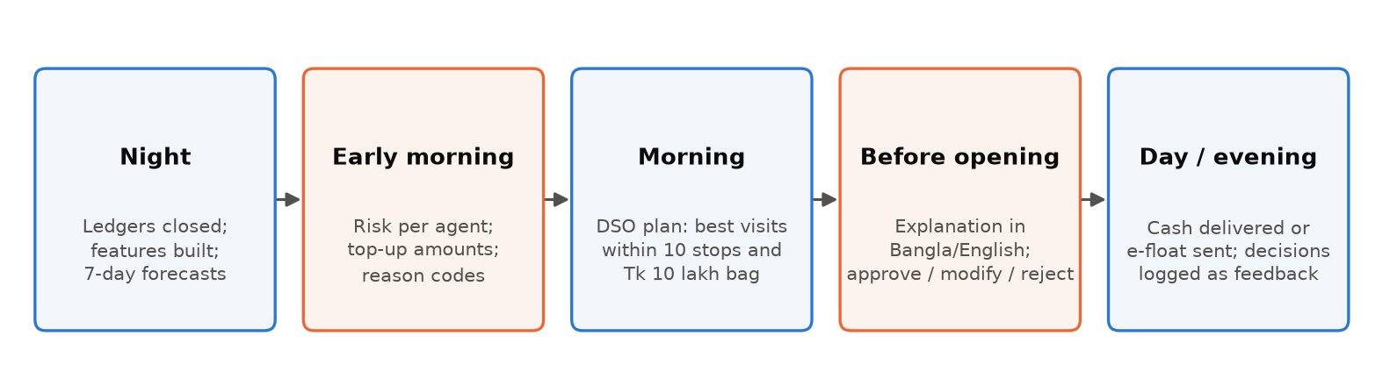
Figure 3. The daily operating loop.

3.4 Worked example: AG00471, five days before Eid
Rahmania Bhandar (AG00471) is a rural remittance shop in Beanibazar, Sylhet. At close on 15 March 2026 it holds Tk 18,501 in cash. FloatWise forecasts Tk 2,60,567 of cash-out for 16 March (P10 Tk 2,14,385 – P90 Tk 3,03,469), a 100% chance of running out. It recommends TOP_UP_CASH Tk 2,66,000 before opening, limited by the agent's total float of Tk 2,88,000. The main SHAP drivers are days to Eid (+Tk 95,410) and Ramadan (+Tk 13,725). True demand fell inside the P10–P90 range on 6 of the 7 forecast days.
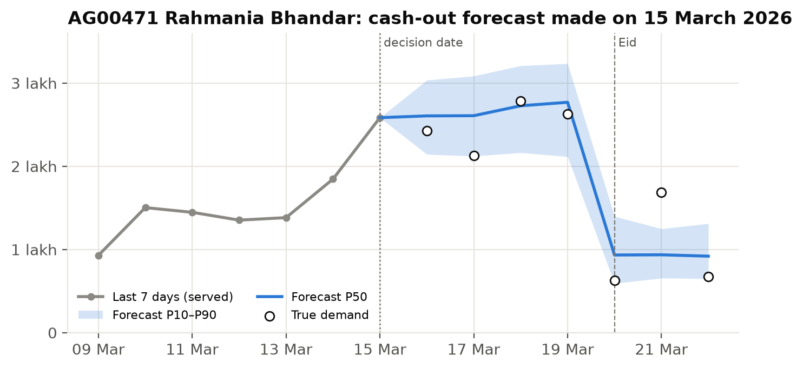
Figure 4. Forecast made on 15 March against what really happened.

4. System architecture
FloatWise is a layered Python backend with a React frontend. Lower layers never import higher ones, and all business rules live in one place (engine/).
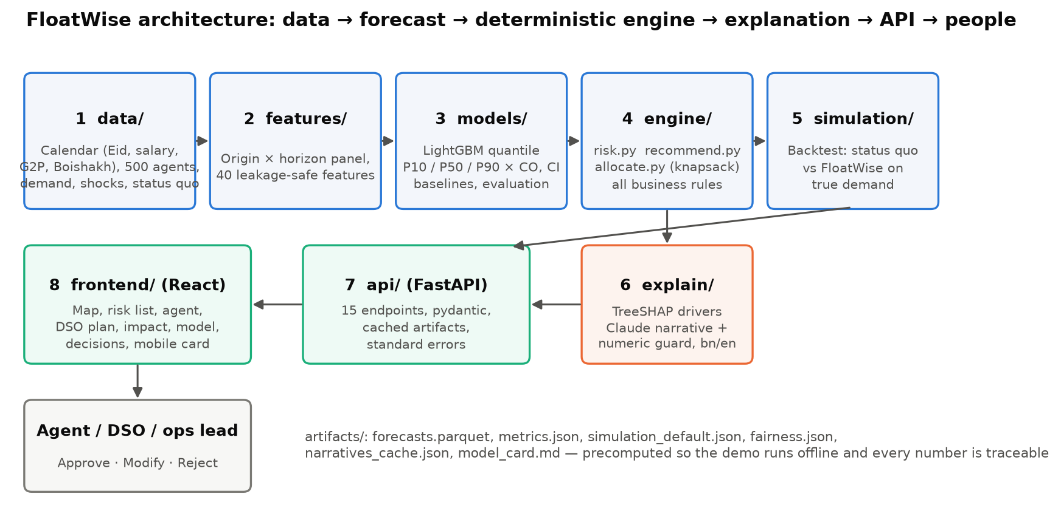
Figure 5. Layers and data flow.

4.1 Layers
Layer | Responsibility | Key modules
data/ | Bangladesh calendar, 500 agents, true demand, shocks, censored ledger under today's rule | calendar_bd.py, agents.py, demand.py, shocks.py, simulate_status_quo.py, generate.py
features/ | Origin × horizon panel with 40 leakage-safe features | build.py
models/ | Baselines, LightGBM quantile training, evaluation, batch prediction | baselines.py, train.py, evaluate.py, predict.py
engine/ | Stockout probability, recommendation, DSO allocation (all business rules) | risk.py, recommend.py, allocate.py
simulation/ | Day-by-day backtest of status quo vs FloatWise on true demand | backtest.py
explain/ | TreeSHAP drivers, Bangla/English templates, Claude narrative with guardrail | shap_explain.py, templates.py, llm.py, labels.py
api/ | FastAPI service over precomputed artifacts; also serves the built web app | main.py, store.py
frontend/ | React + TypeScript single-page app with offline fixtures | pages/, components/, api/, i18n/, fixtures/

4.2 Technology stack
Area | Technology
Language and runtime | Python 3.11+, Node.js 20+
Data and ML | pandas 3.0, NumPy 2.4, PyArrow (Parquet), LightGBM 4.7 (quantile objective), scikit-learn 1.9
Explainability and LLM | LightGBM TreeSHAP (pred_contrib); Anthropic Claude SDK (model from LLM_MODEL env var)
API | FastAPI 0.142, pydantic 2.13, Uvicorn
Frontend | React 19, TypeScript 5.9 (strict), Vite 8, Tailwind CSS 4, Recharts 3, react-leaflet 5 with an offline Bangladesh outline
Quality | pytest (89 tests), ruff, tsc, eslint, Playwright browser walk-through, GitHub Actions (Linux + Windows)
Tooling | run.py cross-platform launcher, Makefile, config.yaml for every assumption

4.3 Data contracts
The pydantic schemas in backend/floatwise/schemas.py are mirrored one-to-one in frontend/src/api/types.ts. Any contract change updates the SRS, both schema files and the frontend fixtures in the same commit. Money is always an integer number of taka.

4.4 Precomputation
Forecasts for the test period are generated once into artifacts/forecasts.parquet. The API reads them, so every GET responds in under 300 ms and the demo runs without internet. The artifacts are deterministic: rebuilding from the same seed reproduces model fw-c078f4bb and every number byte for byte.

5. Synthetic data
No real customer, agent or transaction data is used. The generator is deterministic from a seed in config.yaml, and every assumption is documented in docs/DATA_ASSUMPTIONS.md.

5.1 Scale and split
Item | Value
Period | 1 January 2024 → 30 June 2026 (daily)
Agents | 500 across 15 districts, about 25 per DSO, 5 DSOs per distributor
Train / validation / test | ≤ 30 June 2025 / 1 July – 31 December 2025 / 1 January – 30 June 2026
Eid-ul-Fitr | 11 April 2024, 31 March 2025, 20 March 2026
Eid-ul-Adha | 17 June 2024, 7 June 2025, 27 May 2026

5.2 Generation model
True daily demand is a product of interpretable multipliers:
demand_CO(agent, d) = base[archetype] × size[agent] × weekday × salary(day index) × eid(days to/after Eid) × ramadan × boishakh × g2p × shock(district, d) × trend(d) × lognormal noise
Cash-in follows the same pattern with its own multipliers. The ledger then plays today's rule of thumb against this demand; on stockout days the observed volume is censored (lower than true demand), just as in real data.

5.3 Agent archetypes
Archetype | Base cash-out / day | Base cash-in / day | Signature
urban_residential (125) | Tk 1,50,000 | Tk 1,80,000 | Cash-in spike before Eid → e-float stockouts
garment_belt (100) | Tk 2,50,000 | Tk 1,00,000 | Cash-out spike on salary days 1–10 and the Eid bonus
rural_remittance (150) | Tk 80,000 | Tk 40,000 | Cash-out ×2–3 before Eid as remittance arrives; G2P days
market_hub (75) | Tk 3,00,000 | Tk 3,00,000 | High volume both ways; Boishakh and pre-Eid shopping
university_area (50) | Tk 60,000 | Tk 50,000 | Month-start cash-in from families; vacations

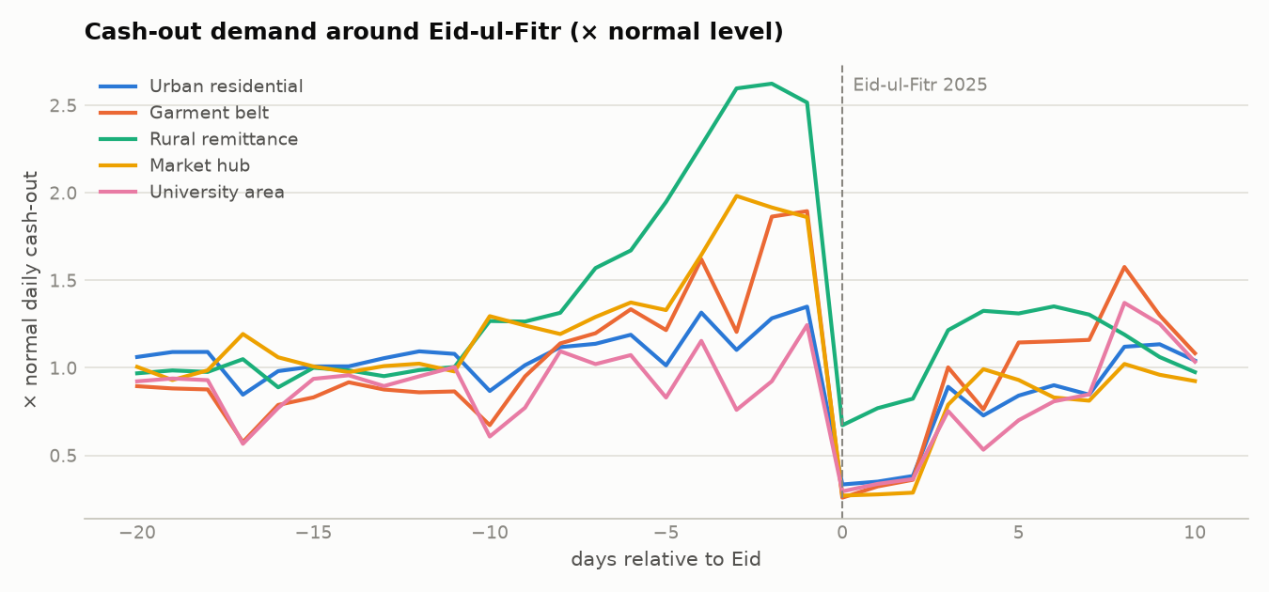
Figure 6. Eid spike by area type in the generated data.
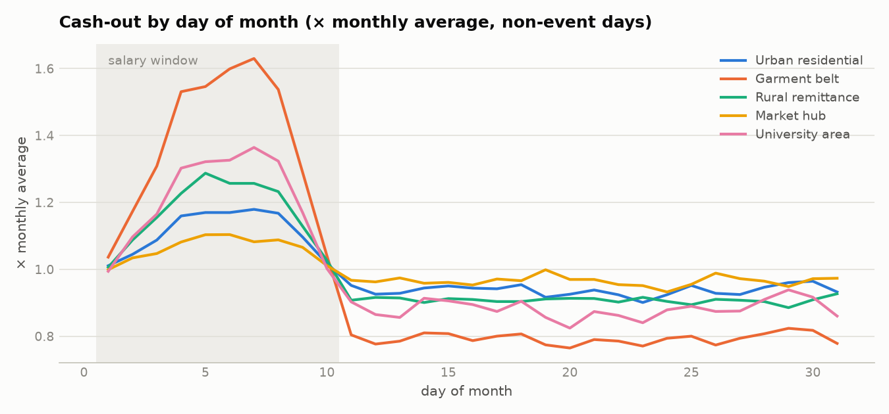
Figure 7. Salary-day cycle for garment-belt agents.

5.4 Alignment with upay
upay reality (public) | In FloatWise
Agent cash-out fee by wallet: primary 1.4%, salary 1.0%, remittance 1.0%, disbursement 0.7% | Fee per area type by wallet mix (garment → salary wallet, rural → remittance/G2P blend)
Agent commission 0.41%, distributor 0.10% per cash-in / cash-out | Commission lost on failed transactions; upay keeps fee − 0.51%
Salary disbursement, inward remittance, G2P allowances | Garment salary days, pre-Eid remittance surge, quarterly allowance days
Distributor → DSO → agent network, ~1,54,000 agents | 500 agents, 15 districts; impact scaled to 1,54,000
Customer cash-out limit Tk 25,000 per transaction | Synthetic ticket sizes Tk 1,500–3,000

5.5 Data quality checks
tests/test_data_quality.py checks that the same seed gives identical files, that cash + e-float equals the agent's float every day, that no balance goes negative, that served volume never exceeds true demand, that stockouts concentrate on event days, and that the Eid, salary and G2P signatures appear where expected.

6. Forecasting model

6.1 Targets and models
- Two targets (cash-out, cash-in) × three quantiles (P10, P50, P90) = six global LightGBM models with the quantile objective.
- Direct multi-horizon: the horizon h = 1..7 is a feature, so one model covers the whole week.
- The target is the ratio of demand to the agent's trailing 28-day mean, so one model learns multipliers across agents of very different size.
- Crossing quantiles are re-ordered (rearrangement) so that P10 ≤ P50 ≤ P90 always holds.

6.2 Features (known at the forecast origin)
Group | Features
Horizon | h
Target-date calendar | weekday, Friday, days to Eid-ul-Fitr / Eid-ul-Adha, days after Eid, Ramadan, salary-day index and window, Boishakh, holiday, G2P day index
Lags (≤ origin) | last value, lags 1/6/13, rolling mean/std 7/14/28, rolling max 28
Event memory | agent's multiplier around the previous Eid
Agent static | archetype, float capacity, district, DSO density
Censoring | stockout count in the last 7 days

No leakage: a feature for origin t may use data up to t only; calendar features of the target date are allowed because they are known in advance. tests/test_no_leakage.py enforces this by perturbing future data and checking that features do not change.

6.3 Baselines and acceptance
Every model is compared with two baselines: same day last week (seasonal naive) and the trailing 7-day mean (today's rule). All four acceptance checks pass.
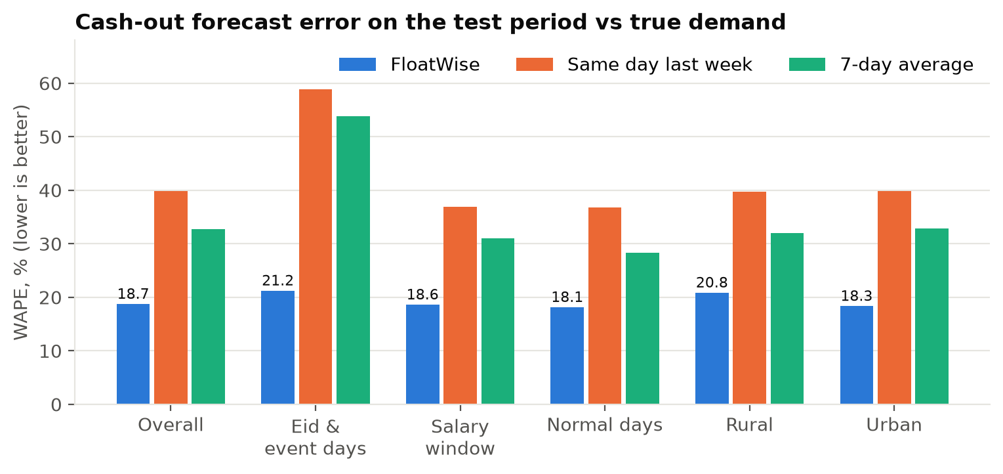
Figure 8. Cash-out WAPE on the test period, measured against true (uncensored) demand.
Acceptance check (SRS §6.4) | Target | Result
Overall improvement vs same day last week | ≥ 20% | 53% (18.7% vs 39.8%)
Event-day improvement | ≥ 35% | 64% (21.2% vs 58.9%)
P10–P90 coverage | 72–88% | 75% overall (60% on event days, reported as a limit)
No archetype worse than the baseline | all five | all five better

7. Decision engine
The engine is deterministic, unit-tested code. It turns quantile forecasts and balances into actions and amounts.

7.1 Stockout probability
A piecewise-linear distribution is built from P10, P50 and P90 with explicit tails. The effective opening cash is open_cash + α × CI_P50 (α = 0.5 for same-day inflows). Its position in the cash-out distribution gives p_cash_stockout; the e-float side is symmetric. Risk bands: high ≥ 0.5, medium ≥ θ, else low.

7.2 Recommendation
target_cash(s) = ceil_1000( CO_q(s) − α·CI_P50 + Tk 5,000 buffer ), and symmetrically for e-float.
If cash and e-float targets fit within the agent's total float: top up the risky side to its target.
If they do not fit: apply the best pro-rata split of the float.
If even the P90-level needs exceed the float: NEEDS_EXTRA_FLOAT, always escalated to a person.
Otherwise: NO_ACTION. Defaults: service level s = 0.99 and risk threshold θ = 0.10, chosen on validation.

Each recommendation carries reason codes from the calendar and balances (for example EID_FITR_IN_5_DAYS, RAMADAN, SALARY_WINDOW, CASH_BELOW_NEED, RECENT_STOCKOUTS) and a 7-day outlook of risk and need.

7.3 DSO allocation
Candidates are a DSO's agents with a top-up action. Priority is the expected shortfall in taka, computed exactly from the forecast distribution. An exact knapsack optimiser picks the visits that cover the most taka at risk within 10 visits and a Tk 10 lakh cash bag; a greedy planner is kept for comparison. Agents not visited receive the advice in the app, and the backtest assumes 70% of them follow it.

7.4 Business values
Value | Setting
Cash-out fee | 1.0–1.4% by area type (upay published tariffs by wallet)
Channel commission | agent 0.41% + distributor 0.10% = 0.51%
Customer churn after a failed cash-out | 5% (assumption, labelled in the UI)
Opportunity cost of idle cash | 10% a year (assumption)
Network scale-up | ~1,54,000 upay agents

8. Explainability and the language model
- Drivers: LightGBM TreeSHAP contributions of the median model, converted to taka and shown as the top five drivers with plain labels in both languages.
- Narrative: a deterministic Bangla or English template always exists. With an API key, Claude writes a friendlier explanation from structured JSON facts only (no free text from users).
- Numeric guardrail: every number in the LLM's text must appear in the facts; otherwise, on refusal, timeout or error, the template is used. The explanation endpoint never fails.
- Caching: narratives for the demo are pre-generated into artifacts/narratives_cache.json, so the demo works offline.
- Labelling: the UI marks the text as AI-generated or template, and keeps predictions, assumptions and generated text visually distinct.
The LLM never decides. Amounts, risk and actions come only from engine/. The model explains them in the agent's language.

9. API and user interface

9.1 REST API (FastAPI, prefix /api/v1)
Method | Endpoint | Purpose
GET | /health | Status, model version, data range, demo date, LLM availability
GET | /agents, /agents/{id} | Agent list with risk and action; profile, balances and 28-day history
GET | /agents/{id}/forecast | 7-day cash-out / cash-in quantiles with actuals when available
GET | /agents/{id}/recommendation | Action, amount, probabilities, reason codes, 7-day outlook
GET | /agents/{id}/explanation | SHAP drivers and Bangla/English narrative
GET | /dsos, /dso/{id}/plan | DSO list; visit plan under max_visits and max_cash
GET | /network/summary | Risk bands, actions, districts, upcoming events
POST | /simulate | Backtest with custom policy parameters
GET | /metrics/model, /calendar | Evaluation, fairness, tuning, assumptions; events
POST / GET | /decisions, /decisions/summary | Approve / modify / reject log and feedback summary

Inputs are validated with pydantic, errors use one standard JSON format without stack traces, and CORS is restricted to the frontend origin.

9.2 Screens
Screen | What it shows
Network | Eid banner, KPI tiles, risk map of 500 agents, districts by risk
Risk list | Filterable list of agents by district, area type and risk
Agent detail | Recommendation, 7-day outlook, forecast vs true demand, drivers, explanation, approve/modify/reject
DSO plan | Visits ranked by taka at risk within the bag; excluded agents and why
Impact | Backtest, upay fee revenue, network scale-up, live re-run with the service-level slider
Model & fairness | Acceptance checks, error by slice, fairness table, policy tuning, assumptions
Decisions | Decision log and feedback summary
Agent mobile card | One clear Bangla action for the agent

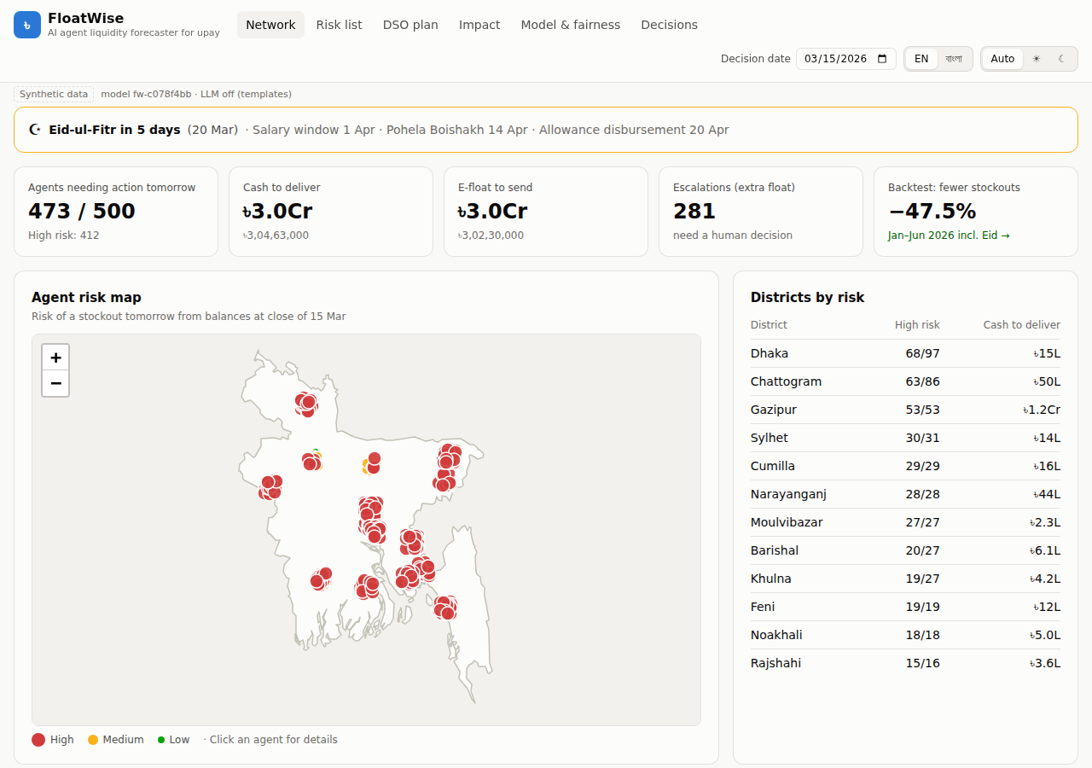
Figure 9. Network screen on 15 March 2026.
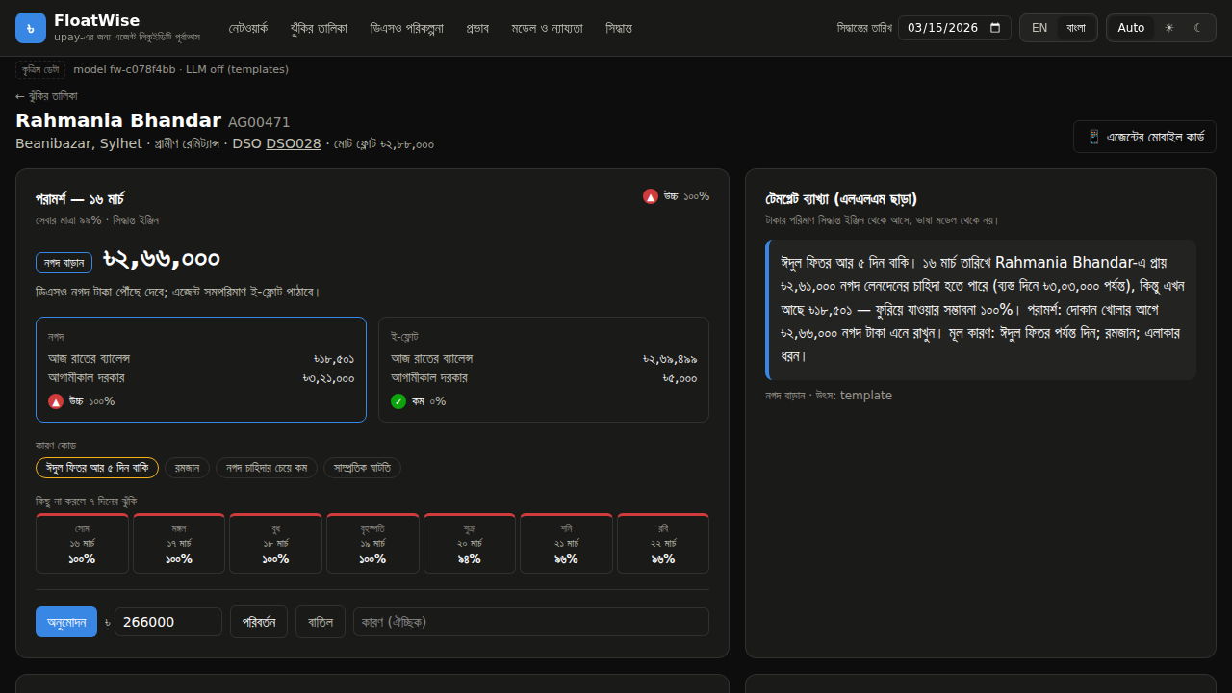
Figure 10. Agent detail in Bangla (dark mode).
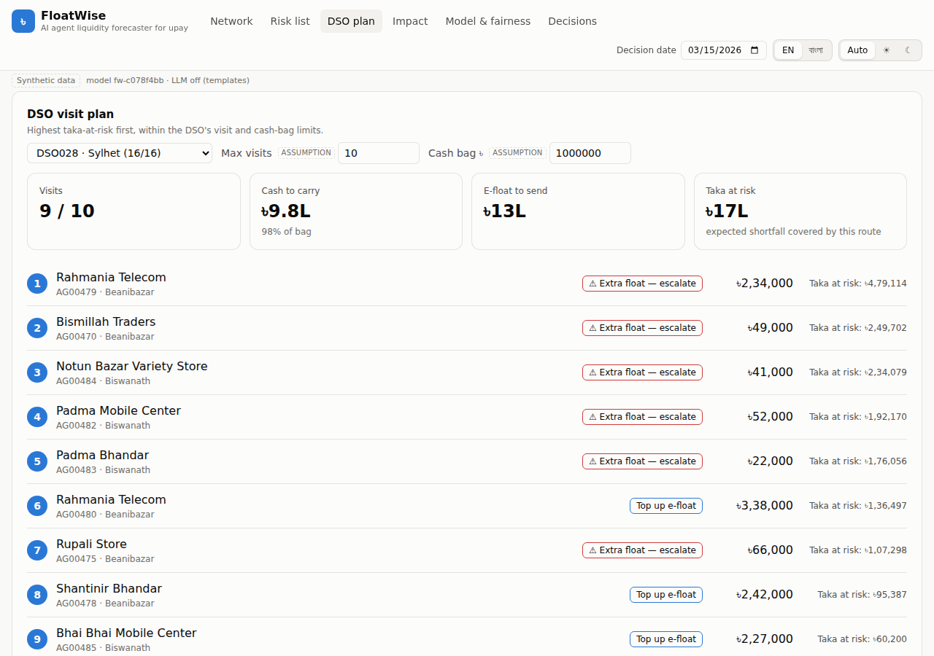
Figure 11. DSO plan within the visit and cash-bag limits.
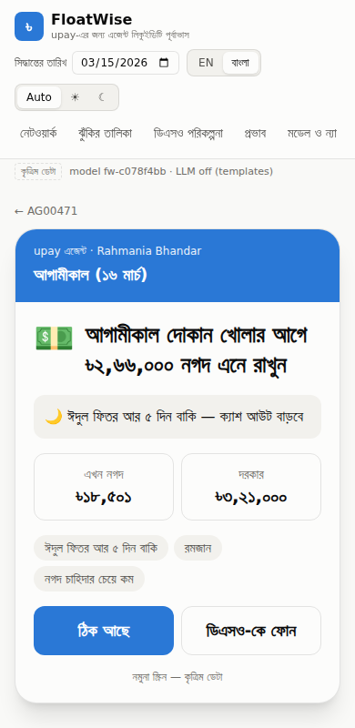
Figure 12. Agent mobile card in Bangla.

10. Business impact
The backtest replays January–June 2026 day by day on true demand. Both policies start from the same balances and float; only the timing and size of each top-up differ. The test period was never used for tuning.
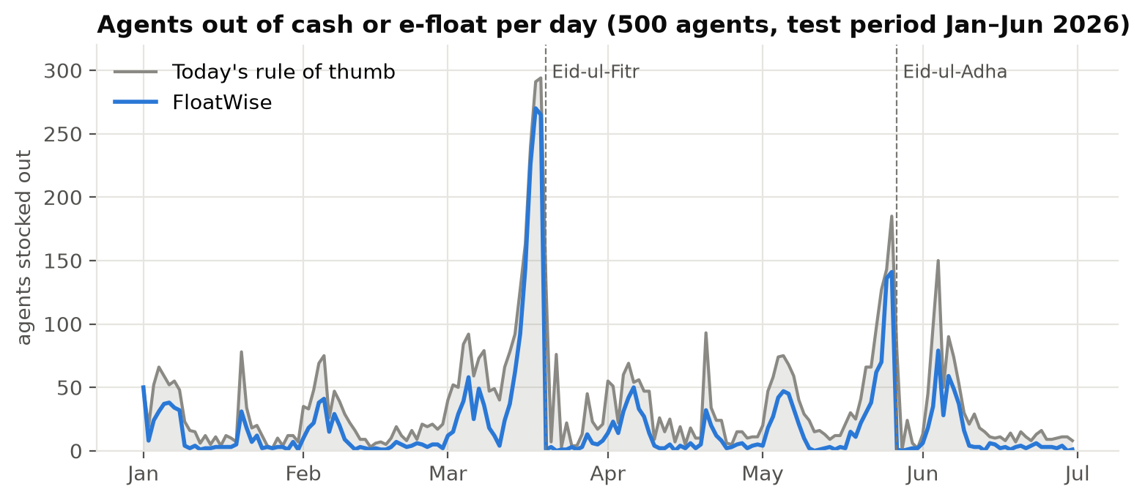
Figure 13. Agents out of cash or e-float per day.
Metric (500 agents, 6 months) | Today's rule | FloatWise | Change
Stockout agent-days | 6,973 | 3,664 | -47.5%
Failed cash-outs (count) | 2,15,101 | 1,09,349 | -49.2%
Failed cash-out value | Tk 52.2 crore | Tk 27.8 crore | -46.7%
upay fee revenue lost | Tk 33.81 lakh | Tk 15.64 lakh | -53.7%
Agent + distributor commission lost | Tk 27.13 lakh | Tk 14.50 lakh | -46.6%
Customers at risk of leaving | 10,755 | 5,467 | -49.2%
Share of demand served | 98.7% | 99.3% | +0.59 pts
Average cash held per agent | Tk 3.53 lakh | Tk 3.61 lakh | +2.3%
DSO rebalancing trips | 49,813 | 51,860 | +4.1%

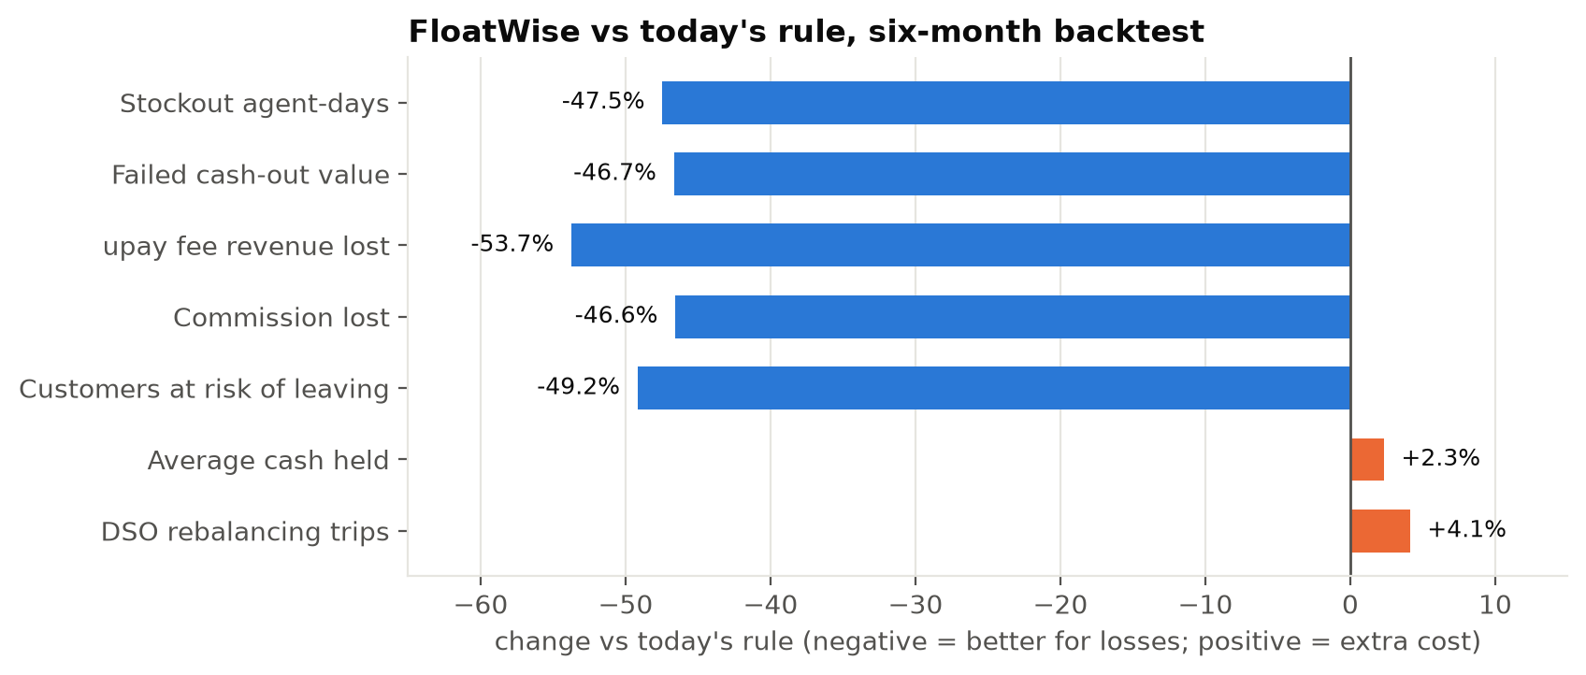
Figure 14. Change against today's rule: losses fall by about half for a small cost in cash and trips.

10.1 Unit economics per 1,000 agents per month
Gains | Value | Costs | Value
Stockout-days avoided | 1,097 | Extra DSO trips | 679
Failed transactions avoided | 35,742 | Extra idle-cash cost (10%/yr) | Tk 67,867
Cash-outs served instead of refused | Tk 8.2 crore
upay fee revenue recovered | Tk 6.02 lakh
Commission for agents and distributors | Tk 4.19 lakh
Customers kept | 1,753

10.2 At upay's network scale
Tk 9.3 Cr  upay fees / month | Tk 6.4 Cr  commission / month | 1.69 lakh  stockout-days avoided / month | 2.7 lakh  customers kept / month
Per-1,000-agent results scaled to ~1,54,000 agents. Customers kept assumes 5% churn after a failed cash-out.

10.3 One control: the service level
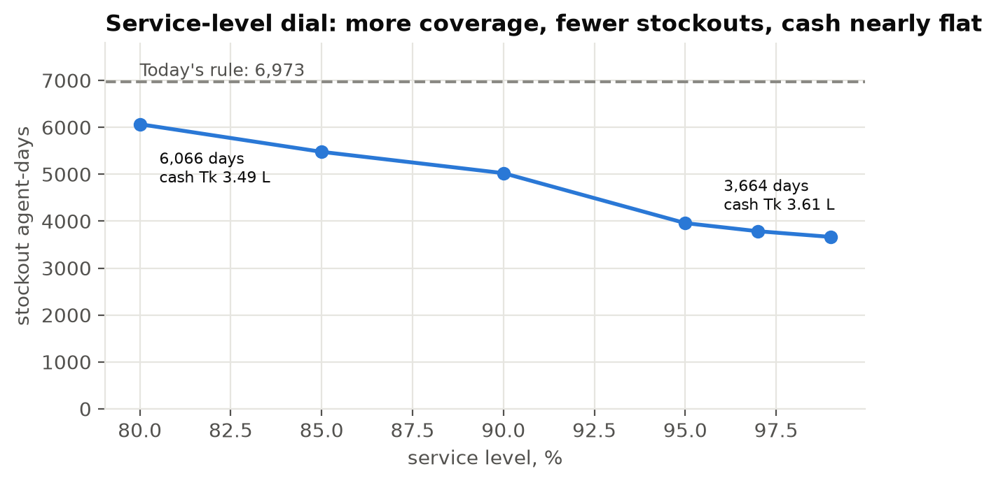
Figure 15. Service-level sweep (shown on the test period for illustration; 0.99 was chosen on validation).

10.4 Fairness
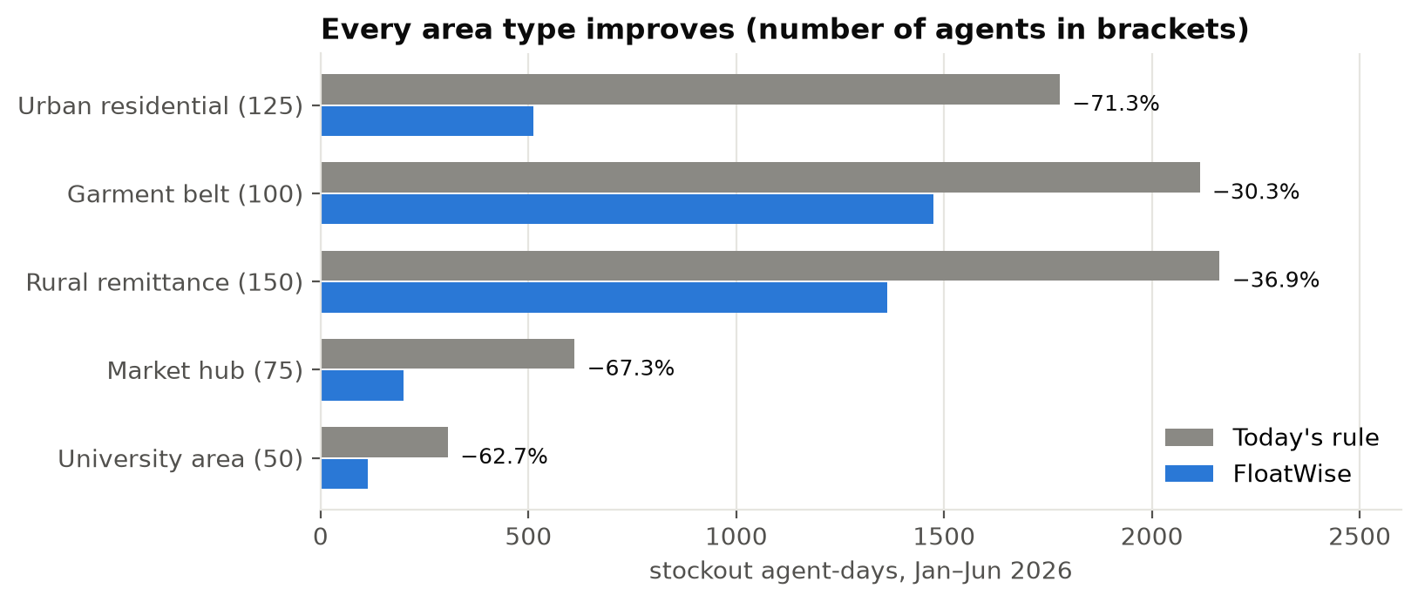
Figure 16. Stockout agent-days by area type.
Every segment improves. Rural remittance and garment-belt agents gain least because their total float is small relative to the Eid and salary peaks; those cases are escalated as NEEDS_EXTRA_FLOAT rather than hidden.

11. Design choices made on held-out data
No choice was made on the test period. Each was decided by a script with a written rule, and its evidence is committed.
Choice | Options | Decided on | Selected | Evidence
Stockout-day labels (censoring) | keep / exclude / inflate | Held-out Eid 2025 | keep: fewest pre-Eid misses above P90 (57.1% vs 57.4% / 59.5%) | censoring_experiment.json
Quantile architecture | independent / spread | Held-out Eid 2025 | independent: spread cut Eid coverage 51% → 42% | quantile_experiment.json
Service level & risk threshold | 15-point grid | Validation Jul–Dec 2025 | 0.99 / 0.10: −55% stockouts, +12.4% trips, +2.4% cash | policy_tuning.json
DSO allocator | greedy / exact knapsack | Validation Jul–Dec 2025 | optimal (1,689 vs 1,692 stockout-days) | allocator_comparison.json

12. Responsible AI and security
Principle | How FloatWise implements it
Synthetic data only | No personal data, real names, phone numbers or NIDs anywhere; generic shop names
LLM explains, never decides | Amounts from engine/; LLM gets structured JSON only; numeric post-check with template fallback
Human in the loop | Approve / Modify / Reject on every action; NEEDS_EXTRA_FLOAT always escalates; no automatic money movement
Fairness | Forecast and service checked per area type and rural vs urban; worse segments must be reported
Transparency | AI text labelled; predictions, assumptions and generated text visually distinct; model card published
Honest evaluation | Time-based split; baselines; test period untouched until final evaluation; missed targets reported
Scope | Operational liquidity only; no credit, lending or penalty decisions about agents
Security | Secrets only in .env; pydantic validation; standard errors without stack traces; restricted CORS; works offline

13. Execution: how it was built and how to run it

13.1 Delivery phases
Phase | Delivered
0–1 Contracts | SRS, implementation plan, rules for AI agents, config, schemas, Makefile
2 Data | Calendar, agents, demand, shocks, status-quo ledger; data-quality tests; check plots
3–4 Models | Feature panel with leakage test; baselines; LightGBM quantile models; evaluation and model card
5–6 Engine and simulation | Risk, recommendation, DSO allocation; backtest; policy tuning on validation
7–8 Explain and API | SHAP drivers, templates, Claude narrative with guardrail; FastAPI with 15 endpoints
9 Frontend | Eight screens, Bangla/English, light/dark, offline fixtures
10 Fairness and feedback | Fairness report; decision log and feedback summary
11 Hardening | Offline demo, screenshots, CI on Linux and Windows, fresh-clone rebuild, e2e walk-through, upay alignment

13.2 Pipeline
- floatwise.data.generate: synthetic data into data/generated/.
- floatwise.models.train: six quantile models (plus the baselines).
- floatwise.models.evaluate: test forecasts, metrics.json, fairness.json, model_card.md.
- floatwise.simulation.backtest: simulation_default.json with the service-level sweep.
- scripts/plot_data_checks.py and scripts/build_narratives.py: plots and cached explanations.

13.3 Run it (about 6 minutes)
git clone https://github.com/redwanhasan980/DIU_AI_Hackathon.git
python run.py setup install Python and web dependencies (~1–2 min)
python run.py all data, training, evaluation, backtest (~3 min)
python run.py demo open http://localhost:8000
Needs Python 3.11+ and Node.js 20+. No API key or internet needed once installed.

13.4 Quality assurance
Check | Coverage
89 unit and integration tests | Data quality, no leakage, models, engine, allocator, backtest, explanations and LLM guardrails, API contract and errors
Lint | ruff for Python; tsc and eslint for the web app
Browser walk-through (21 checks) | Map, agent, Bangla, approval, DSO limits, live backtest, fairness, decisions, agent card, dark mode
CI | GitHub Actions on every push: backend on Linux and Windows, frontend build
Reproducibility | Fresh clone installs and rebuilds the identical model and numbers with a clean git tree

14. Limitations and next steps

14.1 What FloatWise does not fix yet
Limit | Evidence | Response
Some floats are too small for Eid | 265–270 of 500 agents still run out on 18–19 March | Escalate as NEEDS_EXTRA_FLOAT (281 agents flagged on 15 March)
Rural and garment areas gain less | −36.9% and −30.3% vs −62.7% to −71.3% elsewhere | Report per segment; fairness review before rollout
A little more cash and travel | +2.3% cash held, +4.1% DSO trips | Service-level dial trades cash for stockouts
Over-confident at spikes | P10–P90 covers 60% of event days (75% overall) | 99% service level chosen on validation
Synthetic data, daily granularity | Shaped on public tariffs and network size; no spill-over to neighbouring agents | Shadow mode on real, anonymised data first

14.2 Path to a pilot
- Shadow mode (4–6 weeks): run nightly on one distributor's anonymised daily agent balances and compare with what DSOs actually did.
- Pre-Eid pilot: that distributor's DSOs use the plan; compare stockouts and failed value with control distributors.
- Integrate: DSO and agent apps (“keep Tk X cash tomorrow”), nightly retraining, drift monitoring per area type.
- Scale: one global model for all ~1,54,000 agents with forecasts precomputed overnight, approvals in an audit log.
The ask: one distributor, anonymised daily agent balances and DSO visit logs, and one Eid season, measured against today's rule.

Appendix A. Glossary
Term | Meaning
Cash-out / cash-in (CO / CI) | Customer withdraws cash from / deposits cash to the agent
E-float | The agent's electronic balance used to serve cash-ins
Stockout | Agent cannot serve a transaction because cash or e-float is exhausted
DSO | Distributor sales officer who visits agents to rebalance cash and e-float
P10 / P50 / P90 | Forecast quantiles: 10%, 50% and 90% of outcomes fall below them
WAPE | Weighted absolute percentage error: total absolute error / total actual demand
Service level | Quantile of demand the top-up is sized to cover (0.99 by default)
Censoring | On stockout days the recorded volume understates true demand
G2P | Government-to-person allowance payments

Appendix B. Evidence index
File | Contents
artifacts/metrics.json | Forecast accuracy by slice, coverage, acceptance checks
artifacts/simulation_default.json | Backtest, per-1,000-agent and network-scale value, sweep, segments
artifacts/fairness.json | Per-segment forecast and service checks
artifacts/policy_tuning.json | Validation grid for service level and risk threshold
artifacts/censoring_experiment.json, quantile_experiment.json, allocator_comparison.json | Held-out model and allocator choices
artifacts/model_card.md | Model card
docs/SRS.md, docs/IMPLEMENTATION_PLAN.md, docs/DATA_ASSUMPTIONS.md | Requirements, plan, every assumption with sources

