2nd Phase BRD + 1st Phase Improvement

2.1 Ticket Management
2.1.1. Department assigning and forwarding by users from their department should be enabled in both SLA and Workflow based tickets , For SLA based tickets, First checker(L1) should not be fixed from the template. Ticket can be forwarded by ticket creators, users from his department(all users) to another department(all users)
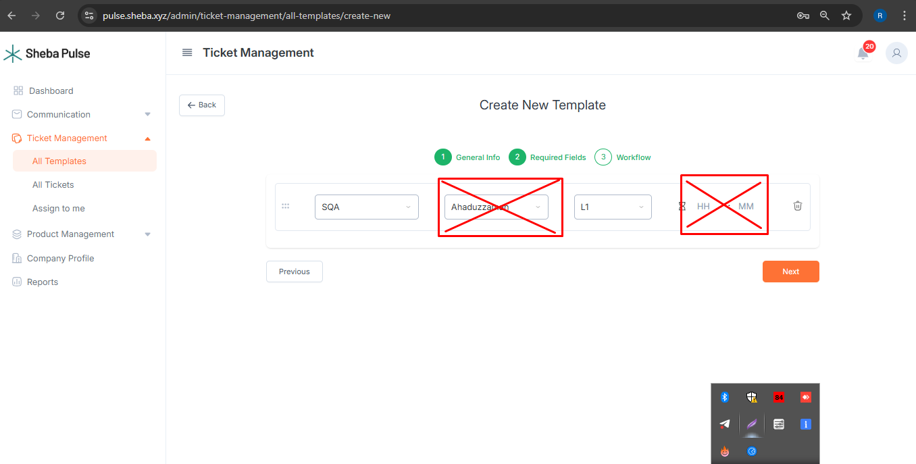
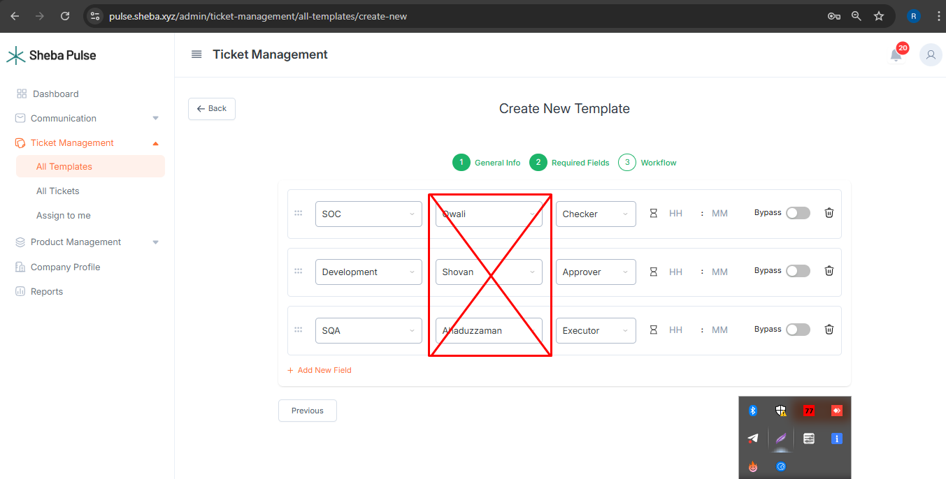
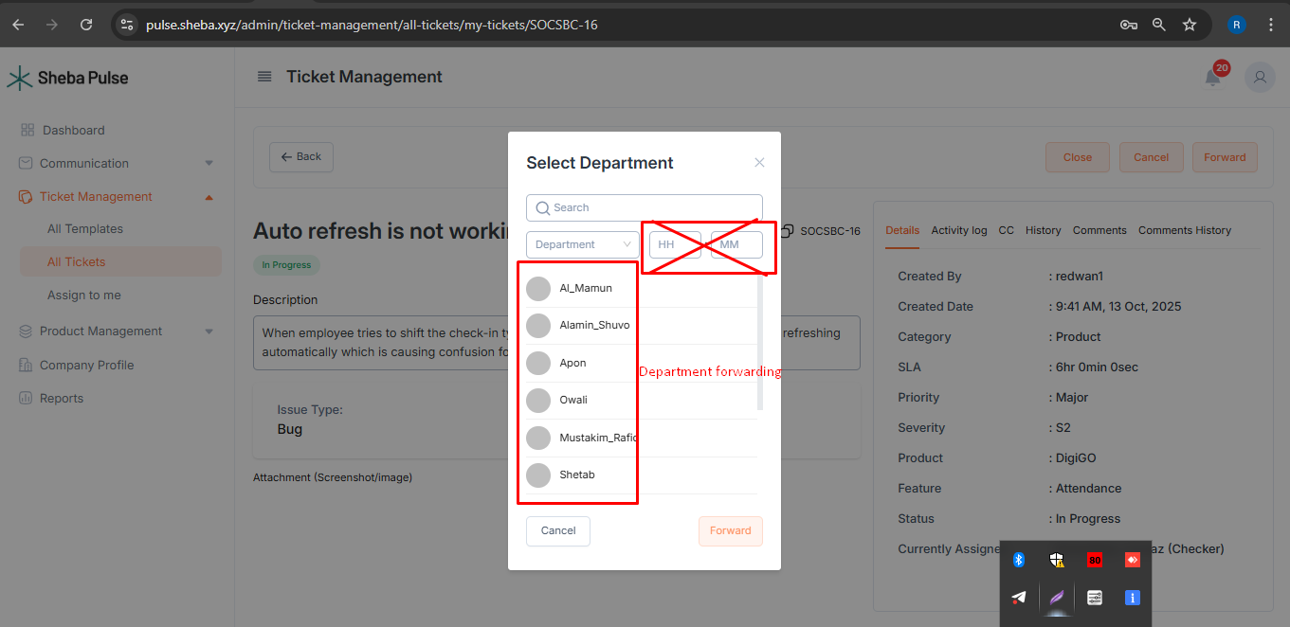2.1.2. Enable ‘resolve, close, cancel, forward, re-open’ option for all the tickets which user can access except CC. (Tickets created by the user's department or assigned to the user's department or forwarded to the user's department).
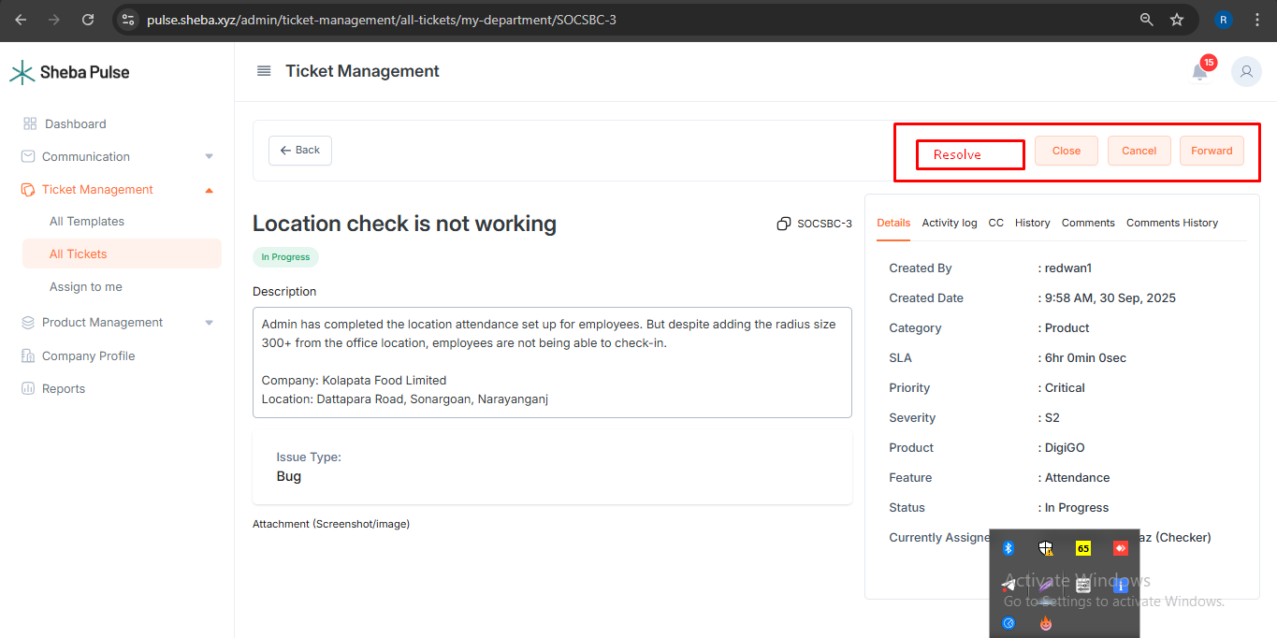
2.1.3. “My role” column incorrectly always shows as ‘checker’ in SLA based tickets; it should reflect the actual role (L1, L2, or L3).
2.1.4. Allow users to assign or forward to themselves or their department while creating SLA-based tickets and proceed to resolve or close them.
2.1.5. All types of dropdown box options should be searchable
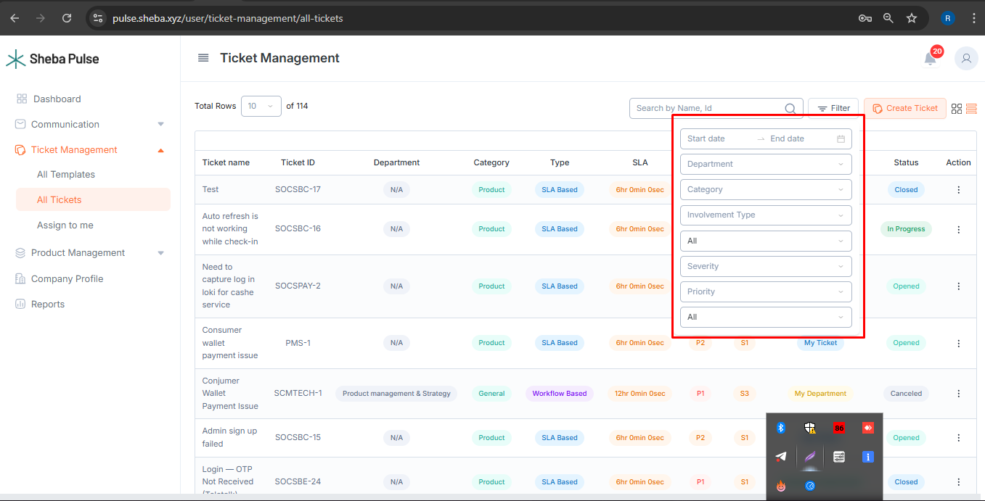
2.1.6. Ensure the comment and comment history section appears separately when viewing ticket details. Need to view comments instantly after entering into tickets. After scrolling down, user will see more comments.
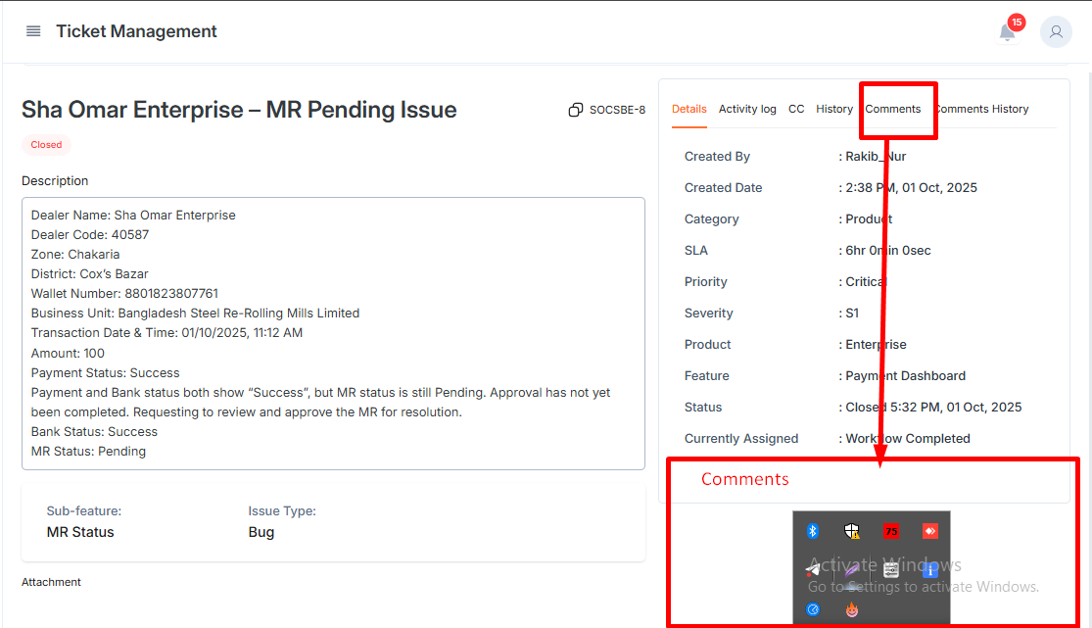
2.1.7. If the user is the assignee, mark their involvement type as 'assignee' (not “assignee's department”) in the ticket listing.
2.1.8. Increment or decrement dashboard count indicators (for tickets, messages, mails) directly on feature names dynamically.
2.1.9. In workflow based tickets, rename the “Forward” button to “Add CC” as “forward’ can not be functioned for workflow based tickets.
2.1.10. Enable “Add CC” option for anyone L2, L3 level. User who can access the ticket, will be able to “Add cc”
2.1.11. In all tickets and details, Severity should be displayed before Priority.
2.1.12. Add the “Created by Team” filter in Dashboard.
2.1.13. Unique and repeated tickets should be searchable and count visible.
2.1.14. “Resolved and Closed by Team” need to be shown in Dashboard.
2.1.15. Comments should appear at the 1st part of the ticket details section.
2.1.16. In product management, Under All Features, there should be another section named “Issue”
2.1.17. Enable video and document(excel, pdf, doc, ppt) attachments during ticket creation, mails, comments, and messaging across the system.
2.1.18. Ticket description should not be editable.
2.1.19. Ticket ID needs to be placed in first column, Ticket name - 2nd column
2.1.20. After clicking on outside the ticket creation box, it should not be missing.
2.1.21. Need to store cache after any type of filter in all tickets list. When user enters into a ticket after filtering, going back to the all ticket list should not remove the selected filters.
2.1.22. Need to enable user tagging in ticket description, ticket comments, messages and mails. User will receive notification after tagged.
2.1.23. Enable proper line break in ticket comments. Besides, show image history changes in comment history.
2.1.24. Prepare responsive mobile version and UI should be structured with proper alignment

2.2 Workflow & Status
2.2.1. Display SLA Status and Working Status as separate columns across all ticket listings.
2.2.2. In reports, include separate columns for:
  - Resolved By User
  - Resolved By Department
2.2.3. If a single user is assigned, the Currently Assigned field should display the user’s name, If a department is assigned, it should display the department name.
2.2.4 A “Create Ticket” button should be available on all pages (Dashboard, Communication, Ticket Management).
2.2.5. Question field from Template should be visible like template selection or product selection. Every field will show blank field under the question title and after clicking on the blank field drop down list will be visible.

2.3 Activity Log & Ticket History
2.3.1. Correct activity log behavior:
  - After resolving, closing,canceling,reopening,rejecting or any other activity, it should show in the ticket log [e.g. closed by ‘user’, reopened by ‘user’]
  - Ticket SLA countdown should stop once resolved/closed.
2.3.2. If SLA is breached, the activity log should automatically display “SLA Breached” without requiring next user action.
2.3.3. For actions such as checking, approving, executing, rejecting, and closing, a mandatory text field should be required. These details must also be recorded in the activity log.
2.3.4. Ticket history UI should clearly show Sender and Receiver transitions. Ticket history must be fully transparent: all logs (comments, forwards, resolutions, closures) should display with date and time after each action.
2.3.5. Both unique and repeated tickets should be searchable. The total count of unique and repeated tickets should be visible.
2.3.6. In activity log, it should show start time & date and end time & date indicating how much time ticket stays at his end, not just the start time.
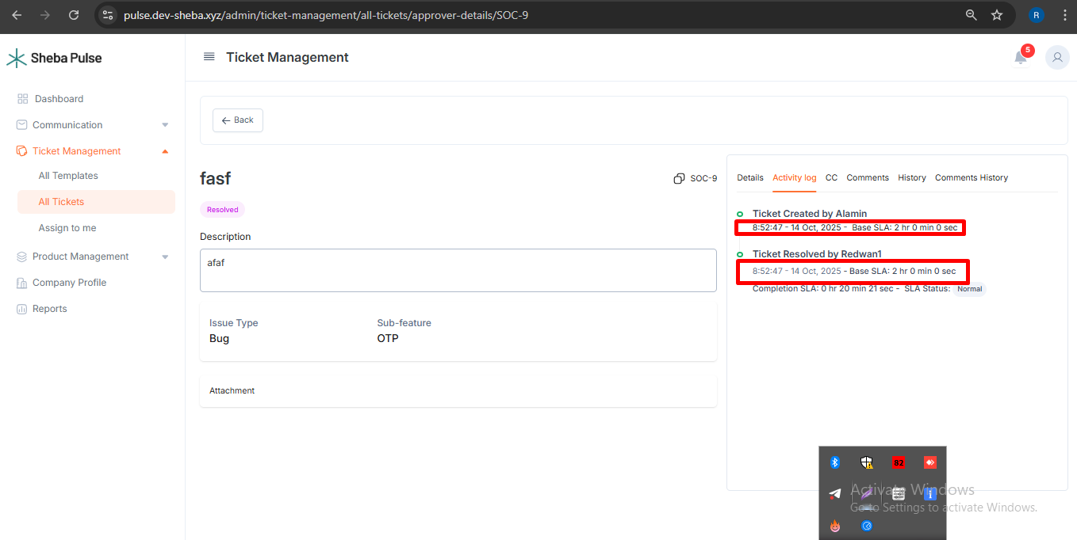

2.4 Image Handling
2.4.1. The default image size should be increased so that users can view images without requiring a preview.
2.4.2. A preview option should still be available for zooming in and out.
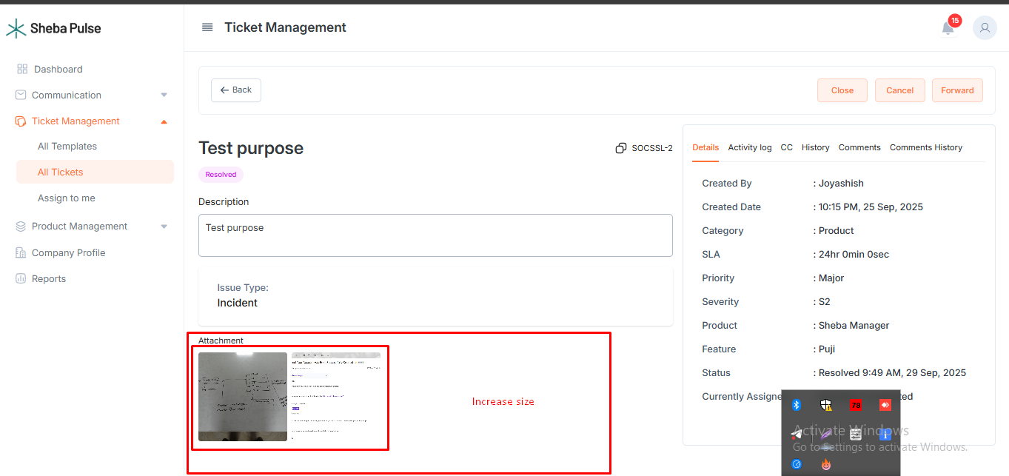

2.5 Notifications
2.5.1. After a ticket is created from a user’s department or assigned to a user department, a notification should be displayed.
2.5.2. After resolving, closing, canceling, or reopening a ticket, notifications should be shown to all users in both related departments.
2.5.3. Clicking on a notification should redirect the user directly to the corresponding ticket details.
2.5.4. Need to enable notification for mail, message or ticketing actions if browser is closed and on mobile.

2.6 Email Enhancements
2.6.1. Support forwarding tickets via email as needed.
2.6.2. Add an “All Mails” section to store all sent, inbox, and draft emails.
2.6.3. Implement text-based search across All Mails, sent, inbox, and draft
2.6.4. Enable external mail functionality.

2.7 Messaging Enhancements
2.7.1. The message box should expand automatically based on text size (not limited to a single line).
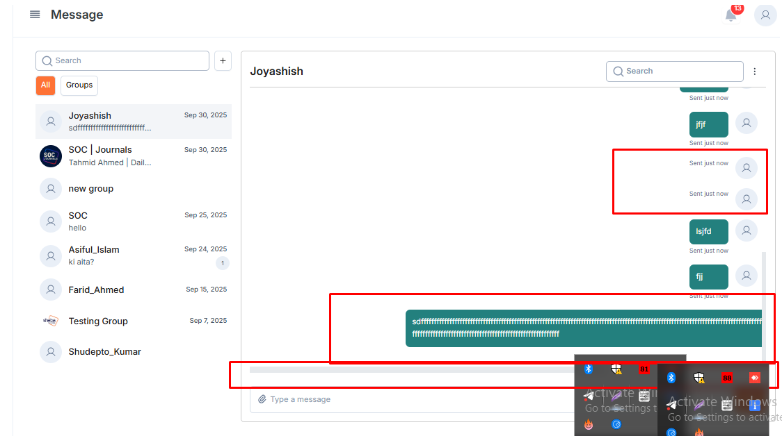
2.7.2. Blank messages should not be allowed.
2.7.3. Date should be displayed for all messages on a specific day.(Reference: telegram/whatsapp chat)
2.7.4. If a message is seen, it should show “Seen” with the seen time after clicking, along with the number of viewers.
2.7.5. A message forwarding option should be available in the three-dot menu.
2.7.6. Need video, voice and any type of document sharing(pdf,doc,ppt) for sending message.
2.7.7. Messaging draft should be saved if the message is not sent.
2.7.8. Enable voice and video calling
2.7.9. Ticket link needs to be sent as link, not text. After clicking on the link, it will redirect to the ticket details

2.8 Validation & UI Enhancements
2.8.1. While creating a ticket, the selected option from dropdown or checkbox is not clear. When the user goes to the next field, the previous selected field becomes hidden. Eliminate double click requirement for dropdown selections—shouldn’t select a dropdown value clicking twice.
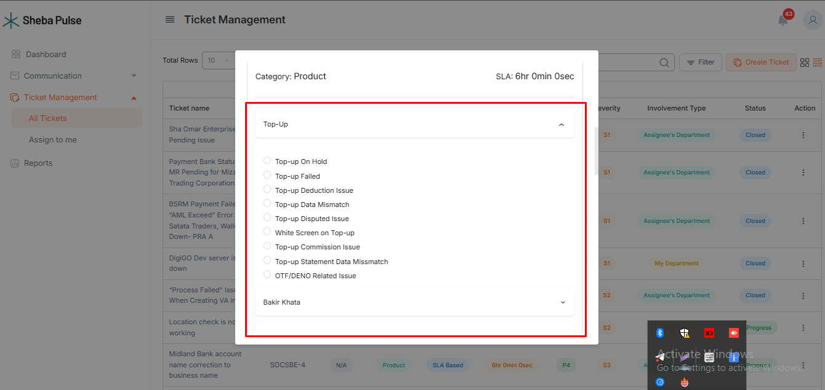
2.8.2. Display error messages in the bottom-left side of the screen for any missing fields during ticket creation.
2.8.3. Mark mandatory fields for creating ticket with a red asterisk (*).
2.8.4. Need error message while ticket creation fails
2.8.5. Currently if a user clicks on outside the user creation field, the field goes missing, it should be fixed.
2.8.6. If a typing error is detected in messages, mails, tickets, comments or anywhere, underline the mistake in red.
2.8.7. After clicking on any status from the dashboard, the system should redirect the user to the corresponding ticket list.
2.8.8. The current department should display the current checker/approver/executor’s department. After resolution, rejection, or execution, it should display the ticket creator’s department.
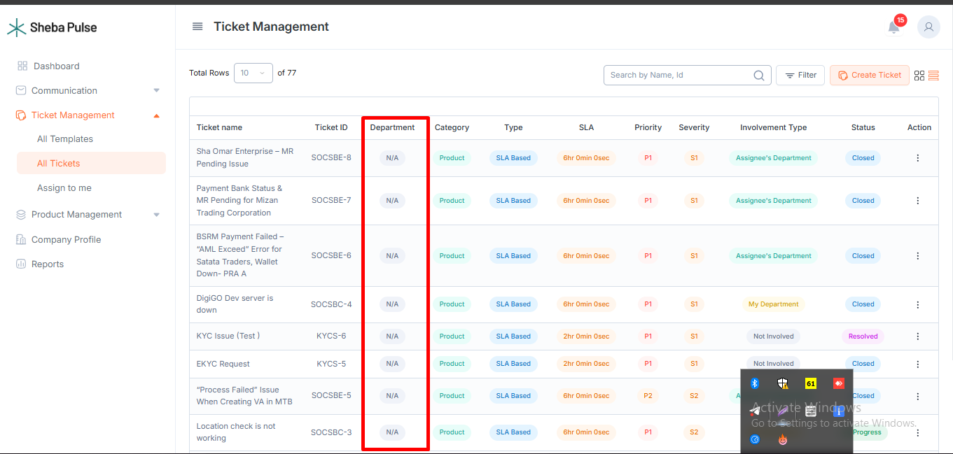

2.9 Dashboard and Reporting
2.9.1. Display the Top 5 Issues in a pie chart format for quick insights.(according to severity and priority)
2.9.2. Show additional pie charts for:
  - SLA: SLA Breached vs. Within SLA
  - Status: Opened, In-progress, Resolved, Closed, Canceled, Checked, Executed, Approved, Rejected, Re-opened.
2.9.3. Add filters for:
  - Resolved by Team(sub-department)
  - Closed by Team
  - Created by Team
  - Top 5 Issues
2.9.4. Clicking on a status in the dashboard should redirect the user to the corresponding ticket list.
2.9.5. Reports should be downloadable in a single action (currently requires two steps).
2.9.6. For admin, Report generation access should include filters for:
  - All
  - Enabled
  - Disabled
2.9.7. Need reporting option in “All tickets”. After filtering or searching by template key, specific ticket download needs to be enabled.
2.9.8. For admin, card structure needs to be updated
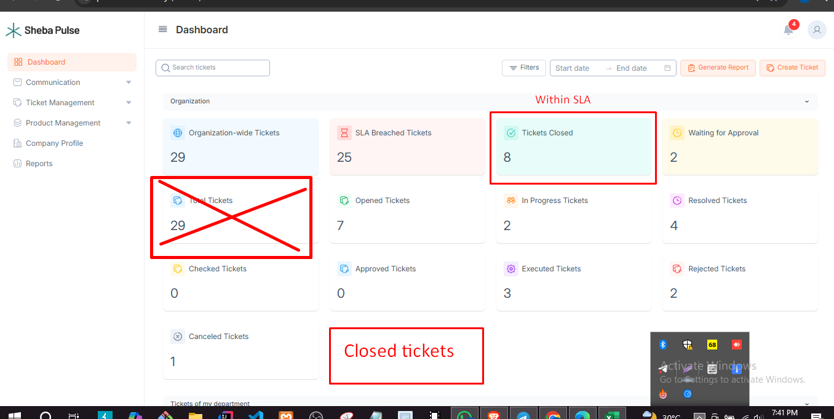
2.9.9. After clicking on a status card, it will redirect those ticket list of the specific status
2.10 Dynamic SLA
SLA Management Section
2.10.1. Under Reports (Admin panel), there should be a new section named “SLA Management.”
Severity, Priority, and SLA Settings
2.10.2. Severity, Priority, and SLA Time add and settings should be available in this section.
2.10.3. SLA time should be fixed according to the selected severity and priority.
Feature- and Issue-Based SLA
2.10.4. Issues need to be added against each feature.
2.10.5. SLA must be defined based on the selected feature and corresponding issue.
2.10.6. Severity and priority settings should be adjustable for each feature and issue.
Fixed SLA Time
2.10.7. SLA time must remain fixed from the moment of ticket creation.
2.10.8. Forwarding a ticket should not change the resolution due time.
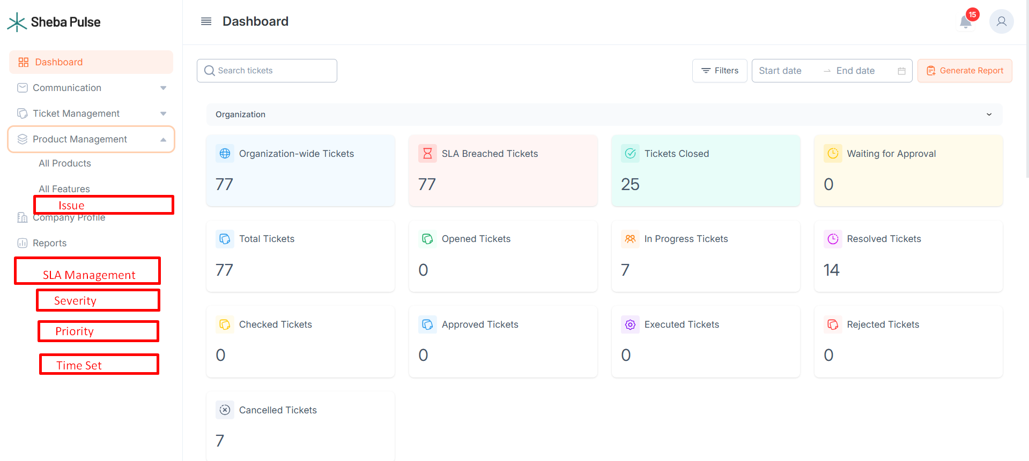

Mapping Example:
In the ticketing system, each issue should be linked to a Product and Feature.When an issue is selected, its Severity (S) and Priority (P) are automatically determined based on a predefined mapping. Each combination of Severity and Priority has a fixed Resolution Time, configurable by the Admin.

Admin Capabilities
- Configure resolution time for each Severity–Priority pair (e.g., S1P1 = 2 Hours).
- Create new Severity and Priority levels as needed.
- When adding a new Issue under a Feature, define its associated Severity and Priority.
SL | Product | Feature | Issue | Severity & Priority | Resolution Time
1 | Sheba Manager | Top-up | Top-up On Hold | S2P2 | 16 Hours
2 | Sheba Manager | Top-up | Top-up Pending On App Screen | S4P4 | 45 days
3 | Sheba Manager | Top-up | Top-up Failed | S2P2 | 16 Hours
4 | Sheba Manager | Top-up | Top-up Deduction Issue | S3P3 | 15 Days
5 | Sheba Manager | Top-up | Top-up Data Missmatch | S3P3 | 15 Days
6 | Sheba Manager | Top-up | Top-up Disputed Issue | S2P2 | 16 Hours
7 | Sheba Manager | Top-up | White Screen on Top-up | S1P1 | 2 Hours
8 | Sheba Manager | Top-up | Top-up Commission Issue | S2P2 | 2 Days
9 | Sheba Manager | Top-up | Top-up Statement Data Missmatch | S3P3 | 15 Days
10 | Sheba Manager | Top-up | OTF/DENO Related Issue | S2P2 | 2 Days
11 | Sheba Manager | Bakir Khata | Bakir Khata Blank screen | S1P1 | 2 Hours
12 | Sheba Manager | Bakir Khata | Bakir khata Loading Issue | S1P1 | 2 Hours
13 | Sheba Manager | Bakir Khata | Bakir Khata Data Migration Complaint | S3P3 | 15 Days
14 | Sheba Manager | Bakir Khata | Bakir Khata Data Miss match | S3P3 | 15 Days
15 | Sheba Manager | Bakir Khata | Bakir Khata PDF Download Issue | S3P3 | 15 Days
16 | Sheba Manager | Bakir Khata | Bakir Khata SMS can not purchase Issue | S2P2 | 16 Hours
17 | Sheba Manager | Bakir Khata | Bakir Khata Picture Data Migration | S3P3 | 15 Days
18 | Sheba Manager | Bakir Khata | Bakir Khata SMS can not sent | S2P2 | 16 Hours
19 | Sheba Manager | Bakir Khata | Bakir Khata Entry not showing | S3P3 | 15 Days
20 | Sheba Manager | Stock | Stock Feature Blank Screen Issue | S2P1 | 6 Hours
21 | Sheba Manager | Stock | Stock Data Mismatch Related Issue | S2P1 | 6 Hours
22 | Sheba Manager | Stock | Stock Report Related Issue | S3P3 | 15 Days
23 | Sheba Manager | Stock | Stock Search option Not working | S3P3 | 15 Days
24 | Sheba Manager | Stock | Stock Filter option not working | S3P3 | 15 Days
25 | Sheba Manager | Stock | Stock report download option is not working | S3P3 | 15 Days
26 | Sheba Manager | Hisab Khata | Data Mismatch Related Issue | S2P3 | 16 Hours
27 | Sheba Manager | Hisab Khata | Entry Not Working | S3P3 | 15 Days
28 | Sheba Manager | Hisab Khata | Hisab Khata Delete option Not Working | S3P3 | 15 Days
29 | Sheba Manager | Hisab Khata | Bakir Hisab Issue | S3P3 | 15 Days
30 | Sheba Manager | Hisab Khata | Transaction History Related Issue | S3P3 | 15 Days
31 | Sheba Manager | Hisab Khata | Hisab Khata Sector (Khat) Change Issue | S3P3 | 15 Days
32 | Sheba Manager | Hisab Khata | Search Option Is not working | S3P3 | 15 Days
33 | Sheba Manager | Hisab Khata | Profit - Loss Issue | S3P3 | 15 Days
34 | Sheba Manager | Hisab Khata | Hisab Khata Merchant Requirement | S3P3 | 15 Days
35 | Sheba Manager | Online Store | Online store Store Link is not Working | S3P3 | 15 Days
36 | Sheba Manager | Online Store | Online Store Screen Blank | S2P1 | 6 Hours
37 | Sheba Manager | Becha Bikkri | Product not showing in stock | S2P3 | 2 Days
38 | Sheba Manager | Bikkri Khata | Bikkri Khata Search option not working | S2P3 | 2 Days
39 | Sheba Manager | Bikkri Khata | Bikkri Khata Delete option not working | S3P3 | 15 Days
40 | Sheba Manager | Bikkri Khata | Bikkri Khata Data Mismatch | S3P3 | 15 Days
41 | Sheba Manager | Bikkri Khata | Bikkri Khata Report Download Issue | S3P3 | 15 Days
42 | Sheba Manager | Subscription Package | Package activate by wrong information | S2P4 | 7 Days
43 | Sheba Manager | Subscription Package | Refund Request by Sells Team | S2P4 | 7 Days
44 | Sheba Manager | Subscription Package | Package Migration Complaint | S2P2 | 16 Hours
45 | Sheba Manager | Subscription Package | Purchased by mistake | S2P4 | 7 Days
46 | Sheba Manager | Subscription Package | Customer wants to cancel package and refund | S2P4 | 7 Days
47 | Sheba Manager | Subscription Package | Self Purchased | S2P4 | 7 Days
48 | Sheba Manager | Subscription Package | Package activated without merchant's permission | S2P4 | 7 Days
49 | Sheba Manager | Subscription Package | Customer wants to change package types | S2P4 | 7 Days
50 | Sheba Manager | Subscription Package | Package activated by agent forcefully | S2P4 | 7 Days
51 | Sheba Manager | Subscription Package | Auto Collect | S2P4 | 7 Days
52 | Sheba Manager | Subscription Package | Did not get proper package duration | S2P2 | 16 Hours
53 | Sheba Manager | Power club | Power club activated without merchant's permission | S2P4 | 7 Days
54 | Sheba Manager | Power club | Power-club activate by wrong information | S2P4 | 7 Days
55 | Sheba Manager | Power club | Merchant wants to cancel Power-club and refund | S2P4 | 7 Days
56 | Sheba Manager | Power club | Power-club Complaint (double deduction) | S2P4 | 7 Days
57 | Sheba Manager | Balance Transfer | Credit balance Transfer To sPay | S3P3 | 15 Days
58 | Sheba Manager | Apps Related Issue | Unable to login in App | S1P1 | 2 Hours
59 | Sheba Manager | Apps Related Issue | Refer Option Not Working | S3P3 | 15 Days
60 | Sheba Manager | Apps Related Issue | OTP not recieved | S1P1 | 2 Hours
61 | Sheba Manager | Apps Related Issue | Banner Related Issue | S3P3 | 15 Days
62 | Sheba Manager | Cashback offer | BQR Campaign Cashback | S2P3 | 2 Days
63 | Sheba Manager | Cashback offer | Add Money Campaign Cashback | S2P3 | 2 Days
64 | Sheba Manager | Cashback offer | Add Money charge Cashback (45days) | S2P3 | 2 Days
65 | Sheba Manager | Cashback offer | Top-up Campaign Cashback | S2P3 | 2 Days
66 | Sheba Manager | Cashback offer | Power Club Commission Issue | S2P3 | 2 Days
67 | Sheba Manager | Cashback offer | Power Club Campaign Gift Winner | S3P3 | 15 Days
68 | Sheba Manager | Cashback offer | Money Out Charge Cashback | S2P3 | 2 Days
69 | Sheba Manager | Wallet Related Issue | Balance mismatch Issue | S2P2 | 16 Hours
70 | Sheba Manager | Puji Related Issue | 1st Puji Did not get | S3P3 | 15 Days
71 | Sheba Manager | Puji Related Issue | 2nd Puji Did not get | S3P3 | 15 Days
72 | Sheba Manager | Puji Related Issue | 3rd Puji Did not get | S3P3 | 15 Days
73 | Sheba Manager | Puji Related Issue | 4th Puji Did not get | S3P3 | 15 Days
74 | Sheba Manager | Other | DND Request | S1P1 | 2 Hours
75 | Sheba Manager | Other | Complaint against agent | S3P3 | 15 Days
76 | Sheba Manager | Business Name | Business Name Change Bangla to English | S1P1 | 2 Hours
77 | Sheba Pay | Bill Payment | Bill Payment On Hold | S2P2 | 16 Hours
78 | Sheba Pay | Bill Payment | Bill Payment Feature Not Working (Specific user) | S2P1 | 6 Hours
79 | Sheba Pay | Bill Payment | Bill Payment Feature Not Working (Specific vendor) | S2P1 | 6 Hours
80 | Sheba Pay | Bill Payment | Bill Payment Full Service down | S1P1 | 2 Hours
81 | Sheba Pay | Bill Payment | Electricity Bill Issue Paid but not received | S2P3 | 2 Days
82 | Sheba Pay | Bill Payment | Water Bill Issue Paid but not received | S2P3 | 2 Days
83 | Sheba Pay | Bill Payment | Gas Bill Paid but not received | S2P3 | 2 Days
84 | Sheba Pay | Bill Payment | Internet Bill Paid but not received | S2P3 | 2 Days
85 | Sheba Pay | Bill Payment | Govt- E- Service Paid but not received | S2P3 | 2 Days
86 | Sheba Pay | Add Money | Add Money On Hold | S2P1 | 6 Hours
87 | Sheba Pay | Add Money | Add Money Dispute | S2P3 | 2 Days
88 | Sheba Pay | Add Money | Add Money Feature Not Working(specific user) | S2P1 | 6 Hours
89 | Sheba Pay | Add Money | Add Money Feature Not Working(specific vendor) | S2P1 | 6 Hours
90 | Sheba Pay | Add Money | Add Money Full service down | S1P1 | 2 Hours
91 | Sheba Pay | Add Money | Add Money Transaction Failed (Card) Spacis Merchant | S3P3 | 15 Days
92 | Sheba Pay | Add Money | Add Money Transaction Failed (MFS) Spacis Merchant | S3P3 | 15 Days
93 | Sheba Pay | Add Money | Add Money Transaction Failed (Bank) Spacis Merchant | S3P3 | 15 Days
94 | Sheba Pay | Add Money | Add Money Charge Issue | S1P2 | 6 Hours
95 | Sheba Pay | Add Money | Add Money option not available | S1P1 | 2 Hours
96 | Sheba Pay | M2M Payment | Sent Money On Hold | S2P3 | 16 Hours
97 | Sheba Pay | M2M Payment | Sent Money Dispute | S2P3 | 16 Hours
98 | Sheba Pay | M2M Payment | Option Not Working | S1P1 | 2 Hours
99 | Sheba Pay | Money Transfer | Money Transfer On Hold | S2P1 | 6 Hours
100 | Sheba Pay | Money Transfer | Money Transfer Dispute | S2P3 | 2 Days
101 | Sheba Pay | Money Transfer | Money transfer Feature Not Working(specific user) | S2P1 | 6 Hours
102 | Sheba Pay | Money Transfer | Money transfer Feature Not Working(specific vendor) | S2P1 | 6 Hours
103 | Sheba Pay | Money Transfer | Money transfer full service down | S1P1 | 2 Hours
104 | Sheba Pay | Money Transfer | Money Transfer Option Not Working (MFS) | S3P3 | 15 Days
105 | Sheba Pay | Money Transfer | Money out Transaction Failed (Bank) Spacis Merchant | S3P3 | 15 Days
106 | Sheba Pay | Money Transfer | Money Out Charge Related Issue | S1P2 | 6 Hours
107 | Sheba Pay | Bangla QR | BQR Partial Not Working | S3P3 | 15 Dayes
108 | Sheba Pay | Device | Device Change Issue | S1P2 | 6 Hours
109 | Sheba Pay | Device | Account Lock | S1P2 | 6 Hours
110 | Sheba Pay | Apps Related Issue | Statement Download issue | S3P3 | 15 Dayes
111 | Sheba Pay | Apps Related Issue | Statement Data Missmatch Issue | S3P3 | 15 Dayes
112 | Sheba Pay | Apps Related Issue | Statement Logo or Name is not showing | S3P3 | 15 Dayes
113 | Sheba Pay | AML | Add Money AML | S2P2 | 16 Hours
114 | Sheba Pay | AML | M2M AML | S2P2 | 16 Hours
115 | Sheba Pay | AML | Money Transfer AML | S2P2 | 16 Hours
116 | Sheba Pay | EKYC | Account verified Issue | S1P2 | 6 Hours
117 | Sheba Pay | EKYC | Account verified Issue | S1P2 | 6 Hours

SLA Time
Severity Type | Priority 1 | Priority 2 | Priority 3 | Priority 4
Severity 1 (Emergency) | 2 Hours | 6 Hours | 48 Hours | 72 Hours
Severity 2 (High) | 6 Hours | 16 Hours | 2 Days | 7 Days
Severity 3 (Moderate) | 5 Days | 10 Days | 15 Days | 30 Days
Severity 4 (Minor) | 7 Days | 15 Days | 30 Days | 45 Days

S1+P1= 2 Hours
S1+P2= 6 Hours
2.11 App Integration
Complain Raise
2.11.1. Customers from different products (DigiGO, Sheba XYZ, Sheba Manager) should have access to create a ticket through the “Complain Raise” option.
Ticket Flow
2.11.2. After a customer raises a complaint, the ticket should automatically be routed to the CX / Inbound department.
2.11.3. The CX team will work on the ticket or forward it to other departments if needed.
2.11.4. Add a new column: “Created by Customer” in the report.
2.11.5. Add filtering options by “created by Customer”.
Workflow Overview
Customer → Feedback → Ticket Created in Pulse → Routed to CX/Inbound → Action Taken or Forwarded

Non-Functional Requirements
Usability: Features should improve user experience and minimize extra steps.
Performance: Dashboard filters and report downloads should work without delays.
Scalability: Dashboard should be adaptable to future filtering/reporting needs.

