Sheba Pulse Ticketing System Enhancement

1. Template Creation Journey

1.1 User Interaction Flow
When an Admin clicks on the Template Create option, the following steps occur:
- Category (Dropdown):
  - Product
  - General
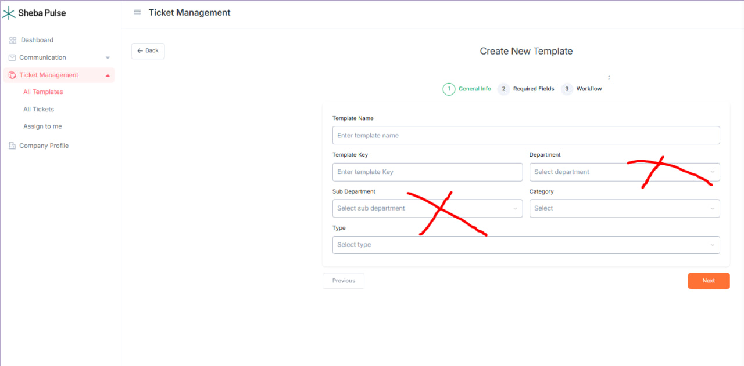
There don’t need to keep the department and sub department box
When an user clicks on the Create Ticket option, the following steps occur:
User will find the template selection field first instead of ticket title.
- If template category is product, then there will be 2 fields,
  - Product: (according to configuration from product setting)
  - Feature: (according to configuration from feature setting for the product selected)
- Product setting: Organization can create their own list of products
- Feature setting: Organization can create their own list of features for each product listed in Product settings

Sidebar items
- Product Management: a) Products b) Features
Products: After selecting the Products, Product list will show. “Add Product” button will be there to add new product.
Features: After selecting the Features, Feature list will show. “Add Feature” button will be there to add new features for each product.

