Using a Landing Page to Redirect Active Domains – Documentation

V1.2

Last Updated: 12-7-20

This process serves to create a server-based domain auto-forward. It's intended to forward any visitor to its domain, over to another domain.

At current time, PlanetMagpie uses this process to redirect domains and former business URLs to Cromer.com.

The forward process uses an HTML landing page homed on MAGCAWEB20, which includes a forwarding script in its code. In the below examples, the landing page forwards all visitors to <https://cromer.com>.

## Phase 1: Set Up Website Redirect Files

1. Log on to MAGCAWEB20 with your PlanetMagpie user account. The account must have administrative permissions.
2. Open the File Manager window.
3. Select the "DATA (E:)" drive.
4. Open the "wwwroot" folder.
5. Create a new folder in the list. It should match the working domain. We will use "WorkingDomain.com" here.
6. Once you have the new folder, locate the "sierraindustrial.com" folder in the list. Open it.
7. Locate the "cromer-2019redirect" subfolder in it. Copy this folder.
8. Return to the list, and open the "WorkingDomain.com" folder. Paste the "cromer-2019redirect" subfolder here.
   1. NOTE: The HTML files in this folder have been configured to forward the website visitor to Cromer.com. If you want to forward the visitor to another website, you will need to edit the index.html file within the folder.
9. Proceed to Phase 2.

## Phase 2: Create a New Site in IIS

1. On the same server, open the IIS Manager window.
2. In the manager window, expand the "Sites" dropdown list.
3. Right-click "Sites" and select **Add Website...** in the menu.

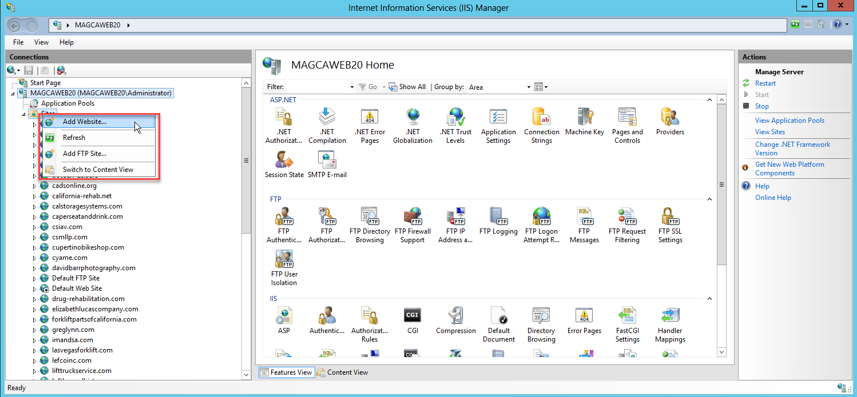

1. Under Site Name, enter "WorkingDomain.com" in the field.
2. Under Physical Path, click the "**...**" button.
3. In the popup window, navigate to the WorkingDomain.com folder, and select the "cromer-2019redirect" subfolder within it.
4. Click **OK**. The entry must read, "E:\\wwwroot\WorkingDomain.com\cromer-2019redirect"

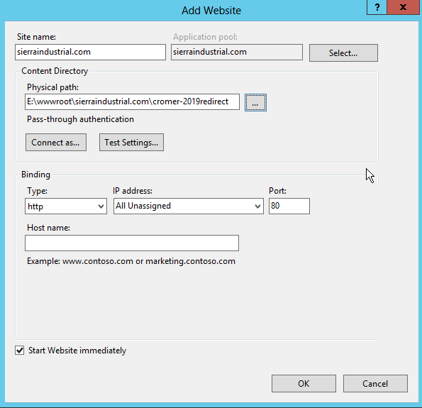

1. Click **OK**.
2. You will receive a message prompt, saying that "Port 80 is already in use." Click **OK** to accept.
3. Right-click the new Site.
4. Click **Edit Bindings**.
5. You will see one binding listed. Highlight it (if not already highlighted), and click the Edit button.
6. In the Host Name field, enter the WWW version of the domain, e.g. "www.WorkingDomain.com".
7. Click **OK**.
8. Click the **Add** button.
9. In the Host Name field, enter the non-WWW version of the domain, e.g. "WorkingDomain.com".
10. Click **OK**.

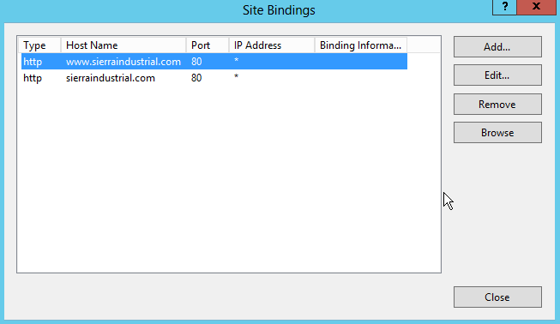

* 1. NOTE: If the domain you're redirecting has an SSL certificate, add bindings for HTTP and HTTPS versions of the domain. In addition, change the Port value for the HTTPS entries from 80 to 443.

1. Click **Close**.
2. Left-click once on the WorkingDomain.com Site. You will see a central window with multiple management icons.
3. Under the IIS section, double-click "Authentication" to open it.

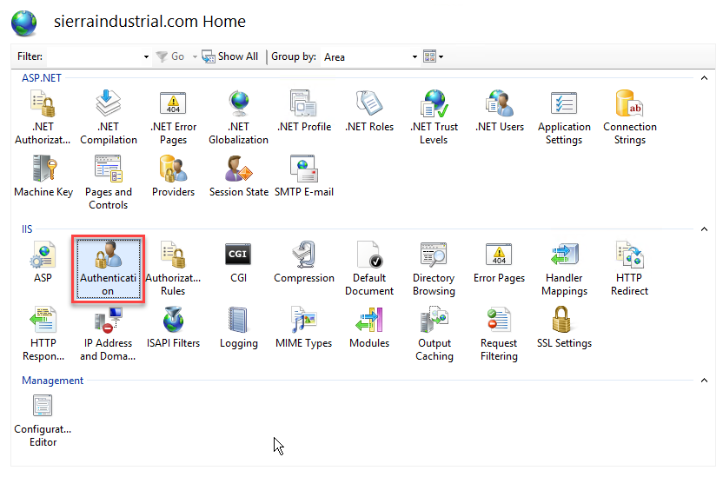

1. Click "Anonymous Authentication" to select it.
2. Click **Edit…** in the right-hand column at the top.
3. You'll see a popup window with two options: "Specific User" and "Application Pool Identity."
4. Click "Application Pool Identity" to select it.
5. Click **OK**.
6. Proceed to Phase 3.

## Phase 3: Modify Domain DNS Records

Now that the redirect is in place and the bindings set in ISS, the final step requires modifying the active domain's DNS records to point to the landing page.

1. Access the domain's DNS zone. You may do this through a website host such as GoDaddy, a domain registrar such as Network Solutions, or a custom DNS such as the PlanetMagpie DNS.
   1. NOTE: We may opt to transfer the domain into our Network Solutions Partner Account, or employ our own DNS for the domain. If so, perform those actions before proceeding with Phase 3.
2. Make a copy of all DNS records in this zone, for future reference/scaling back in case of error.
3. Locate the domain's A records for @ (root) and WWW.
4. Change both A records to this value: **208.156.112.20**
   1. This is the server IP address for the redirect folder we set up in Phase 1.
   2. IMPORTANT: This will prevent access to the domain's old website, if one exists. Save copies of any pages/content from the old website if you'll need them, before taking this step!
5. Click **Save** to save the changes.
6. Test the domain by refreshing in a browser window. Results tend to appear within 10 minutes.
7. If you do not see the redirect landing page after 1 hour, contact PlanetMagpie Support for help.

NOTE: Phase 3 may change following a shirt to using the F5 as proxy. Check with Support before proceeding, as you may need a different IP address.