# 6. SYSTEM READY STATE

The system is in a ready state when fully powered and the Supervisor Station, Operator Stations and the Sentry turrets are in the following conditions.

## Supervisor Station

The Supervisor Station should be as follows.

Station Controls**:**

|  |  |  |
| --- | --- | --- |
| **Control** | **Type** | **Position** |
| EMERGENCY STOP | Push/pull button | Pulled Out |
| DISABLE/ENABLE | Switch | DISABLE |

SNU Panel Controls:

|  |  |  |
| --- | --- | --- |
| **Control** | **Type** | **Position** |
| TRIGGER | Switch | DISABLE |
| MODE | Switch | ROWS |

Supervisor map view:

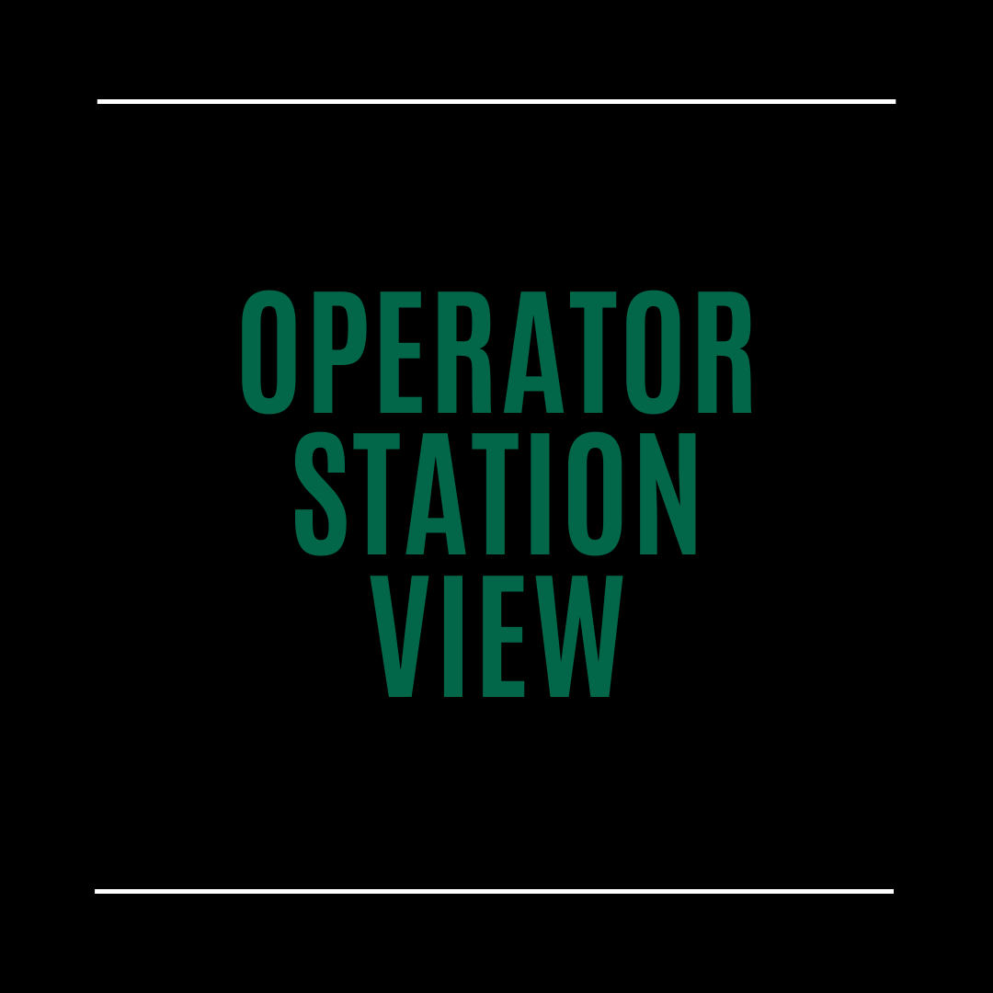

Operator Stations appear as Disabled. Sentry turrets appear as green (enabled).

## Operator Station

Both Operator Stations should be as follows.

Station Controls:

|  |  |  |
| --- | --- | --- |
| **Control** | **Type** | **Position** |
| EMERGENCY STOP | Push/pull button | Pulled Out |
| DISABLE/ENABLE | Switch | ENABLE |

Operator map views will display this message:

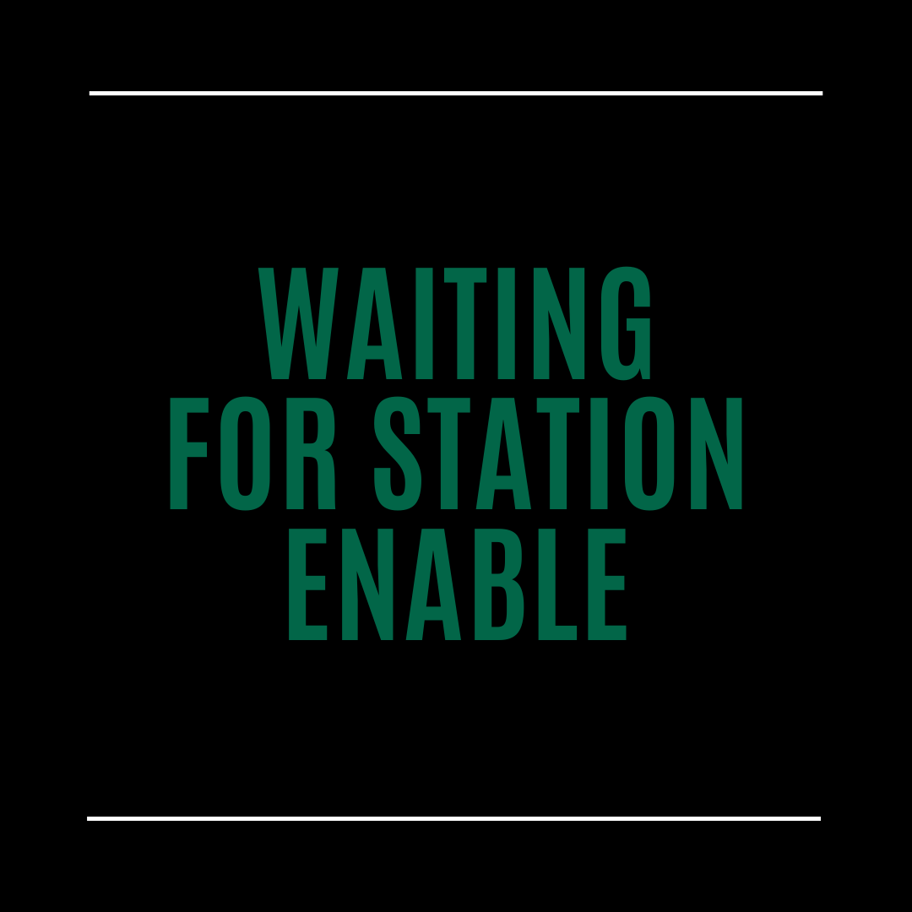

When the Supervisor Station turns its Disable/Enable switch to “ENABLE,” this message will clear.

## Sentry Turrets/ROWS



Note: Always disable the Sentry turrets prior to performing any hands-on operations on, near or around them. Disabling the Sentry prevents the operation of the door, trigger and pan-tilt mechanisms. Serious injuries may result to personnel should the Sentry operate unexpectedly due to not being disabled.

Follow the instructions in the “WEAPON SETUP” section for weapon installation, setup and testing. For bore-sighting see the “ROWS BORE SIGHT” section.

The ROWS is in the ready state when the Sentry turret door is closed, and the Sentry’s Junction Box is set as follows.

|  |  |
| --- | --- |
| **Switch** | **Position** |
| TRIGGER & MOTION | ON |
| COVER POWER | ON |
| MAIN POWER | ON |