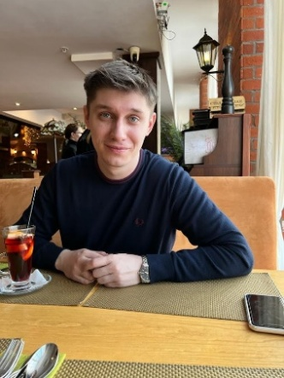 | BOGDAN ISAEV  Senior Full-Stack Developer | Solutions Architect  Location: Saint Petersburg (Relocation / Office / Remote)  Contact: +7 (921) 611-81-65 | redwickel@gmail.com  Telegram: @redwick  Profiles: github.com/redwick | redwick.ru/cv/

Summary
An engineer-developer with a deep understanding of how software works "under the hood." My approach is not just about writing code according to specifications, but identifying and solving real business problems. I have experience in reverse engineering, which allows me to design secure systems and work effectively with undocumented code. Expert in applied mathematics for automation and engineering computations. I take full responsibility for the product: from architecture and cost estimation to deploying secure infrastructure.
Core Skills
- Frontend: Angular (v2-19), RxJS, TypeScript, Ionic (Mobile), Tailwind CSS, Bootstrap, SCSS.
- Backend: Rust (Axum, Tokio), Scala (Akka/Pekko), NestJS, C# (.NET Core/Framework), Java.
- Databases: PostgreSQL, MongoDB, Oracle, Redis, S3 (MinIO).
- DevOps & Cloud: Kubernetes (K8s), Docker Compose, GitHub Actions, Nginx (Reverse Proxy, SSL).
- Security & Auth: Keycloak SSO, OIDC, VPN (WireGuard/OpenVPN), Firewall.
- Engineering Math: Computational geometry, transformation matrices, vectors, and collision detection algorithms.
- Software Security & Reverse: Binary analysis (x64dbg), software protection development (anti-debugging, logic obfuscation, licensing systems via external DLLs).
- Product Ownership: End-to-end business process analysis, estimation, and implementation of labor automation solutions.
- Infrastructure: Linux Server (Ubuntu), Matrix Synapse, iRedMail, Samba AD DC, NextCloud.
- Management: BPMN modeling, mentoring, and development team leadership.

Experience

Marine Solutions LLC | Senior Full-Stack Developer
Nov 2024 — Present
Key Projects:
- B2B Spare Parts Search & Sales Platform: Designed and implemented a processing system for supplier price lists (1M+ items). Developed a Rust-based (Axum) engine providing sub-second search results. Implemented analytics and demand forecasting modules using charts and statistical reports.
- Comprehensive Dealer Portal for Motorcycle Distributors: Developed a vehicle lifecycle management system (digital passports, maintenance history), interactive parts catalogs, and real-time stock monitoring.
- Consulting & Architecture: Act as an IT change initiator: audit departments, identify "bottlenecks," and implement automation tools that reduce operational time.
- Internal Ecosystem: Developed a microservices-based Task Management system and configured a secure corporate network with VPN access.
- Stack: Angular, Rust, PostgreSQL, VPN/Networking.

Nautic Rus LLC | Lead / Senior Full-Stack Developer
Feb 2018 — Nov 2024 (6 years 9 months)
- Engineering Automation: Developed a C# (.NET/WPF) command library for AutoCAD.
  - Algorithmics: Created an intelligent layout system for drawing annotations using collision avoidance and matrix transformations.
  - Data Extraction: Implemented parsing and serialization of complex drawing data (blocks, attributes) into JSON/Custom formats for external integration.
  - Security: Designed and deployed a custom software licensing system with anti-reverse engineering protection and remote key validation.
- Industrial BI: Built a platform (Angular/Scala) for real-time production data visualization (3D models, charts, statistics).
- Infrastructure Architecture: Deployed a self-managed ecosystem of services from scratch (Rocket.Chat, iRedMail, Keycloak, GitLab).
- Leadership: Coordinated the team, conducted system analysis, and deconstructed business requirements into technical tasks.

Education
Immanuel Kant Baltic Federal University (IKBFU) Specialist Degree: Mathematics and Applied Computer Science | 2015
Additional info
- Languages: Russian (Native), English (Upper-Intermediate — technical documentation, meetings).
- Soft Skills: Bridging business needs with technical implementation, proactiveness, architectural mindset.

