REDX MITAOE

TEAM: KSHATRIYA
During our fifth meeting we discussed about the solutions of the problem and gathered all the possible solutions required. In our discussion the solution which have been discussed are:
- Using ultrasonic sensors to detect the crowd which is to placed at the path or street of the devotees.
- Using android app to send the current status of a place whether it is crowded or not.
- Using thermal camera sensors which will detect the temp of a place where the crowd is gathered and when the temperature gets increased due to overcrowding it will send the signal or information to the authorities.
- Using LIDAR technology which will too help in detecting whether area is crowded or not.
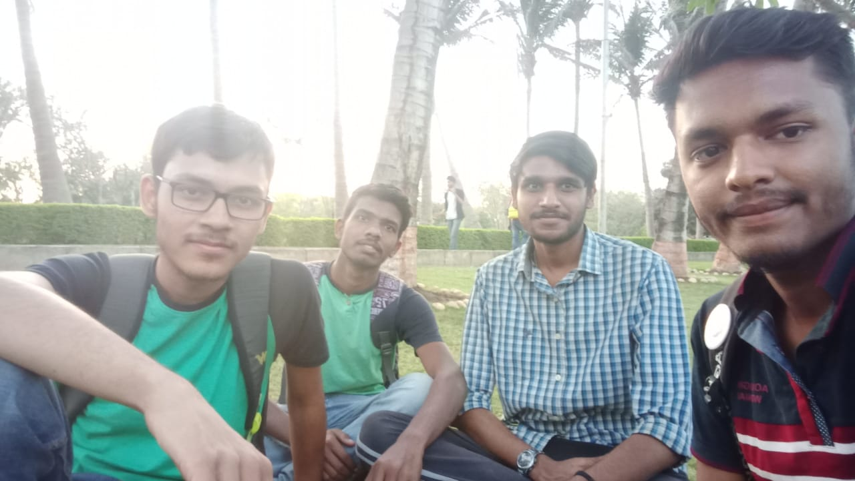
- Using simple camera, we can use face detection technology by the help of opencv python algorithm respectively.

