EXTERNAL TECHNICAL DISCUSSION DRAFT

Public Review Brief
  - The Autonomous Enterprise Reference Architecture - governance and assurance for delegated autonomous decision authority
Field | Controlled value
Specification | AERA-001
Edition | 1.2 Working Draft
Package build | AERA-001-1.2WD-20260807.1
Author | Angelis Pseftis
Affiliation | Independent author
Document date | 7 August 2026
Review status | Developmental-review candidate; public review not open
Review purpose | Technical criticism, mapping adjudication, and pilot design

STATUS: AERA is a proposed architecture. It is not an adopted standard, certification scheme, NIST publication, or evidence of government support or endorsement.

AERA-001 | Version 1.2 WD | Working Draft
CORE RULE: Every autonomous decision shall be governed, assured, attributable, temporally valid, and recoverable before it can produce a mission effect.

1. The Control Gap
Access is not authority.
Autonomous systems create a boundary problem that identity, resource access, model quality, and policy statements cannot solve separately. The relevant engineering question is whether this actor may cause this exact consequence now, under current authority, evidence, policy, time, risk, and recovery state.
Common proxy | Why it is insufficient | AERA control response
Authenticated identity | Establishes who or what acts, not the right to cause a specific effect. | Resolve a current, attributable, revocable delegation.
Model output | A recommendation is not a governed action commitment. | Bind intent, evidence, policy, consequence, and time before authorization.
Available control | Present or monitored does not mean active in the decision path. | Report the highest evidenced operational-use state.
Execution receipt | A command or API success does not prove the intended external state. | Reconcile independent effect observations, divergence, recovery, and closure.

EXECUTIVE IMPLICATION: Delegating execution to autonomous actors does not delegate institutional accountability. Named people or governance bodies remain responsible for risk acceptance, control floors, and suspension authority.

2. The AERA Thesis
Govern the complete decision-authority transaction.
AERA treats the path from accountable delegation to verified effect as the primary unit of assurance. Each transition must preserve attribution, integrity, policy, temporal validity, consequence constraints, evidence, and recovery obligations.
Stage | Required state | Failure question
1 Delegate | Bounded, revocable authority rooted in an accountable grantor. | Was authority absent, expired, expanded, or improperly subdelegated?
2 Propose | Canonical actor, action, target, purpose, parameters, and expected effect. | Did the proposal conceal or substitute a material field?
3 Assemble | Current evidence, provenance, policy, threat, time/PNT, and recovery state. | Was evidence stale, correlated, contradicted, or manipulated?
4 Authorize | Visible assurance-vector results and consequence-appropriate disposition. | Was a permit inferred from one score or an incomplete policy view?
5 Enforce | Authorization bound to the exact effect boundary and validity interval. | Could the proposer bypass or broaden enforcement?
6 Observe | Attempted effect and achieved external state observed independently. | Did the command succeed while the mission effect failed or diverged?
7 Recover/close | Containment, rollback, takeover, reconciliation, and retained evidence. | Was the transaction closed without verified effect and recovery state?

INVARIANT: A material change to any bound actor, authority, intent, action, target, evidence, policy, consequence, time, recovery, or enforcement object requires reassessment or a new transaction.

3. Logical Architecture
Eight logical capability domains connect accountable governance to operational effect.
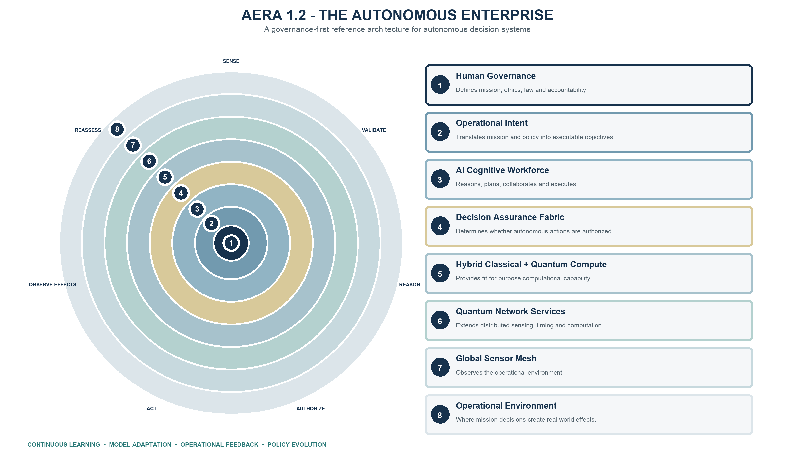
The rings are logical capability domains and extension points, not mandatory deployment tiers, products, cloud layers, or organizational boundaries. AI, classical compute, quantum services, RF sensing, PNT, operational technology, and networks are governed resources inside the same authority-and-effect model.
TECHNOLOGY BOUNDARY: A conforming implementation does not require quantum computing, quantum networking, or a globally deployed sensor mesh. Applicability is determined by capability, credible consequence, dependency, and risk.

4. Decision Assurance Fabric
A permit is an enforceable, evidence-bounded disposition - not a recommendation.
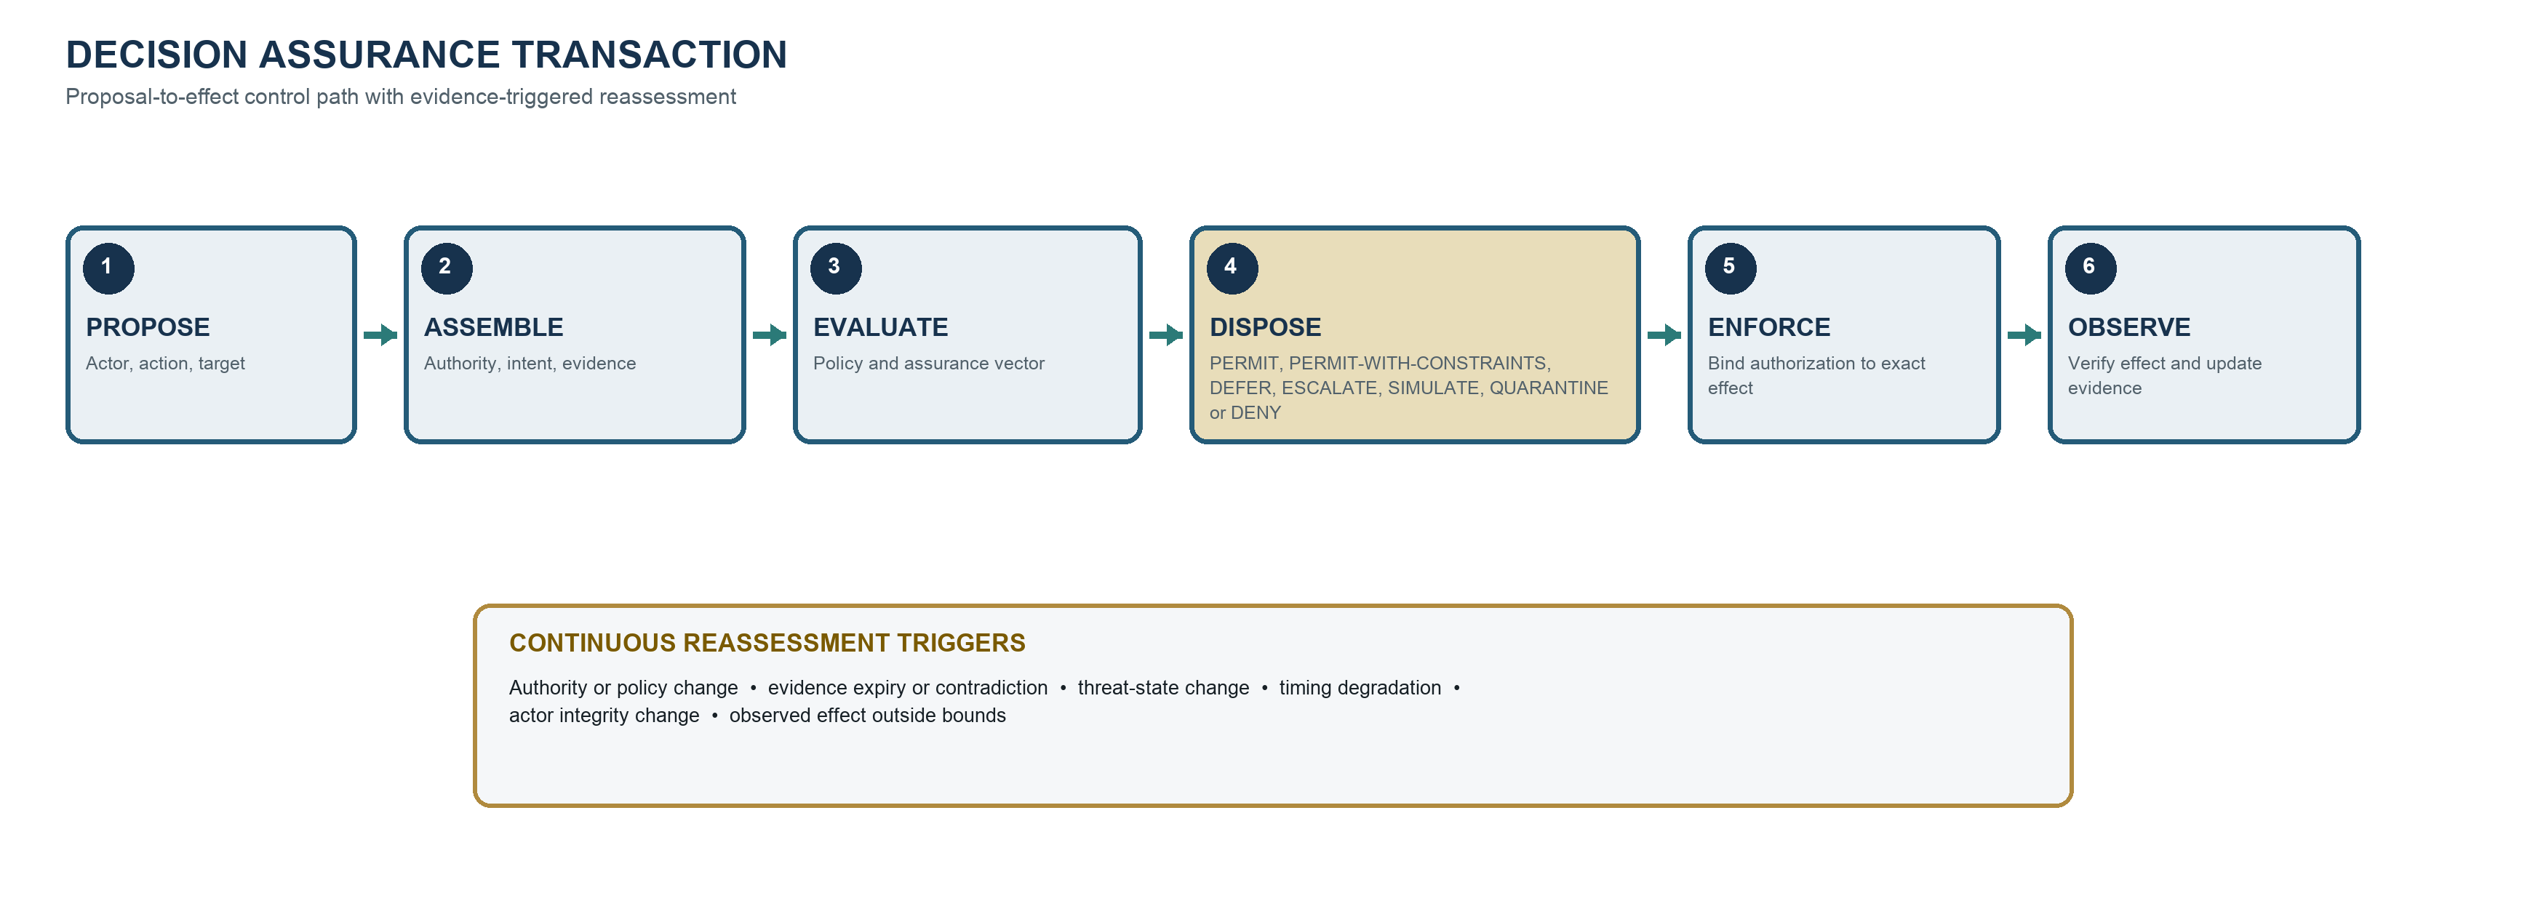
Fabric property | Engineering obligation
Exact binding | Bind actor, action, target, parameters, purpose, evidence, policy, consequence, time, use, and enforcement boundary.
Visible assurance vector | Keep authority, identity, mission, evidence, provenance, competence, cyber integrity, time/PNT, consequence, recovery, and oversight results distinct.
Independent enforcement | The proposer cannot be the sole authorizer, evidence source, and effect path for a material action.
Effect reconciliation | Record attempted effect, independently observe achieved state, and retain divergence and recovery evidence.
Continuous reassessment | Invalidate or constrain authorization when authority, evidence, policy, threat, integrity, timing, or effect state materially changes.

5. Decision Contract
Make authority portable, testable, enforceable, and reconstructable.
Object | Minimum semantics | Assurance purpose
Actor | Workload identity, owner, role, competence, integrity, configuration. | Establish accountable execution subject.
Authority | Grantor, grantee, scope, bounds, expiry, subdelegation, revocation. | Prove current decision rights.
Intent | Mission objective, priorities, constraints, version. | Bind action to current purpose.
Action / target | Canonical operation, parameters, resource, environment, stakeholder boundary. | Prevent substitution and define effect destination.
Evidence | Source, provenance, freshness, uncertainty, integrity, independence. | Support decision-relevant claims.
Consequence | Class, credible harms, reversibility, propagation, cumulative limits. | Select the minimum control floor.
Policy / assurance | Rule and evaluator versions; visible vector results and limitations. | Make authorization reproducible and contestable.
Time / PNT | Source, uncertainty, integrity, ordering, validity, degraded state. | Preserve temporal and spatial validity.
Recovery | Stop, rollback, containment, compensation, takeover, resource bounds. | Bound failure and restore accountable control.
Disposition / effect | Authorization state, enforcement receipt, observations, divergence, closure. | Separate permission, attempt, achieved state, and recovery.

INTEROPERABILITY RULE: Producers publish required semantics. Consumers record validation, rejection, acceptance, and actual use in the computed decision. Presence alone is not operational use.

6. Consequence and Human Control
Scale assurance to the worst credible effect, not to model confidence or vendor claims.
Class | Credible effect | Minimum control-floor direction
CC-0 Non-effecting | Analysis, recommendation, shadow mode, or isolated simulation. | Identity, provenance, production isolation, labeling, proportional retention.
CC-1 Bounded | Localized, detectable, reversible effect with routine recovery. | Explicit delegation, exact action binding, enforcement, validity, effect receipt.
CC-2 Material | Meaningful but limited operational, financial, security, privacy, or mission effect. | Independent enforcement, consequence-specific evidence, tested recovery, cumulative limits.
CC-3 High | Severe, safety-significant, fast-propagating, cross-domain, or difficult-to-reverse effect. | Independent evidence/enforcement, positive oversight or validated preauthorization, exercised takeover.
CC-4 Critical | Catastrophic, potentially fatal at scale, strategically irreversible, or systemic effect. | Explicit accountable-authority approval, deterministic interlocks, multiple inhibition means, narrow authorization, pre-positioned recovery.

Human-control modes
- INFORMED - a human receives decision-relevant status but does not authorize each action.
- SUPERVISED - a human monitors and can intervene within a validated response window.
- APPROVED - a human or governance authority approves the bounded action or action class.
- CONTROLLED - deterministic interlocks, inhibition, and accountable human release remain in the path.
CONTROL FLOOR: Probability, model sophistication, automation benefit, or high confidence cannot lower the minimum controls required by credible consequence.

7. Relationship to NIST Work
AERA is designed to complement NIST risk outcomes with decision-authority architecture and implementation evidence.
NIST work | How AERA uses it | Boundary
AI RMF 1.0 | Risk outcomes and trustworthiness characteristics inform governance, assurance, metrics, and review questions. | AERA is not a NIST framework and has not been NIST-validated.
CSF 2.0 | Cybersecurity governance, protection, detection, response, and recovery provide risk-management anchors. | AERA does not establish CSF implementation or outcomes.
SP 800-53 / 53A | Candidate control and assessment evidence may be reused when scope, subject, implementation, context, and evidence period match. | Mapping does not prove control selection, implementation, or effectiveness.
SP 800-207 | Zero Trust access decisions are necessary inputs; AERA adds delegated authority, consequence, effect, and recovery semantics. | Complementary relationship, not equivalence.
IR 8477 / OLIR | Provides the method and publication pathway for future atomic mappings. | The 1.2 mapping ledger is developmental, not submitted or NIST-reviewed.
Critical Infrastructure Profile COI | A possible forum for guardrailed autonomous response, IT/OT mission threads, TEVV, recovery, supply chain, and fail-safe design input. | Participation would not imply adoption or endorsement.

PUBLIC CLAIM: Use: 'designed for compatibility with selected NIST outcomes, with mappings under development.' Do not use: 'NIST-supported,' 'NIST-approved,' 'NIST-aligned,' or 'NIST-endorsed.'

8. What Changed in 1.2 WD
Change area | 1.2 WD improvement | Reviewer focus
Normative control | Clarified normative perimeter, canonical requirement source, and release-blocking divergence rule. | Can an implementer determine exactly what is mandatory?
Conformance | Separated applicability from result; defined four conformance outcomes and operational-use evidence states. | Are claims reproducible and deviations bounded?
Governance | Added roles, balanced review, dissent/disposition, release control, evidence-bound claims, and publication-family separation. | What would a credible consensus process require?
NIST mappings | Adopted IR 8477 / OLIR mapping semantics and isolated legacy codes as non-translatable working data. | Are candidate relationships atomic, directional, and correctly scoped?
NIST status | Added current lifecycle, incident, identity, measurement, ERM, OSCAL, AI evaluation, and engagement sources. | Are source statuses and implications accurate?
Release integrity | Removed stale filenames and recharacterized same-author review as I1 self-assessment. | Do all human- and machine-readable artifacts reconcile?

Controlled package counts
Registry | 1.2 WD count | Interpretation
Normative requirements | 199 | Active canonical rows; applicability is claim-specific.
Decision-authority threats | 25 | Each applicable threat requires control, negative test, and evidence.
Controlled sources | 69 | Final, draft, living, and proprietary sources remain status-bounded.

WORKING-DRAFT LIMIT: The requirement count and supporting registers may change through controlled review. Review comments must cite the exact edition and artifact reviewed.

9. Review Questions and Participation

Questions that matter
- Is the decision-authority transaction complete and implementable from accountable delegation through observed effect and closure?
- Are any normative requirements ambiguous, duplicative, infeasible, non-testable, or assigned to the wrong profile or consequence class?
- Does the threat model cover credible failures of authority, evidence, identity, policy, enforcement, time/PNT, recovery, learning, and human oversight?
- Can independent assessors reproduce applicability, conformance, deviation, maturity, and evidence-state judgments?
- Are candidate NIST mappings directionally accurate without implying reciprocal compliance, adoption, or endorsement?
- What implementation, inter-rater, mission-effect, usability, and adverse-case evidence is required before stronger claims?

How to comment
- Use the AERA_1.2_WD_Review_Comment_Matrix.xlsx for substantive comments.
- Identify the exact section, page, requirement, threat, interface, table, figure, source, or mapping row.
- Classify the issue and explain its technical rationale, mission consequence, and evidence basis.
- Propose replacement language, test criteria, mapping rationale, or a concrete corrective action where practical.
- Disclose reviewer role, relevant competence, affiliation, sponsorship, and conflicts when the review is not anonymous.
REVIEW BOUNDARY: Acknowledgment of a comment is not acceptance. Participation, citation, correspondence, or pilot involvement is not endorsement. Every disposition remains part of the controlled AERA change record.

