ENGINEERING STATUS AND FORWARD PLAN
AI Decision Firewall - Phase 2.5 predecessor design freeze and package candidate
Evidence baseline | 0.2.0-alpha.5 | commit f7f6b5c | Phase 2.4
Predecessor design freeze | 0.2.0-alpha.6 | commit 08ce203c | CI and Dependency Graph succeeded
Package state | Post-freeze code, documentation, visual, and status-package candidate
Review date | 2026-08-15
Authority | Offline, read-only engineering candidate; no operational authority
Evidence boundary | P2-CE-005 remains CE-0 NOT_EVALUATED

Executive assessment
The repository is aligned to the actual program boundary as of 2026-08-15. The latest evidence-bearing baseline remains 0.2.0-alpha.5 at commit f7f6b5c (Phase 2.4). Exact commit 08ce203c0965e8d43b7653454d4ea8315996021f is the predecessor 0.2.0-alpha.6 Phase 2.5 design-freeze baseline; its historical GitHub CI and Dependency Graph workflows completed successfully. This package candidate is rebased onto the already-published public-site baseline at github/main@c3400e0 and adds bounded local-write interlocks, campaign constructor instrumentation, selected Gate B causal-identity/oracle and payload-observer scaffolding, documentation, visuals, and this status package. Its source reconciliation is complete, its tracked data, campaign-bound model, and outputs/baseline/** remain at their committed bytes, and its Phase 2.5 technical suite passed 222/222. The separate public-site module passed 9/9, producing a combined repository aggregate of 231/231; the site and its tests are not Phase 2.5 or P2-CE-005 evidence. The campaign module passed 21/21, the chart check passed in the frozen renderer, and the candidate includes a generated-and-verified integrity manifest plus paired final-source DOCX/PDF renders whose 15 pages were inspected without blank, clipped, or run-in-heading defects. It is not a tag, release, or evidence package. Package commit and publication, followed by GitHub CI on the exact published package commit, remain external release gates. Phase 2.5 does not add historical data, a live feed, an operational connector, action authority, or an observed campaign result.
The predecessor design-freeze implementation passed 193/193 tests in a fresh isolated review run and passed commit-bound repository CI. This package candidate subsequently passed 222/222 Phase 2.5 technical tests in a local isolated run; the separate public-site module passed 9/9, and the combined repository aggregate passed 231/231. Only the 222-test technical scope supports the narrow CE-1 implementation-conformance statements below. Neither the site module nor the repository aggregate creates P2-CE-005 evidence.
Release hold: Do not describe alpha.6 as a tagged release or released evidence package, and do not describe P2-CE-005 as evaluated. The local manifest, rendering, visual, and test gates are complete. Before release, publish the exact package commit and require GitHub CI to pass on that published commit. Execute the P2-CE-005 campaign only under its separate two-commit evidence protocol.

State | Current truth
Latest evidence-bearing baseline | 0.2.0-alpha.5, commit f7f6b5c, Phase 2.4
Predecessor design-freeze baseline | 0.2.0-alpha.6, commit 08ce203c; historical 193/193 local run, GitHub CI, and Dependency Graph succeeded for that exact commit
This package candidate | Bounded campaign and run_poc path controls; campaign constructor instrumentation; selected Gate B failure/oracle/observer scaffolding; documentation, diagrams, charts, and this status package; source reconciliation complete and Phase 2.5 technical suite passed 222/222
Separate published-site scope | Rebased onto github/main@c3400e0; public-site module passed 9/9 and remains outside Phase 2.5 and P2-CE-005 evidence
Combined repository aggregate | 231/231 passed locally: 222 Phase 2.5 technical tests plus 9 separate public-site tests
Completed local package gates | 222/222 Phase 2.5 technical suite; 9/9 separate public-site module; 231/231 repository aggregate; 21/21 campaign module; frozen-renderer chart check; generated-and-verified integrity manifest; paired final-source DOCX/PDF; all 15 rendered pages inspected with no blank, clipped, or run-in-heading defects
Remaining external gates | Package commit and publication; GitHub CI on the exact published package commit
Published Phase 2 evidence | P2-CE-001 through P2-CE-004, each version-bound to its recorded artifacts and limitations
Planned Phase 2.5 evidence | P2-CE-005, CE-0 NOT_EVALUATED; no result ledger, evidence record, pass rate, or CE-2 claim
Data maturity | Synthetic fixtures only; zero historical cases
Operational maturity | Offline and read-only in Phase 2; no connector, credential, token, broker, target, or effect path

What changed in this review
- Separated the published alpha.5 evidence baseline from the alpha.6 release candidate across the README, changelog, roadmap, Phase 2 index, engineering plans, cards, safety case, traceability records, and Gate B material.
- Replaced the four v0.1-centric architecture diagrams with Phase 2 system-context, logical-architecture, run-state, and trust-boundary views.
- Preserved the three Phase 1 metric charts as historical v0.1 synthetic-simulation results, added explicit provenance and nonclaim labels, and added deterministic PNG/SVG regeneration with a check mode.
- Preserved the 32-page v0.1 DOCX/PDF as immutable historical artifacts. They are not the current Phase 2 package and are not overwritten by this document.
- Added ADR 007 for the accepted Phase 2.4 reference feature projector and ADR 008 for the accepted Phase 2.5 source-to-decision design candidate.
- Corrected source-to-decision arithmetic and campaign accounting defects found during review and added negative and boundary regression coverage.
- Added a bounded run_poc write interlock. Ordinary repository writes are limited to data/local/** and outputs/local/**; the explicit freeze flag expands that allowance only to data/** and outputs/baseline/**. Preflight covers every generated leaf, including run_manifest.json, rejects redirects, case-variant repository aliases, and unsafe existing leaves, and the local manifest binds its seven other outputs. Fourteen focused tests pass. This is not an OS sandbox, mount boundary, TOCTOU/race guarantee, comprehensive hardlink defense, or confinement of direct writer APIs.
- Added CE-1-only Gate B scaffolding: a closed registry of 25 selected causal identities, exact-match oracle tuples for 24 selected pre-payload mutations plus one post-qualification threshold identity, and a bounded observer that recorded zero cases or adjudications role access under its enumerated Python APIs for the 24 selected pre-payload mutations. Unclassified Gate B failures remain unscorable; this is not a complete taxonomy, OS-level nonaccess proof, reference monitor, or campaign result.
- Kept the full research-screen date at 2026-08-14 because the 2026-08-15 activity was a targeted source check, not a complete rescreen. A full Phase 2.5 claim-class refresh remains pending.

Current system context
The current architecture is a governed, offline, read-only decision and assurance path. Under the enumerated application controls, the historical-origin path is designed to stop before governed payload access when structural Gate B preflight fails. Accepted cases proceed through deterministic evidence, model, policy, verifier, and read-only final surfaces. The action plane is structurally absent in Phase 2. This is an application-level control statement, not proof of OS-level nonaccess or non-egress.
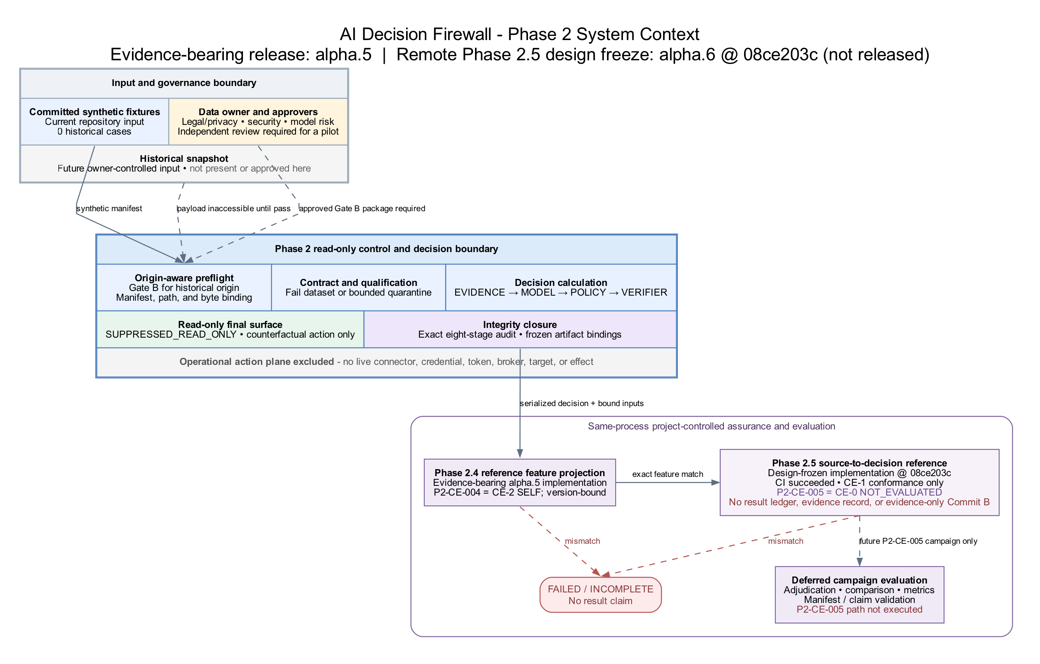
Figure 1. Phase 2 application-level system context - alpha.5 evidence baseline and alpha.6 package candidate; not OS-level nonaccess proof

Logical architecture
Phase 2 puts governance, custody, qualification, decision calculation, integrity checking, and deferred evaluation into separate control stages. The Phase 1 authorization and in-memory simulator path remains available only under synthetic_simulation compatibility testing.
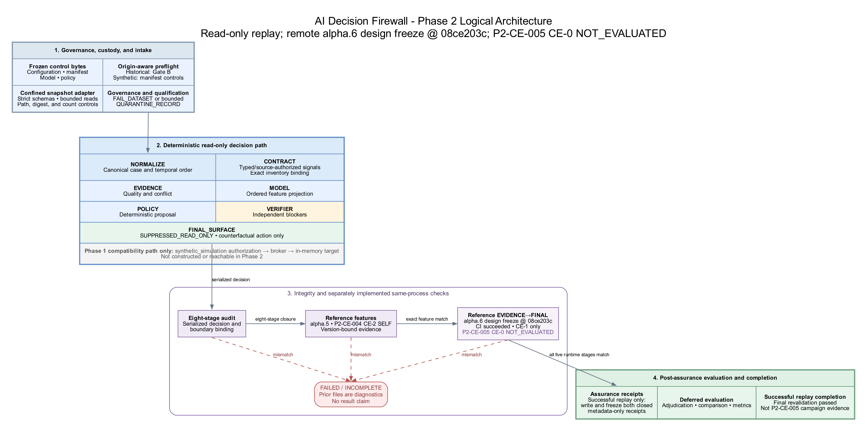
Figure 2. Phase 2 logical architecture - no operational action path

Assurance and completion semantics
- The harness first validates the serialized decision and its exact eight-stage audit trace.
- Phase 2.4 separately reconstructs the 20 modeled feature values and event trace.
- Phase 2.5 then separately reconstructs EVIDENCE, MODEL, POLICY, VERIFIER, and FINAL_SURFACE from frozen normalized-case, model, policy, and decision bytes.
- A source-to-decision mismatch publishes neither reference receipt and stops before evaluator decoding, comparison, metrics, and completed-run finalization.
- A successful run writes and binds both metadata-only assurance receipts, revalidates deterministic and volatile artifacts, and returns successfully only after final manifest checks.
- The two reference implementations are separate in code but remain same-process, same-project, and project-controlled. Agreement is calculation consistency, not external independence, source truth, policy fitness, efficacy, or custody.

Evidence state
Record | Evidence class | Observed state | Permitted statement
P2-CE-001 | CE-2 SELF | Published, three-case synthetic starter | Version-bound replay behavior only
P2-CE-002 | CE-2 SELF | Published, seven-record synthetic qualification result | Exact 3 accepted plus 4 quarantined accounting only
P2-CE-003 | CE-2 SELF | Published, 32/32 fixed Gate B outcomes | Exact project-controlled preflight behavior only
P2-CE-004 | CE-2 SELF | Published, 32/32 fixed feature-assurance outcomes | Exact project-controlled feature-assurance behavior only
P2-CE-005 | CE-0 | Plan and implementation scaffolding only | NOT_EVALUATED; no result, rate, or CE-2 language

None of the evidence above establishes historical or live performance, statistical representativeness, organizational approval, independent replication, OS-level isolation, target-side outcomes, production readiness, efficacy, or an operational failure bound.

Review verification
Check | Outcome
Phase 2.5 technical suite | This package candidate passed 222/222 locally; this is the technical evidence scope and a prepublication observation, not a GitHub CI result
Separate public-site module | 9/9 passed locally; site behavior is outside Phase 2.5 and P2-CE-005 evidence
Combined repository aggregate | 231/231 passed locally after the package candidate was rebased onto github/main@c3400e0
Predecessor design freeze | Commit 08ce203c retains its version-bound historical 193/193 local result and successful GitHub CI and Dependency Graph results
Campaign CLI and reference-attempt instrumentation | 3/3 CLI checks, one check-leaf safety regression, one constructor-sensitivity regression, and 21/21 campaign-module tests passed in an isolated clean clone; bounded operator-error and Python-construction controls only
run_poc local-write guard | 14 focused checks passed; ordinary and explicit-freeze destinations, case-variant repository aliases, every generated leaf, and seven-output local-manifest binding covered within the documented application-level limits
Gate B causal/oracle/observer scaffolding | 25 selected identities registered; 24 selected pre-payload mutations exercised with zero observed governed payload roles under the enumerated Python APIs, plus one post-qualification threshold identity; CE-1 scaffolding only
Source-to-decision campaign | Test-level in-memory and temporary-artifact paths were exercised; no eligible clean exact-Commit-A evidence execution or publication occurred
Published claim-evidence records | Revalidated under their exact version-bound profiles
Architecture visuals | DOT sources regenerated to PNG and SVG and visually reviewed
Phase 1 metric visuals | Source totals verified; chart check passed in the frozen renderer
Document structure | Relative links, Markdown fences, CSV widths, and whitespace checked
Repository integrity manifest | Generated and verified for this package candidate
Generated status package | Paired DOCX/PDF rebuilt from the final source with the final builder; all 15 rendered pages inspected with no blank, clipped, or run-in-heading defects

The predecessor 193-test and commit-bound workflow records remain bound to exact design-freeze Commit 08ce203c. The 222/222 result covers this package candidate's Phase 2.5 technical scope in a local isolated run, including five campaign-delta tests, 14 run_poc tests, six Gate B oracle tests, and four payload-observer tests. The separately inherited public-site module passed 9/9, bringing the local repository aggregate to 231/231 without changing the Phase 2.5 evidence boundary. The generated-and-verified integrity manifest, frozen-renderer chart check, paired final-source DOCX/PDF rebuild, and 15-page inspection complete the local package gates.

Run state machine
The run is complete only after read-only suppression, exact audit validation, both reference checks, deferred evaluation, output revalidation, and successful harness return. Any failed gate terminates the run; intermediate file presence is diagnostic, not evidence of completion.
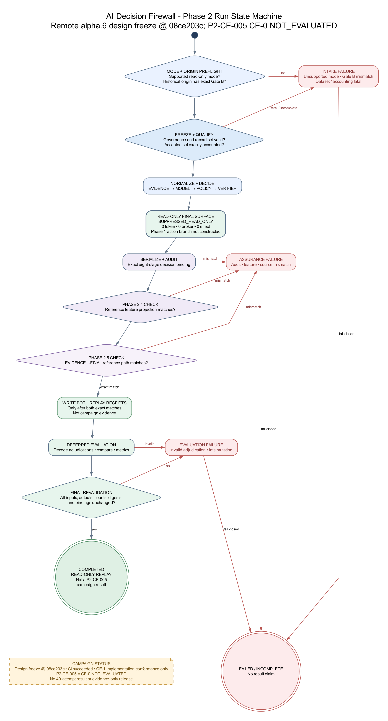
Figure 3. Phase 2 run state machine - fail-closed completion sequence

Trust and custody boundaries
The implementation provides application-level controls around authority, frozen control bytes, untrusted payloads, owner-only snapshots and outputs, read-only decision calculation, evaluator-only adjudications, and same-process assurance. It does not create independent custody or an OS-enforced sandbox.
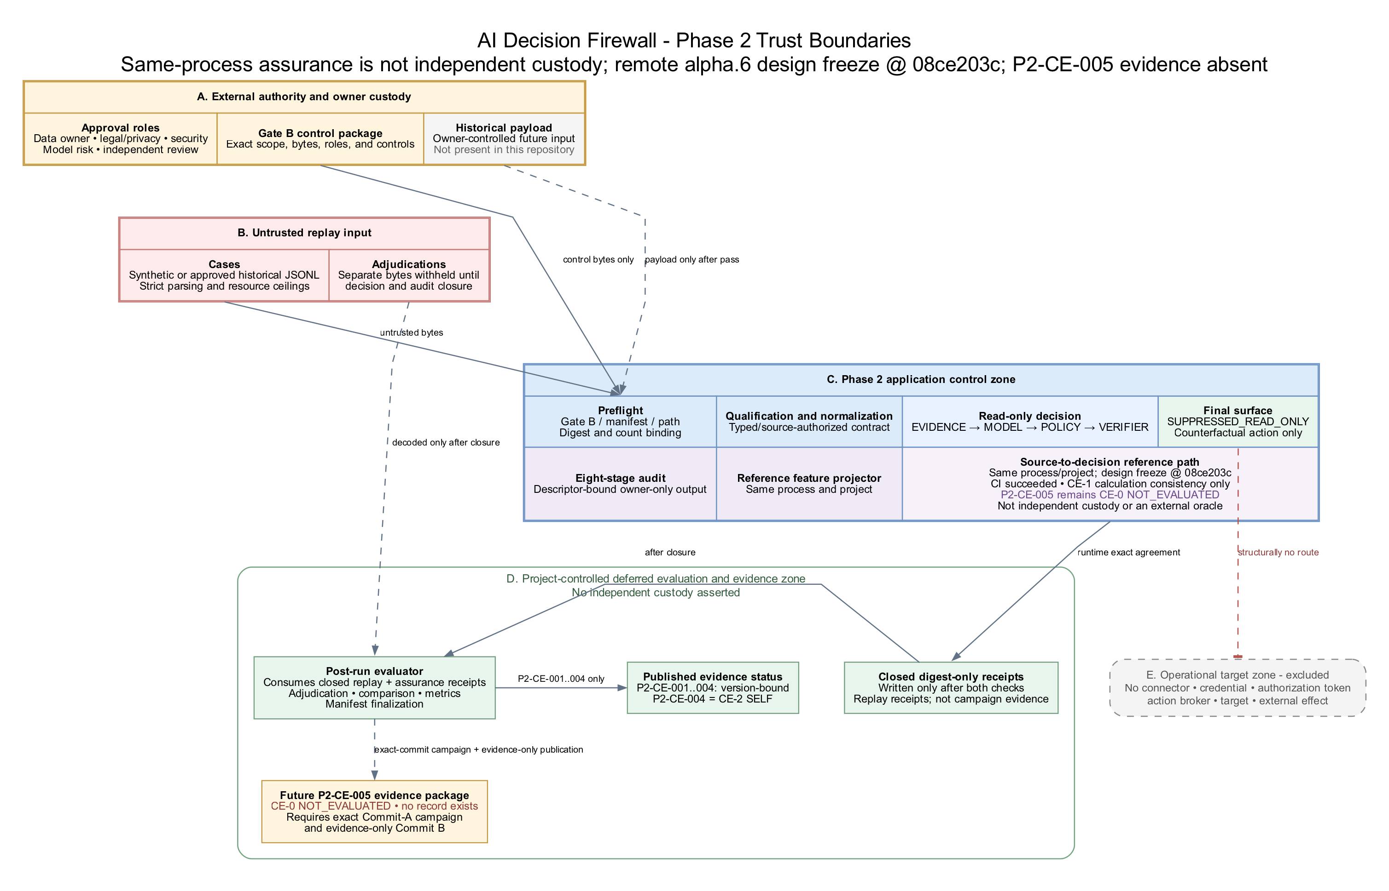
Figure 4. Phase 2 trust boundaries - application controls and excluded target zone

Known limitations and prohibited inferences
- There are zero historical cases, no approved Gate B package, and no authenticated real-world adjudication set in the repository.
- There is no live-feed adapter, test-tenant integration, production connector, credential, action broker, target, or operational effect path in Phase 2.
- The self-custodied SHA-256 audit chain detects presented-record inconsistency but does not resist wholesale replacement by a writer that can recompute the chain.
- Exact agreement between production and reference calculations does not prove that source assertions are authentic, complete, truthful, or semantically correct.
- The run_poc destination interlock is an application-level operator-error guard. It does not provide an OS sandbox, mount containment, TOCTOU/race resistance, comprehensive hardlink defense, or confinement of direct writer functions.
- The Gate B observer covers an enumerated set of Python file APIs in the observed process. It does not cover direct system calls, native extensions, subprocesses, pre-opened descriptors, hard-link aliases to governed files, other unenumerated aliases, or same-user access outside that process, and the 25 registered identities are not a complete failure taxonomy.
- Synthetic results are generator-consistent controls, not evidence of field calibration, analyst agreement, false-containment risk, mission suitability, or operational efficacy.
- The research mapping informs threat models and evaluation design. It is not evidence that this implementation inherits another system's safeguards or results.

Forward plan and release gates
1. Preserve the completed local package gates. Source reconciliation, the 222/222 Phase 2.5 technical suite, separate 9/9 public-site module, 231/231 repository aggregate, 21/21 campaign module, frozen-renderer chart check, generated-and-verified manifest, paired final-source DOCX/PDF rebuild, and 15-page inspection are complete. Keep the site tests outside the Phase 2.5 evidence boundary and keep all results bound to this package candidate without promoting them to release or evidence status.
2. Publish and verify the exact package commit. Commit and push the complete package, then require GitHub CI and the remaining repository checks to pass on that exact published commit. Tag or release only after every gate passes.
3. Execute P2-CE-005 under the evidence protocol. Use the clean detached final candidate as Commit A, no retries or exclusions, the complete 40-attempt denominator, direct boundary instrumentation, and a fresh frozen evaluator. Publish only an evidence-only Commit B. Invalidate a defective package instead of repairing it in place.
4. Complete the Phase 2.5 research refresh. Repeat the documented research-screen procedure before changing the claim class or publishing new evidence.
5. Prepare Gate B outside the public repository. Accountable owners must authenticate legal/privacy, mission, security, records, custody, de-identification, mapping, adjudication, sampling, retention, incident, and stop-condition evidence in a restricted system.
6. Run a small approved offline historical pilot. Only after Gate B passes, measure complete intake, accepted and quarantined records, mapping loss, source delay, temporal fidelity, analyst disagreement, conditional performance, and survivorship effects.
7. Defer live shadow and action progression. A live read-only feed requires a separately approved Phase 3 architecture and safety case. Test-tenant actions and any operational pilot require new authority, integrations, rollback evidence, target-side verification, and action-specific statistical release gates.

Immediate decision points
Decision | Recommended position
Is alpha.6 ready to be called a release? | No. Local package gates are complete, but package commit and publication and GitHub CI on that exact published commit remain incomplete.
Should P2-CE-005 be run now? | Only after the complete final alpha.6 candidate becomes the clean Commit A and the exact two-commit evidence controls are in place.
Should historical data be introduced next? | Only through an authenticated, independently reviewed Gate B package retained outside the public repository.
Should live shadow or operational action be enabled? | No. Both require separate architecture, authority, safety, privacy, integration, and validation gates.
Where should engineering effort go after P2-CE-005? | Independent custody and review, evaluation-environment controls, and a small approved historical pilot - not more same-process agreement alone.

Maintained document map
Artifact family | Current role
README.md, CHANGELOG.md, docs/ROADMAP.md | Published-versus-candidate status and forward sequence
docs/phase2/ | Current architecture, contracts, safety, validation, claim evidence, research, qualification, and Gate B controls
docs/adr/ | Architecture decisions, including the accepted Phase 2.4 and Phase 2.5 assurance paths
docs/architecture/ | Current Phase 2 diagrams and historical Phase 1 metric charts with reproducible generators
Legacy v0.1 DOCX/PDF package | Immutable historical Phase 1 engineering baseline
Current alpha.6 status package | Engineering state, evidence boundary, and forward plan for the release candidate

Review conclusion
The repository now tells one consistent story: Phase 1 demonstrated a synthetic action-capable simulator; the latest evidence-bearing Phase 2.4 baseline added structurally read-only replay, qualification, Gate B controls, exact audit checks, and feature assurance; predecessor design-freeze Commit 08ce203c added source-to-decision calculation assurance; and this package candidate adds bounded application-level path controls and selected Gate B causal-test scaffolding. Source reconciliation and all local package gates are complete. The current technical direction is to publish the exact package commit, require its GitHub CI to pass, publish P2-CE-005 only through its controlled evidence protocol, and then seek an externally authenticated Gate B package for a small offline historical pilot. No successor campaign has been executed, and nothing in the current tree authorizes historical access, a live feed, or operational action.

