ENGINEERING STATUS AND FORWARD PLAN
AI Decision Firewall - published Phase 3 and Phase 3.1 model-evaluation candidate
Prior evidence baseline | 0.2.0-alpha.5 | commit f7f6b5c | Phase 2.4
Published predecessor | 0.2.0-alpha.6 | commit 854b15c | CI and Dependency Graph succeeded
Published Phase 3 | 0.3.0-alpha.1 | commit 423685d | exact-commit CI succeeded
Review date | 2026-08-15
Authority | In-memory synthetic simulation only; no live connector or operational authority
Evidence boundary | Phase 3 simulation-only CE-1; Phase 3.1 local candidate; P2-CE-005 remains CE-0

Executive assessment
The program has three distinct current boundaries.
First, Phase 2.5 is published on main at exact Commit 854b15c56397a81de6326b719d3d7d1dc847608f. GitHub CI and Dependency Graph checks passed for that exact commit. It retains the local 222/222 Phase 2.5 technical result, separate 9/9 public-site result, and 231/231 then-current repository aggregate. P2-CE-005 was not executed or published and remains CE-0 NOT_EVALUATED; green package CI is not campaign evidence.
Second, Phase 3 0.3.0-alpha.1 is published at exact Commit 423685d105be813056617db738297eba83d3d9d0; exact-commit CI and Dependency Graph checks passed. It adds a raw external request, opaque-credential identity resolution, signed target-bound evidence, trusted policy/target context, deterministic four-way decision, consequence evaluation, exact-scope single-use authorization, mandatory in-memory broker, functionally separate same-project target readback, bounded human approval, lifecycle audit, metrics, two SOC demonstrations, and a 46-scenario adversarial corpus. The current published boundary passed 57/57 focused Phase 3 tests; both demo acceptance checks reported PASS; the corpus reported 46/46; and the full repository regression passed 288/288 locally and in exact-commit CI.
Third, Phase 3.1 is a working 0.3.1-alpha.1 synthetic model-evaluation candidate. It adds digest-bound repository fixtures, disjoint temporal training/calibration/evaluation roles, a logistic baseline, a Platt calibration challenger, aggregate discrimination/calibration/error/abstention/subgroup metrics, and an unconditional NOT_AUTHORIZED promotion state. It contains no historical/live adapter or action path and has no owner-approved performance threshold or model-promotion authority.
All Phase 3 observations are CE-1 implementation-conformance evidence over synthetic inputs and effects. They do not establish live containment, operational efficacy or calibration, production safety, statistical risk, or external independence.

Decision table
State | Current truth
Published Phase 2.5 code/package | Exact Commit 854b15c56397a81de6326b719d3d7d1dc847608f on main; exact-commit CI and Dependency Graph green
Published Phase 2 evidence | P2-CE-001 through P2-CE-004, version bound to their records and limitations
Phase 2.5 campaign evidence | P2-CE-005 CE-0 NOT_EVALUATED; no execution, result ledger, pass rate, CE-2 record, or evidence-only Commit B
Phase 3 implementation | Published at exact Commit 423685d; raw request through optional synthetic effect and separate readback implemented
Phase 3 T&E | Required high-risk/no-effect and low-risk/verified-effect demo acceptance PASS; deterministic corpus 46/46; focused tests 57/57; exact-commit CI passed
Phase 3 repository aggregate | Then-current 288/288 passed locally and in exact-commit CI
Phase 3.1 model evaluation | Working synthetic-only candidate; temporal baseline/challenger mechanism; no historical data or promotion authority
Data/action boundary | Synthetic only; no historical organizational data, live feed, test tenant, production connector, credential, or live action

What Phase 3 adds
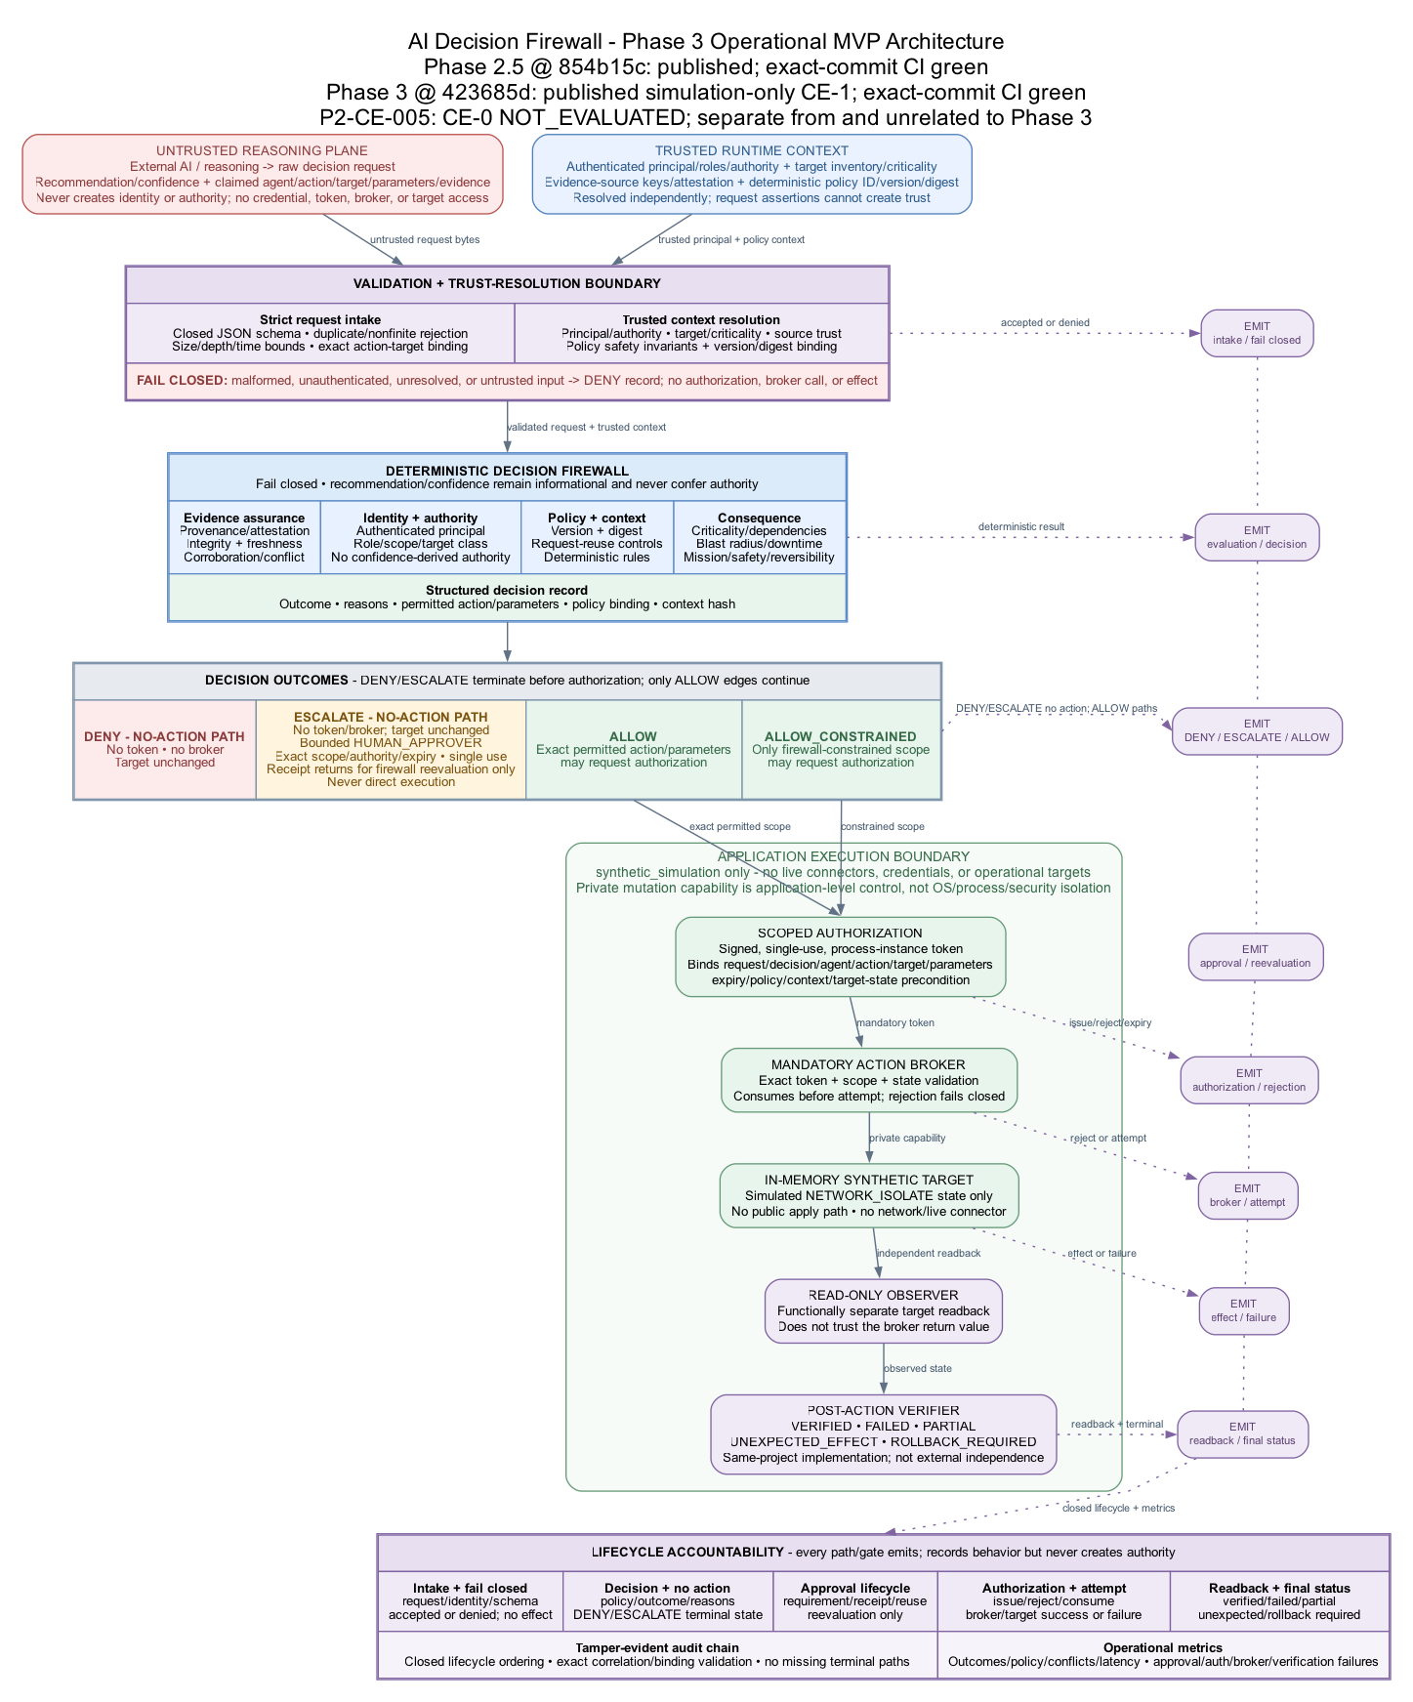
Figure 1. Phase 3 simulation-only operational MVP control flow and accountability boundary.

Request and trust plane
- Closed v0.3.0 raw-request and policy schemas with strict duplicate/non-finite,
size/depth, version, field, and timestamp handling.
- Opaque invocation credential resolution to a signed ResolvedPrincipal, plus
trusted policy registries for agent authority, source properties, action constraints, target criticality/dependencies/consequences, and firewall-owned time.
- Runtime HMAC evidence attestation over source, provenance, observation time,
content, semantic support/contradiction, relevance, and subject target.
- Freshness-at-decision, reliability, relevance, corroboration, conflict,
missing-source, content-integrity, and poisoned-text assessment.

Decision and consequence plane
- Exact ALLOW, DENY, ESCALATE, and ALLOW_CONSTRAINED outcomes.
- Structured stable reason codes, applicable rules, evidence/authority/
consequence findings, constraints, policy digest, and decision-context digest.
- Explicit consequence evaluation for reversibility, criticality, dependencies,
cascade, blast radius, downtime, mission, safety, availability, and required human authority.
- Recommendation/confidence separation: agent output remains advisory and never
grants authority.
- Functionally separate deterministic decision verification before token issue.
- Code-owned policy safety invariants for unique closed rule precedence,
evidence trust/strength/corroboration/zero-conflict floors, severe-consequence approval floors, and Tier-0 treatment for every domain controller.

Authorization, execution, and verification plane
- HMAC authorization binding issuer instance, request, decision, agent, action,
target, canonical permitted parameters, issue/expiry time, policy identity and digest, decision context, target precondition, nonce, and signature.
- Atomic process-local single-use consumption, including failed attempts;
sequential, concurrent, prior-instance, expired, altered, and wrong-scope reuse is rejected.
- Mandatory broker and in-memory target mutation guarded by a private execution
capability and a target-state precondition.
- Separate read-only target observation; broker-reported success cannot produce
VERIFIED. Final classes include FAILED, PARTIAL, UNEXPECTED_EFFECT, and ROLLBACK_REQUIRED.
- Signed registered expiring human-approval requirement. A separately resolved
opaque human credential can create one atomically recorded exact-scope signed reevaluation receipt; the approval gate cannot mint a token, cause reevaluation, or invoke the broker.

Audit and observability
- Correlated hash-linked request lifecycle through validation/decision,
authorization or suppression, broker/attempt, verification, and final state.
- Explicit nonexecuting and broker-rejected terminal paths without fabricated
downstream events.
- Exact executed-path request/decision/token/attempt/target/state/effect/
verification correlation. A post-effect prewrite audit failure closes through one honest POST_EFFECT_ACCOUNTING_FAILURE, returns ROLLBACK_REQUIRED, and reconciles the decision/verification-failure counters exactly once; it does not automate rollback.
- Decision/rule/conflict/authorization/broker/verification/latency metrics.
- Demo and corpus outputs omit reusable token signatures and runtime keys and
refuse to overwrite nonempty destinations.

Demonstrated mission paths
Demonstration | Trusted conditions | Observed local result
Tier-0 domain controller | AI requests isolation at confidence 0.96; stale and conflicting evidence; authentication-service dependency and cascading consequence; agent lacks Tier-0 authority | ESCALATE; bound human-review requirement; no authorization, broker call, or state change
Low-criticality workstation | Credential-resolved workstation-containment authority; fresh corroborated HMAC-attested evidence; reversible bounded action | ALLOW; one exact-scope authorization and synthetic broker attempt; functionally separate same-project observation VERIFIED

The deterministic corpus adds 46 declared canonical, evidence, authority, consequence, token/replay/bypass, broker/verifier, metamorphic, and combined attack cases. All 46 matched their project-controlled expectations locally. This is complete coverage of the declared corpus, not exhaustive security coverage or a statistical failure estimate.

Safety defects found and closed
Adversarial review found and closed release-blocking defects across cascading consequence and signed subject-target evidence binding; opaque credential and trust-domain key handling; polymorphic/late-mutable security values; machine policy safety floors; request/token/verifier/approval replay and failure atomicity; injected clock, identifier, verifier, broker, observer, and audit dependency failures; and executed-path/post-effect audit correlation. The 57-test focused suite includes dedicated negative regressions for these classes. These corrections are meaningful CE-1 implementation evidence, not exhaustive security assurance.

Security and evidence boundaries
- The broker capability, private target method, and exact environment type are
application-level Python controls. They are not OS/process isolation, a reference monitor, or protection against arbitrary hostile same-process code.
- Request and authorization ledgers are process-local memory. They are not
durable, distributed, crash consistent, or sufficient for multi-node replay prevention/idempotency.
- Evidence attestations use domain-separated runtime HMAC synthetic keys. They do not establish
enterprise device identity, PKI/HSM custody, source authenticity, nonrepudiation, rotation/revocation, or independent provenance.
- Decision and target verifiers are functionally separate non-model components
in the same project/process. They are not an external oracle or organizationally independent assurance.
- Human approval authorizes a reevaluation receipt for an exact scope only. It
is not an action token, cannot execute, and does not itself cause reevaluation.
- Audit is self-custodied and hash linked, not externally anchored, WORM
protected, trusted-time bound, or resistant to complete authorized replacement/truncation.
- Two synthetic targets and injected faults do not establish vendor semantics,
real topology, eventual consistency, rollback feasibility, human workflow, mission outcome, or operational safety.

Reproduce the published Phase 3 observations
PYTHONDONTWRITEBYTECODE=1 PYTHONPATH=src python3 -m unittest \
tests.test_phase3_contracts \
tests.test_phase3_decision_path \
tests.test_phase3_authorization_boundary \
tests.test_phase3_adversarial \
tests.test_phase3_end_to_end \
tests.test_phase3_corpus \
tests.test_phase3_release_blockers -v

demo_dir="$(mktemp -d /tmp/adf-phase3-demo.XXXXXX)"
PYTHONDONTWRITEBYTECODE=1 PYTHONPATH=src python3 run_phase3.py \
--output-dir "$demo_dir"

corpus_dir="$(mktemp -d /tmp/adf-phase3-corpus.XXXXXX)"
PYTHONDONTWRITEBYTECODE=1 PYTHONPATH=src python3 run_phase3_corpus.py \
--output-dir "$corpus_dir"

Reproduce the current repository aggregate:
PYTHONDONTWRITEBYTECODE=1 PYTHONPATH=src python3 -m unittest discover -s tests -v

Successful local return is diagnostic evidence for the checkout that ran. The published Phase 3 result remains version-bound to exact Commit 423685d; a later result requires its own exact commit, CI and manifest verification.

Phase 3.1 model-evaluation boundary
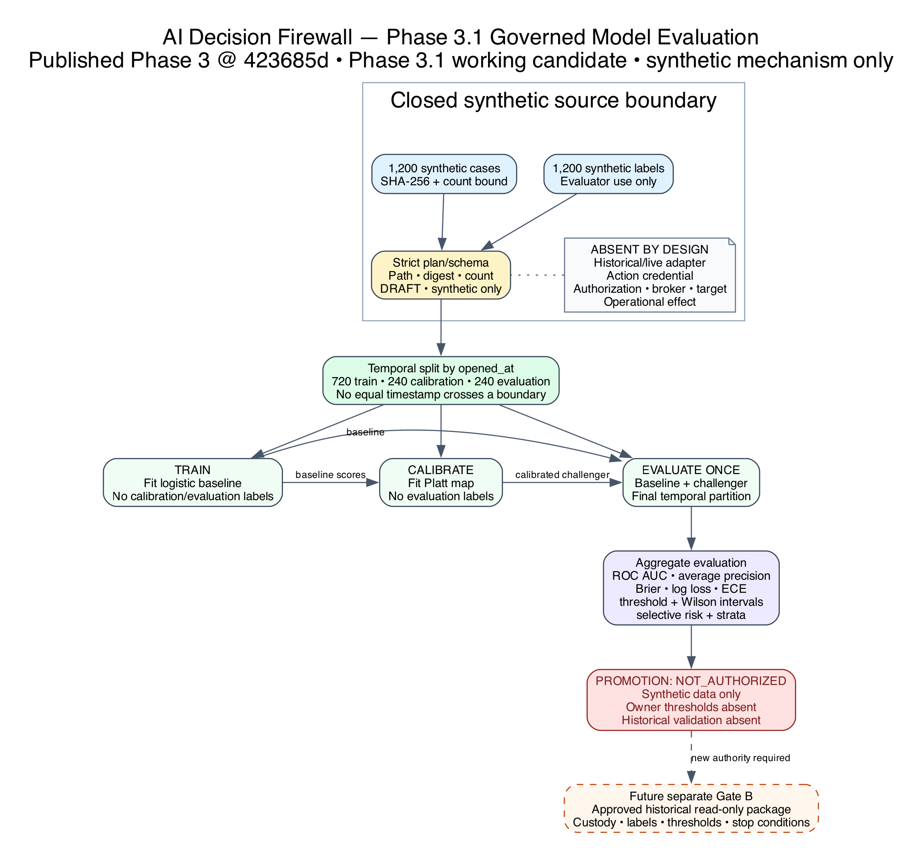
Figure 2. Phase 3.1 synthetic-only temporal model-evaluation and authority boundary.
The working Phase 3.1 package trains only on the earliest temporal partition, fits the calibration challenger only on the middle partition, and evaluates both candidates once on the final partition. The same project-controlled evaluator holds all synthetic labels; this is logical role separation, not independent custody. Current results are mechanism observations only and cannot support superiority, promotion, operational calibration, or historical-data claims.

Forward plan and gates
1. Freeze Phase 3.1 separately. Reconcile the exact synthetic mechanism,
tests, traceability, diagram and integrity manifest without changing the published Phase 3 boundary.
2. Publish deliberately. Publish a Phase 3.1 commit only under explicit
authorization and require exact-commit CI and Dependency Graph checks.
3. Keep promotion prohibited. Require owner-approved metrics, thresholds,
uncertainty rules, subgroup floors and rollback criteria before any model replacement can be proposed.
4. Keep data-bearing work separate. P2-CE-005, if pursued, retains its
two-commit protocol. Historical replay requires an authenticated restricted Gate B package. Neither is implied by Phase 3 simulation success.
5. Require a new architecture before integration. A read-only service or
controlled non-production action phase requires enterprise identity and source trust, process isolation, managed keys, durable distributed idempotency, vendor-specific broker/readback, rollback/reconciliation, external audit custody, change/incident authority, and authorizing-official acceptance.
See the Phase 3 index, architecture, security and safety case, T&E plan, and requirements traceability.

