電通二乙微處理器實驗 實驗結報

實驗名稱 | LED Blink
組別 | 16 | 組員 | 鄭宏毅

- 實驗目的
使用Tinkercad模擬Arduino UNO 電路及程式
繪製電路圖
觀察Arduino UNO之輸出
- 實驗步驟
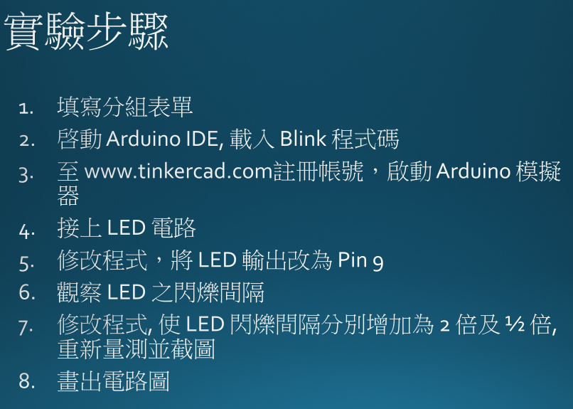
- 程式碼

byte led=9;
void setup()
{
// initialize digital pin LED_BUILTIN as an output.
pinMode(led, OUTPUT);
}

// the loop function runs over and over again forever
void loop()
{
digitalWrite(led, HIGH); // turn the LED on (HIGH is the voltage level)
delay(500); // wait for a second
digitalWrite(led, LOW); // turn the LED off by making the voltage LOW
delay(500); // wait for a second
}

- 實驗結果及分析
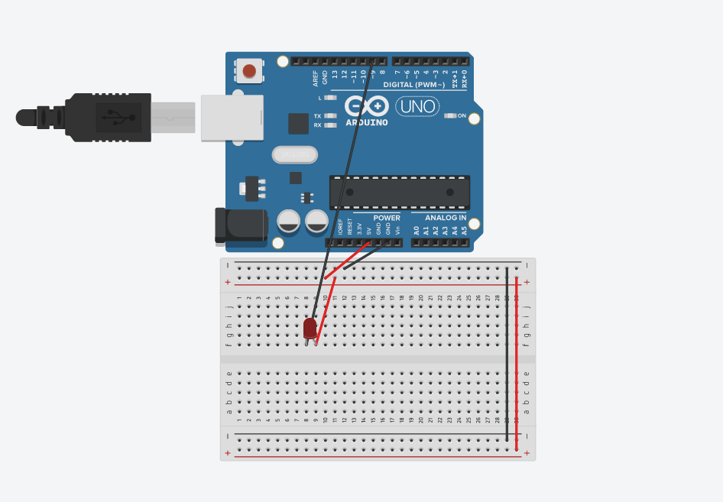
- 心得討論

第一次嘗試新東西新程式，感覺很新奇且很有挑戰性，希望在未來的課程，都能將所學的牢記且會運用，變成自己的工具。
- 修正電路圖
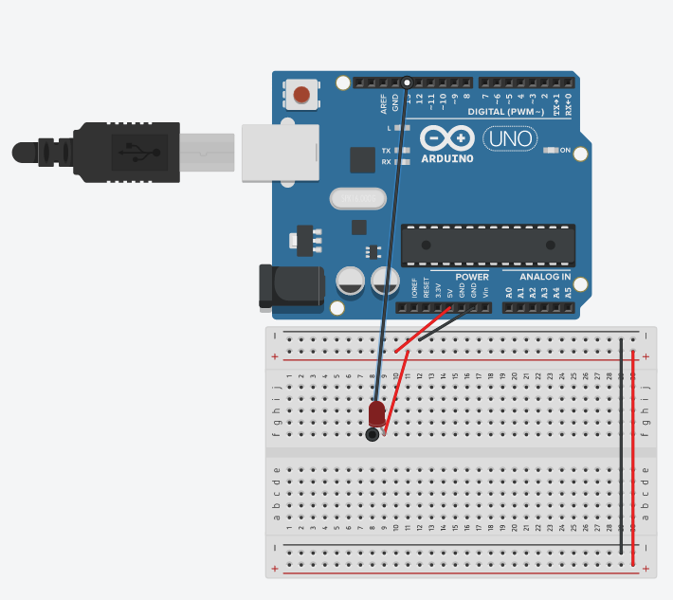
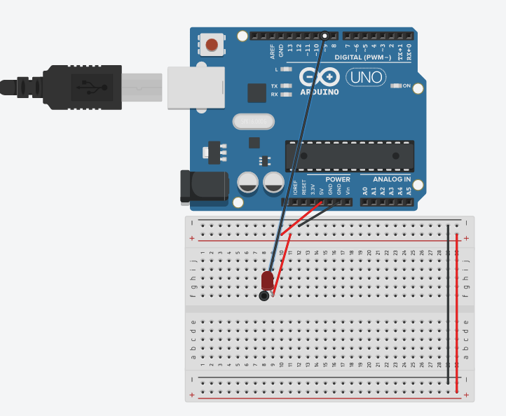
- 修正程式碼
// the setup function runs once when you press reset or power the board
void setup()
{
// initialize digital pin LED_BUILTIN as an output.
pinMode(LED_BUILTIN, OUTPUT);
}

// the loop function runs over and over again forever
void loop()
{
digitalWrite(LED_BUILTIN, HIGH); // turn the LED on (HIGH is the voltage level)
delay(1000); // wait for a second
digitalWrite(LED_BUILTIN, LOW); // turn the LED off by making the voltage LOW
delay(1000); // wait for a second
}

修改後
byte led=9;
void setup()
{
// initialize digital pin LED_BUILTIN as an output.
pinMode(led, OUTPUT);
}

// the loop function runs over and over again forever
void loop()
{
digitalWrite(led, HIGH); // turn the LED on (HIGH is the voltage level)
delay(500); // wait for a second
digitalWrite(led, LOW); // turn the LED off by making the voltage LOW
delay(500); // wait for a second
}

