電通二乙微處理器實驗 實驗結報

實驗名稱
組別 | 16 | 組員

- 實驗目的

- 實驗步驟

- 程式碼
1.
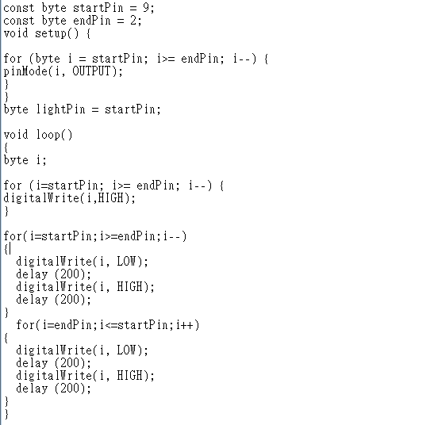

2.
const byte total =8;
const byte LED[] = {8,7,6,5,4,3,2,1};
int i;
void setup()
{
for (i=0;i<total;i++)
{
pinMode(LED[i],OUTPUT);
}
}

void loop()
{
for (i=0;i<total;i++)
{
digitalWrite(LED[i], LOW);
}
delay(250);
for (i=0;i<total;i++)
{
digitalWrite(LED[i], HIGH);
}
delay(250);
for (i=0;i<total;i++)
{
digitalWrite(LED[i], LOW);
}
delay(250);
for (i=0;i<total;i++)
{
digitalWrite(LED[i], HIGH);
}
delay(250);
for (i=total;i>=0;i--)
{
digitalWrite(LED[i],LOW);
delay(250);
digitalWrite(LED[i], HIGH);
delay(250);
}
for (i=0;i<total;i++)
{
digitalWrite(LED[i], LOW);
}
delay(250);
for (i=0;i<total;i++)
{
digitalWrite(LED[i], HIGH);
}
delay(250);
for (i=0;i<total;i++)
{
digitalWrite(LED[i], LOW);
}
delay(250);
for (i=0;i<total;i++)
{
digitalWrite(LED[i], HIGH);
}
delay(250);

for (i=0;i<total;i++)
{
digitalWrite(LED[i], LOW);
delay(250);
digitalWrite(LED[i], HIGH);
delay(250);
}
}
- 實驗結果及分析
1.
LED 向左及向右執行花色展示
2.
LED 自訂花色展示 所有LED亮滅兩次 -> 左移八次 -> 所有LED亮滅兩次 -> 右移八次

- 心得討論

這學期的實驗並非那麼簡單，需要多加練習，釐清觀念，才能得心應手，確實的完成每次實驗。
- 修正電路圖
1.
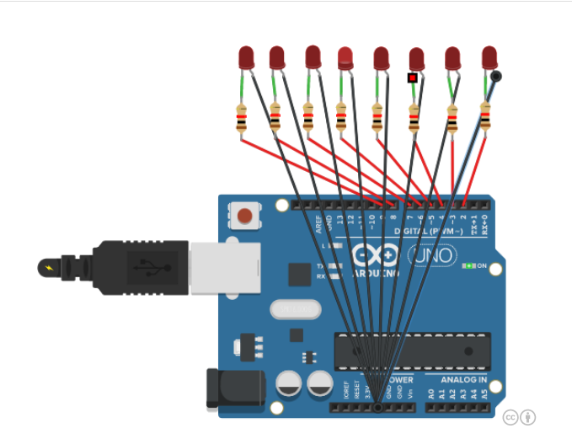
2.
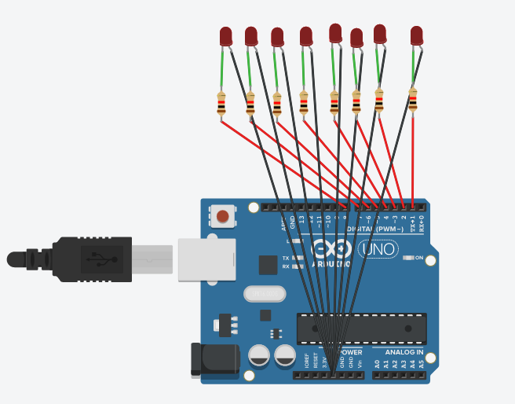
- 修正程式碼
1.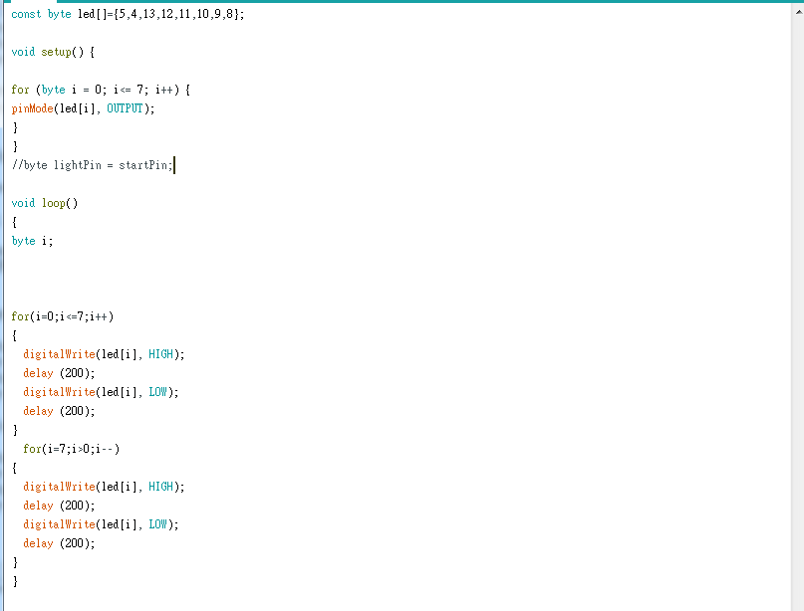

2. 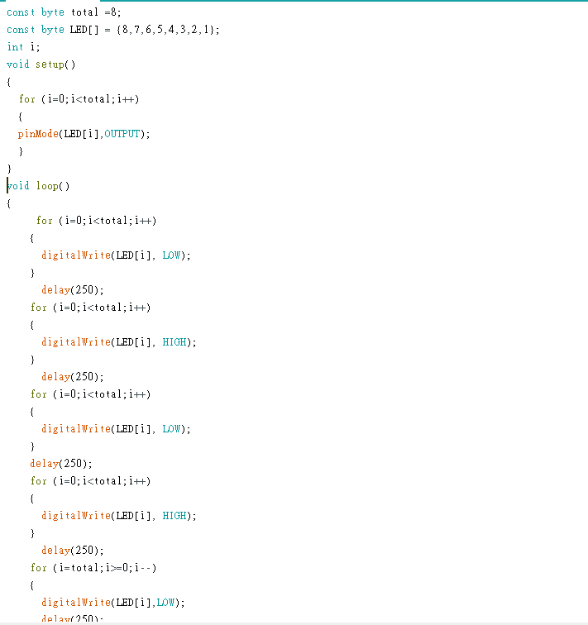
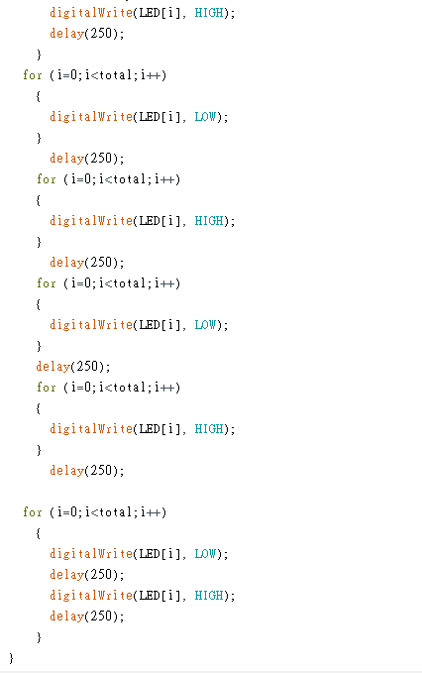
3.
const byte startPin = 8;
const byte endPin = 15;
void setup()
{
for (byte i = startPin; i<= endPin; i++)
{
pinMode(i, OUTPUT);
pinMode(6,INPUT);
}
}
void loop()
{
byte i;

boolean val = digitalRead(6);
if(val)
{

for (i=startPin; i<= endPin; i++)
{
digitalWrite(i, LOW);
}
delay(1000);
for (i=startPin; i<= endPin; i++)
{
digitalWrite(i, HIGH);
}
delay(1000);
for (i=startPin; i<= endPin; i++)
{
digitalWrite(i, LOW);
}
delay(1000);
for (i=startPin; i<= endPin; i++)
{
digitalWrite(i, HIGH);
}
delay(1000);
//亮滅兩次
for (i=startPin; i<= endPin; i++)
{
digitalWrite(i, LOW);
delay (200);
digitalWrite(i,HIGH);
delay (200);
}//右到左

for (i=startPin; i<= endPin; i++)
{
digitalWrite(i, LOW);
}
delay(1000);
for (i=startPin; i<= endPin; i++)
{
digitalWrite(i, HIGH);
}
delay(1000);
for (i=startPin; i<= endPin; i++)
{
digitalWrite(i, LOW);
}
delay(1000);
for (i=startPin; i<= endPin; i++)
{
digitalWrite(i, HIGH);
}
delay(1000);
for (i=endPin; i>= startPin; i--)
{
digitalWrite(i, LOW);
delay (100);
digitalWrite(i, HIGH);
delay (100);
}//左到右
}
else
{
for (i=endPin; i>= startPin; i--)
{
digitalWrite(i, LOW);
delay (100);
digitalWrite(i, HIGH);
delay (100);
}//左到右
for (i=startPin; i<= endPin; i++)
{
digitalWrite(i, LOW);
delay (100);
digitalWrite(i,HIGH);
delay (100);
}//右到左
}
}

