電通二乙微處理器實驗 實驗結報

實驗名稱 | MCS
組別 | 16 | 組員 | 鄭宏毅

- 實驗目的
控制LED並檢視狀態
- 實驗步驟
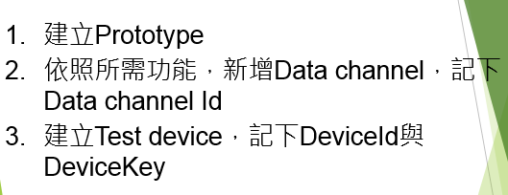
- 程式碼
1
#include <LWiFi.h>
#include "MCS.h"
char _lwifi_ssid[] = "Redyee";
char _lwifi_pass[] = "0963496434";
MCSDevice mcs("DvBKR3rU", "w2cF8W6WjAxBSD2d");
MCSControllerOnOff led("05050705");
MCSDisplayOnOff remote("LED");
void setup()
{
Serial.begin(9600);
Serial.println("Connect to Wifi");
while (WiFi.begin(_lwifi_ssid, _lwifi_pass) != WL_CONNECTED) {
Serial.println("Wifi Reconnecting..");
delay(1000);
}
Serial.println("Connect to MCS...");
while (!mcs.connected()) {
Serial.println("MCS Reconnecting..");
mcs.connect();
}
Serial.println("MCS Connected!");
mcs.addChannel(led);
pinMode(7, OUTPUT);
mcs.addChannel(led);
mcs.addChannel(remote);
while(!mcs.connected())
{
Serial.println("MCS.connect()...");
mcs.connect();
}
}
void loop()
{
while(!led.valid())
{
Serial.println("read LED value from MCS...");
led.value(); //取得MCS數值
}
Serial.print("done, LED value = ");
Serial.println(led.value());
digitalWrite(7, led.value() ? HIGH : LOW);
while (!mcs.connected()) {
mcs.connect();
if (mcs.connected()) {
Serial.println("MCS Reconnect");
}
}
mcs.process(1000);
if (led.value() == 1) {
digitalWrite(7, HIGH);
} else {
digitalWrite(7, LOW);
}
if(!remote.set(led.value()))
{
Serial.print("Failed to update remote");
Serial.println(remote.value());
}
delay(200);
}
2
#include <LWiFi.h>
#include "MCS.h"

char _lwifi_ssid[] = "Redyee";
char _lwifi_pass[] = "0963496434";
MCSDevice mcs("D2yoAoCU", "Y37rMX8XsGFFlqc1");

MCSDisplayInteger Temp("Temp");

void setup()
{
Serial.begin(9600);

Serial.println("Connect to Wifi");
while (WiFi.begin(_lwifi_ssid, _lwifi_pass) != WL_CONNECTED) {
Serial.println("Wifi Reconnecting..");
delay(1000);
}

Serial.println("Connect to MCS...");
while (!mcs.connected()) {
Serial.println("MCS Reconnecting..");
mcs.connect();
}
Serial.println("MCS Connected!");

mcs.addChannel(Temp);

}

void loop()
{
while (!mcs.connected()) {
mcs.connect();
if (mcs.connected()) {
Serial.println("MCS Reconnect");
}
}
mcs.process(1000);

int sensor = analogRead(A0);

Temp.set(sensor);
Serial.println("Add sensor value.");
delay(200);
}
- 實驗結果及分析
2
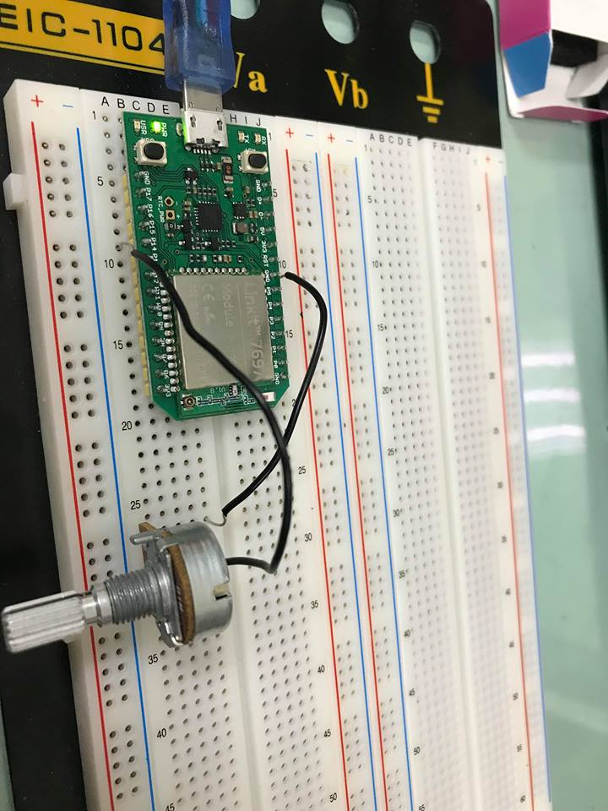
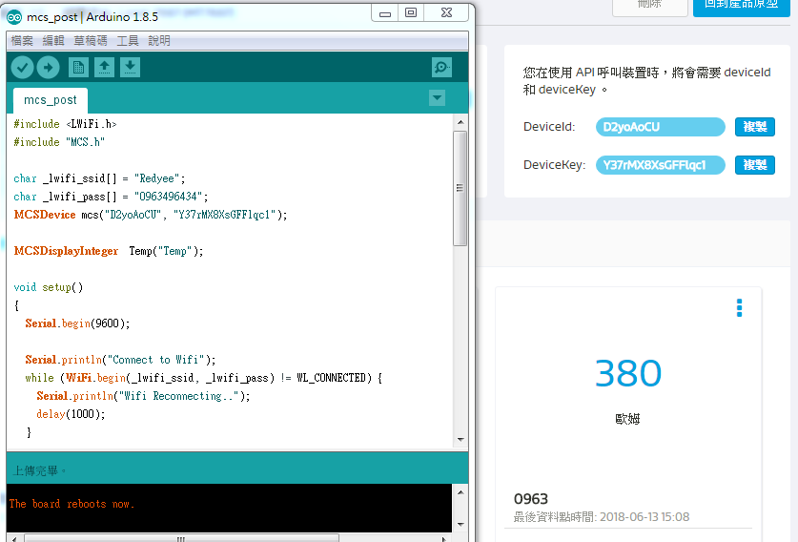
- 心得討論
這次實驗比較有趣，而且也做得很順利，希望期末考能有好表現。

