程式碼

num_bit = 10;

bit = rand(1, num_bit);

bit_4out5in = round(bit) #四捨五入

plot(bit_4out5in)

wave_bit = bit_4out5in'*ones(1, 100) #轉至完，生成每列100個相同數字

wave_bit_wave = reshape(wave_bit', 1, 1000) ; #10*100轉至完，改成一列1000個數字

%wave_bit_wave = reshape(wave_bit', 1, 1000) + rand(1,1000,2); #10*100轉至完，改成一列1000個數字，加雜訊

t = 10^-3:10^-3:1; #開始：間隔：結尾

figure(2);

plot(t, wave_bit_wave); #發射端

ylim([-0.5 2.5]);

inv_bit = abs(wave_bit_wave-1);

%%%%%%%%%

%carriers

f1 = 10; f2 = 5;

cal1 = cos(2*pi*f1*t);

cal2 = cos(2*pi*f2*t);

figure(3);

subplot(2,1,1);

plot(t, cal1);

subplot(2,1,2);

plot(t, cal2);

%%%%%%%%%

%fsk_wave

fsk_wave = cal1.*wave_bit_wave + cal2.*inv_bit

figure(4);

subplot(2,1,1);

plot(t, wave_bit_wave);

ylim([-0.5 1.5]);

subplot(2,1,2);

plot(t, fsk_wave);

%%%%%%%%%%%%%%%%%%

%demondulation FSK

ca1_rx = cos(2*pi*f1*1.022444*t);

ca2_rx = cos(2*pi*f2*1.022444*t);

rxf1 = fsk_wave.*ca1_rx;

rxf2 = fsk_wave.*ca2_rx;

figure(5);

subplot(2,1,1);

plot(t, rxf1);

subplot(2,1,2);

plot(t, rxf2);

rx_2nd = rxf1 - rxf2;

figure(6);

subplot(2,1,1);

plot(t, wave_bit_wave);

ylim([-0.5 1.5]);

subplot(2,1,2);

plot(t, rx_2nd);

%%%%%%%%%%%%%%%%%%%%%%%%%%%%%%%%%

total_arr_rxf1 = 1:10;

value_onehundred = 0;

j = 1;

for i = 1:1000

if(rem(i, 100) != 0)

value_onehundred = value_onehundred + rxf1(i);

else

total_arr_rxf1(j) = value_onehundred + rxf1(i);

value_onehundred = 0;

j = j+1;

end

end

total_arr_rxf2 = 1:10;

value_onehundredd = 0;

j = 1;

for i = 1:10

rxf1_int(i) = sum(rxf1((i-1)*100+1:i*100),2);

rxf2_int(i) = sum(rxf2((i-1)*100+1:i*100),2);

end

figure(7);

subplot(2,1,1);

plot(rxf1_int);

subplot(2,1,2);

plot(rxf2_int);

figure(8);

subplot(2,1,1);

plot(rx_bit);

ylim([-0.5 1.5]);

subplot(2,1,2);

plot(rx_bit_wave); #接受端，圖2會和圖8一樣

ylim([-0.5 1.5]);

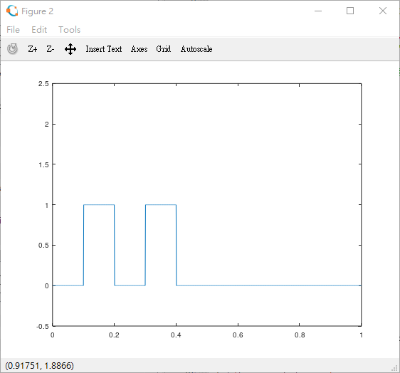

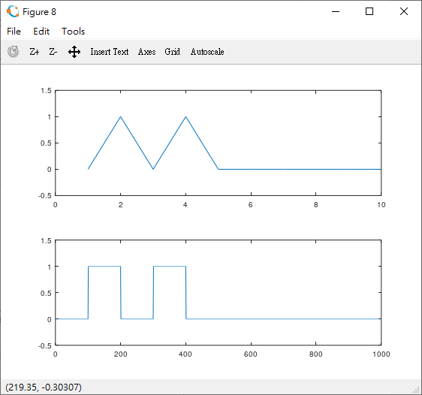

接收端與發射端(下面圖)相同。

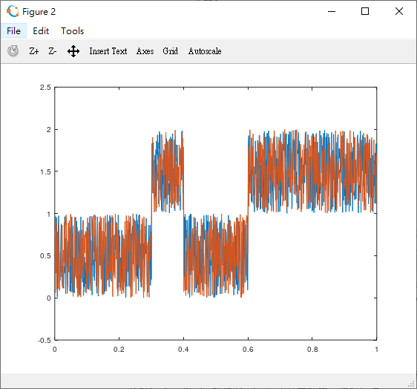

接收端加入雜訊。

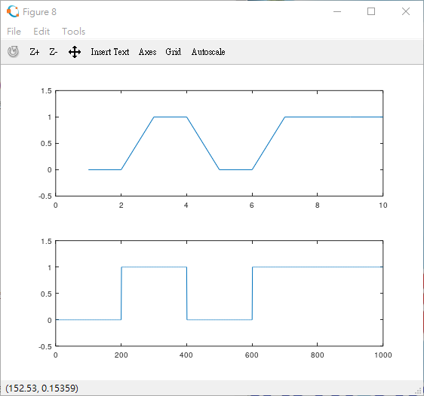

接收端與發射端(下面圖)同位元。

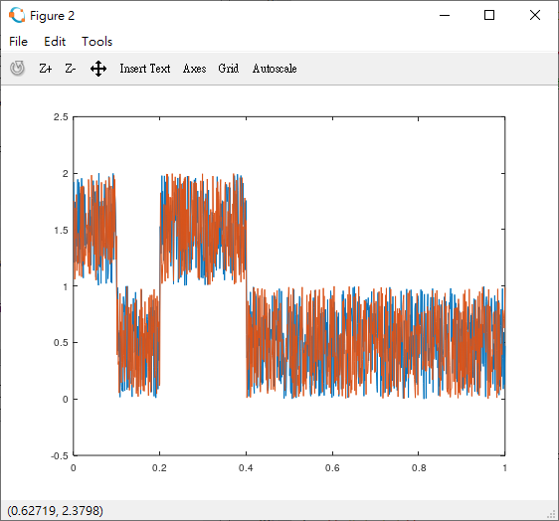

接收端加入雜訊。

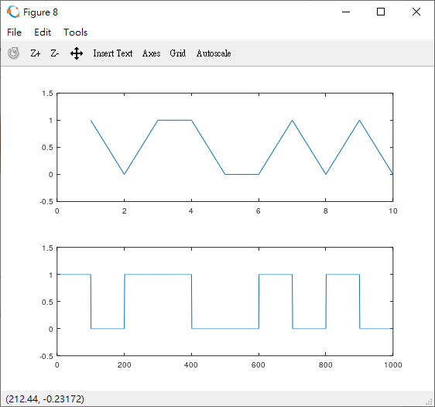

接收端與發射端(下面圖)非同位元。

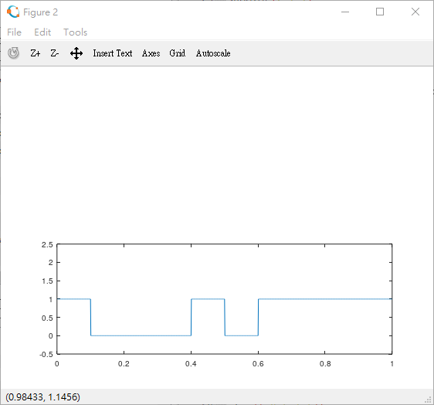

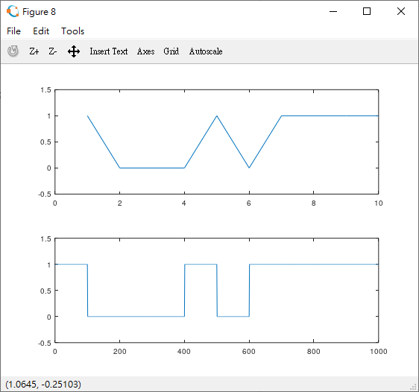

ca1_rx = cos(2*pi*f1*1.022444*t);

ca2_rx = cos(2*pi*f2*1.022444*t);

rxf1 = fsk_wave.*ca1_rx;

rxf2 = fsk_wave.*ca2_rx;

偏移量0.2244…..4都還能夠承受

發射端跟接收端一樣