Did it Make the News?

# Overview

Millions of people visit news websites daily. Someone who works in the financial markets might be interested in a search engine that operates on financial new source data. And that is the type of data you’re going to use in this project. For your final project in CS 2341, you’re going to build a search engine for a large collection of financial news articles from Jan - May 2018. The dataset contains more than 300,000 articles.

You can download the dataset from Kaggle at <https://www.kaggle.com/jeet2016/us-financial-news-articles> . You will need to make a Kaggle account to download it. Note that the download is around 1.3 GB and the uncompressed dataset is around 2.5 GB.

# Search Engine Architecture

Search engines are designed to allow users to quickly locate the information they want. Building a custom search engine requires input of the documents that the user will eventually want to search. This is called the **corpus**. Then, once indexed, users can begin entering search queries. The search engine will take a query, find the documents that satisfy the request, and order them by some measure of relevancy.

Figure 1 provides a general overview of a search engine system architecture. The main parts are the document parser which extracts keywords to be indexed by the index handler, and the query engine which uses the index to answer user queries. The “**document**” for this project is one news article with its associated metadata such as publication venue, date, author, associated entities and the full text of the article.

The files containing the news articles are in JSON format. JSON is a “lightweight data interchange format” (<https://www.json.org/json-en.html>) that is easily understood by both humans and machines. There are a number of open source JSON parsing libraries available. The “officially supported parser” for this project is **RapidJSON** (<https://rapidjson.org/>). The code is already included with an example in your project template.

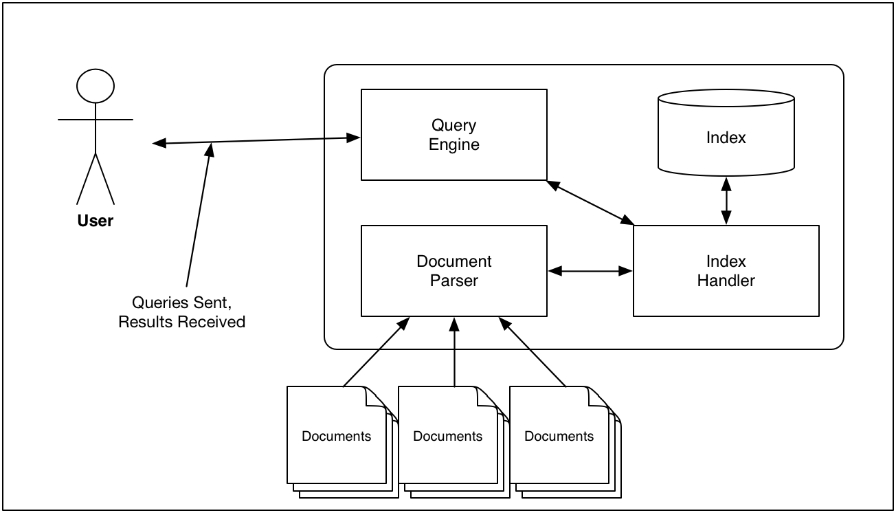 Figure 1 – Sample Search Engine System Architecture

## An Explanation of the Parts of a Search Engine

The **index handler**, the workhorse of the search engine, is responsible for reading and writing to the index. An index is an **inverted file index** which stores references from each index term to the corresponding document(s) in which those terms exist. The index may also store additional information like term frequencies. It also searches the inverted file index based on a request from the query processor.

You will create three indices:

1. Create and maintain the main index for terms (words) in the documents.
2. Create and maintain an additional index for **ORGANIZATION** entities
3. Create and maintain an additional index an index of **PERSON** entities.

The **document parser** is responsible for the following tasks:

* Processing each news article in the corpus. The dataset contains one news article per file. Each document is in JSON format. Processing of an article involves the following steps:
  + Removing stopwords from the articles. Stopwords are common words that appear in text but that provide little useful information with respect to the value of a document relative to a query because of the commonality of the words. Example stop words include “a”, “the”, and “if”. One possible list of stop words to use for this project can be found at <http://www.webconfs.com/stop-words.php> . You may use other stop word lists you find online.
  + Stemming words. Stemming (<https://en.wikipedia.org/wiki/Stemming>) refers to removing certain grammatical modifications to words. For instance, the stemmed version of “running” may be “run”. For this project, you may make use of any previously implemented stemming algorithm that you can find online.
    - One such algorithm is the Porter Stemming algorithm. More information as well as implementations can be found at <http://tartarus.org/~martin/PorterStemmer/> .
    - Another option is <http://www.oleandersolutions.com/stemming/stemming.html>.
    - C ++ implementation of Porter 2: <https://bitbucket.org/smassung/porter2_stemmer/src> .
* Computing/maintaining information for relevancy ranking. You’ll have to design and implement some algorithm to determine how to rank the results that will be returned from the execution of a query. You can make use of metadata provided, important words in the articles (look up term-frequency/inverse document frequency metric), and/or a combination of several metrics.

The **query processor** is responsible for:

*Parsing queries entered by the user of the search engine.* For this project, you will start with a simple interface like google’s search interface where all entered terms need to be in the result. This is equivalent to a logical AND. Terms that are preceded by a `-` cannot be in the document.

Additional Operators: A query can contain zero or more of the following:

* ORG:<some organization name> - the org operator will search a special index you maintain related to organizations mentioned in the entity metadata
* PERSON:<some person name> - the person operator will search a special index you maintain related to persons mentioned in the article’s entity metadata.
* Additional Operator Notes:
  + the order of ORG or PERSON doesn’t matter (meaning, you should accept queries that have them in either order)
  + the operators will always be entered in all caps.
  + you may assume that neither ORG nor PERSON will be search terms themselves.

Here are some examples:

* + **markets**
    - This query should return all articles that contain the word *markets*.
  + **social network**
    - This query should return all articles that contain the words “social” and “network” (doesn’t have to be as a 2-word phrase)
  + **social network PERSON:cramer**
    - This query should return all articles that contain the words social and network and that mention cramer as a person entity.
  + **social network ORG:facebook PERSON:cramer**
    - This query should return all articles that contain the words social and network, that have an entity organization of facebook and that mention cramer as a person entity.
  + **facebook meta -profits**
    - This query should return all articles that contain facebook and meta but that do not contain the word profits.

A better query processor could be implemented using a parse tree, but that would require a lot more time.

*Ranking the Results.* **Relevancy ranking** refers to organizing the results of a query so that “more relevant” documents are higher in the result set than less relevant documents. The difficulty here is determining what the concept of “more relevant” means. One way of calculating relevancy is by using a basic **term frequency – inverse document frequency** (tf/idf) statistic. tf/idf is used to determine how important a particular word is to a document from the corpus. If a word appears frequently in document dt but infrequently in other documents, then document dt would be ranked higher than another document ds in which a query term appears frequently, but it also appears frequently in other documents as well. There is quite a bit of other information that you can use to do relevancy ranking as well such as date of publication of the article, etc.

## The Index

The **inverted file index** (see <http://en.wikipedia.org/wiki/Inverted_index>) is a data structure that relates each unique term from the corpus to the document(s) in which it appears. It allows for efficient execution of a query to quickly determine in which documents a particular query term appears. For instance, let's assume we have the following documents with ascribed contents:

* doc d1 = Computer network security
* doc d2 = network cryptography
* doc d3 = database security

The inverted file index for these documents would contain, at a very minimum, the following:

* computer = d1
* network = d1, d2
* security = d1, d3
* cryptography = d2
* database = d3

The query “computer security” would find the ***intersection*** of the documents that contained *computer* and the documents that contained *security*.

* set of documents containing computer = d1
* set of documents containing security = d1, d3
* the intersection of the set of documents containing computer AND security = d1

In addition, you probably need to efficiently match document IDs like d1 to actual file names.

### Inverted File Index Implementation Details

The heart of this project is the **inverted file index**. The goal is to efficiently find terms in the indices.

* To index the text of the articles, you will create an inverted index with an AVL tree. Each node of the tree would represent a word being indexed and would provide information about all the articles that contain said word using an appropriate data structure.
* To index organizations and persons, you will use separate instances of an AVL tree.
* Your implementation of AVL Tree will be a version that has a key (the term) and values (the documents) and will operate like a map (see <https://en.cppreference.com/w/cpp/container/map>). Note that your values can be a list of documents.

In other words, you’ll have 3 AVL Trees: one for the main index of words, one for organizations, and lastly, one for persons.

### Persistence

Often, we need to keep the information stored in data structures between two runs of a program. You need to implement a way to store each AVL Tree as a file and read it back into memory again. This is called persistence since the data structure persists over multiple runs of the program. Typical solutions include Google protocol buffers <https://developers.google.com/protocol-buffers/docs/cpptutorial> and similar libraries. Converting objects or data structures into a sequence of bytes that can be stores or transmitted is called serialization (<https://en.wikipedia.org/wiki/Serialization>). Popular formats include XML, JSON, YAML, etc.

For this exercise you have to **implement your own persistence mechanism**. You need to write a member function that saves the information in your AVL tree into a text file and then a second function (a constructor) that reads the text file and recreates the AVL tree in memory. You will need to think about an appropriate structure for this file so it is easy to create, read and convert back into a tree. A simple approach would be to create a text file and write each tree node as a line with different information separated by semicolons (this is similar to CSV).

## User Interface

The user interface of the application should provide the following options:

* allows the user to create an index from a directory with documents.
* allows the user to write the index to a file (make it persistent) and read an index from a file.
* allow the user to enter a query (as described above).
  + You may assume the query is properly formatted.
  + The results should display the article’s identifying/important information including Article Title, publication, and date published. If the result set contains more than 15 results, display the 15 with the highest relevancy. If less than 15 are returned, display all of them ordered by relevance. If you’d like to show more, please paginate.
  + The user should be allowed to choose one of the articles from the result set above and have the complete text of the article printed.
  + **Helpful Hint: make sure that the query terms should have stop words removed and stemmed before querying the index.**
* Output basic statistics of the search engine including:
  + Timing for indexing and for queries (use std::chrono).
  + Total number of individual articles in the current index.
  + The total number of unique words indexed (total nodes in the word AVL Tree)
  + Any other interesting stats that you gather in the course of parsing.

# Mechanics of Implementation

Some things to note:

* This project may be done individually or in teams of two students.
  + Individually: Finish all work on your own.
  + Team of 2 students:
    - Each team member must contribute to both the design AND implementation of the project.
    - Each class in the design must have an “owner”. The owner is a group member that is principally responsible for its design, implementation and integration into the overall project.
  + This project must be implemented using an object-oriented design methodology.
* **You are free to use as much of the C++ standard library as you would like**. In fact, I encourage you to make generous use of it. You may use other libraries as well except for the caveat below.
  + You **must** implement your own version of an AVL tree and persistence mechanism. You may, of course, refer to other implementations for guidance, but you MAY NOT incorporate the total implementation from another source.
* You should research and use the RapidJSON parser. See <https://rapidjson.org/> for more info. The other alternative is to create your own parser from scratch (which isn’t as bad as it sounds).
  + RapidJson Tutorial made by TA Christian: <https://github.com/Gouldilocks/rapidTutorial>
* All of your code must be properly documented and formatted.
* Each class should be separated into interface and implementation (.h and .cpp) files unless templated.
* Each file should have appropriate header comments to include the owner of the class and a history of updates/modifications to the class.

# Thoughts and Suggestions

* If you wait even a day or two to start this project, you will likely not finish.
* Create a design early. Structuring the problem and your code is key.
* A significant portion of your grade will come from your demonstration of the project. Be ready for this.
* Take an hour to read about the various parts of the C++ STL, particularly the container classes. They can help you immensely in the project.
* As mentioned previously, beware of code that you find on the Internet. It isn't always as good as it seems. **Make sure that any code you use in the project is cited/referenced in the header comments of the project.**
* Take time to open a few of the articles in a text editor and examine them. Data is rarely beautiful and nicely formatted. However, this stuff is pretty good.