Wireless Integrated Microsystems Engineering (WIMS)

WIMS for Teens
Women in Engineering
Summer 2008


Prepared by
Nathan Usher
Andy Ball
Alex Stewart
Andrew Temme

Copyright © 2008. Property of Michigan State University, College of Engineering, Recruitment and K-12 Outreach
Table of Contents
Lab Documents 1
Circuit Lab 1
Microcontroller Programming Lab 1 7
Microcontroller Programming Lab 2 13
Microcontroller Programming Lab 3 15
Microcontroller Programming Lab 4 19
Microcontroller Programming Lab 5 23
Final Projects 27
Alarm System 27
Drag Strip Timing System 28
Music Box / Karaoke Machine 31
Notes 34
Common Pre-processor Directives 34
Common Microcontroller Functions 35
How to Read Resistor Color Codes 36
Useful Resistor Circuits and Equations 37
Abbreviated Pin Layout for the PIC16F876 Microcontroller 38

Table of Figures
Figure 1- Bread board connections 1
Figure 2 - Texas Instruments UA7805 (5-volt voltage regulator) 2
Figure 3 - 0.33 microfarad,0 .10 microfarad, and 15 Pico farad capacitors 3
Figure 4 - Microchip PIC16F876 and PIC16C76 reprogrammable microcontrollers. 4
Figure 5 - Wiring diagram for this lab 4
Figure 6 - Circuit element symbols used in wiring diagrams 4
Figure 7 - Resistors 5
Figure 8 - 20 MHz crystal oscillator 5
Figure 9 - LED sub-circuit diagram 12
Figure 10 - LED polarity diagram 12
Figure 11 - Switch sub-circuit diagram 14
Figure 12 - RS232 waveforms when sending the string “PIC” 16
Figure 13- Crystalfontz 634 (20x4 character serial LCD 16
Figure 14 - National Semiconductor LM335A (precision temperature sensors) 20
Figure 15 - Temperature sensor connections 20
Figure 16 - Grayhill 96A Keypad 23
Figure 17 - Grayhill 96A Keypad Connection Diagram 24

List of Tables
Table 1- Keypad pinout 23
Table 2 - Table of notes and corresponding frequencies 33
Table 3 - Resistor Color Code 36
Table 4 - Useful Circuit Equations 37
Table 5 - PIC16F876 Pinout 38

Lab Documents

Circuit Lab

Objective
In this lab, you will learn how to build a circuit on a breadboard, and you will learn how to connect the devices you will be using in the following labs. Some of the devices you will be connecting are voltage regulators, capacitors, resistors, oscillators, microcontrollers, and light emitting diodes (LEDs). The circuit you build in this lab will be used in all of following labs; so do not remove any of the components used in this lab from the breadboard.

Procedure
You will start with an empty breadboard. The holes in the board are where you will be inserting wires to make your circuit. Each of the holes is connected with some of the other next to it with an internal wire. A diagram of the internal wire connections is shown in Figure 1. Parts of a circuit that are connected with wires are called a node. All parts of a node will always have the same voltage. You will notice that there are two rows of holes running along the long edges of the breadboard. These will be used for power and ground, so that you can use short wires to tap into power anywhere along the edge of the board, instead of using long wires to connect directly to the power source.

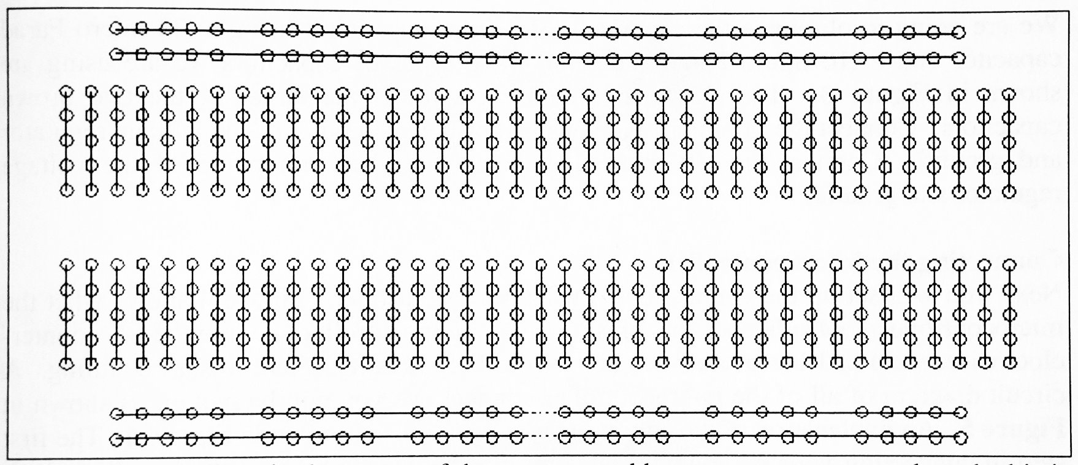
Figure 1- Bread board connections

Connecting a Voltage Regulator
You will be using a 5-volt voltage regulator in your circuit. A voltage regulator takes a higher voltage source (your voltage regulator can accept 7 – 25 volts input) and converts it to a different voltage. 5 volts is the standard voltage used in most devices. Your regulator is the 3-pin device that has a big metal tab on it as shown in Figure 2. The regulator works by switching on and off rapidly to create an average of 5V. The tab is a heat sink, which helps dissipate the heat the regulator creates when it is running.
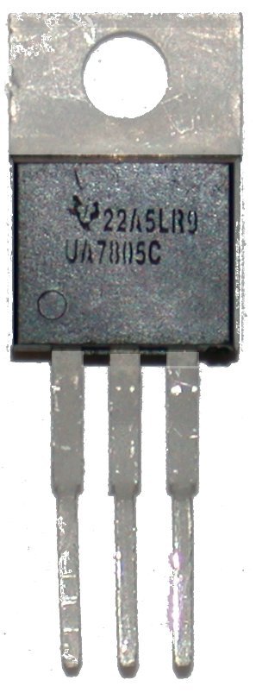
Figure 2 - Texas Instruments UA7805 (5-volt voltage regulator)

When putting your voltage regulator in your circuit, it is best to put it near one of the ends of the breadboard, this way you can leave more room between it and the other devices, so that you do not accidentally connect the high voltage source going into the regulator to one of the other devices. After you have chosen a good place to put the regulator, insert the regulator in the breadboard so that each of the pins is connected to a different node, i.e. each pin should be in a different row. Later, you will connect Pin 1 of the voltage regulator to your battery. (You can identify Pin 1 by the small dot that is above it.)

Using a wire, connect Pin 2 of the regulator to one of the long nodes that run along the edge of the breadboard. This is now the ground node, since Pin 2 is the regulator’s ground.

Connect Pin 3 to the other long node that runs along the same side of the breadboard. This is now the power node, since Pin 3 is the regulator’s 5-volt output. It does not matter which of the two rows is power and which is ground, but you should connect them in a way that you can remember which is which.

The last step is to use two wires to connect your power and ground nodes to the two nodes on the other side of the breadboard, so that you have power and ground nodes on both sides of the board.

Adding Capacitors to Decrease Electrical Noise
Capacitors are circuit elements that store a charge, similar to a battery; the difference is that capacitors can charge and discharge nearly instantaneously. Capacitors hold a charge that is proportional to the voltage to which they are connected, and they try to hold the voltage in a circuit constant. Because of this they are used to minimize electrical noise.

Electrical noise is when there are random variations in the voltage in a circuit. This interference can cause your microcontroller to have unpredictable behavior, especially if you are using the built-in analog to digital converter. The voltage regulator creates a lot of electrical noise, because it continuously switches the battery on and off to make the average voltage in the circuit 5 volts. You are going to eliminate the electrical noise from your circuit using a 0.33 micro Farad capacitor and a 0.10 micro Farad capacitor. The types of capacitors you will use are shown in Figure 3.
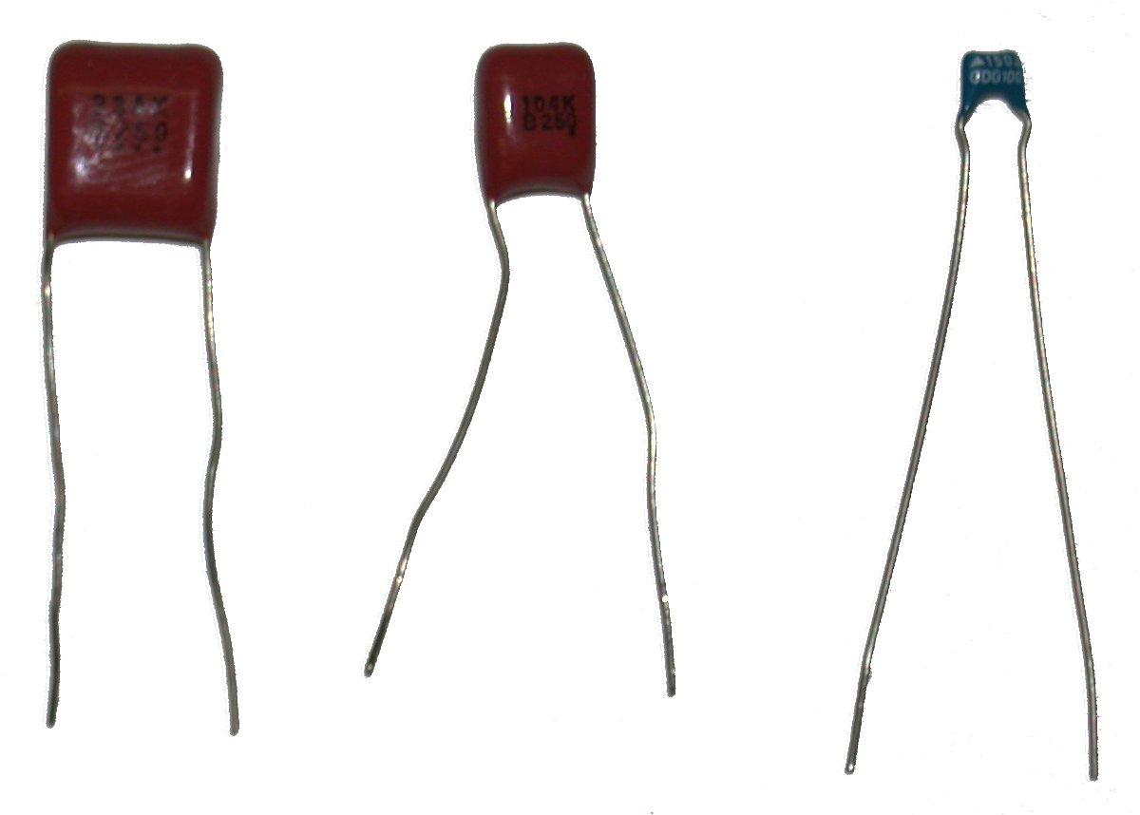
Figure 3 - 0.33 microfarad,0 .10 microfarad, and 15 Pico farad capacitors

The 0.33 micro Farad capacitor is the larger of the two brown capacitors. Although some capacitors have a positive pin and a negative pin, the ones you are using do not, so they can be connected in either direction. Connect the 0.33 micro Farad capacitor between pin 1 of the voltage regulator and ground. Connect the 0.10 micro Farad capacitor between pin 3 of the voltage regulator and ground.

Connecting the Microcontroller
Now, you will set up the connections for the microcontroller. Figure 4 shows what the microcontroller looks like. The pins on the microcontroller are numbered counter-clockwise, and Pin 1 has a small dot above it to help identify where to start counting. A circuit diagram of all of the microcontroller connections you will be making is shown in Figure 5. An explanation of common circuit symbols is shown in Figure 6.

The first step in connecting your microcontroller is to insert it somewhere on the breadboard. You should insert it in the middle of the board so that each pin is connected to a different node, i.e. it should span the middle gap of the board. Be sure to leave some extra space between the microcontroller and the voltage regulator, so that you do not accidentally touch the battery directly to any of the pins on the microcontroller. Also, since you will be removing the microcontroller to program it, it will be easier to get it out if it is farther away from the other circuit elements. When you have decided where to place your microcontroller, make sure none of the pins are bent, and insert it into the board. Push down until it snaps into place.

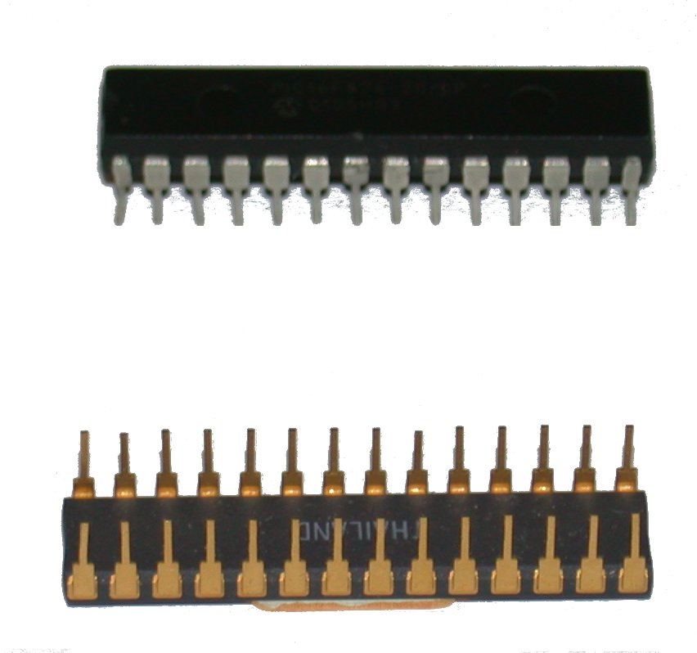
Figure 4 - Microchip PIC16F876 and PIC16C76 reprogrammable microcontrollers.
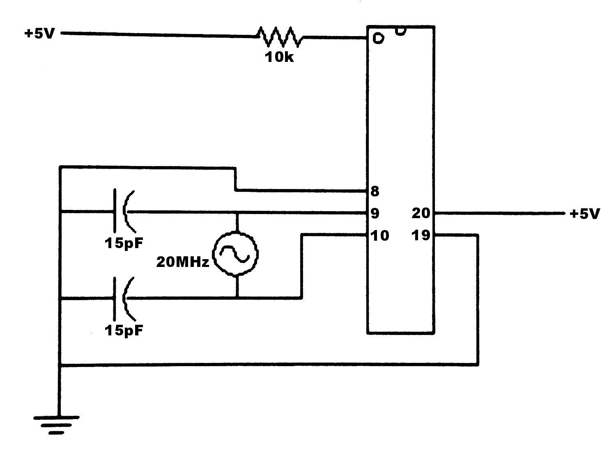
Figure 5 - Wiring diagram for this lab
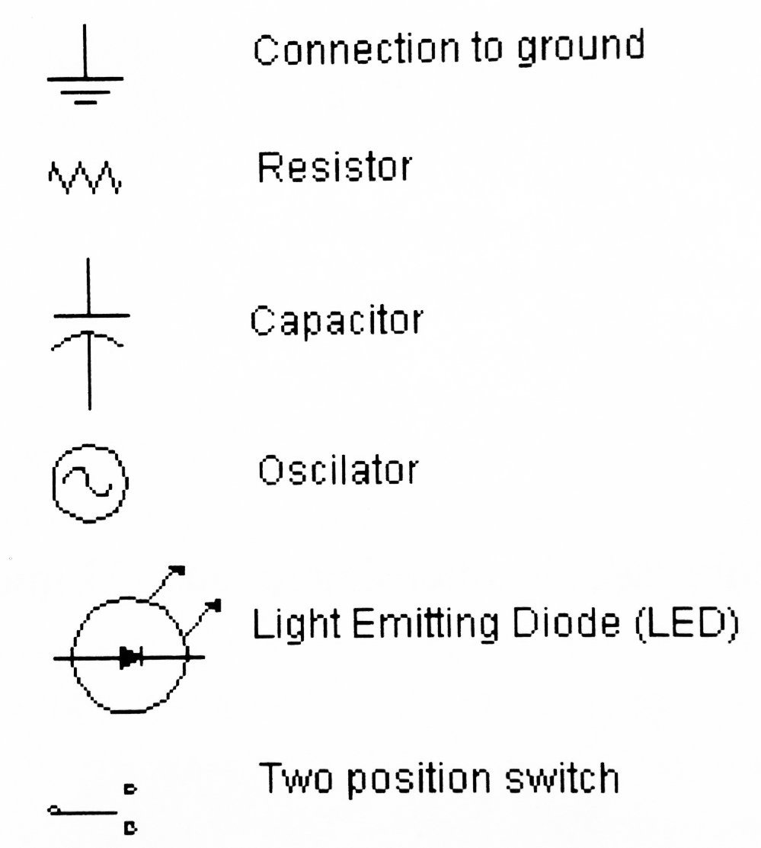
Figure 6 - Circuit element symbols used in wiring diagrams

Connecting Power and Ground to the Microcontroller
Now that the microcontroller is in place, you can start connecting its pins to the circuit. For now, you will only need to make connections to six of the pins. A complete diagram for all of the pins is included at the end of this document.

Start by connecting pins 8 and 19 to ground using your wires. It is best to use the shortest wire possible, so that there is less chance of wires getting in the way when adding on to the circuit.

Next, connect Pin 20 to power with a wire.

Pin 1 is the reset pin, which needs to be connected to power through a 10 kilo Ohm resistor (brown-black-orange). A picture of a resistor is shown in Figure 7. The resistor prevents too much current from entering this pin and damaging the microcontroller. Resistors are similar to the capacitor you connected earlier: they can be connected in either orientation, since they do not have a positive and negative pin. An explanation of resistor color codes is provided on page 36 so you can pick out the correct resistor.
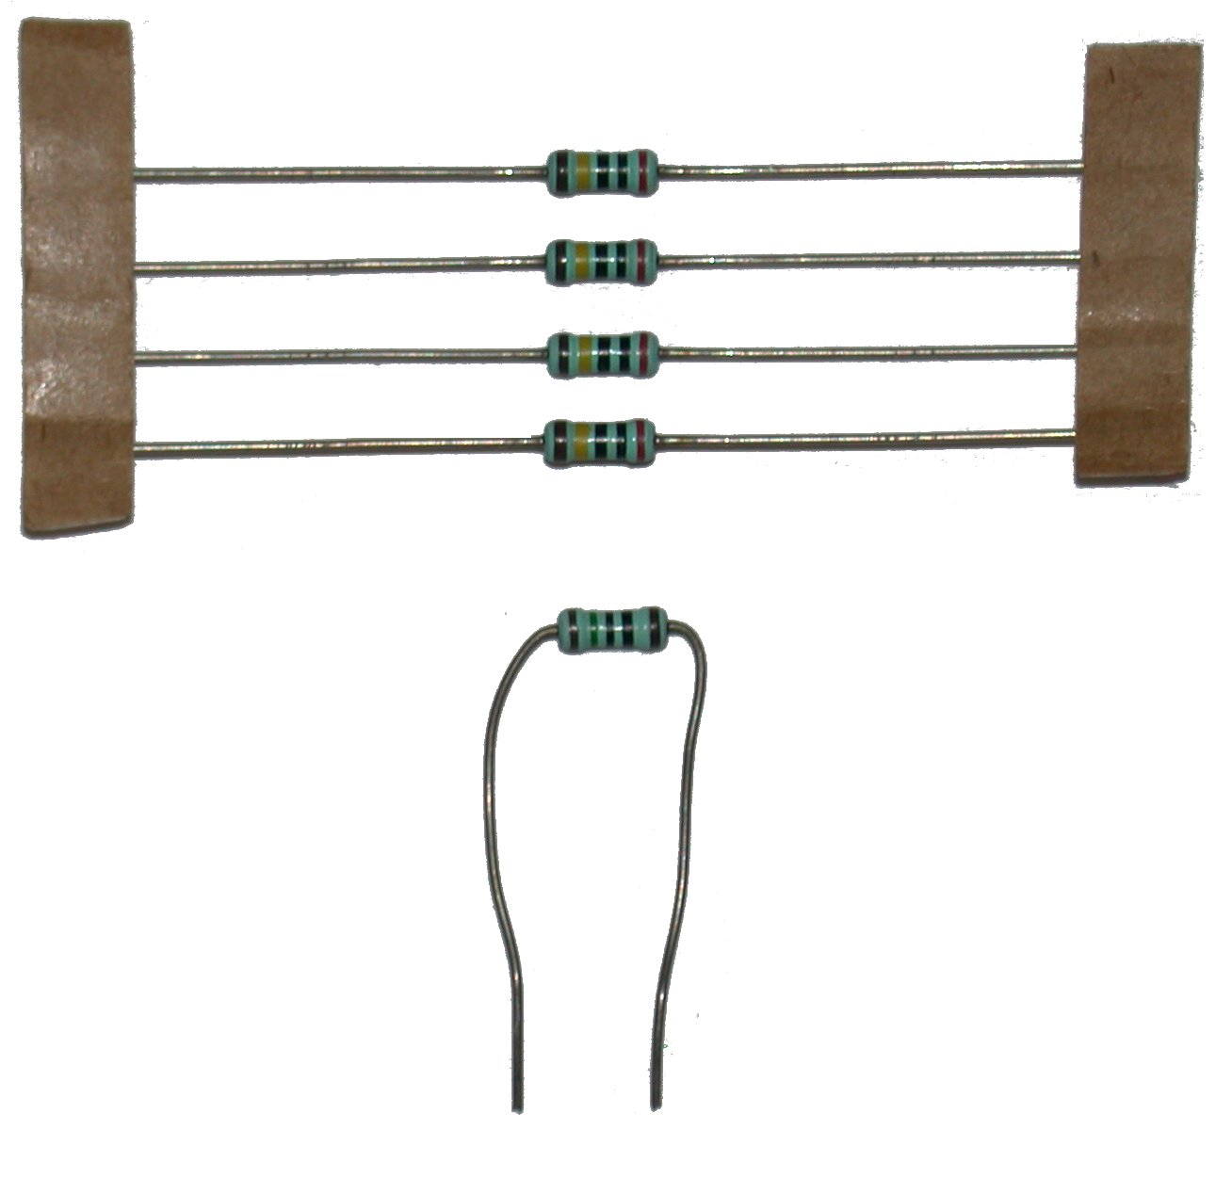
Figure 7 - Resistors

Connecting an Oscillator to the Microcontroller
The oscillator keeps all parts of the microcontroller synchronized with each other and sets how fast the microcontroller will run. You will be using a 2-pin 20 MHz crystal oscillator. A picture is shown in Figure 8.
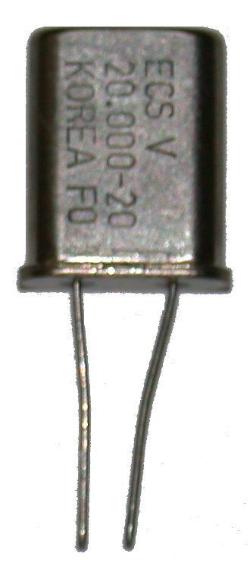
Figure 8 - 20 MHz crystal oscillator

With this kind of oscillator, you connect one of the pins to Pin 9 of the microcontroller and the other pin to Pin 10 of the microcontroller.

The final step is to connect two 15 pico Farad capacitors to the oscillator to ensure that it runs correctly. These capacitors are blue and are smaller than the ones you connected to the voltage regulator. You should connect one pin of the capacitor to ground and the other pin to a pin on the oscillator.

When you are done, have your instructor verify that your circuit is connected properly.

Microcontroller Programming Lab 1

Objective
In this lab, you will learn some basic skills of microcontroller programming. When you complete this lab, you should be able to write a program in C, compile it, and download it into your microcontroller. For this lab, your program will blink two LEDs whenever power is applied to the microcontroller. You will demonstrate your working program to the instructor.

Procedure
Making a New Program
Start by opening the PIC C Compiler. There is a shortcut for this program on your desktop. When the compiler opens, select File->New. This will open the Save As box. Make sure the folder is My Documents, and then type in lab1.c as the filename and click Save. You are now ready to start typing your program.

Pre-Processor Directives
Pre-processor directives are lines of code that tell the compiler what kind of microcontroller you are using and what kind of peripheral devices it is connected to. All pre-processor directives begin with a ‘#’. The ‘#’ is how the compiler tells the difference between a pre-processor directive and a normal line of code.

The first part of your code needs to tell the compiler what kind of microcontroller you are programming. Since you are using the PIC16F876, your first line needs to be:
#include <16F876.H>

Next, you need to tell the compiler which of the hardware options you want to enable. For this lab, your second line of code should be:
#fuses hs, nowdt, nolvp, brownout, put

The “hs” tells the compiler that you are using a high speed oscillator. Oscillators between 4 and 20 MHz are considered high speed. The “nowdt” turns off the watchdog timer. The watchdog timer can be used to reset the microcontroller if there is an error in the program, but for your programs it is best to disable it. The “nolvp” disables the low voltage program option. This changes which pins are used to program the microcontroller and allows you to use Pin B3 as an output pin. The “brownout” option enables brownout detection, which puts the microcontroller into sleep mode if the voltage in the circuit is too low to function properly. The “put” enables the power up timer, which makes the microcontroller wait for the voltage in its circuit to stabilize before it begins its program.

The last pre-processor directive that you need is the one that tells the compiler the speed of the oscillator you are using. Your oscillator is 20 MHz, so the third line of your program should be:
#use delay(clock = 20000000)

The “main” Function
In the C programming language, the “main” function is where the program starts, and { } are used to group lines of code together. For now, add the following lines underneath your pre-processor directives:
main( )
{

}

The “while” Loop
For this lab, your program will have to repeat the same block of code over and over. This is done by using a while loop. The syntax for your while loop is a lot like the syntax for your main function. The difference is that you have to put a true or false statement in the parentheses. If the statement is false, the microcontroller will skip the code in the { }. If the statement is true, the microcontroller will run the code in the { } then jump back up to the beginning of the “while” loop and start over. The statement is usually an equality or inequality like “x < 4” or “y == 3”, with the value of x or y changing each time through the loop, but since you want your code to repeat forever you can just put “True”. Now that you know how a “while” loop works, add one to your “main” function. Your code should now look like this:
#include <16F876.H>
#fuses hs, nowdt, nolvp, brownout, put
#use delay(clock = 20000000)

main( )
{
while ( True )
{

}
}

The “output_high” and “output_low” Functions
In this lab, you will use the “output_high” and “output_low” functions to turn your LEDs on and off. The “output_high” function outputs 5 volts at the pin you specify, and the “output_low” function outputs 0 volts at the pin you specify. When you have an LED connected to the pin, “output_high” will make it turn on, and “output_low” will make it turn off. The syntax for these functions is

output_high( pin );
output_low( pin );
where pin is replaced with the pin you want to turn on or off. An example of correctly using the “output_high” and “output_low” functions is shown below:
output_high( PIN_B7 );
output_low( PIN_B7 );
The first line sets Pin B7 (pin 28) to 5 volts; the second line sets it back to 0 volts.

There is a table on page 38 that has the names of each pin and their corresponding pin numbers. You will need this, because the pin names must be entered in exactly the format shown in the example. For this lab, you can connect LEDs to any of the pins labeled as RA, RB, or RC in the table.

Notice that these lines of code in a semicolon. Most lines of C code end in a semicolon. If a line has a { following it, there usually is not a semicolon. Leaving out semicolons is a common error. Always check this if your program is not compiling.

The “delay_ms” Function
The last function you need to use in this lab is the “delay_ms” function. This function makes the microcontroller wait the specified amount of time (in milliseconds) before going on to the next line. The syntax for the “delay_ms” is identical to the syntax of the “output_high” and “output_low” functions, except that instead of specifying a pin in the parentheses, you specify an amount of time to wait. An example is shown below:
delay_ms( 1000 );

This example will make the microcontroller wait for 1 second before moving on to the next line. This function is needed to blink your LEDs, because you must specify the amount of time you want them to stay on or off. If you do not specify an amount of time to delay between turning an LED on and off, you will not be able to see it blink. This is because the microcontroller is connected to such a fast clock. The microcontroller can do one operation every four clock pulses, and the clock sends 20,000,000 pulses per second. This means that if you do not use a delay, your LED will only be on for .0000002 seconds before it is turned back off.

Writing Your Program
Now, it is time to write your program. Choose two of the output pins in port B (PIN_B0 to PIN_B7) that you want to use, and write code that will make them blink as long as the microcontroller is on. Be sure to place any code you write inside of the while loop.

If you have questions, ask your instructor

Compiling Your Program
After saving your file, you will need to compile it. Compiling your program will create a file that is in the machine code that the microcontroller can understand. Later, you will download the new file into your microcontroller, and it will be able to run your program. To compile your program, select Compile->Compile in the menu bar. If the compilation was successful, a window will pop up saying so.

If you have errors, check over your code; you probably made a typing error. If you can not find what is causing the error, your instructor will help you.

By compiling your code, you are creating a new file with the extension .HEX and some other files that you will not use. The .HEX file is the information that will be downloaded into your microcontroller.

Programming Your Microcontroller
You will be using the PICSTART Plus programmer to program your microcontroller. First make sure that your programmer is properly connected to your computer’s serial port and make sure the power cord is plugged in. Next, open MPLAB. There is a shortcut to this program on your computer’s desktop. This program will take your lab1.HEX file and send it to the PICSTART Plus, which will use it to program the microcontroller.

To use the programmer you must enable it in MPLAB. To selec the programmer, click Programmer-> Select Programmer -> PicstartPlus.

To enable the programmer click Programmer -> Enable Programmer. A message saying that there is new firmware available should appear in the Output window.
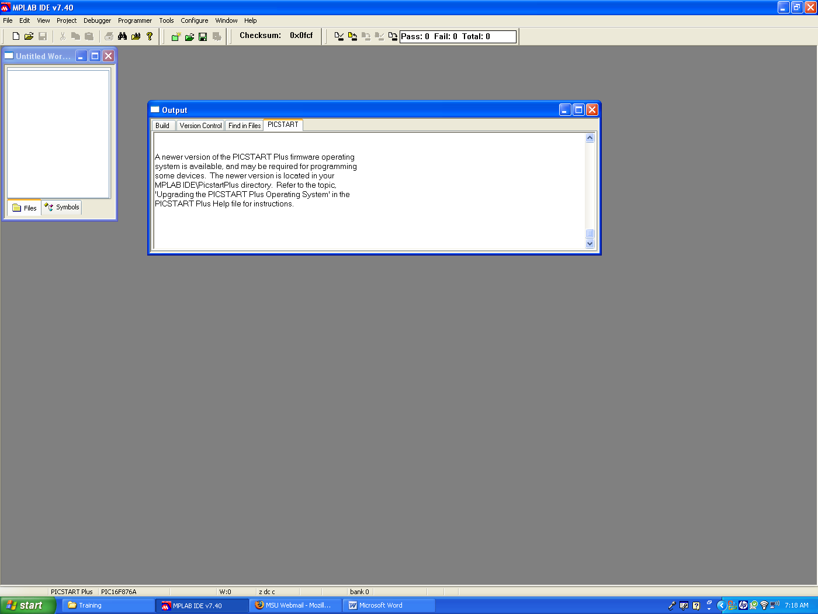
Now check in the bottom left corner of the MPLAB window for the device type. This should say PIC16F876A. If it does not, go to Configure -> Select Device and select PIC16F876A as the device.
Next, click on File->Import->Import to memory. Find your lab1.HEX file and open it. A message should show up in the Output window that say “Loaded C:\...” with a path telling which file was loaded.
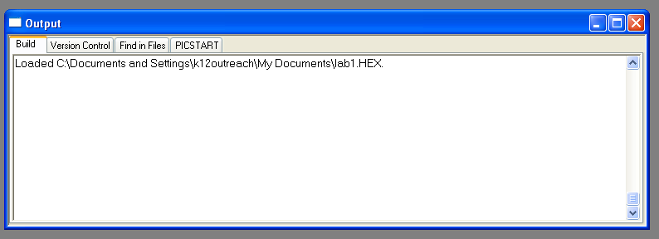

Place your microcontroller in the programmer. To remove your microcontroller from the breadboard, use your pen tip to slightly raise each end of the programmer. DO NOT lift only one end of the microcontroller. This will bend the pins and your instructor will not be happy.

Make sure that pin 1 is in the topmost slot on the programmer. Lift the lever on the programmer to lock the chip in place. Click Programmer->Program. If successful, a message will say “Programming/Verification completed successfully!” You can watch for the active light on the programmer to turn on while you are programming it or the bottom of the screen for a progress bar.

If you have any problems, ask your instructor.

Your microcontroller is now programmed and can be placed back into your circuit

Completing Your Circuit
To finish your circuit, you will need to add two LEDs. When you connect the LED, you need to connect a resistor in series with it to limit the current. If you do not limit the current using a resistor, you may damage the microcontroller or burn out the LED.

You can find the proper resistance using Ohm’s Law, V= I/R, where V is the voltage, I is current, and R is resistance. In your circuit, when the microcontroller turns on the LED, it will output 5 volts, and the voltage drop across the LED is 2 volts, so there needs to be a 3 volt voltage drop across the resistor. I is the amount of current we want to have running through the LED. The absolute maximum the microcontroller can supply is 0.025 amps, but to be safe, you should limit the current to about 0.02 amps. Use Ohm’s law to calculate the correct resistor size, and then use the resistor color code guide in the appendix to find the color code for that size resistor. When you have the correct color code, your instructor will give you the two resistors and two LEDs.

Now, using the pin diagram for the microcontroller in the appendix, locate the two pins on the microcontroller that correspond to the pins you used in your program. For each pin, connect a resistor from the pin to an unused node on your breadboard. Then, connect the positive pin of the LED to the resistor and the negative pin of the LED to ground. The positive pin is the longer of the two pins. Figure ? shows how you can tell which pin is which. If the LED is connected backwards, it will not light up. Figure 9 is a schematic diagram of the LED circuit.
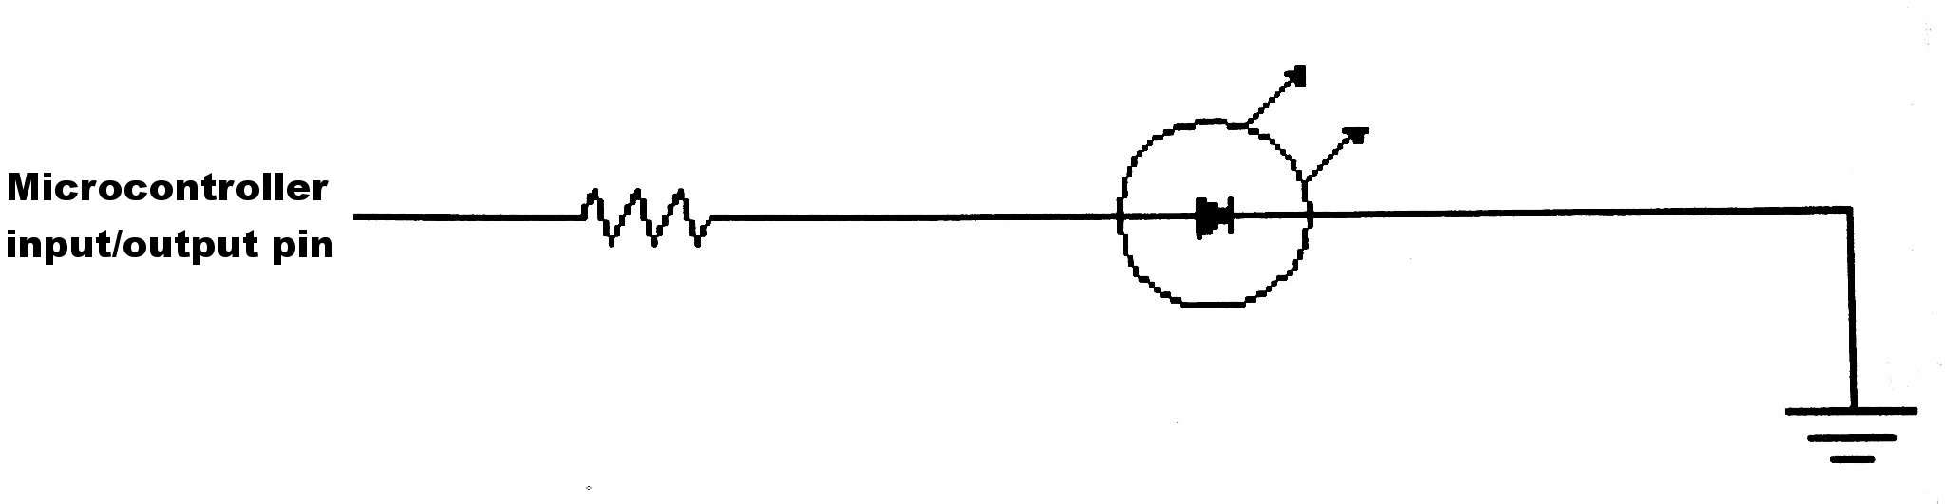
Figure 9 - LED sub-circuit diagram

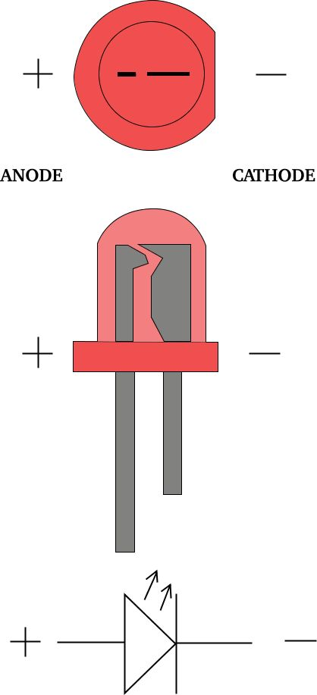
After both LEDs are connected, show the circuit to your instructor.

After your instructor verifies that everything is connected properly, you can connect your battery. The negative terminal (black lead) on the battery will be connected to ground on your circuit, and positive terminal (red lead) on the battery will be connected to pin 1 on the voltage regulator.

If your circuit is not working, verify that you have not made any mistakes in your program and that the output pins used in your program match the pins you connected the LEDs to. If this does not help, your instructor will help you identify the problem.

When your circuit is working, demonstrate it to your instructor.

You should now be able to write a program in C, compile it, and download it to a microcontroller. You should also be comfortable using digital output and delay functions.

Figure 10 - LED polarity diagram

Microcontroller Programming Lab 2

Objective
In this lab you will learn how to connect switches to a microcontroller. You will use switches to execute different blocks of code, depending on how the switches are set. Learning how to use inputs to the microcontroller is one of the most important aspects of microcontroller programming. Switches are digital inputs, because they send either “on” or “off” to the microcontroller. Later, you will learn about analog inputs, which are more useful when sending information from sensors to the microcontroller. In this lab, you will write, compile, and download programs into your microcontroller that use switches, and you will connect them to your microcontroller. You will demonstrate your working program to your instructor.

Procedure
Modifying Your C Program
The program you will write in the first part of this lab will build on the program you wrote in the previous lab, so you can start with what you have already written. To do this, open your lab1.c file, then go to File->Save As and save it as lab2a.c.

There is a small bug in the compiler where it will compile the original file after you do a “save as”. To get around this, select File->Close All, then File->Open and re-open lab2a.c.

The “if” Statement and “input” Function
To use the input from a switch, we will need to use an “if” statement and the “input” function. The “input” function is used to tell when the switch is on or off. It is used similarly to the “output_high” and “output_low” functions, except that instead of setting a pin to either 0 or 5 volts, it checks what the voltage is and returns either “True” if the voltage on the pin is near 5 volts, or “False” if the voltage on the pin is near 0 volts. The “if” statement is used exactly like the “while” loop, except that when the microcontroller is running the code, it will not loop back to the beginning of the “if” statement the way it does with a “while” loop. An example showing how to use an “if” statement is shown below:
if ( input( PIN_A5 ) )
{
output_high( PIN_B7 );
delay_ms( 250 );
}

This example will turn on the LED connected to Pin 28 and wait 250 milliseconds only if the switch connected to Pin 7 is on.

You should now modify your program to use a switch connected to Pin 2 (PIN_A0). Be sure to place your code inside the while loop. The program should blink the LEDs when the switch is on and leave them off when the switch is off.

After you have modified the program, save and compile it and download it into the microcontroller. (If you can not remember the procedure to do this, you can look back at the previous lab; the procedure is the same except for the filename.)

The only modification you will need to make to your circuit is to add the switch to it. To add the switch, connect it to an unused portion of the breadboard, making sure that it spans the middle gap. Connect a 3.3 kilo ohm resistor between one side of the switch and power. Also connect this pin of the switch (the one with the resistor) to your microcontroller’s pin that you used in your if statement. Connect the pin on the other side of the switch to ground. Figure 11 shows these connections.
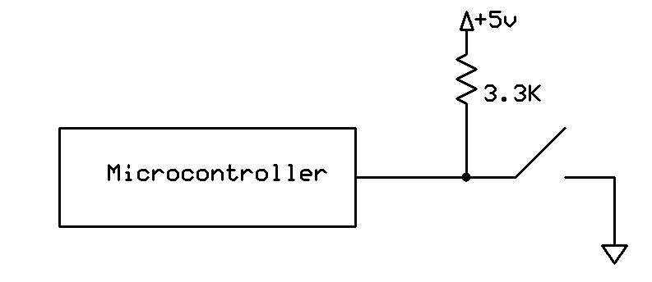
Figure 11 - Switch sub-circuit diagram
Demonstrate the working program to your lab instructor.

You should now be able to accept digital input using the “input” function; selectively run parts of your program using “if” statements; and decide when it is appropriate to use “output_b”, “output_high”, and “output_low” functions.

Microcontroller Programming Lab 3

Objective
In this lab you will learn how to use a serial LCD to display information. You will connect your microcontroller to a Crystalfontz LCD using the RS232 interface, then write a message to the LCD.

The RS232 Communications Protocol
RS232 is a serial interface protocol. A serial interface is a connection where information is sent over a single wire, one bit at a time. RS232 is different from most other serial protocols, because it does not use a clock connection. Instead, both devices must be set to the same transmission rate, which determines how quickly data will be sent. This means that you only have to connect one wire from the microcontroller to the LCD, but you have to make sure that both are set to the same baud rate. If you were using a parallel interface instead of a serial interface, you would need to connect 8 wires for data and 2 or 3 other wires for control information. Since you only need to connect the LCD to one pin, you have more pins available for other devices.

RS232 works by sending a start signal followed by one byte of information (a byte is 8 bits), an optional parity bit, and a stop signal. The parity bit is used to check for errors, because in some situations there may be an error receiving the byte. There are two types of parity, even and odd. When even parity is used, the sum of the eight data bits and the parity bit is always even; when odd parity is used, the sum of the eight data bits and the parity bit is always odd. This way, if the sum of these nine bits is not what it is supposed to be, the receiving device knows that there was an error in the transmission of that byte, and it can ask the other device to send that byte again. In your setup, you will not be using parity, because it is not necessary for such a short connection, and it would make your program more complicated.

A sample RS232 waveform is shown in Figure 12. This sample waveform send “PIC” over an RS232 interface. In binary, ‘P’ is represented as 01010000; ‘I’ is 01001001; and ‘C’ is 01000011. The amount of time that the waveform stays at high or low when sending a data bit is the inverse of the baud rate. For a 19,200 baud connection (which is what you will be using), it sends one bit of data every 52.083 microseconds, so each byte of data takes 520.83 microseconds to send.

The waveform at the top of Figure 12 is a standard RS232 waveform, the one on the bottom is a TTL (Transistor – Transistor Logic) waveform. A TTL signal is the one that is used by most small electronic devices, because they usually can not run at more than 5 volts. This is what is used by the microcontroller. Normally a TTL signal is sent to a converter that changes it to the standard waveform, but your LCD has a converter built in, so you can connect it directly to the microcontroller.
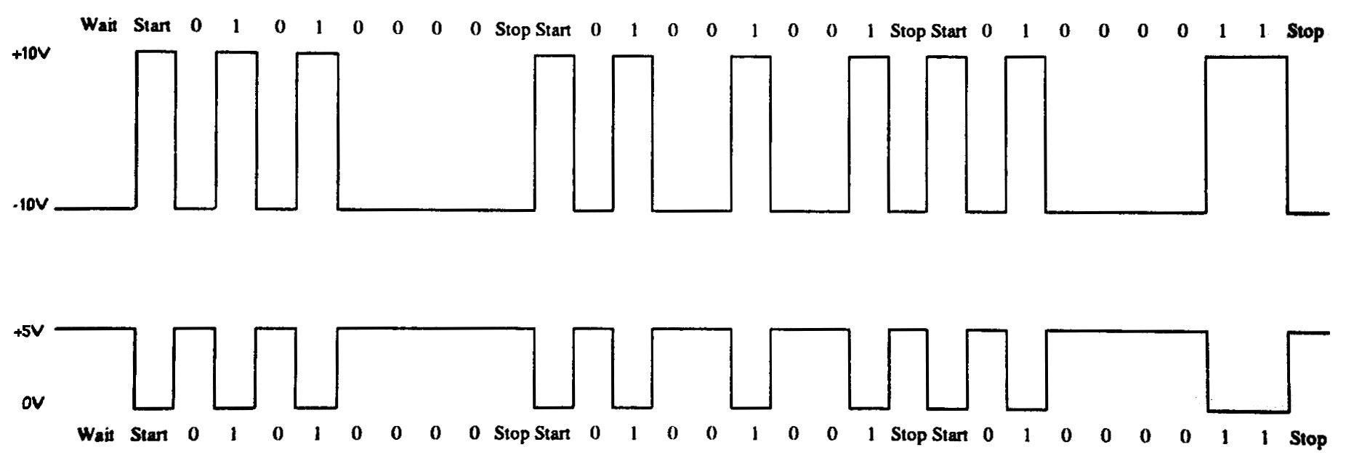
Figure 12 - RS232 waveforms when sending the string “PIC”
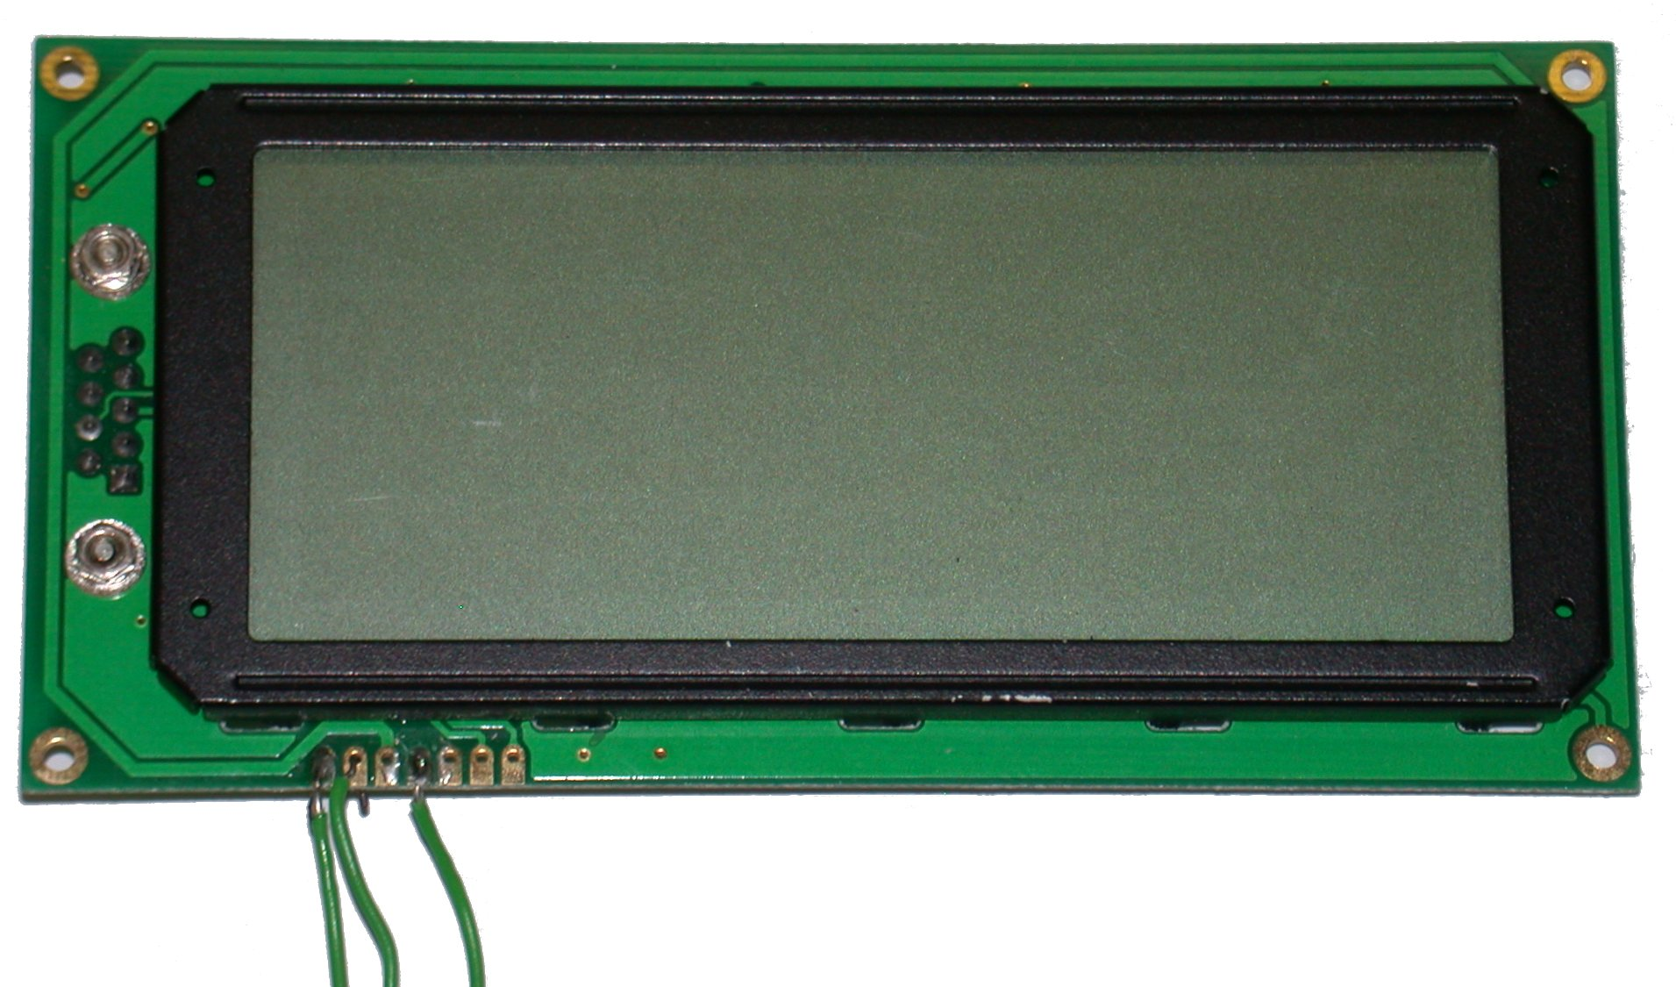
Figure 13- Crystalfontz 634 (20x4 character serial LCD

Connecting Your LCD
The LCD that you will be using is shown in Figure 13. The LCD only has three wires, so the connection is very easy. On the bottom of the LCD, each of the wires is labeled. The wire labeled “GROUND” connects to ground on your breadboard. The wire labeled “+5V(LCD)” should connect to the 5 volt power on your breadboard. The wire labeled “DATA_IN” connects to Pin 17 (PIN_C6).

Have your instructor check your connection before continuing, because an incorrect power connection will permanently damage the LCD.

Programming (Part 1)
You should now open the C Compiler and make a new file. Name it lab3.c. (Remember to then close the file and re-open it). For this file, you will need to have all of the #include, #set, and #use lines that you used in your previous programs. In addition, you will also need to add:
#use rs232(BAUD=19200, XMIT=PIN_C6)

This line will enable the hardware rs232 capability of the microcontroller and sets the baud rate and transmit pin. Now, you can write to your LCD using the “printf” and “putc” functions. The “printf” is useful for writing words and phrases to the LCD, because it writes multiple characters consecutively. However, it can only send characters that will be displayed on the screen; it can not send control commands to the LCD. Control commands must be sent using the “putc” function. The “putc” is most useful when sending commands, but it can be used for outputting single characters to the LCD. When using the “putc” function, each data bye must be sent in a separate “putc” function. If an LCD command is three bytes long, you will have to use three different “putc” function calls. Some examples of the “printf” and “putc” functions are as follows:
printf(“MSU Engineering”); // Writes the phrase “MSU Engineering” on the LCD
// Note: The quotation marks must be used to make the function work

putc(17); // moves the cursor to column 11, row 2: 17 is the command to set
putc(11); // a new cursor position; this command must be followed by a
putc(2); // column number and row number
// (rows and columns are numbered starting with 0)

Initialization Delay
When writing a program that uses the LCD, you need a delay at the beginning to give the LCD enough time to initialize before you start sending information to it. 500 ms is usually enough time, but you may want to use 1000 ms to be safe. If you do not use a delay, the LCD will not be ready to accept data when the microcontroller starts sending it. If this happens, the LCD will just ignore the data and nothing will happen.

Checking the Baud Rate of the LCD
The last step before downloading your program is to verify that the baud rate of the LCD matches the baud rate of the microcontroller. The baud rate of the LCD is set by two DIP switches on the back of the LCD. Make sure that both switches are in the on position.

Compiling and Downloading Your Program
After you have written a program that outputs something to the LCD and has the proper initialization delay, compile and download your program. If your LCD displays what you told it to, then your circuit is set up properly and you should demonstrate it to your instructor before moving on to Part 2 of the lab. If you see the LCD splash screen for 5 seconds followed by a blank screen, you probably did not use a long enough delay at the beginning of the program. If you are still having trouble getting your LCD to work after making the delay longer, see your instructor.

Programming (Part 2)
For this part of the lab, you should make a program that takes advantage of some of the other features of the LCD. For example, you can make a program that blinks lines of text or has a scrolling marquee, or use the contrast control to have messages that fade in and out. Try to do something that none of the other groups are doing. A complete list of commands is in the LCD’s datasheet. The datasheet can be downloaded from:
http://www.crystalfontz.com/products/634/634full.pdf

It may also be helpful to look at the LCD’s CGROM, which is a table showing every possible character the LCD can display. The file can be downloaded from:
http://www.crystalfontz.com/products/634/632_634_CGROM_v2.0.gif

Demonstrate your working program to your instructor.

You should now be comfortable using the RS232 interface of the microcontroller. You should also be comfortable writing information on the LCD and turning various LCD features on and off.

Microcontroller Programming Lab 4

Objective
In this lab, you will learn how to use the analog to digital converter that is inside the microcontroller. You will connect a temperature sensor to the analog to digital converter port, and then display the temperature on your LCD.

The Analog to Digital Converter
The analog to digital converter (ADC) is a device that takes an analog voltage signal input and two reference voltages and converts the signal to a number that can be used in your program. In this lab, the lower voltage reference will be set to Ground, and the upper reference voltage will be set to +5V. The PIC16F876A has a 10-bit ADC, which means that it produces a number between 0 and 1023 (2¹⁰ – 1). This means that in this lab, the ADC can accept voltages between 0 and 5 volts, and it will be accurate to the nearest 4.89 millivolts. The ADC works by comparing the input voltage to the two reference voltages. The output number from the ADC tells what the input voltage is relative to the two reference voltages. For example, if the input is 0V, the output from the ADC is 0; if the input is 5V, the output from the ADC is 1023; and if the input is 2.5V, the output from the ADC is 512.

In your program, you have to use three functions to set up the analog to digital converter. The setup functions are shown below:
Setup_adc( adc_clock_internal ); // This function turns on the ADC
Setup_adc_ports( all_analog ); // This function defines which ports will be inputs
// and which will be reference voltages. When
// “all_analog” is used, the reference voltages will
// be 0V and the voltage the microcontroller is
// running at (5V in your circuit)
Set_adc_channel( 0 ); // This sets which pin to read the voltage from. (0 is
// pin A0) When changing from one channel to
// another, you should wait at least 1 millisecond to
// ensure an accurate reading

To take a reading, you will use the “read_adc” function. This function returns a 16-bit number (the first 6 bits are 0, the other 10 are the ADC output), so you need to store it as either a “long int” or a “float”. A “float” is usually more useful; because input from the analog to digital converter is usually used in calculations and you want it to be as accurate as possible. After storing the input from the analog to digital converter, you can convert it back to the voltage by multiplying by the upper reference voltage (5 volts) and dividing by 1023.

National Semiconductor LM335A Precision Temperature Sensor
The LM335A is a temperature sensor that outputs a linear analog voltage. It outputs 10 mV / K, with 0V set at 0 K. The temperature sensor is a three terminal device that comes in various packages. We will be using the one with the plastic package (Figure 14). This device has 3 pins: a voltage input, ground, and an adjustment pin. The adjustment pin can be used to adjust the output so that it outputs more precisely. (When mass-producing devices, individual devices do not always perform as precisely as the customer needs them to, so this pin can be used to adjust for these irregularities.) You will not use the adjustment pin, because it is easier to calibrate the device inside of your program. A circuit diagram for connecting the other two pins is shown in Figure 15. A complete product datasheet is available from your instructor if you want to look at it.
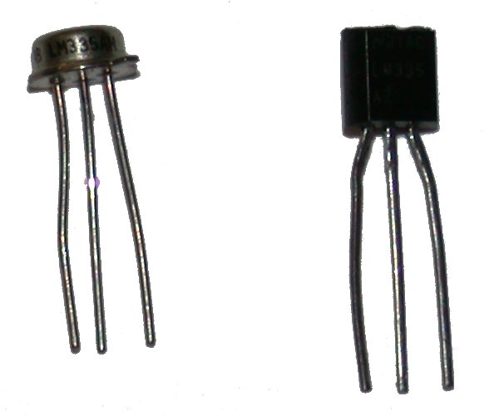
Figure 14 - National Semiconductor LM335A (precision temperature sensors)
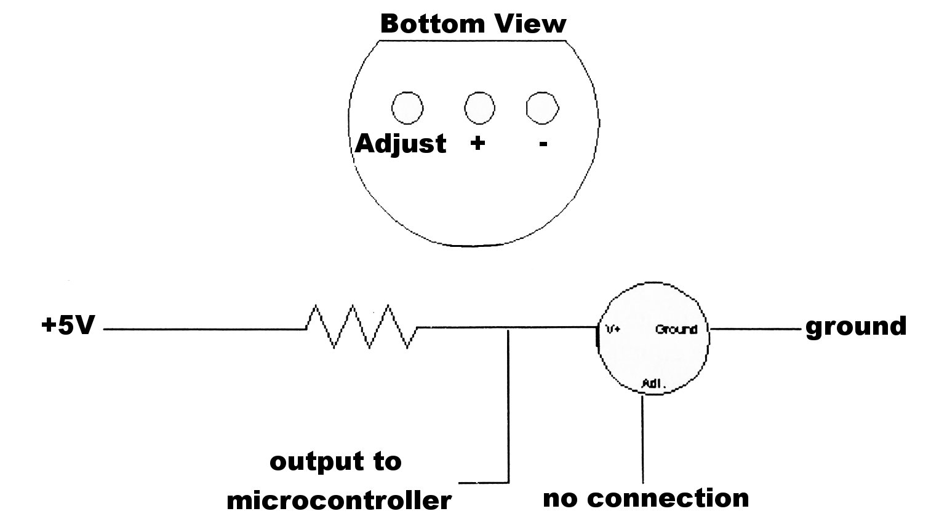
Figure 15 - Temperature sensor connections
You should now connect the temperature sensor as shown in the diagram. The resistor should be 4.02 kilo ohms.

Procedure
Programming
You should now write a program that will display the temperature on your LCD and update it once per second. It will probably be useful to display the temperature in Kelvin, Celsius, and Fahrenheit simultaneously. You should also display the voltage being output by the sensor, because you will need this later in the lab. This way, if the temperature is way off of what it should be, you can quickly tell if it is a mistake in the program or a problem with the circuit. Also, when calibrating the sensor, you will want to know the temperature in Kelvin.

You first need to define the variables used in the temperature calculations. Variable initializations need to go within the main loop, at the very top. It is good practice to initialize all variables with some value, in this case with 0, to avoid having some previous unknown values stored in them.

Float Voltage = 0;
Float Celsius = 0;
Float Kelvin = 0;

The necessary conversion equations are shown below:
Voltage = (read_adc()) * 5 / 1023;
Kelvin = Voltage * 100;
Celsius = Kelvin – 273.15;
Fahrenheit = Celsius * 9 / 5 + 32;

When outputting a floating-point value using the “printf” function, you must define the number of digits to show before and after the decimal point. An example is shown below:
Printf( “Celsius = %2.3f”, Celsius );

The “%” symbol tells the “printf” function that a variable is going to be output. The first number indicates that there should be 2 digits before the decimal, and the second number indicates that there should be 3 digits after the decimal. The “f” indicates that the variable is a floating-point number. Finally, outside of the quotation marks, and separated by a comma, you have to give the name of the variable being output. A complete list of formatting options is given in the help for the PIC C Compiler.

When you have completed your program, download it to your microcontroller and demonstrate it to your instructor. At this point, your program should output a number that is close to the actual temperature, but not exact. You can verify that the temperature sensor is working by touching the temperature sensor with your finger and watching the temperature rise.

The final step in this lab is to calibrate your temperature sensor. Since the sensor outputs a linear signal, and it output 0V at 0 Kelvin, you know the voltage output is in the form y=Ax. (y is voltage output, x is temperature input) To calibrate the sensor, you have to first find the output at an arbitrary temperature, and solve to find A (Note: When doing these calculations, make sure the temperatures you are using are in Kelvin). Next, you have to calculate a conversion factor that will map the sensor’s actual output to its ideal output. The sensor’s ideal output is y = .01x, so the conversion factor is .01/A. Your instructor will have the actual temperature in the room, and you will use the voltage displayed the program you wrote previously. After performing your calculations, you should have a calibration constant that is very close to 1. If your constant is very far off, you probably made a mistake somewhere, and you should recalculate it. Now, you just need to add a line to your program that multiplies your temperature by the conversion factor you just calculated. This line needs to be before the program converts the temperature to Celsius or Fahrenheit, and it needs to be before the program displays the temperature on the LCD.

Now that your sensor has been precisely calibrated, you should format the display nicely, and verify that it is reading the temperature more precisely than it was before.

You should now be comfortable reading input from analog sensors and converting that raw data into useful information.

Microcontroller Programming Lab 5

Objective
In this lab, you will learn how to use a keypad as an input to a microcontroller. You will learn how to create C functions to get input from the keypad and return that input to the main function.

Grayhill 96A Keypad
The Grayhill 96A is a 12-button, 7-pin keypad (Figure 16). Pin 1 on the keypad is the rightmost pin when looking at the back of the keypad, and leftmost pin when looking from the front. On this device, the first 4 pins correspond to the rows on the keypad, and the other 3 pins correspond to the columns. Each button acts as a switch. When a button is pressed, the pins for the row and column of the button’s position are connected. For example, when the button labeled “7” is pushed, pins 3 and 5 are connected, because the button is in the third row and first column. To interface this device with the microcontroller, you will set pins 1-4 as input and pins 5-7 as output, and then use a technique called polling to find out when any buttons are being pushed.

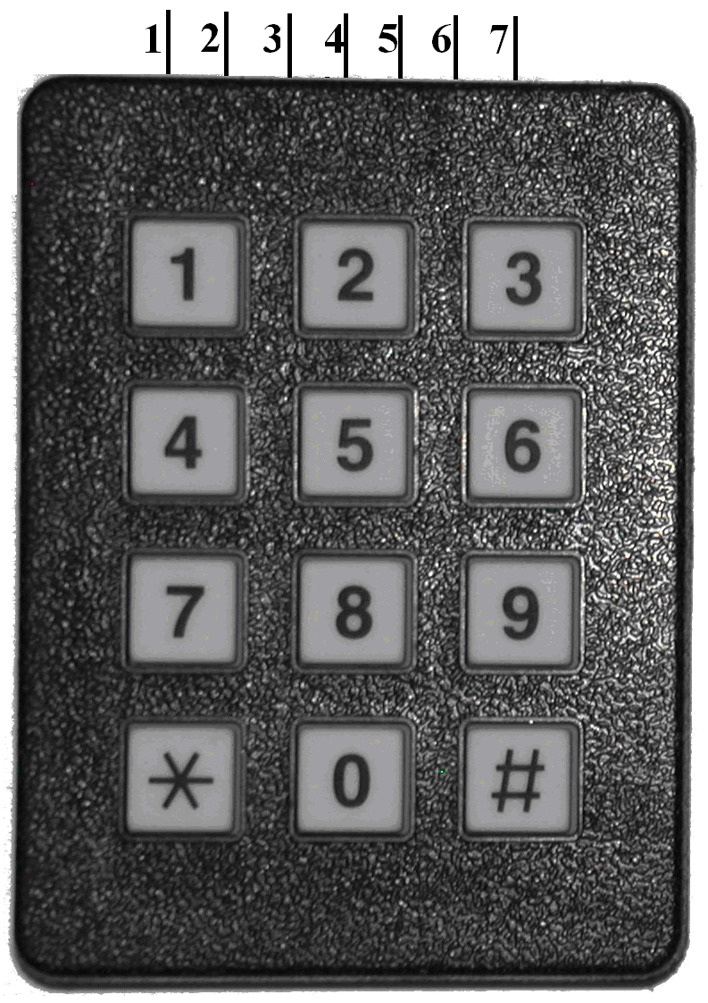
Pin 1 | Row 1
Pin 2 | Row 2
Pin 3 | Row 3
Pin 4 | Row 4
Pin 5 | Column 1
Pin 6 | Column 2
Pin 7 | Column 3
Figure 16 - Grayhill 96A Keypad
Table 1- Keypad pinout

Connecting Your Keypad
The easiest way to connect your keypad is to remove all of your LEDs and connect the pins on the keypad to pins B1-B7 on the microcontroller. However, if you want to leave your LEDs connected, you can connect your keypad to port C instead (Pins C0-C5 and C7). Using wires connect each pin on the keypad to a different pin on the microcontroller, makes sure they are connected sequentially. For example pin 1 to C0, pin 2 to C1, etc. Also, make sure you remember which keypad pins are connected to which microcontroller pins. The last step is to connect 10k resistors from each of the three output pins of the keypad to ground (Pins 5-7) as seen in Figure 17.
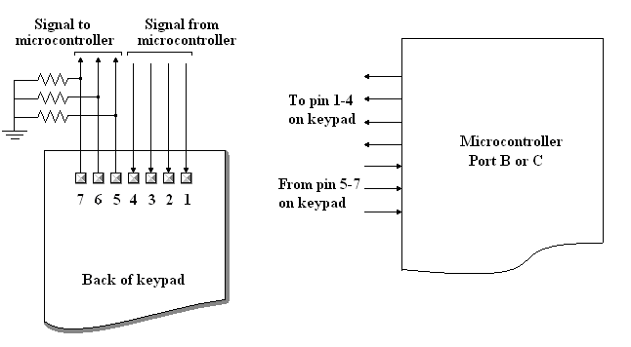
Figure 17 - Grayhill 96A Keypad Connection Diagram

To explain the connections, let us look at a specific example. Remember when you press number 7, the keypad connects pin 3 and 5 together like a closed switch. If the microcontroller is programmed to output a voltage to pin 3 and your finger is still on number 7, current flows from pin 3 to pin 5, through the resistor and then to ground. Current flowing through a resistor creates a voltage drop; in this case it will be roughly 5V. The voltage across the resistor is what changes the state of the output pin of the keypad; in this case it will turn pin 5 on the keypad to high. When you remove your finger, the switch between pin 3 and pin 5 is opened. Regardless of whether the microcontroller is output a voltage to pin 3, no current will flow from pin 3 to pin 5. The voltage drop across the resistor changes to 0V, and so the output state of pin 5 changes to low.

The microcontroller will be programmed to poll the keypad. Polling is when the program is expecting data from a device and it repeatedly checks the device until that data arrives. The program will output a voltage to the input pins (pin 1-4) on the keypad, one at a time. It will then check the state of each output pin on the keypad, to determine whether it is high or low. If an output line turns on, the microcontroller knows the row (the input line that is on) and the column (the output line that is on) of the button being pressed and sends that information back to the part of the program that requested it. Continuing from the example above, when pin 3 on the keypad is turned on, and the program reads that pin 5 is high, it can determine that number 7 is being pressed.

Writing a “get_keypad” Function
Create a new program for your microcontroller called keypad.c. This program will just read a number from the keypad and display it on the LCD. Include all of the pre-processor directives you used in your previous programs. Don’t forget to include the main() function. In this program, you will create a function called “get_keypad” that will work like the “predefined get_adc” function used in lab 4. To create the “get_keypad” function, write the following in your program before the main function:
int get_keypad( )
{

}
This tells the compiler that you are creating a new function called “get_keypad”, and that it will return an 8-bit integer when called. Now, you have to fill in the rest of the function. The first thing to add is a while loop that repeats forever, because the function needs to wait until a button is pressed. Inside the “while “loop, you will need to add the code that checks whether or not a button is being pushed. For each row in the keypad, you will need to add a section of code that turns on the pin corresponding to that row, turns off all the pins corresponding to other rows, waits one millisecond for the pins to changed voltage, checks for any output pins that are on, and returns a number corresponding to that button. The code inside your while loop should look similar to the following:
output_high(PIN_C0); // Turn on the pin for row 1
output_low(PIN_C1); // Turn off the pins for rows 2-4
output_low(PIN_C2);
output_low(PIN_C3);
delay_ms(1); // Wait for the pins to change voltage
if (input(PIN_C4)) // Check if the button labeled “1” is pressed
return 1; // If “1” is being pushed, return 1 to the main function
if (input(PIN_C5)) // Check if the button labeled “2” is pressed
return 2; // If “2” is being pushed, return 2 to the main function
…
…

Extend this code so that it includes all 12 buttons on the keypad. The function should return 10 when “*” is pushed and 11 when “#” is pushed. Make sure that the pins used in your code are the same pins that your keypad is actually connected to.

Now that your “get_keypad” function is done, make your main function repeatedly get numbers from the keypad and display them by adding the following code to your “main” function:
while(True)
{
printf(“%u”, get_keypad( ));
}

If your program worked correctly, when you push a button, it should display 20 or more copies of that number on the screen. This is because your current version of “get_keypad” does not check whether or not a button is being held down, it just assumes that no buttons have been held.

Altering Your “get_keypad” Function
To fix the “get_keypad” function so that it only displays one number for each button press, you just have to add a few lines to the beginning of the function before its “while” loop. You want to make sure that no buttons are being pressed when the microcontroller enters the while loop, so you just need to add another while loop that will make the microcontroller do nothing until none of the buttons are pressed. The easiest way to do this is to turn on all four of the keypad’s input lines, then make an empty “while” loop that will run while any of the three keypad output pins are on. To check to see if any pins are on, use the input function and the “or” command (“||”).

output_high(PIN_C0);
output_high(PIN_C1);
output_high(PIN_C2);
output_high(PIN_C3);

while(input(PIN_C5)||input(PIN_C6)||input(PIN_C7))
{

}

When you have finished modifying your “get_keypad” function, recompile your program and download it to the microcontroller again.

Your program should now display exactly one number for each button press. If it does not, your instructor can help you find the problem.

Final Projects

Alarm System

For this project, you will design and build an alarm system, incorporating as many sensors as possible. The alarm system must be designed so that only the owner can arm and disarm the system. You can use a keypad to enter the secret code to turn the system on and off, and there are a variety of sensors available that can be used. You can either build a small alarm, (One of the groups built a lunchbox alarm to prevent people from stealing food) or you can build a scale model of a larger system, like a car alarm or home security system.

Some of the sensors that are available to you are microphones, light sensors, infrared LEDs and photodiodes, and you can build your own custom switches. An off-the-shelf siren can be used for the alarm, or a speaker can be used. A speaker is more difficult to program, but can be programmed to do more than just play a siren.

If you choose to use sensors that were not used in the labs, your instructors will help you connect them correctly with the microcontroller.

Drag Strip Timing System

The two required components of the drag strip timing system that have not already been covered in lab are the use of the microcontroller’s timer and designing a sensor that can signal the microcontroller when the cars cross the finish line. Only these two components will be covered here. If you want to add extra features to your project and are unsure of how to design them, your instructor will help you.

Building a Finish Line Sensor
The easiest way to do this is to have two long wires (The wires need to be stripped of insulation.) parallel to each other sticking out across the car’s path. They need to be set up so that they are not normally touching, but when the car runs over the wires they do touch. The wires are then connected similarly to how a switch or keypad would connect to the microcontroller. One of the wires is connected to +5V and the other is connected to an input pin on the microcontroller. You will need to connect a pull-down resistor to the input pin of the microcontroller as you did with the keypad. If the wires are connected as explained above, they will act like a switch that is on when the car is driving over the wires and off otherwise.

Using the Microcontroller’s Timer
Setting up the timer to work properly is the most difficult part of the project. The microcontroller has three timers, but you will want to use timer 1. All three of the timers can be set to count every 4,8,16, or 32 clock cycles, but timer 0 and timer 2 are 8-bit timers, while timer 1 is a 16-bit timer. This means that timer 1 can count up to 65,535 before wrapping around to 0 (this is referred to as overflow), but the other two timers can only count up to 255 before wrapping around to 0.

Even if you set timer 1 to increment every 32 clock cycles, it will still overflow every 104.8576 ms (65536 * 32 / 20000000 = 0.1048576). Since you will need to time for longer than 104.8576 ms, you will need to use an interrupt to count the number of times the timer overflows. An interrupt is a special signal that interrupts the “main” function and tells the microcontroller to run a different function immediately (called an interrupt service routine or ISR). When the microcontroller is done running the interrupt service routine, it returns to the “main” function where it left off. If the timer’s interrupt service routine is written correctly, your program can accurately time for any length of time.

To learn how to write code that uses the microcontroller’s timer, start by reading the compiler’s help for “#int_timer1,” “enable_interrupts,” disable_interrupts,” “setup_timer_1,” “set_timer1,” and “get_timer1.” The help is a little difficult to read, but it includes sample code that shows the proper syntax for reading the timer and setting up the timer interrupt.

You can look at the included sample program to see the proper syntax for using the interrupt. The sample program is for a stopwatch, so it uses the timer1 interrupt and it has both buttons setup to use the “RB” interrupt. Your instructor can answer any questions you have about using the timer that are not answered by the help or the example program. Before moving on to the next section, it would be a good idea to write a simple timing program to verify that you understand using the timer and interrupts. This way, if you get any errors now, you know they are from the timing, and if you get errors later, you know they are from the sensors. (Do not use the “RB” interrupt like the example did, that will be explained in the next section.)

Programming Your Microcontroller to Use the Finish Line Sensors
There are two ways to program the microcontroller to respond to the finish line sensors. You can either program to poll the sensors or use an interrupt to respond to them. Polling is what is done in lab 5 when checking for input from the keypad. This is when the microcontroller has a loop in its “main” function that continuously checks to see if the sensor is being pushed. This is generally not as precise as using an interrupt, and for this project, setting up the sensors to use interrupts is probably easier. If you choose to poll the finish line sensors, your program will be a lot like the program from lab2, where you were polling the switches, so polling will not be explained in more detail here. Using the finish line sensors as interrupts is explained in the next paragraph.

To use your finish line sensors as an interrupt, you must first connect them to pins B4, B5, B6, or B7. Next, you have to write an interrupt service routine for “#INT_RB.” This interrupt is triggered whenever any of the four pins listed above change from high to low or low to high. If you are not using all four pins, set the others to output at the beginning of your main function. If you do this, the microcontroller will ignore those pins so they can not trigger the interrupt.

The most important thing to remember when using the “RB” interrupt is that any of the four inputs can trigger the interrupt, so you need to use “if” statements to figure out which sensor triggered the interrupt. Also, each sensor will trigger the interrupt multiple times, and you only want the microcontroller to do anything the first time. You can check the sample stopwatch program to see how it responds to interrupts and to check the proper syntax.

Finishing the Project
The final step is to decide how you want to start the race. You could construct another switch similar to the finish line that is pressed when you start the cars. There are many other ways to start the timer as well. Experiment and try different ways.

Adding on to the Project
If you finish your project early, you should spend the remaining time adding more features to it. The following is a list of ideas for additional features:

Calculating the final speed of the cars:
To do this, you can either add another sensor just before the finish line at a known distance, or if you know the wheelbase of the cars, you can take sensor reading when each axle crosses the finish line. Then, use the two time readings to calculate the speed.

More accurate sensors:
The sensor described above is not particularly precise, and it can easily be bent so that it does not work at all. It would be a good idea to build a sensor that is more robust or more precise.

Christmas tree:
All real drag strips use a “Christmas tree” to signal to the drivers when to start. You can build a “Christmas tree” using LEDs. If you want to, you could also program the cars to have random reaction times, so that they do not always start at exactly the same time.

Music Box / Karaoke Machine

For this project, you will connect a speaker to your microcontroller and program your microcontroller to play a song. If you have enough time, you will also connect a display and program the microcontroller to display the song’s lyrics while playing the song. This document explains how to connect a speaker and program your microcontroller to use it. A table is included with the frequencies that correspond to each music note.

Connecting a Speaker
The speaker can be connected to any of the input/output pins on the microcontroller. The connection is the same as an LED (you need to use a resistor in series with it), but when connecting your speaker, you should use a resistor with a resistance of at least 200 Ohms. If one of the speaker’s wires is black, that wire is the ground wire and must be connected to ground, if neither of the wires is black, either one of the wires can be connected to ground.

Verifying the Connection
You should start by writing a program that just plays a single note forever. This will verify that your speaker connection is correct. To get the speaker to play a note, the microcontroller must output a square wave of the correct frequency. For example, since the frequency for A natural is 440 Hz, to play this note, the microcontroller would output a square wave with a frequency of 440 Hz on the appropriate output pin.

To write a program to output a square wave, you just need to use the “output_high” and “output_low” functions with the correct delay between them, and then loop everything. The delay between the two output functions should be half of the period of the wave, and the period of the wave is the inverse of the frequency, so the delay should be 1 / ( 2f ). For your first program, just calculate the delay using a calculator and put that value into the delay function.

Writing a Function That Can Play Any Note
Next, you should write a function that will play a specific note, when given that note’s frequency. Since the compiler’s delay functions have some bugs in them, they do not always work as expected, so you can use the function below for this part. This function needs to be declared before your main function to work correctly.
void playnote( float frequency )
{
float period = 1 / frequency; // Calculates the period of the wave
int32 usdelay = 500000 * period; // Calculates the necessary delay (in us)
int32 compare = 256;

output_high( /* your output pin */ ); // Make the pin go high
while ( usdelay >= compare ) // This is necessary, because the delay
{ // functions only accept 8-bit values, so they
delay_us(255); // have to be called multiple times
usdelay -= compare;
}
delay_us(usdelay);
usdelay = 500000 * period;

output_low( /* your output pin */ ); // Make the pin go low
while ( usdelay >= compare ) // Same as above
{
delay_us(255);
usdelay -= compare;
}
delay_us(usdelay);
}

This function will play the note at the correct frequency, but it only plays the note for one period. You need to modify the function so that it accepts a second argument (The amount of time to play the note), and add a loop so that the function plays the note for the correct amount of time. If you are unsure of how to do this, your instructor can help you.

After modifying the “playnote” function, you will be able to play any note for any amount of time by calling the “playnote” function from your “main” function. Table 2 is a table of frequencies for each musical note..

Programming the Microcontroller to Play the Song
Now, get the sheet music for your song, and program each note using the “playnote” function. If your song has a chorus that repeats multiple times, you can make your code shorter by creating another function that plays the chorus, instead of programming each note in the chorus every time it needs to play.

Printing Song Lyrics on an LCD
The next step is to print the song’s lyrics on an LCD as the song plays. If you do not remember how to use some of the LCD’s features, refer back to lab 3, or read the LCD’s datasheet.

When adding all the lyrics to your program, there is a chance that you might need more memory than the microcontroller has. If this happens, you will need to split your program onto multiple microcontrollers so that one plays the song and the other displays the lyrics. The two microcontrollers will have to send signals to each other to stay synchronized. Your instructor can help you with this if you need to do it.

Frequencies for one octave
(Doubling a notes frequency will give the frequency for the same note one octave higher)
Note | Frequency
C | 261.63 Hz
C# | 277.18 Hz
D | 293.67 Hz
D# | 311.13 Hz
E | 329.63 Hz
F | 349.23 Hz
F# | 369.99 Hz
G | 392.00 Hz
G# | 415.30 Hz
A | 440.00 Hz
A# | 466.16 Hz
B | 493.55 Hz
Table 2 - Table of notes and corresponding frequencies
Notes

Common Pre-processor Directives
Command | Common Options | Description | Restrictions
#fuses | hs, nowdt, put, brownout, nolvp | Sets the configuration bits for the microcontroller. A complete list of options can be found in the compiler’s help | If this is not used, the configuration bits must be set manually in MPLAB
#include <16F876.H> |  | Specifies which microcontroller is being used | Required
#use delay(clock=speed) | Speed is the oscillator frequency in Hertz | This tells the compiler what speed the microcontroller will be running at. This is need for any program that uses timing. | Required for most programs
#use rs232 (BAUD=rate, XMIT=pin) | XMIT, RCV, BAUD, PARITY, BITS | This sets up the RS232 interface. BAUD is required, the others are optional. The hardware transmit and receive pins are pins c6 and c7, respectively, but software rs232 can be run on any other I/O pin. The complete list of options is in the compiler’s help | Required to when using RS232 to send or receive data

Common Microcontroller Functions
Function | Common Options | Description | Restrictions
delay_ms(value) | value must be a 16-bit constant (0-65535) or an 8-bit variable (0-255) | Delays for the specified time (in milliseconds) | The #use delay directive must be used
delay_us(value) | Value must be a 16-bit constant (0-65535) or an 8-bit variable (0-255) | Delays for the specified time (in microseconds) | The #use delay directive must be used
input(pin) | pin can be any I/O pin | Sets the pin as input and returns the value of the pin
output_b(value) | value must be 8-bit (0-255) | Sets the pins of port b to the binary representation of value
output_high(pin) | pin can be any I/O pin | Outputs 5V on the specified pin
output_low(pin) | pin can be any I/O pin | Outputs 0V on the specified pin
printf( ) | The options are listed in the compiler’s help | Sends a string of characters to the rs232 interface, or another function. It can format and output variables. | #use rs232 directive must b used to send data to the rs232 interface
putc(value) | value must be 8-bit (0-255) | Sends a byte across the rs232 interface | #use rs232 directive must be used
set_adc_channel(pin) | pin is a number between 0 and 4: these numbers correspond to pins A0 – A4 | Sets the pin where the next analog reading will be taken. You must wait at least 20 us after using this function to ensure the reading is accurate | Must be used before read_adc and after setup_adc and setup_adc_ports
setup_adc(adc_clock_internal) | adc_clock_internal, adc_off | Turns the analog to digital converter on or off | Must be used before read_adc
setup_adc_ports(all_analog) | all_analog, analog_ra3_ref | sets which pins will be used as analog inputs | Must be used before read_adc

How to Read Resistor Color Codes

4-band resistors (5% or 10% tolerance)
The fourth band will be either silver or gold, the first band is on the opposite end.
First Band: First Digit of resistance
Second Band: Second digit of resistance
Third Band: Multiplier (Number of zeroes to add to the end of the number
Fourth Band: Tolerance (How close the actual resistance will be to the ideal resistance)

Formula for Calculating Resistance
first band second band x 10^{third band}

5-band resistors (1% tolerance)
These resistors never have a gold or silver band. The fifth band is always brown. For resistor values beginning with a 1, the first band is also brown, and it is impossible to tell which direction to read the bands. For these resistors, it is best to just check them with a multi-meter.
First Band: First Digit of resistance
Second Band: Second digit of resistance
Third Band: Third digit of resistance
Fourth Band: Multiplier (Number of zeroes to add to the end of the number
Fifth Band: Tolerance (How close the actual resistance will be to the ideal resistance)

Color | Multiplier | Tolerance
Silver | -2 | 10%
Gold | -1 | 5%
Black | 0 | -
Brown | 1 | 1%
Red | 2 | -
Orange | 3 | -
Yellow | 4 | -
Green | 5 | -
Blue | 6 | -
Violet | 7 | -
Gray | 8 | -
White | 9 | -
Table 3 - Resistor Color Code

Useful Resistor Circuits and Equations

Resistor in Series | Resistors in Parallel | Voltage Divider
Total Resistance  R = R₁ + R₂ + R₃ + . . . + R_{n} | Total Resistance  Any number of resistors  R = 1 / (1/ R₁ + 1/ R₂ + 1/ R₃ + . . . + 1/R_{n})  2 Resistors  R = R1 * R2 / (R1 + R2)  If all resistors are same size  R = R₁ / n | V₂ = V₁ * R₂ / (R₁ + R₂)  Note: This only works when you are sampling V₂ with a device that does not draw current.
Table 4 - Useful Circuit Equations

Voltage Across a Resistor
V = i * R

Current Through a Resistor
i = V / R

Power Dissipated by a Resistor (in Watts)
P = V * i
P = i² * R
P = v² / R

Abbreviated Pin Layout for the PIC16F876 Microcontroller
Pin | Name | Description
1 | MCLR’ (VPP) | If this pin is connected to ground, the microcontroller will reset. (This is also the programming voltage input.)
2 | RA0/AN0 | These pins can all be used as digital input/output pins. This port is also the analog-to-digital converter port. Pins AN0-AN4 can be used as analog input. Pins 4 and 5 can be set as the voltage references, or V_{dd} can be used. T0CKI is the optional clock input for timer 0. SS’ can be used as the slave select for the synchronous serial port
3 | RA1/AN1
4 | RA2/AN2/V_{ref}-
5 | RA3/AN3/V_{ref}+
6 | RA4/T0CKI
7 | RA5/AN4/SS’
8 | V_{SS} | Ground
9 | OSC1/CLKIN | These are the pins where the oscillator connects. This microcontroller can run at speeds up to 20 MHz
10 | OSC2/CLKOUT
11 | RC0/T1OSO/T1CKI | These pins can all be used as digital input/output pins. This port can be used for hardware serial communications via RS232, SPI, I²C protocols. Pins 11 and 12 can be used to connect an external clock to timer 1. Pins 12 and 13 can be used as capture/compare or PWM pins.
12 | RC1/T1OSI/CCP2
13 | RC2/CCP1
14 | RC3/SCK/SCL
15 | RC4/SKI/SDA
16 | RC5/SDO
17 | RC6/TX/CK
18 | RC7/RX/DT
19 | V_{SS} | Ground
20 | V_{DD} | Positive voltage supply
21 | RB0/INT | These pins can all be used as digital input/output pins. Pin B0 can be used as an external interrupt. Pins B4-B7 can be used as interrupt-on-change pins. B3 can be used as a low voltage programming input. Pins B6 and B7 are used if the device is being used with an In-Circuit Debugger.
22 | RB1
23 | RB2
24 | RB3/PGM
25 | RB4
26 | RB5
27 | RB6/PGC
28 | RB7/PGD
Table 5 - PIC16F876 Pinout

