Sensitivity Assessment

Reed Scott

2025-01-22

# Introduction

Hi Brittany and Mark!

Per your suggestion last week, I have done some exploratory sensitivity assessments. As a refresher, because we are taking educated guesses at the potential values for many of the necessary disease parameters, you both sugggested that I explore how variation in potential parameters values could affect the model output. Specifically I have looked at how

* connectivity
* Transmission rate ($β$)
* death rate(d)
* recovery rate (d) and
* dispersal rate ($ϕ$)

affect the $R_{0L}$ of a 2 patch, 6 species meta-community. I have not done a more formal sensitivity analysis: what I report here are just the raw results of 100 simulations where I varied 1 of the 5 parameters of interest. Also, please note that I will be trying to keep displayed code to a minimum, and will try to report generally on my methods for creating these simulations. This is so I don’t bog you down and keep the focus on the big picture / so we can explore the general meaning of the “analysis”.

**My main ask of you is this:**

1. **Please review this document and let me know if there is any other sensitivity analysis you would like to see done, and if so what?**
2. **Do you feel I have accurately assessed the outcome of these analysis? Do you agree with the effects I suggest?**
3. **Are there any adjustments you’d like to see to the ranges I’ve choosen?**

Now, let’s get into it!

# Connectivity

In the original analysis I presented last week, I simulated connectivity by creating an Patch * Patch matrix. This followed the key assumption that individuals are more likely to stay in a patch then they are to leave the patch. In this simulation we tested 100 metacommunities, and for each metacommunity constructed a different connectivity matrix. Generally, this took the shape of:

stay <- rbeta(n = 1, shape1 = 4, shape2 = 2) #probability individuals stay in a patch?  
go <- 1 - stay # probability individuals move  
connect <- matrix(data = NA,  
 nrow = num_patches,   
 ncol = num_patches)  
for(i in 1:ncol(connect)){  
 for(j in 1:nrow(connect)){  
 connect[i,j] <- ifelse(i == j, stay, go)  
 }  
}

I put this construction of the connectivity matrix within the for{} loop for the simulation. After the simulation was complete, I compared connectivity to disease risk by measuring the relationship between probability of leaving a patch (go) and $R_{0L}$. The results are shown in figure 1. Overall, this seems to suggest that connectivity is positively related with $R_{0L}$.

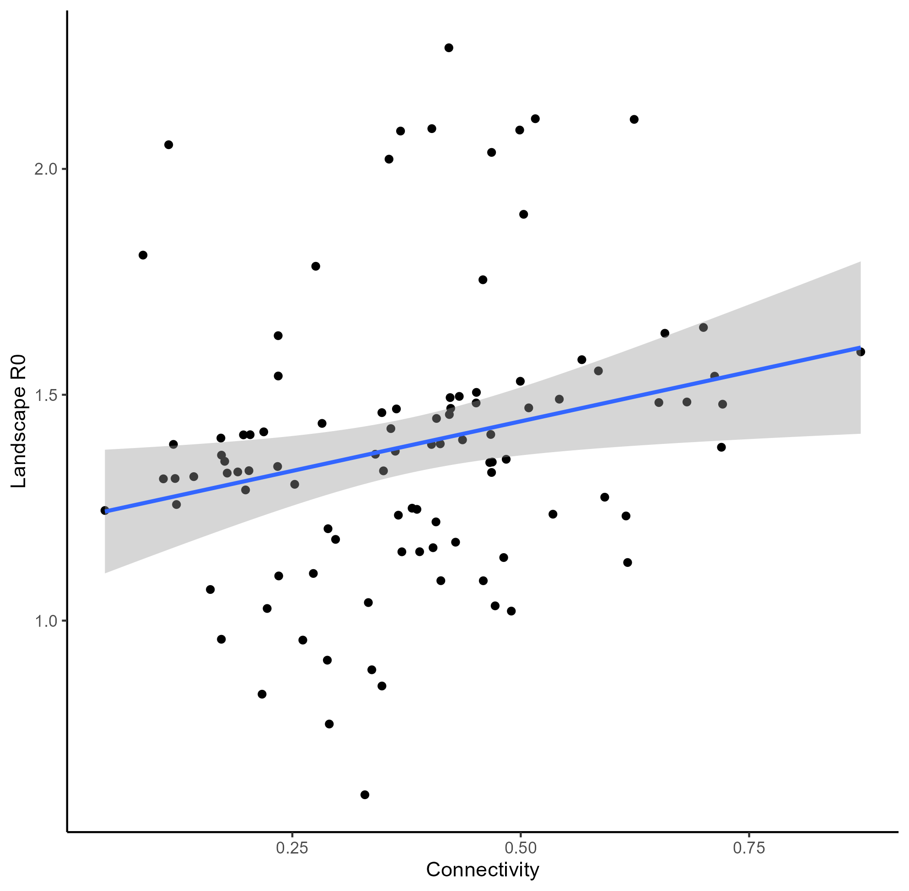

Figure 1: Relationship between connectivity and $R_{0L}$

# Transmission

Next, I tried varying transmission rates for all species to see how that affects $R_{0L}$. As a reminder, we held the assumption that more abundant species would have higher transmission rates, and that $β_{ss}$ would be higher than $β_{si}$. For each of the 100 simulated meta-communities in this example, we simulated transmission rates in the following way:

trans_rate <- function(n = 1,l = 0, u, alpha,beta){  
 trans <- rBeta.4P(n = n, l = l, u = u, alpha = alpha, beta = beta)  
 return(trans)  
}  
  
 # PREG  
 intra_PREG <- trans_rate(l = 0, u = 1, alpha = 4,beta = 2)  
 inter_PREG <- trans_rate(l = 0, u = intra_PREG, alpha = 4, beta = 2.5)  
   
 # TGRAN  
 intra_TGRAN <- trans_rate(l = 0, u = intra_PREG, alpha = 4, beta = 2.25)  
 inter_TGRAN <- trans_rate(l = 0, u = intra_TGRAN, alpha = 4, beta = 2.5)  
   
 #TTOR  
 intra_TTOR <- trans_rate(l = 0, u = intra_TGRAN, alpha = 4,beta = 2)  
 inter_TTOR <- trans_rate(l = 0, u = intra_TTOR, alpha = 3, beta = 2.75)  
   
   
 #ABOR  
 intra_ABOR <- trans_rate(l = 0, u = intra_TTOR, alpha = 4,beta = 2)  
 inter_ABOR <- trans_rate(l = 0, u = intra_ABOR, alpha = 2.5, beta = 3.0)  
   
   
 #RCAT  
 intra_RCAT <- trans_rate(l = 0, u = intra_ABOR, alpha = 4,beta = 2)  
 inter_RCAT <- trans_rate(l = 0, u = intra_RCAT, alpha = 2.0, beta = 3.25)  
   
 #RDRAY  
 intra_RDRAY <- trans_rate(l = 0, u = intra_RCAT, alpha = 4,beta = 2)  
 inter_RDRAY <- trans_rate(l = 0, u = intra_RDRAY, alpha = 1.5, beta = 3.5)  
   
   
   
   
   
 beta <- matrix(data = NA, nrow = num_spp, ncol = num_spp)  
 for (i in 1:nrow(beta)) {  
 for (j in 1:ncol(beta)) {  
 beta[i,j] <- if(i == 1 & j == 1){  
 intra_PREG}else if(i != 1 & j == 1){  
 inter_PREG} else if(i == 2 & j == 2){  
 intra_TGRAN} else if(i != 2 & j == 2){  
 inter_TGRAN} else if(i == 3 & j == 3){  
 intra_TTOR} else if(i != 3 & j == 3){  
 inter_TTOR} else if(i == 4 & j == 4){  
 intra_ABOR} else if(i != 4 & j == 4){  
 inter_ABOR} else if(i == 5 & j == 5){  
 intra_RCAT} else if(i != 5 & j ==5){  
 inter_RCAT} else if(i == 6 & j == 6){  
 intra_RDRAY} else if(i != 6 & j == 6){  
 inter_RDRAY}  
 }  
 }  
 beta <- beta/90

I used beta/90 to help simulate a 90 day breeding season. Additionally, I used the rBeta.4P() to create truncated beta distributions so that the I could not have a $β_{si}$ higher than $β_{ss}$ and so that each $β_{ss}$ would follow our assumptions in regards to rank abundance. This simulation resulted in figure 2. I used $β_{ss}$ of *P. regilla,* which should be the highest transmission rate in each simulation, to test the relationship between $β$ and $R_{0L}$. Overall, I think this shows a pretty strong positive relationship between $β$ and $R_{0L}$.

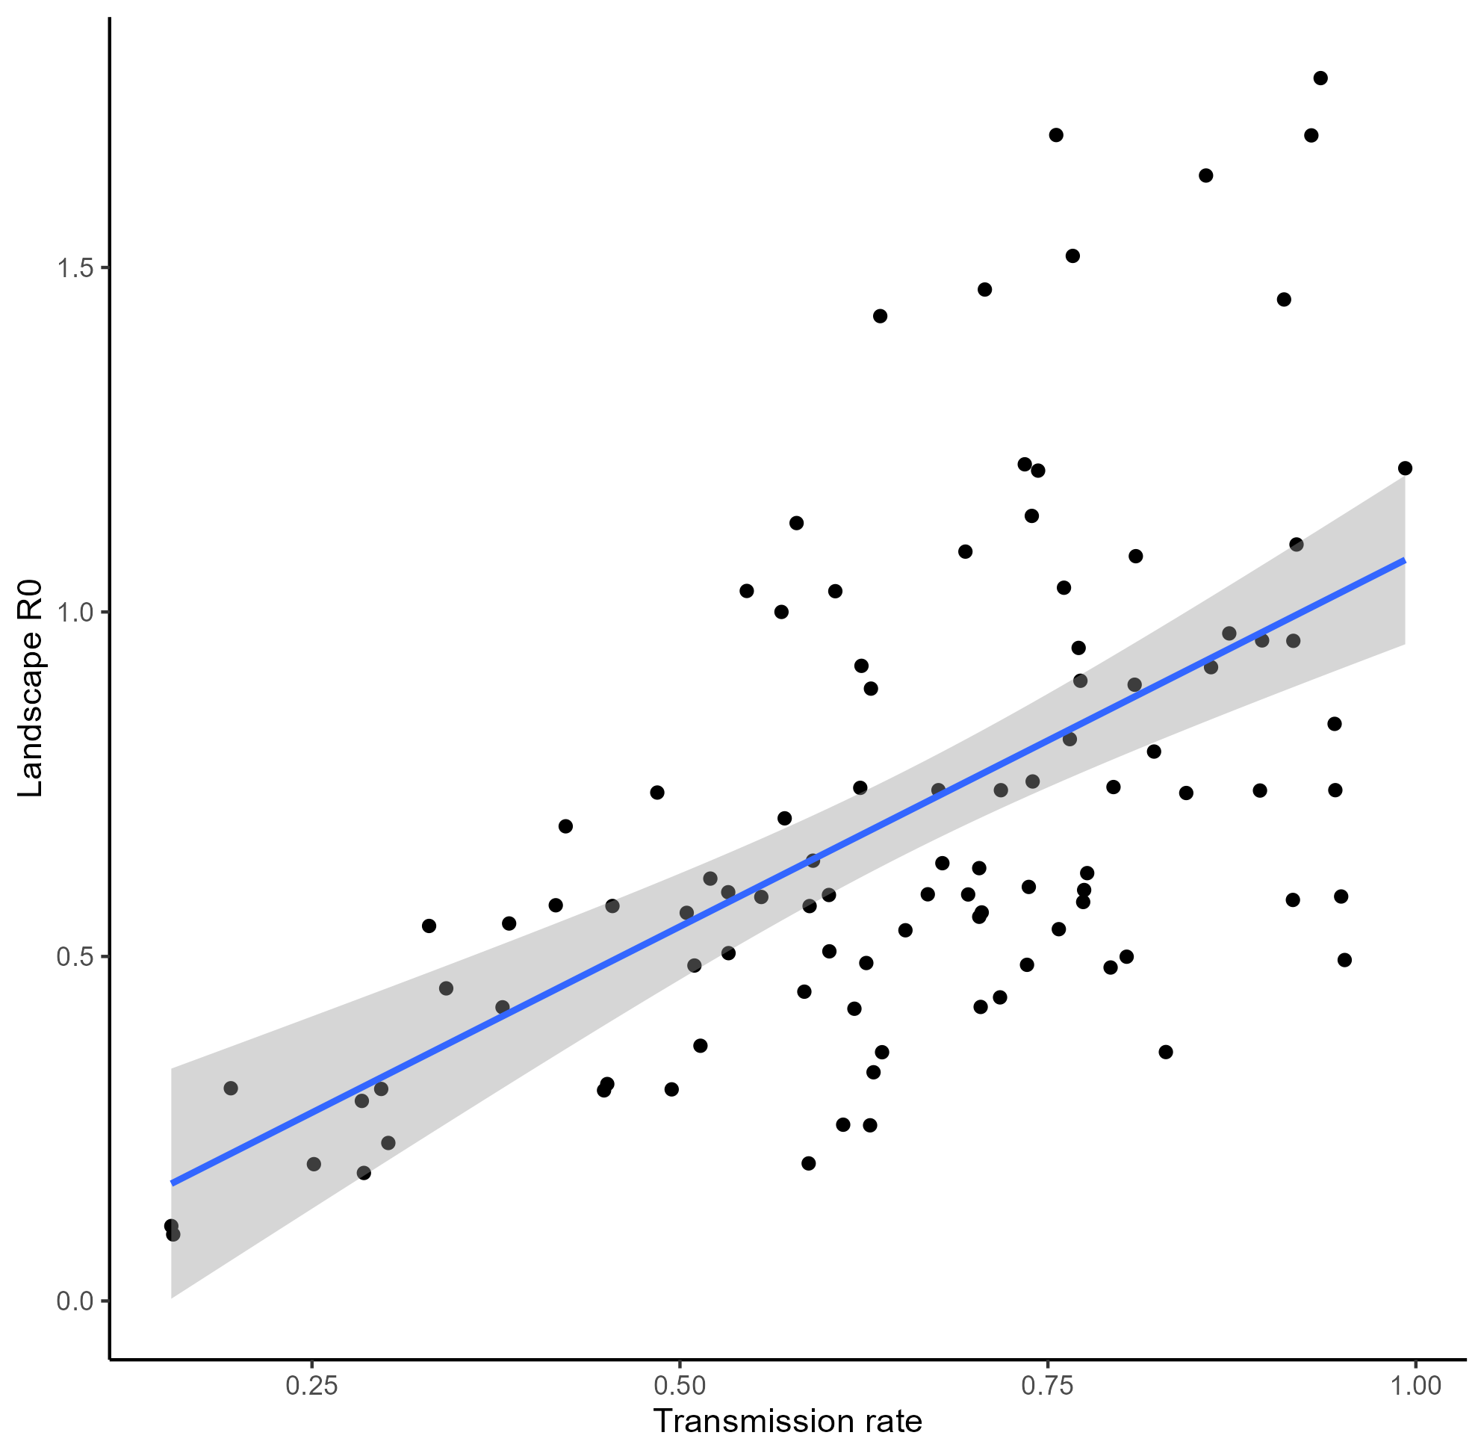

Figure 2: Effect of $β$ on $R_{0L}$

# Death rate

In these simulations, death rate is a vector d of 6 possible values. Originally, I had filled in 4 of the 6 species based on prior literature and the other 2 were filled in based on their rank abundance and the values of other species. Here, however, I created 6 random numbers using runif(6). This means death rates could vary between 0 and 1. When I ran this simulation 100 times, I compared $d_{max}$, $d_{min}$, and the range of values $d_{range}$. The results are shown below in figure 3.

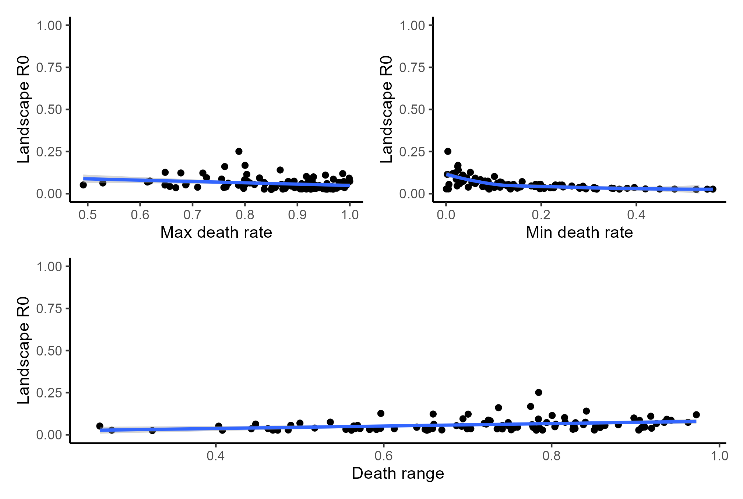

Figure 3: Effect of d on $R_{0L}$

# Recovery rate

Sensitivity testing for recovery rate was similar to how I tested death rate, because recovery rate is also a value between 0 and 1 and could be simulated using runif(6). As such, my process was very similar: I conducted 100 simulations and tested the compared the effects of $v_{max}$, $v_{min}$, and $v_{range}$. Results of the simulations are shown in figure 4. Overall, I think that these results suggest a limited affect of recovery rate on $R_{0L}$.

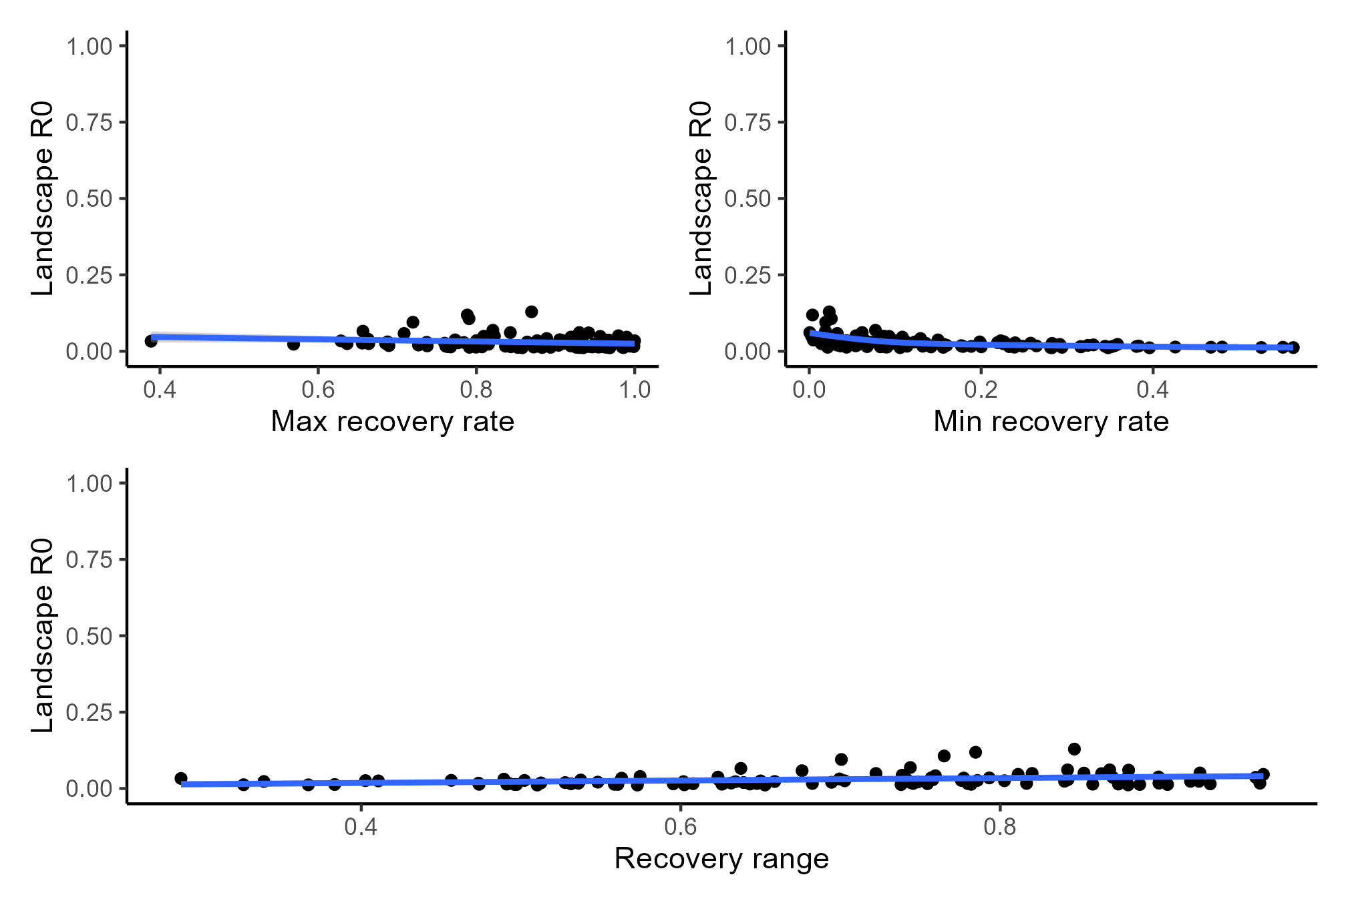

Figure 4: Effect of v on $R_{0L}$

# Dispersal

Lastly, I wanted to test the effect of dispersal. Similar to d and v, dispersal ($ϕ$), is a vector of length S. I also envision this as a variable ranging between 0 and 1 so I again used runif(6). Again, I think these results suggest limited effect of dispersal on $R_{0L}$.

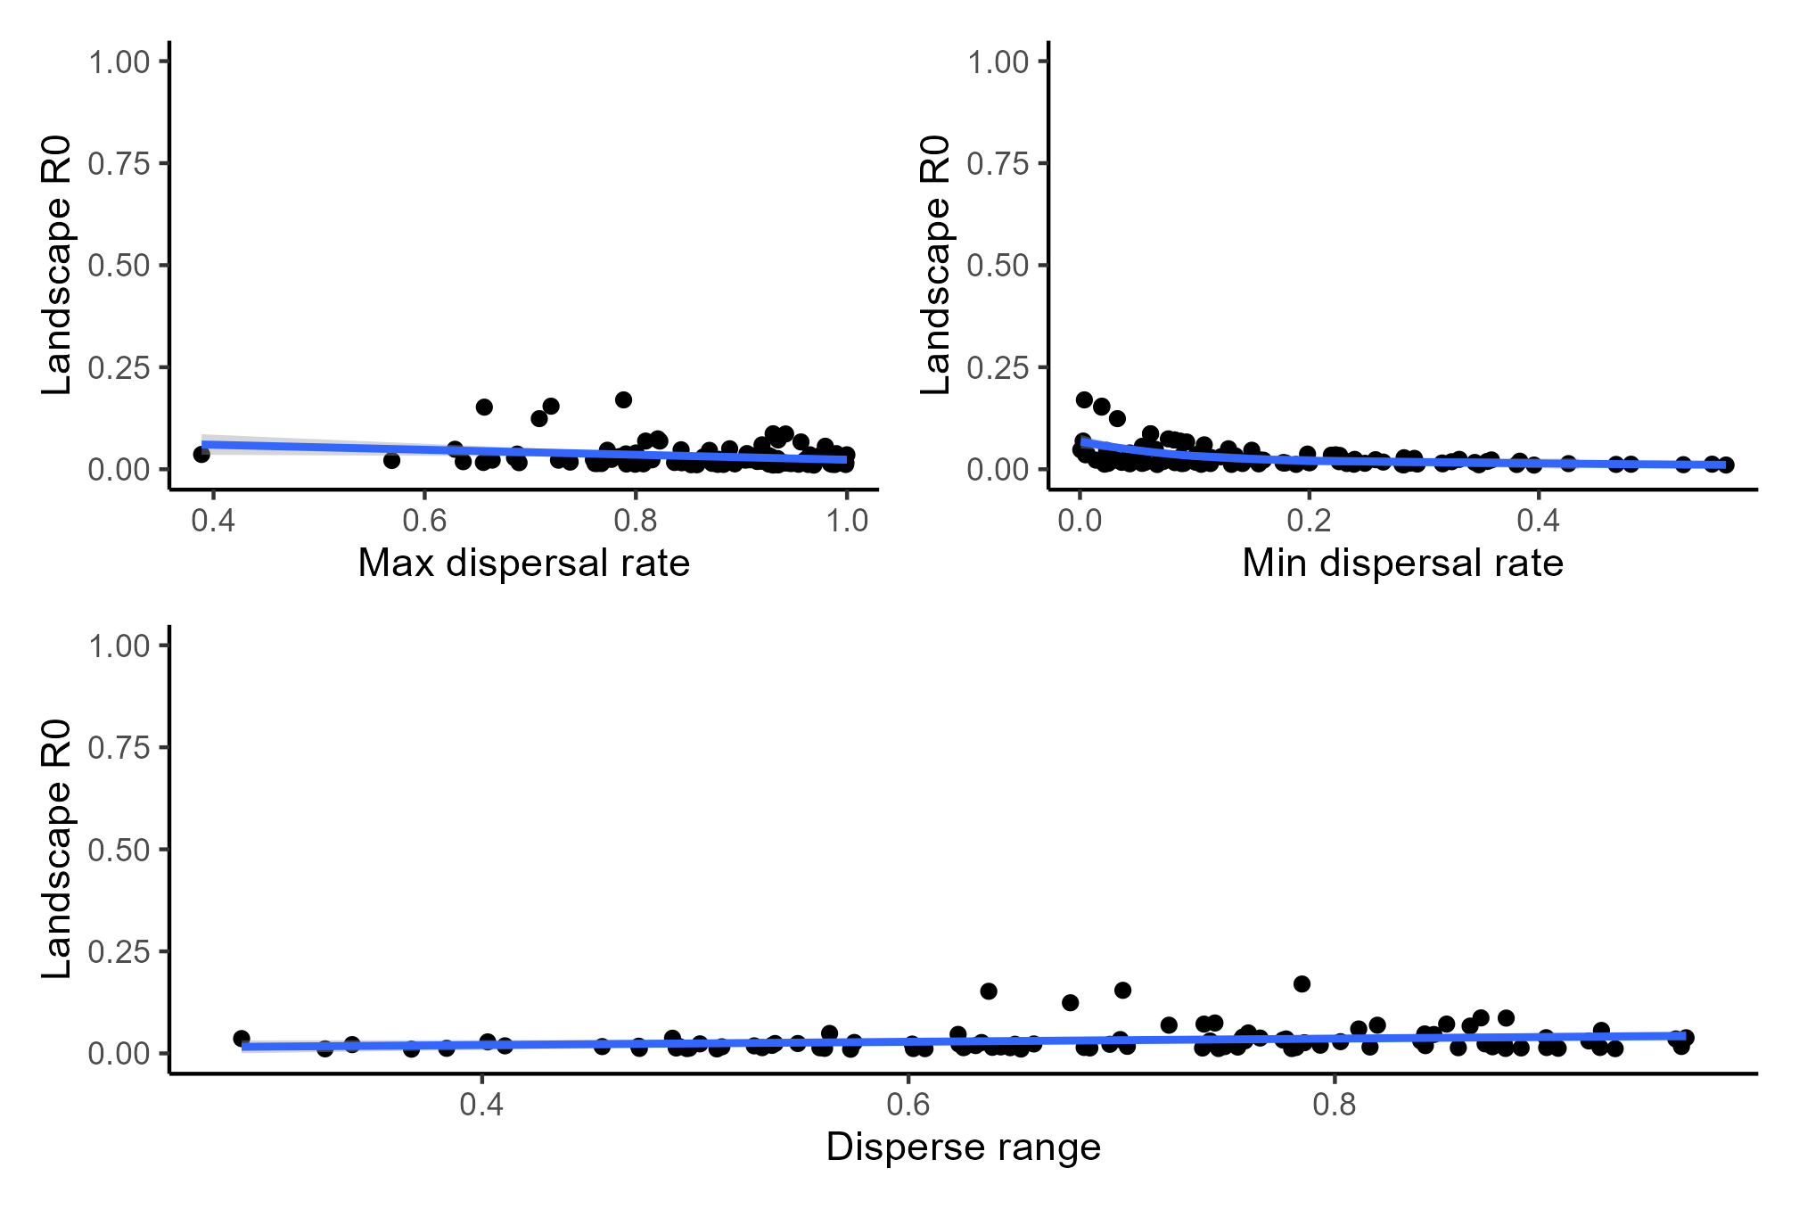

Figure 5: Effect of $ϕ$ on $R_{0L}$

# Conclusion

**IF** I have done this analysis similar to how you envisioned and **IF** I have interpreted this correctly, I take this to mean that connectivity and transmission have relatively strong effects, while death rate, recovery rate, and dispersal rate don’t necessarily impact $R_{0P}$.