CPE301 – Fall 2019

Design Assignment 1A

Student Name: Jacob Patrick Reed

Student #: 1008448895

Student Email: reedj35@unlv.nevada.edu

Primary Github address: www.github.com/reedjacobp

Directory: <https://github.com/reedjacobp/submission_da/tree/master/DesignAssignments/DA1A>

Submit the following for all Labs:

1. In the document, for each task submit the modified or included code (only) with highlights and justifications of the modifications. Also, include the comments.
2. Use the previously create a Github repository with a random name (no CPE/301, Lastname, Firstname). Place all labs under the root folder ESD301/DA, sub-folder named LABXX, with one document and one video link file for each lab, place modified asm/c files named as LabXX-TYY.asm/c.
3. If multiple asm/c files or other libraries are used, create a folder LabXX-TYY and place these files inside the folder.
4. The folder should have a) Word document (see template), b) source code file(s) and other include files, c) text file with youtube video links (see template).

1. **COMPONENTS LIST AND CONNECTION BLOCK DIAGRAM w/ PINS**

No components used

1. **INITIAL/MODIFIED/DEVELOPED CODE OF TASK 1/A**

.org 0x00

start:

ldi r25, 0xFF ; upper 8 bits of multiplicand

ldi r24, 0xFF ; lower 8 bits of multiplicand

ldi r23, 0xFF ; upper 8 bits of multiplier

ldi r22, 0xFF ; lower 8 bits of multiplier

ldi r20, 0x00 ; r20 and r19 are upper 16 bits of result

ldi r19, 0x00

ldi r18, 0x00 ; r18 and r17 are lower 16 bits of result

ldi r17, 0x00

ldi r16, 0x00

upper:

add r17, r24 ; adding lower 8 bits of multiplicand to r17

adc r18, r25 ; if there is a carry from r17, it will carry over to r18

adc r19, r20 ; if there is a carry from r18, it will carry over to r19

subi r23, 1 ; subtract 1 from upper 8 bits of the multiplier

cpi r23, 0 ; checking to see if r23 (upper 8 bits of multiplier) is zero

breq lower ; if so, branch to operate on lower 8 bits of multiplier

jmp upper ; otherwise, continue in this loop

lower:

add r18, r24 ; adding lower 8 bits of multiplicand to r18

adc r19, r25 ; if there is carry from r18, it will carry over to r19

adc r20, r16 ; if there is carry from r19, it will carry over to r20

subi r22, 1 ; subtract 1 from lower 8 bits of multiplier

cpi r22, 0 ; checking to see if r22 (lower 8 bits of multiplier) is zero

breq end ; if so, end the program

jmp lower ; otherwise, continue in this loop

end:

jmp end ; loop here to end the program

1. **DEVELOPED MODIFIED CODE OF TASK 2/A from TASK 1/A**

N/A

1. **SCHEMATICS**

N/A

1. **SCREENSHOTS OF EACH TASK OUTPUT (ATMEL STUDIO OUTPUT)**

Task 0

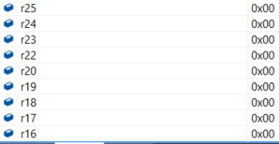

Figure 1: The registers before program is run

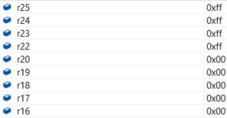

Figure 2: All registers being used are initialized

Task 1

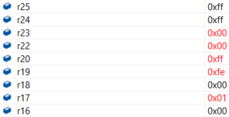

Figure 3: The registers holding result shows a hex number of FF FE 00 01

Verification

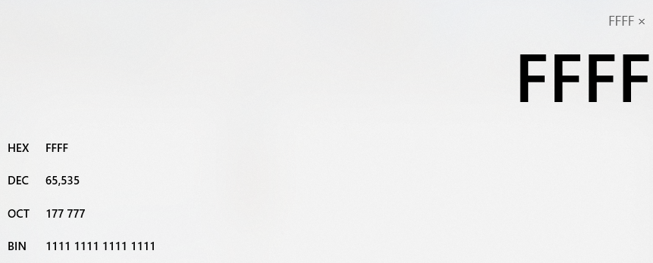

Figure 4: Using calculator which shows multiplicand and multiplier

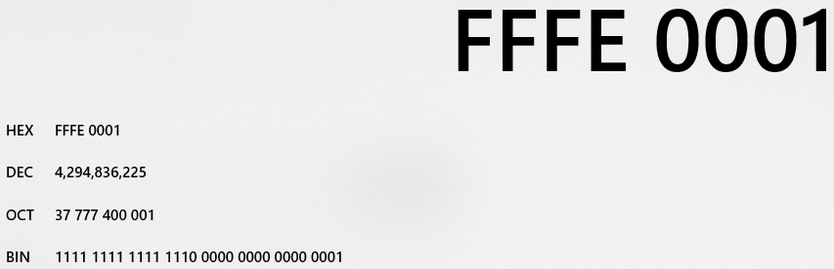

Figure 5: Final result showing the multiplication of FFFF and FFFF to be FFFE 0001

The result in the calculator (Fig. 5) is the same as the result obtained from the program (Fig. 3).

Task 4

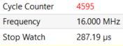

1. **SCREENSHOT OF EACH DEMO (BOARD SETUP)**

N/A

1. **VIDEO LINKS OF EACH DEMO**

https://youtu.be/YZq2mltBVVY

1. **GITHUB LINK OF THIS DA**

<https://github.com/reedjacobp/submission_da/tree/master/DesignAssignments/DA1A>

**Student Academic Misconduct Policy**

<http://studentconduct.unlv.edu/misconduct/policy.html>

“This assignment submission is my own, original work”.

Jacob Patrick Reed