CPE301 – Fall 2019

Design Assignment 1B

Student Name: Jacob Patrick Reed

Student #: 1008448895

Student Email: reedj35@unlv.nevada.edu

Primary Github address: <https://github.com/reedjacobp>

Directory: <https://github.com/reedjacobp/submission_da>

Submit the following for all Labs:

1. In the document, for each task submit the modified or included code (only) with highlights and justifications of the modifications. Also, include the comments.
2. Use the previously create a Github repository with a random name (no CPE/301, Lastname, Firstname). Place all labs under the root folder ESD301/DA, sub-folder named LABXX, with one document and one video link file for each lab, place modified asm/c files named as LabXX-TYY.asm/c.
3. If multiple asm/c files or other libraries are used, create a folder LabXX-TYY and place these files inside the folder.
4. The folder should have a) Word document (see template), b) source code file(s) and other include files, c) text file with youtube video links (see template).

1. **COMPONENTS LIST AND CONNECTION BLOCK DIAGRAM w/ PINS**

Atmel Studio 7

1. **INITIAL/MODIFIED/DEVELOPED CODE OF TASK 1/A**

;

; DA1B.asm

;

; Created: 9/22/2019 3:13:07 PM

; Author : jreed

;

.equ STARTADDS = 0x0200 ; set starting address

.equ FIVEADDS = 0x0300 ; set address for numbers divisible by 5

.equ ELSEADDS = 0x0500 ; set address for any other number

ldi ZL, LOW(STARTADDS) ; ZL=0x00

ldi ZH, HIGH(STARTADDS) ; ZH=0x02

ldi R20, 0x05 ; load R20 with starting value to store (decimal 5)

ldi R21, 0xFA ; load R21 with counter value (decimal 255)

L1: st Z+, R20 ; Z=R20 then increment pointer (e.g. 0x0200 -> 0x0201)

inc R20 ; increment value to be stored (e.g. 5 -> 6)

dec R21 ; R21 -= 1

brne L1 ; loop until R21=0 (255 iterations)

; the code above should store each incremented value as the pointer moves

; --- SEPARATING AND ADDING VALUES ---

ldi ZL, LOW(STARTADDS) ; ZL=0x00

ldi ZH, HIGH(STARTADDS) ; ZH=0x02

ldi YL, LOW(FIVEADDS) ; YL=0x00

ldi YH, HIGH(FIVEADDS) ; YH=0x03

ldi XL, LOW(ELSEADDS) ; XL=0x00

ldi XH, HIGH(ELSEADDS) ; XH=0x05

ldi R16, 0 ; initialize sum register to zero

ldi R17, 0 ; initialize sum register to zero

ldi R18, 0 ; initialize sum register to zero

ldi R19, 0 ; initialize sum register to zero

ldi R20, 250 ; load R20 with counter value

ldi R22, 0

ldi R23, 0 ; used to add carry

PARSE: ld R21, Z+ ; R21=Z then inc Z

mov R22, R21 ; R22=R21

DIVFIVE: subi R21, 0x05 ; R21 -= 5 to check for divisibility

breq DIV ; branch if R21 = 0 (divisible by 5)

brsh DIVFIVE ; branch if R21 >= 5, continue parsing

st X+, R22 ; store value not divisible by 5

add R18, R22 ; add value to running sum

adc R19, R23 ; add carry

rjmp CONT_PARSE ; jump to continue parsing

DIV: st Y+, R22 ; store value divisible by 5

add R16, R22 ; add value to running sum

adc R17, R23 ; add carry

CONT_PARSE: dec R20 ; R20 -= 1

brne PARSE ; loop until R20=0

END: jmp END ; end of program

1. **DEVELOPED MODIFIED CODE OF TASK 2/A from TASK 1/A**

N/A

1. **SCHEMATICS**

N/A

1. **SCREENSHOTS OF EACH TASK OUTPUT (ATMEL STUDIO OUTPUT)**

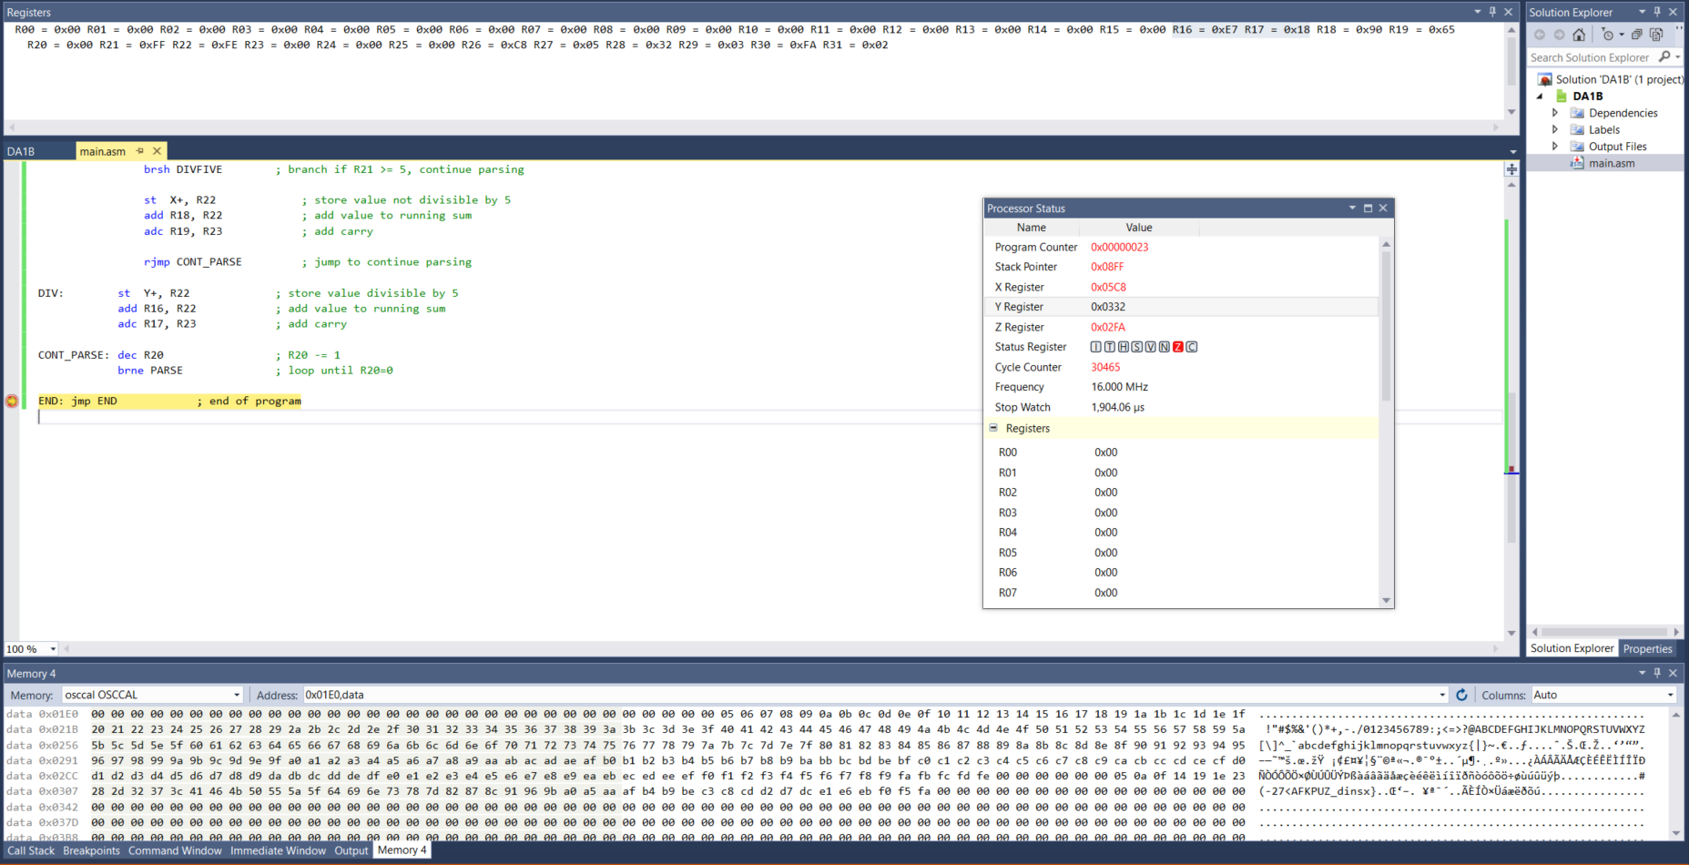

1. **SCREENSHOT OF EACH DEMO (BOARD SETUP)**

N/A

1. **VIDEO LINKS OF EACH DEMO**

https://youtu.be/HnfwcXqJ99M

1. **GITHUB LINK OF THIS DA**

<https://github.com/reedjacobp/submission_da/tree/master/DesignAssignments/DA1B>

**Student Academic Misconduct Policy**

<http://studentconduct.unlv.edu/misconduct/policy.html>

“This assignment submission is my own, original work”.

Jacob Reed