CPE301 – Fall 2019

Design Assignment 2A

Student Name: Jacob Patrick Reed

Student #: 1008448895

Student Email: reedj35@unlv.nevada.edu

Primary Github address: <https://github.com/reedjacobp>

Directory: <https://github.com/reedjacobp/submission_da>

Submit the following for all Labs:

1. In the document, for each task submit the modified or included code (only) with highlights and justifications of the modifications. Also, include the comments.
2. Use the previously create a Github repository with a random name (no CPE/301, Lastname, Firstname). Place all labs under the root folder ESD301/DA, sub-folder named LABXX, with one document and one video link file for each lab, place modified asm/c files named as LabXX-TYY.asm/c.
3. If multiple asm/c files or other libraries are used, create a folder LabXX-TYY and place these files inside the folder.
4. The folder should have a) Word document (see template), b) source code file(s) and other include files, c) text file with youtube video links (see template).

1. **COMPONENTS LIST AND CONNECTION BLOCK DIAGRAM w/ PINS**

ATmega32PB Xplained Mini

Multi-Function Shield

1. **INITIAL/MODIFIED/DEVELOPED CODE OF TASK 1 and TASK 2**

Assembly Code

.org 0x00

LDI R16, 0xFF ; R16 = 0b11111111

OUT DDRB, R16 ; make PORTB as an output

OUT PORTB, R16 ; all LEDs should turn off

LDI R16, 0x00 ; R16 = 0b00000000

OUT DDRC, R16 ; switches are inputs

START: CBI PORTB, 3 ; turn on PB5/D1

; 250 ms delay loop

LDI R18, 21

LDI R19, 75

LDI R20, 191

DELAY1: DEC R20

BRNE DELAY1

DEC R19

BRNE DELAY1

DEC R18

BRNE DELAY1

NOP

SBI PORTB, 3 ; turn off PB5/D1

; 375 ms delay loop

LDI R18, 31

LDI R19, 113

LDI R20, 31

DELAY2: DEC R20

BRNE DELAY2

DEC R19

BRNE DELAY2

DEC R18

BRNE DELAY2

NOP

SBIS PINC, 3 ; skip next instruction if switch is pressed

RJMP TASK2 ; go to task 2 if switch is pressed

RJMP START ; if switch is not pressed, go back to the beginning of code

TASK2: CBI PORTB, 2 ; turn on PB2/D4

; 1.333 sec delay

LDI R18, 109

LDI R19, 51

LDI R20, 106

DELAY3: DEC R20

BRNE DELAY3

DEC R19

BRNE DELAY3

DEC R18

BRNE DELAY3

SBI PORTB, 2 ; turn off PB2/D4

RJMP START ; go back to the beginning of code

C Code

#define *F_CPU* 16000000UL

#include <avr/io.h>

#include <util/delay.h>

int main(void)

{

DDRB = 0xFF;

DDRC = 0x00;

PORTB = 0xFF;

// DDRB |= (1 << PORTB3);

// DDRB |= (1 << PORTB2);

// DDRC &= ~(1 << PORTC3);

while(1)

{

PORTB |= (1 << PORTB3);

*_delay_ms*(375);

PORTB &= ~(1 << PORTB3);

*_delay_ms*(250);

if ( !(PINC & (1 << 3)))

{

PORTB |= (1 << PORTB3);

PORTB &= ~(1 << PORTB2);

*_delay_ms*(1333);

PORTB |= (1 << PORTB2);

}

}

return 0;

}

1. **DEVELOPED MODIFIED CODE OF TASK 2/A from TASK 1/A**

N/A

1. **SCHEMATICS**

N/A

1. **SCREENSHOTS OF EACH TASK OUTPUT (ATMEL STUDIO OUTPUT)**

N/A

1. **SCREENSHOT OF EACH DEMO (BOARD SETUP)**

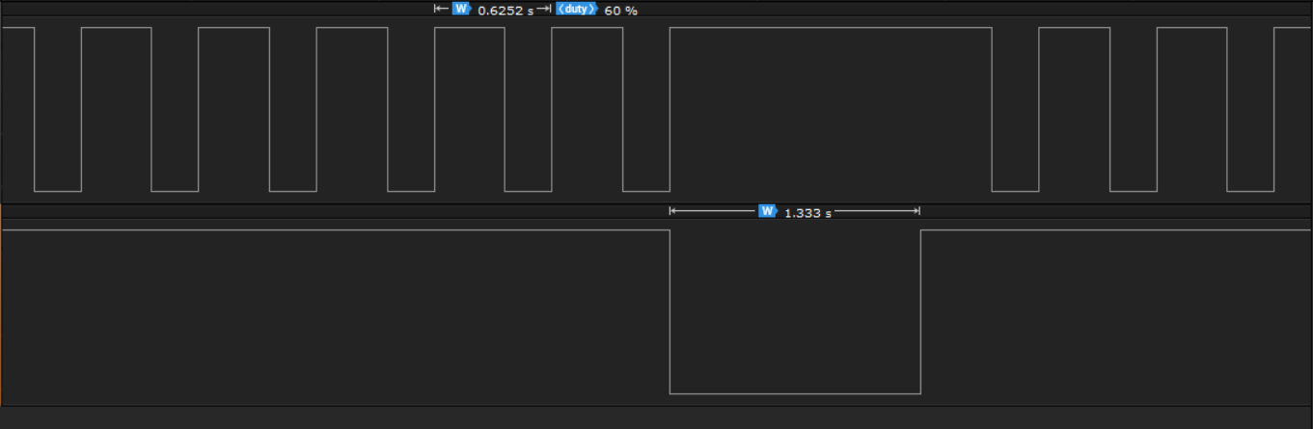

1. **VIDEO LINKS OF EACH DEMO**

https://youtu.be/qnk2Cp3dPsE

1. **GITHUB LINK OF THIS DA**

<https://github.com/reedjacobp/submission_da/tree/master/DesignAssignments/DA2A>

**Student Academic Misconduct Policy**

<http://studentconduct.unlv.edu/misconduct/policy.html>

“This assignment submission is my own, original work”.

NAME OF THE STUDENT