CPE301 – Fall 2019

Final Project

Student Name: Jacob Patrick Reed

Student #: 1008448895

Student Email: reedj35@unlv.nevada.edu

Primary Github address: <https://github.com/reedjacobp>

Directory: <https://github.com/reedjacobp/submission_da>

Submit the following for all Labs:

1. In the document, for each task submit the modified or included code (only) with highlights and justifications of the modifications. Also, include the comments.
2. Use the previously create a Github repository with a random name (no CPE/301, Lastname, Firstname). Place all labs under the root folder ESD301/DA, sub-folder named LABXX, with one document and one video link file for each lab, place modified asm/c files named as LabXX-TYY.asm/c.
3. If multiple asm/c files or other libraries are used, create a folder LabXX-TYY and place these files inside the folder.
4. The folder should have a) Word document (see template), b) source code file(s) and other include files, c) text file with youtube video links (see template).

1. **COMPONENTS LIST AND CONNECTION BLOCK DIAGRAM w/ PINS**

ATmega328PB Xplained Mini

ESP Module

APDS9960

1. **DEVELOPED CODE OF TASK 1**

/*

* FinalProject.c

*

* Created: 12/8/2019 12:32:56 AM

* Author : jreed

*/

#ifndef F_CPU

#define F_CPU 16000000UL

#endif

// Global constants for uart

#define BAUD 115200

#define FOSC 16000000

#define UBRR FOSC/8/BAUD-1

#define APDS9960_WRITE 0x72

#define APDS9960_READ 0x73

//include standard libraries

#include <avr/io.h>

#include <stdlib.h>

#include <stdio.h>

#include <util/delay.h>

#include <math.h>

//include custom libraries

#include "APDS9960_def.h"

#include "i2c_master.h"

//Function declarations

void getValues(void);

// void TIMER1_init();

void init_APDS9960(void);

void usart_init();

void USART_putstring(volatile unsigned char *StringPtr);

//AT commands

volatile unsigned char AT[] = "AT\r\n"; // Test

volatile unsigned char CWMODE[] = "AT+CWMODE=3\r\n"; // Set Wi-Fi mode

volatile unsigned char CWJAP[] = "AT+CWJAP=\"blahblah\",\"blahblah\"\r\n"; // Get Wi-Fi info

volatile unsigned char CIPSTART[] = "AT+CIPSTART=\"TCP\",\"184.106.153.149\",80\r\n"; // Establish connection with ThingSpeak

volatile unsigned char CIPSEND[] = "AT+CIPSEND=104\r\n"; // Set send function to 104

volatile unsigned char CIPMUX[] = "AT+CIPMUX=0\r\n"; // Enable connection

volatile unsigned char SEND_DATA[] = "GET /update?key=IW250NQFTF4HL1KZ&field1="; // Get Write Key

volatile unsigned char RESET[] = "AT+RST\r\n"; // Get AT Firmware info

volatile unsigned char LINEBREAK[] = "\r\n"; // end of temperature transmission

volatile unsigned char CLOSE[] = "AT+CIPCLOSE\r\n";

//string for colors

volatile unsigned char RedStr[10];

volatile unsigned char GreenStr[10];

volatile unsigned char BlueStr[10];

*uint16_t* redVal, greenVal, blueVal;

int main(void){

i2c_init();

usart_init(115200);

init_APDS9960();

//Start up Esp

//Start AT communication

*_delay_ms*(10);

USART_putstring(AT); //send AT to the USART

//connect to network

*_delay_ms*(10);

USART_putstring(RESET); //reset ESP

*_delay_ms*(10);

USART_putstring(AT); //confirm communication

*_delay_ms*(10);

USART_putstring(CWMODE); //WiFi mode = 3

*_delay_ms*(10);

USART_putstring(CWJAP); //Send wifi login

while(1){

//getValues();

*_delay_ms*(10);

USART_putstring(CIPMUX); //Single connection point

*_delay_ms*(10);

USART_putstring(CIPSTART); // Connect to ThingSpeak

*_delay_ms*(10);

USART_putstring(CIPSEND); // Declare send length 50

*_delay_ms*(10);

getValues();

USART_putstring(SEND_DATA); // Connect to proper key

USART_putstring(RedStr); // Send adc data

USART_putstring("&field2=");

USART_putstring(GreenStr); // Send adc data

USART_putstring("&field3=");

USART_putstring(BlueStr); // Send adc data

*_delay_ms*(1000);

}

return 0;

}

void init_APDS9960(void){

*uint8_t* setup;

i2c_readReg(APDS9960_WRITE, APDS9960_ID, &setup,1);

if(setup != APDS9960_ID_1) while(1);

setup = 1 << 1 | 1<<0 | 1<<3 | 1<<4;

i2c_writeReg(APDS9960_WRITE, APDS9960_ENABLE, &setup, 1);

setup = DEFAULT_ATIME;

i2c_writeReg(APDS9960_WRITE, APDS9960_ATIME, &setup, 1);

setup = DEFAULT_WTIME;

i2c_writeReg(APDS9960_WRITE, APDS9960_WTIME, &setup, 1);

setup = DEFAULT_PROX_PPULSE;

i2c_writeReg(APDS9960_WRITE, APDS9960_PPULSE, &setup, 1);

setup = DEFAULT_POFFSET_UR;

i2c_writeReg(APDS9960_WRITE, APDS9960_POFFSET_UR, &setup, 1);

setup = DEFAULT_POFFSET_DL;

i2c_writeReg(APDS9960_WRITE, APDS9960_POFFSET_DL, &setup, 1);

setup = DEFAULT_CONFIG1;

i2c_writeReg(APDS9960_WRITE, APDS9960_CONFIG1, &setup, 1);

setup = DEFAULT_PERS;

i2c_writeReg(APDS9960_WRITE, APDS9960_PERS, &setup, 1);

setup = DEFAULT_CONFIG2;

i2c_writeReg(APDS9960_WRITE, APDS9960_CONFIG2, &setup, 1);

setup = DEFAULT_CONFIG3;

i2c_writeReg(APDS9960_WRITE, APDS9960_CONFIG3, &setup, 1);

}

void getValues(void){

*uint8_t* redVH, redVL;

*uint8_t* greenVH, greenVL;

*uint8_t* blueVH, blueVL;

unsigned char i;

char dummy[10];

// Read red value

i2c_readReg(APDS9960_WRITE, APDS9960_RDATAH, &redVH, 1);

i2c_readReg(APDS9960_WRITE, APDS9960_RDATAL, &redVL, 1);

// Read green value

i2c_readReg(APDS9960_WRITE, APDS9960_GDATAH, &greenVH, 1);

i2c_readReg(APDS9960_WRITE, APDS9960_GDATAL, &greenVL, 1);

// Read blue value

i2c_readReg(APDS9960_WRITE, APDS9960_BDATAH, &blueVH, 1);

i2c_readReg(APDS9960_WRITE, APDS9960_BDATAL, &blueVL, 1);

redVal = (redVH << 8) | redVL;

greenVal = (greenVH << 8) | greenVL;

blueVal = (blueVH << 8) | blueVL;

// Set max threshold values

if (redVal > 255){

redVal = 255;

}

if (greenVal > 255){

greenVal = 255;

}

if (blueVal > 255){

blueVal = 255;

}

*itoa*(redVal, dummy, 10); //convert char to ascii

for(i = 0 ; i < 10 ; i++){

RedStr[i] = dummy[i]; //move converted ascii

}

*itoa*(greenVal, dummy, 10); //convert char to ascii

for(i = 0 ; i < 10 ; i++){

GreenStr[i] = dummy[i]; //move converted ascii

}

*itoa*(blueVal, dummy, 10); //convert char to ascii

for(i = 0 ; i < 10 ; i++){

BlueStr[i] = dummy[i]; //move converted ascii

}

}

void usart_init() {

UBRR0H = ((UBRR) >> 8);

UBRR0L = UBRR;

UCSR0A |= (1<< U2X0); // divisor baud = 8

UCSR0B |= (1 << TXEN0); // Enable transmission

UCSR0C |= (1 << UCSZ01) | (1 << UCSZ00); // 8 bits

}

void USART_putstring(volatile unsigned char *StringPtr)

{

while ((*StringPtr != '\0')){

while (!(UCSR0A & (1 << UDRE0)));

UDR0 = *StringPtr;

StringPtr++;

}

}

1. **INCLUDE FILES**

uart.h

/*

* uart.h

*

* Created: 12/8/2019 12:55:25 AM

* Author: jreed

*/

#ifndef USART_RS232_H_FILE_H_ /* Define library H file if not defined */

#define USART_RS232_H_FILE_H_

#define F_CPU 16000000UL /* Define CPU clock Frequency e.g. here its 8MHz */

#include <avr/io.h> /* Include AVR std. library file */

#define BAUD_PRESCALE (((F_CPU / (BAUDRATE * 16UL))) - 1) /* Define prescale value */

void USART_Init(unsigned long); /* USART initialize function */

char USART_RxChar(); /* Data receiving function */

void USART_TxChar(char); /* Data transmitting function */

void USART_SendString(char*); /* Send string of USART data function */

#endif

uart.c

/*

* uart.c

*

* Created: 12/8/2019 12:54:27 AM

* Author: jreed

*/

#include "uart.h" /* Include USART header file */

void USART_Init(unsigned long BAUDRATE) /* USART initialize function */

{

UCSR0B |= (1 << RXEN0) | (1 << TXEN0); /* Enable USART transmitter and receiver */

UCSR0C |= (1 << UCSZ00) | (1 << UCSZ01); /* Write USCRC for 8 bit data and 1 stop bit */

UBRR0L = BAUD_PRESCALE; /* Load UBRRL with lower 8 bit of prescale value */

UBRR0H = (BAUD_PRESCALE >> 8); /* Load UBRRH with upper 8 bit of prescale value */

}

char USART_RxChar() /* Data receiving function */

{

while (!(UCSR0A & (1 << RXC0))); /* Wait until new data receive */

return(UDR0); /* Get and return received data */

}

void USART_TxChar(char data) /* Data transmitting function */

{

UDR0 = data; /* Write data to be transmitting in UDR */

while (!(UCSR0A & (1<<UDRE0))); /* Wait until data transmit and buffer get empty */

}

void USART_SendString(char *str) /* Send string of USART data function */

{

int i=0;

while (str[i]!=0)

{

USART_TxChar(str[i]); /* Send each char of string till the NULL */

i++;

}

}

i2c_master.h

/*

* i2c_master.h

*

* Created: 12/8/2019 12:59:39 AM

* Author: jreed

*/

#ifndef I2C_MASTER_H

#define I2C_MASTER_H

#define I2C_READ 0x01

#define I2C_WRITE 0x00

void i2c_init(void);

*uint8_t* i2c_start(*uint8_t* address);

*uint8_t* i2c_write(*uint8_t* data);

*uint8_t* i2c_read_ack(void);

*uint8_t* i2c_read_nack(void);

*uint8_t* i2c_transmit(*uint8_t* address, *uint8_t*\* data, *uint16_t* length);

*uint8_t* i2c_receive(*uint8_t* address, *uint8_t*\* data, *uint16_t* length);

*uint8_t* i2c_writeReg(*uint8_t* devaddr, *uint8_t* regaddr, *uint8_t*\* data, *uint16_t* length);

*uint8_t* i2c_readReg(*uint8_t* devaddr, *uint8_t* regaddr, *uint8_t*\* data, *uint16_t* length);

void i2c_stop(void);

#endif // I2C_MASTER_H

i2c_master.c

/*

* i2c_master.c

*

* Created: 12/8/2019 12:58:22 AM

* Author: jreed

*/

#ifndef F_CPU

#define F_CPU 16000000UL

#endif

#include <avr/io.h>

#include <util/twi.h>

#include "i2c_master.h"

#define F_SCL 100000UL // SCL frequency

#define Prescaler 1

#define TWBR_val ((((F_CPU / F_SCL) / Prescaler) - 16 ) / 2)

#define *TW_STATUS* (TWSR0 & *TW_STATUS_MASK*)

void i2c_init(void)

{

TWBR0 = (*uint8_t*)TWBR_val;

}

*uint8_t* i2c_start(*uint8_t* address)

{

// reset TWI control register

TWCR0 = 0;

// transmit START condition

TWCR0 = (1<<TWINT) | (1<<TWSTA) | (1<<TWEN);

// wait for end of transmission

while( !(TWCR0 & (1<<TWINT)) );

// check if the start condition was successfully transmitted

if((TWSR0 & 0xF8) != *TW_START*){ return 1; }

// load slave address into data register

TWDR0 = address;

// start transmission of address

TWCR0 = (1<<TWINT) | (1<<TWEN);

// wait for end of transmission

while( !(TWCR0 & (1<<TWINT)) );

// check if the device has acknowledged the READ / WRITE mode

*uint8_t* twst = *TW_STATUS* & 0xF8;

if ( (twst != *TW_MT_SLA_ACK*) && (twst != *TW_MR_SLA_ACK*) ) return 1;

return 0;

}

*uint8_t* i2c_write(*uint8_t* data)

{

// load data into data register

TWDR0 = data;

// start transmission of data

TWCR0 = (1<<TWINT) | (1<<TWEN);

// wait for end of transmission

while( !(TWCR0 & (1<<TWINT)) );

if( (TWSR0 & 0xF8) != *TW_MT_DATA_ACK* ){ return 1; }

return 0;

}

*uint8_t* i2c_read_ack(void)

{

// start TWI module and acknowledge data after reception

TWCR0 = (1<<TWINT) | (1<<TWEN) | (1<<TWEA);

// wait for end of transmission

while( !(TWCR0 & (1<<TWINT)) );

// return received data from TWDR

return TWDR0;

}

*uint8_t* i2c_read_nack(void)

{

// start receiving without acknowledging reception

TWCR0 = (1<<TWINT) | (1<<TWEN);

// wait for end of transmission

while( !(TWCR0 & (1<<TWINT)) );

// return received data from TWDR

return TWDR0;

}

*uint8_t* i2c_transmit(*uint8_t* address, *uint8_t*\* data, *uint16_t* length)

{

if (i2c_start(address | I2C_WRITE)) return 1;

for (*uint16_t* i = 0; i < length; i++)

{

if (i2c_write(data[i])) return 1;

}

i2c_stop();

return 0;

}

*uint8_t* i2c_receive(*uint8_t* address, *uint8_t*\* data, *uint16_t* length)

{

if (i2c_start(address | I2C_READ)) return 1;

for (*uint16_t* i = 0; i < (length-1); i++)

{

data[i] = i2c_read_ack();

}

data[(length-1)] = i2c_read_nack();

i2c_stop();

return 0;

}

*uint8_t* i2c_writeReg(*uint8_t* devaddr, *uint8_t* regaddr, *uint8_t*\* data, *uint16_t* length)

{

if (i2c_start(devaddr | 0x00)) return 1;

i2c_write(regaddr);

for (*uint16_t* i = 0; i < length; i++)

{

if (i2c_write(data[i])) return 1;

}

i2c_stop();

return 0;

}

*uint8_t* i2c_readReg(*uint8_t* devaddr, *uint8_t* regaddr, *uint8_t*\* data, *uint16_t* length)

{

if (i2c_start(devaddr)) return 1;

i2c_write(regaddr);

if (i2c_start(devaddr | 0x01)) return 1;

for (*uint16_t* i = 0; i < (length-1); i++)

{

data[i] = i2c_read_ack();

}

data[(length-1)] = i2c_read_nack();

i2c_stop();

return 0;

}

void i2c_stop(void)

{

// transmit STOP condition

TWCR0 = (1<<TWINT) | (1<<TWEN) | (1<<TWSTO);

}

APDS9960_def.h

/*

* APDS9960_def.h

*

* Created: 12/8/2019 2:04:11 AM

* Author: jreed

*/

#ifndef SparkFun_APDS9960_H

#define SparkFun_APDS9960_H

/* APDS-9960 I2C address */

#define APDS9960_I2C_ADDR 0x39

/* Gesture parameters */

#define GESTURE_THRESHOLD_OUT 10

#define GESTURE_SENSITIVITY_1 50

#define GESTURE_SENSITIVITY_2 20

/* Error code for returned values */

#define ERROR 0xFF

/* Acceptable device IDs */

#define APDS9960_ID_1 0xAB

#define APDS9960_ID_2 0x9C

/* Misc parameters */

#define FIFO_PAUSE_TIME 30 // Wait period (ms) between FIFO reads

/* APDS-9960 register addresses */

#define APDS9960_ENABLE 0x80

#define APDS9960_ATIME 0x81

#define APDS9960_WTIME 0x83

#define APDS9960_AILTL 0x84

#define APDS9960_AILTH 0x85

#define APDS9960_AIHTL 0x86

#define APDS9960_AIHTH 0x87

#define APDS9960_PILT 0x89

#define APDS9960_PIHT 0x8B

#define APDS9960_PERS 0x8C

#define APDS9960_CONFIG1 0x8D

#define APDS9960_PPULSE 0x8E

#define APDS9960_CONTROL 0x8F

#define APDS9960_CONFIG2 0x90

#define APDS9960_ID 0x92

#define APDS9960_STATUS 0x93

#define APDS9960_CDATAL 0x94

#define APDS9960_CDATAH 0x95

#define APDS9960_RDATAL 0x96

#define APDS9960_RDATAH 0x97

#define APDS9960_GDATAL 0x98

#define APDS9960_GDATAH 0x99

#define APDS9960_BDATAL 0x9A

#define APDS9960_BDATAH 0x9B

#define APDS9960_PDATA 0x9C

#define APDS9960_POFFSET_UR 0x9D

#define APDS9960_POFFSET_DL 0x9E

#define APDS9960_CONFIG3 0x9F

#define APDS9960_GPENTH 0xA0

#define APDS9960_GEXTH 0xA1

#define APDS9960_GCONF1 0xA2

#define APDS9960_GCONF2 0xA3

#define APDS9960_GOFFSET_U 0xA4

#define APDS9960_GOFFSET_D 0xA5

#define APDS9960_GOFFSET_L 0xA7

#define APDS9960_GOFFSET_R 0xA9

#define APDS9960_GPULSE 0xA6

#define APDS9960_GCONF3 0xAA

#define APDS9960_GCONF4 0xAB

#define APDS9960_GFLVL 0xAE

#define APDS9960_GSTATUS 0xAF

#define APDS9960_IFORCE 0xE4

#define APDS9960_PICLEAR 0xE5

#define APDS9960_CICLEAR 0xE6

#define APDS9960_AICLEAR 0xE7

#define APDS9960_GFIFO_U 0xFC

#define APDS9960_GFIFO_D 0xFD

#define APDS9960_GFIFO_L 0xFE

#define APDS9960_GFIFO_R 0xFF

/* Bit fields */

#define APDS9960_PON 0b00000001

#define APDS9960_AEN 0b00000010

#define APDS9960_PEN 0b00000100

#define APDS9960_WEN 0b00001000

#define APSD9960_AIEN 0b00010000

#define APDS9960_PIEN 0b00100000

#define APDS9960_GEN 0b01000000

#define APDS9960_GVALID 0b00000001

/* On/Off definitions */

#define OFF 0

#define ON 1

/* Acceptable parameters for setMode */

#define POWER 0

#define AMBIENT_LIGHT 1

#define PROXIMITY 2

#define WAIT 3

#define AMBIENT_LIGHT_INT 4

#define PROXIMITY_INT 5

#define GESTURE 6

#define ALL 7

/* LED Drive values */

#define LED_DRIVE_100MA 0

#define LED_DRIVE_50MA 1

#define LED_DRIVE_25MA 2

#define LED_DRIVE_12_5MA 3

/* Proximity Gain (PGAIN) values */

#define PGAIN_1X 0

#define PGAIN_2X 1

#define PGAIN_4X 2

#define PGAIN_8X 3

/* ALS Gain (AGAIN) values */

#define AGAIN_1X 0

#define AGAIN_4X 1

#define AGAIN_16X 2

#define AGAIN_64X 3

/* Gesture Gain (GGAIN) values */

#define GGAIN_1X 0

#define GGAIN_2X 1

#define GGAIN_4X 2

#define GGAIN_8X 3

/* LED Boost values */

#define LED_BOOST_100 0

#define LED_BOOST_150 1

#define LED_BOOST_200 2

#define LED_BOOST_300 3

/* Gesture wait time values */

#define GWTIME_0MS 0

#define GWTIME_2_8MS 1

#define GWTIME_5_6MS 2

#define GWTIME_8_4MS 3

#define GWTIME_14_0MS 4

#define GWTIME_22_4MS 5

#define GWTIME_30_8MS 6

#define GWTIME_39_2MS 7

/* Default values */

#define DEFAULT_ATIME 219 // 103ms

#define DEFAULT_WTIME 246 // 27ms

#define DEFAULT_PROX_PPULSE 0x87 // 16us, 8 pulses

#define DEFAULT_GESTURE_PPULSE 0x89 // 16us, 10 pulses

#define DEFAULT_POFFSET_UR 0 // 0 offset

#define DEFAULT_POFFSET_DL 0 // 0 offset

#define DEFAULT_CONFIG1 0x60 // No 12x wait (WTIME) factor

#define DEFAULT_LDRIVE LED_DRIVE_100MA

#define DEFAULT_PGAIN PGAIN_4X

#define DEFAULT_AGAIN AGAIN_4X

#define DEFAULT_PILT 0 // Low proximity threshold

#define DEFAULT_PIHT 50 // High proximity threshold

#define DEFAULT_AILT 0xFFFF // Force interrupt for calibration

#define DEFAULT_AIHT 0

#define DEFAULT_PERS 0x11 // 2 consecutive prox or ALS for int.

#define DEFAULT_CONFIG2 0x01 // No saturation interrupts or LED boost

#define DEFAULT_CONFIG3 0 // Enable all photodiodes, no SAI

#define DEFAULT_GPENTH 40 // Threshold for entering gesture mode

#define DEFAULT_GEXTH 30 // Threshold for exiting gesture mode

#define DEFAULT_GCONF1 0x40 // 4 gesture events for int., 1 for exit

#define DEFAULT_GGAIN GGAIN_4X

#define DEFAULT_GLDRIVE LED_DRIVE_100MA

#define DEFAULT_GWTIME GWTIME_2_8MS

#define DEFAULT_GOFFSET 0 // No offset scaling for gesture mode

#define DEFAULT_GPULSE 0xC9 // 32us, 10 pulses

#define DEFAULT_GCONF3 0 // All photodiodes active during gesture

#define DEFAULT_GIEN 0 // Disable gesture interrupts

#endif

1. **SCREENSHOTS OF EACH TASK OUTPUT (ATMEL STUDIO OUTPUT)**

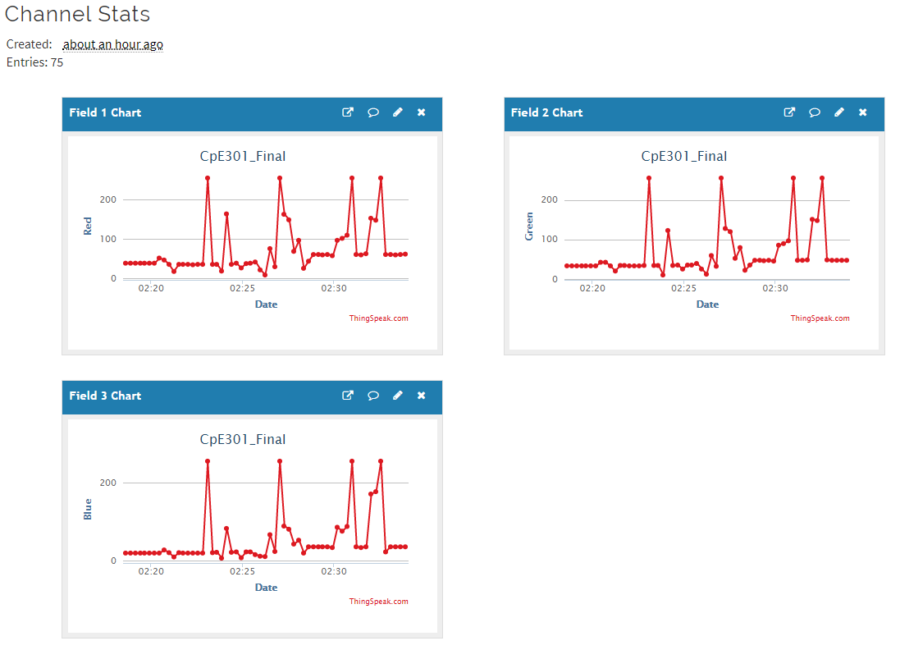

1. **SCREENSHOT OF EACH DEMO (BOARD SETUP)**

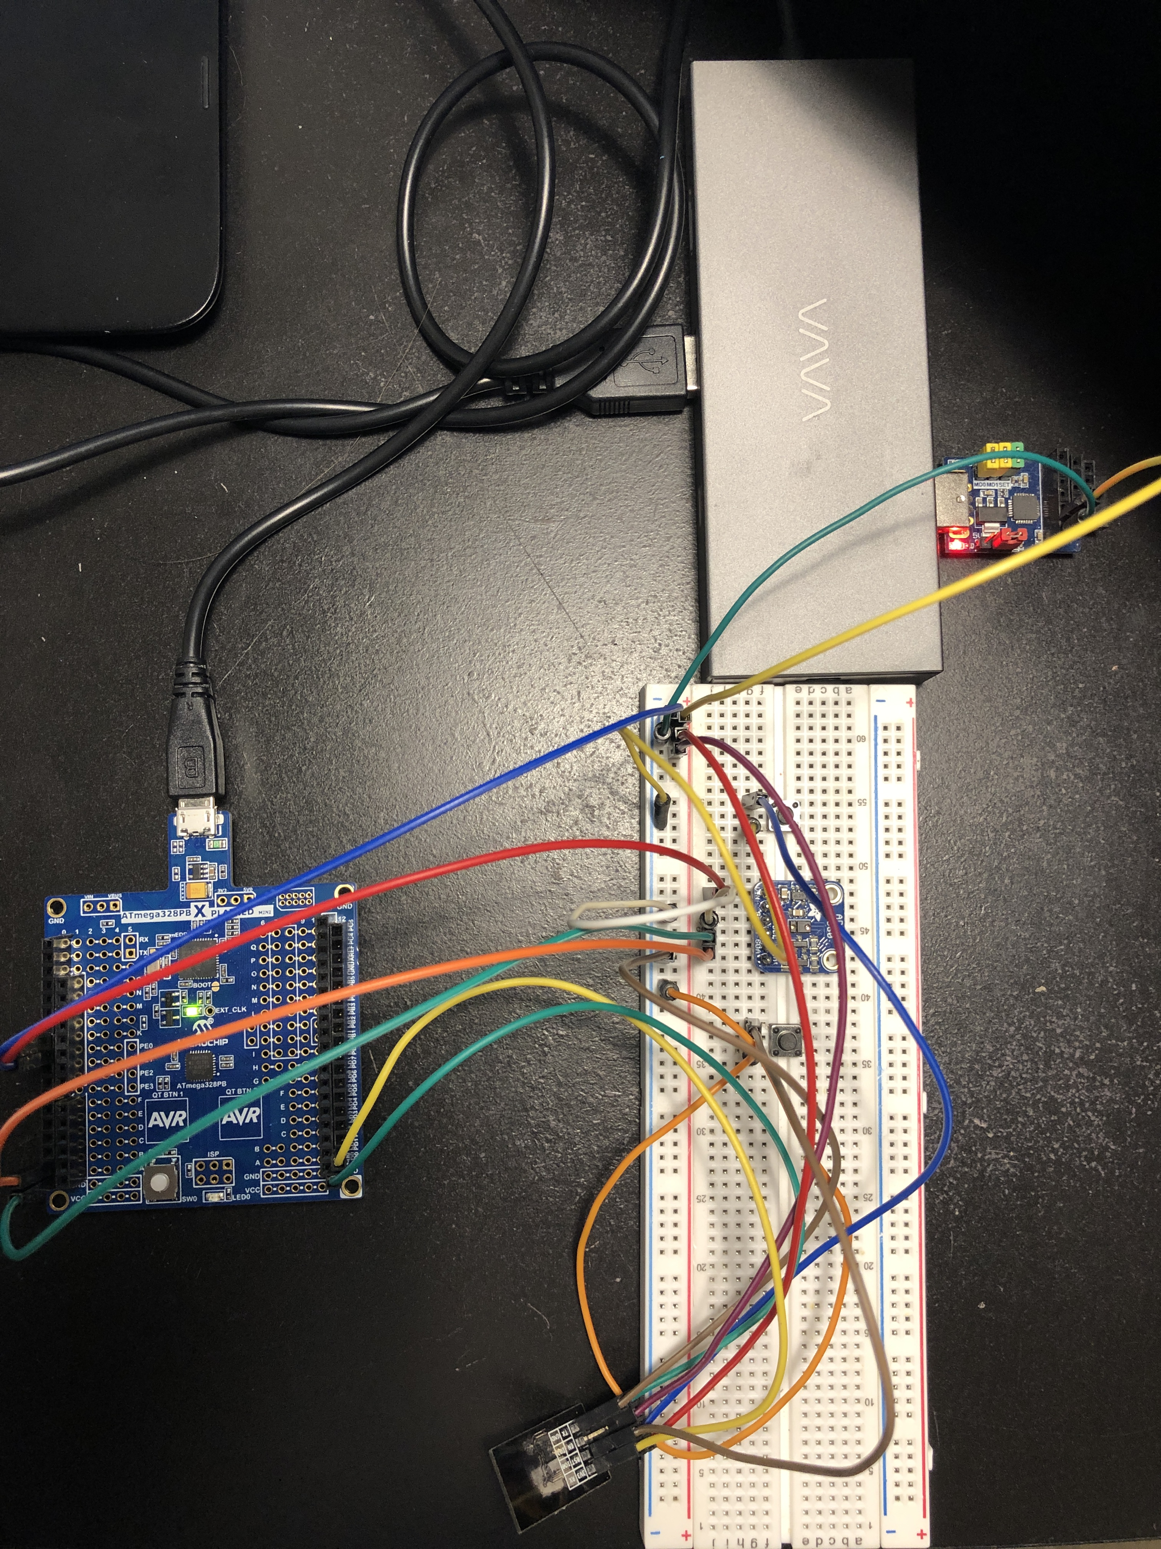

1. **VIDEO LINKS OF EACH DEMO**

https://youtu.be/5QeY6dw3u6M

1. **GITHUB LINK OF THIS DA**

<https://github.com/reedjacobp/submission_da/tree/master/FinalProject>

**Student Academic Misconduct Policy**

<http://studentconduct.unlv.edu/misconduct/policy.html>

“This assignment submission is my own, original work”.

Jacob Patrick Reed