CPE301 – FALL 2019

MIDTERM 1

Student Name: Jacob Patrick Reed

Student #: 1008448895

Student Email: reedj35@unlv.nevada.edu

Primary Github address: <https://github.com/reedjacobp>

Directory: <https://github.com/reedjacobp/submission_da>

1. **COMPONENTS LIST AND CONNECTION BLOCK DIAGRAM w/ PINS**

* Atmega328PB Xplained Mini
* LM35
* ESP01
* Multifunction Shield

FTDI Vcc 🡪 ESP01 3.3V & EN

ATmega328PB Xplained Mini GND 🡪 ESP01 GND

Multifunction Shield APC220 Bluetooth Voice Recognition Module TX (Pin 4) 🡪 ESP01 RX

Multifunction Shield APC220 Bluetooth Voice Recognition Module TX (Pin 4) 🡪 ESP01 RX

Multifunction Shield PC4 GND (Pin 1) 🡪 LM35 GND (Pin 3)

Multifunction Shield PC4 Data (Pin 2) 🡪 LM35 Vout (Pin 2)

Multifunction Shield PC4 Vcc +5V (Pin 3) 🡪 LM35 Vs (Pin 1)

1. **DEVELOPED CODE**

/*

* Midterm1.c

*

* Created: 10/25/2019 2:07:45 PM

* Author : jreed

*/

#define *F_CPU* 16000000UL

#include <avr/io.h>

#include <avr/interrupt.h>

#include <util/delay.h>

#include <stdio.h>

#include <stdint.h>

#include <stdlib.h>

#include <math.h>

#define BAUDRATE 115200

#define BAUD_PRESCALLER (int)*round*(((((double)*F_CPU* / ((double)BAUDRATE * 8.0))) - 1.0))

void USART_init(void); //function to initialize USART

void USART_send(unsigned char data); //function to send through USART

void USART_putstring(char* StringPtr); //goes through each character in a string to send through USART

void ADC_init(void); //used to initialize analog to digital conversion

*uint8_t* OVF_COUNT = 0; //initialize the overflow count for interrupt

*uint8_t* OVF_LIMIT = 250; //set the limit the count can reach to set 1 sec delay

int main(void)

{

USART_init(); //initialize USART

ADC_init(); //initialize conversion

USART_putstring("AT+CWMODE=1\r\n"); //sets ESP01 in station mode, all of the \r\n seen throught the code is to "press enter/return" and create a new line

*_delay_ms*(10); //the delays seen throughout the code is so that when strings are sent, there's enough time to process

USART_putstring("AT+CWJAP=\"SBG6700AC-8AD50\",\"98aa7a769e\"\r\n"); //set wifi and password here

*_delay_ms*(10);

USART_putstring("AT+CIPMUX=0\r\n"); //sets ESP01 to have a single connection

*_delay_ms*(10);

TCCR0A = 0x00; //normal operation

TCCR0B |= (1 << CS02); //set prescalar to 256

TCNT0 = 16; //TOP = 256-250 = 16

TIMSK0 |= (1 << TOIE0);

sei(); //enable interrupt

while (1)

{

}

}

void USART_init(void)

{

UCSR0A = (1 << U2X0); //double USART transmission speed

UBRR0H = (*uint8_t*)(BAUD_PRESCALLER >> 8); //set the baud rate register

UBRR0L = (*uint8_t*)(BAUD_PRESCALLER);

UCSR0B = (1 << RXEN0) | (1 << TXEN0); //enable transmit and receive

UCSR0C = (3 << UCSZ00); //sets character size to 8-bits

}

void USART_putstring(char* StringPtr)

{

while(*StringPtr != 0x00)

{

USART_send(*StringPtr);

StringPtr++;

}

}

void USART_send(unsigned char data) { // Function to transmit ASCII value into UDR0

while (!(UCSR0A & (1 << UDRE0))); // Keep Checking until UDRE0 data register 'High' to break loop

UDR0 = data; // Store unsigned char serial data into UDR0

}

void ADC_init(void)

{

ADMUX = (0<<REFS1)| // reference selection bits

(1<<REFS0)| // AVcc - external cap at AREF

(0<<ADLAR)| // ADC Left Adjust Result

(1<<MUX2)| // Analog Channel Selection Bits

(0<<MUX1)| // ADC4 (PC4)

(0<<MUX0);

ADCSRA = (1<<ADEN)| // ADC Enable

(0<<ADSC)| // ADC Start Conversion

(0<<ADATE)| // ADC Auto Trigger Enable

(0<<ADIF)| // ADC Interrupt Flag

(0<<ADIE)| // ADC Interrupt Enable

(1<<ADPS2)| // ADC Prescaler Select Bits

(0<<ADPS1)|

(1<<ADPS0);

}

ISR (TIMER0_OVF_vect)

{

OVF_COUNT++; //increment the overflow counter

if (OVF_COUNT == OVF_LIMIT) //check to see if the limit was reached

{

ADCSRA|=(1<<ADSC); //start conversion

while((ADCSRA&(1<<ADIF))==0);//wait for conversion to finish

ADCSRA |= (1<<ADIF);

int a = ADCL; //a is temperature

a = a | (ADCH << 8);

a = (a/1024.0) * 5000/10;

a = (a*2)+32; //equation to convert celsius to fahrenheit. cannot use 9/5, 2 must be used

a = a % 100;

USART_putstring("AT+CIPSTART=\"TCP\",\"api.thingspeak.com\",80\r\n"); //connect to thingspeak

*_delay_ms*(10);

USART_putstring("AT+CIPSEND=51\r\n"); //start sending data in transparent transmission mode

*_delay_ms*(10);

USART_putstring("GET /update?key=YLVIWUJ8MIHKPKCR&field1="); //prepare to send data using "Write" API Key

*_delay_ms*(10);

USART_send((a/10)+'0');

*_delay_ms*(10);

a = a % 10;

USART_send((a)+'0');

*_delay_ms*(10);

USART_putstring(" ");

*_delay_ms*(10);

USART_putstring("\r\n");

*_delay_ms*(10);

OVF_COUNT = 0; //reset overflow counter

}

TCNT0 = 16; //reset TOP

}

1. **SCREENSHOTS OF EACH TASK OUTPUT (ATMEL STUDIO OUTPUT)**

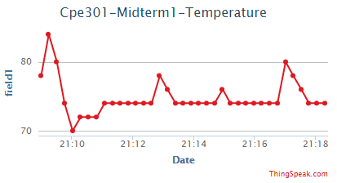

1. **SCREENSHOT OF EACH DEMO (BOARD SETUP)**

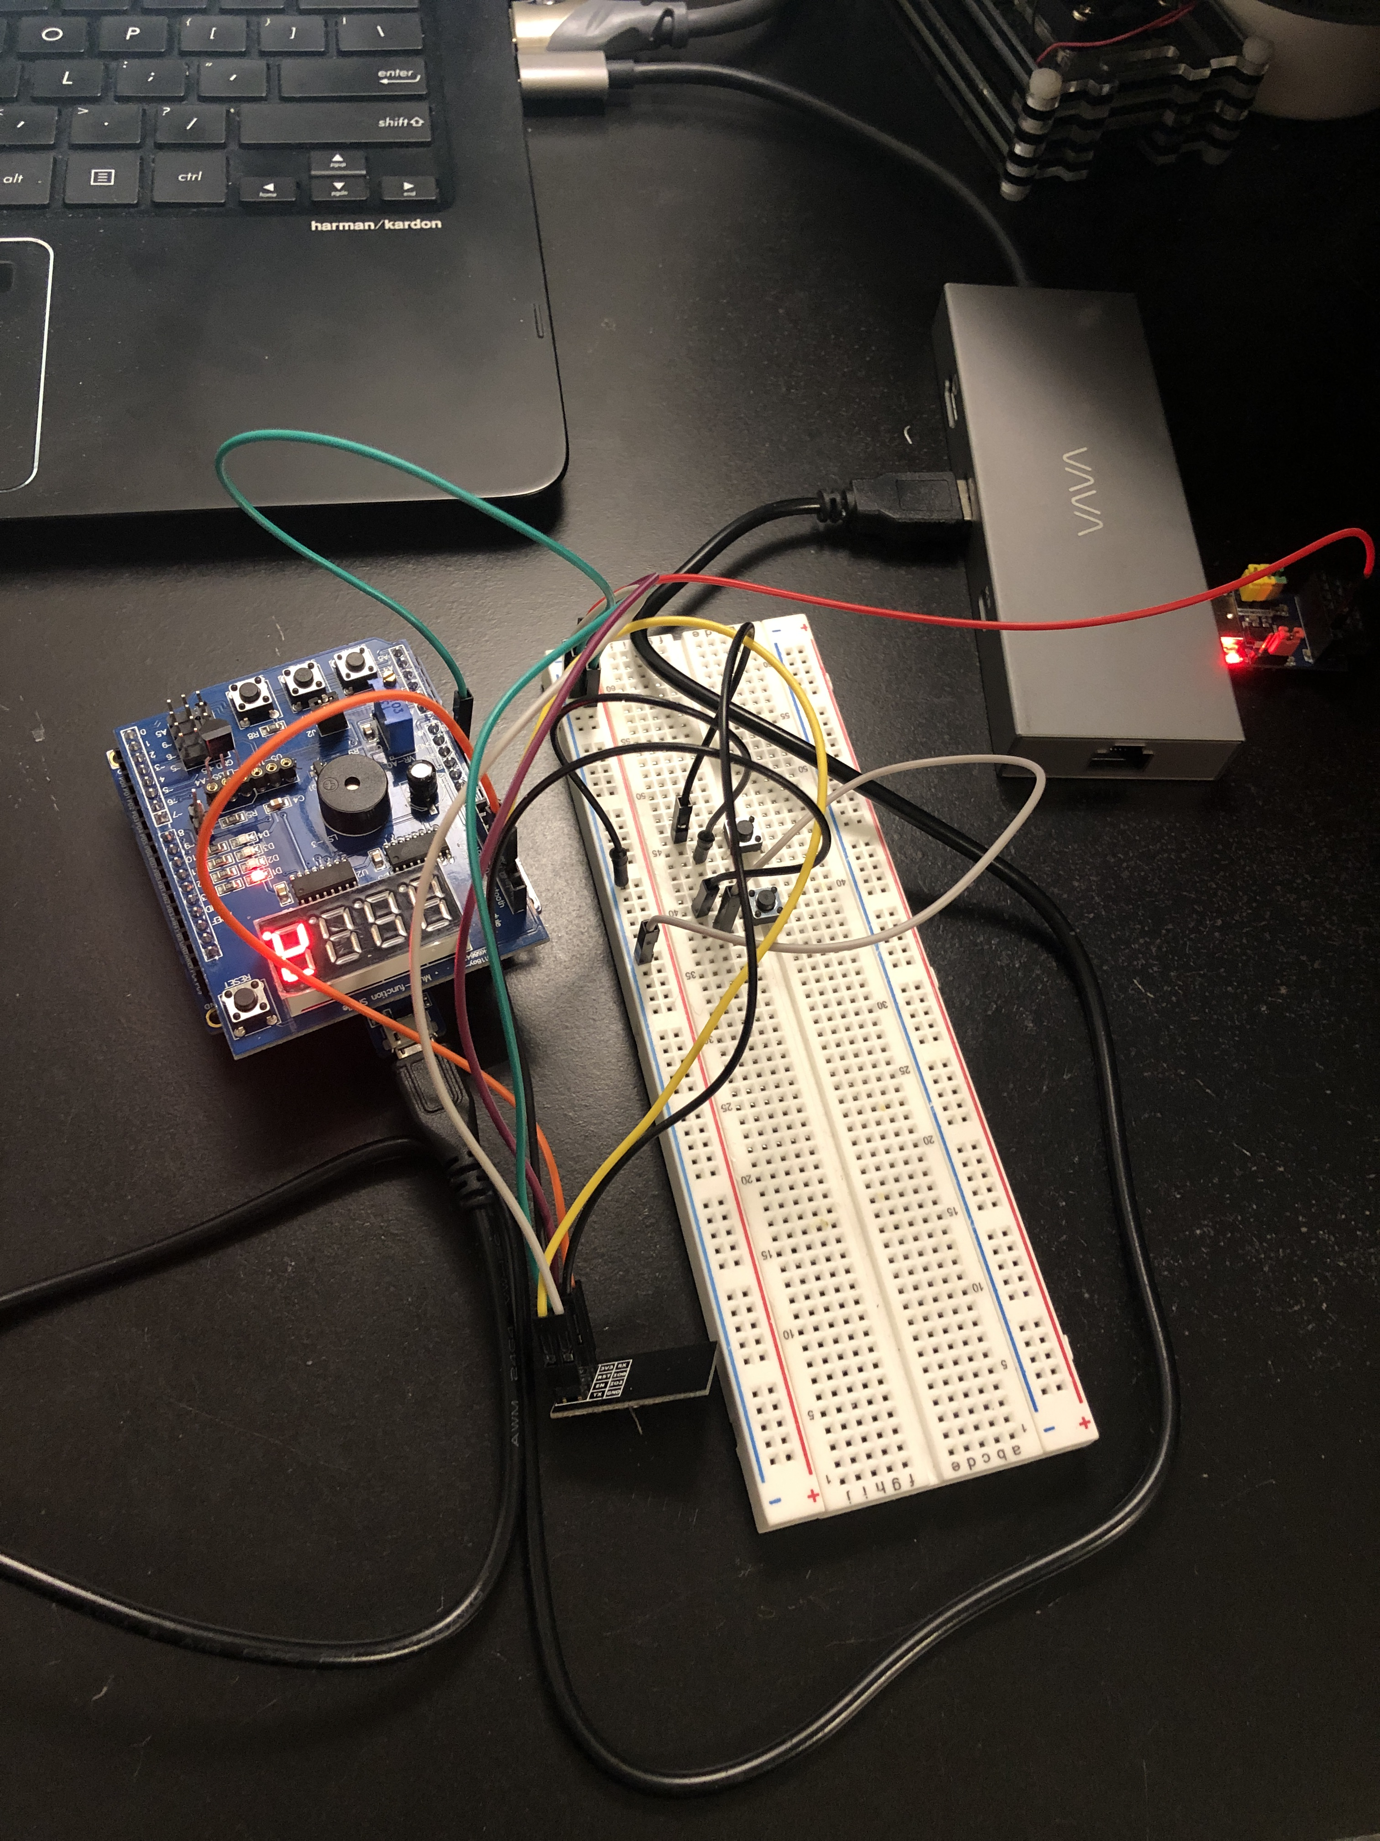

1. **VIDEO LINKS OF EACH DEMO**

https://youtu.be/6JFHt2f-pCQ

1. **GITHUB LINK OF THIS MIDTERM**

<https://github.com/reedjacobp/submission_da/tree/master/Midterms/Midterm%201>

**Student Academic Misconduct Policy**

<http://studentconduct.unlv.edu/misconduct/policy.html>

“This assignment submission is my own, original work”.

Jacob Patrick Reed