VLSI Adder

By: Joshua Reed
February 18, 2016
Introduction:
The design goal of this project was to build an adder and flip-flop, and then to cascade several flip-flops and adders as shown in the image below. The project was from logical drawings to tape out.

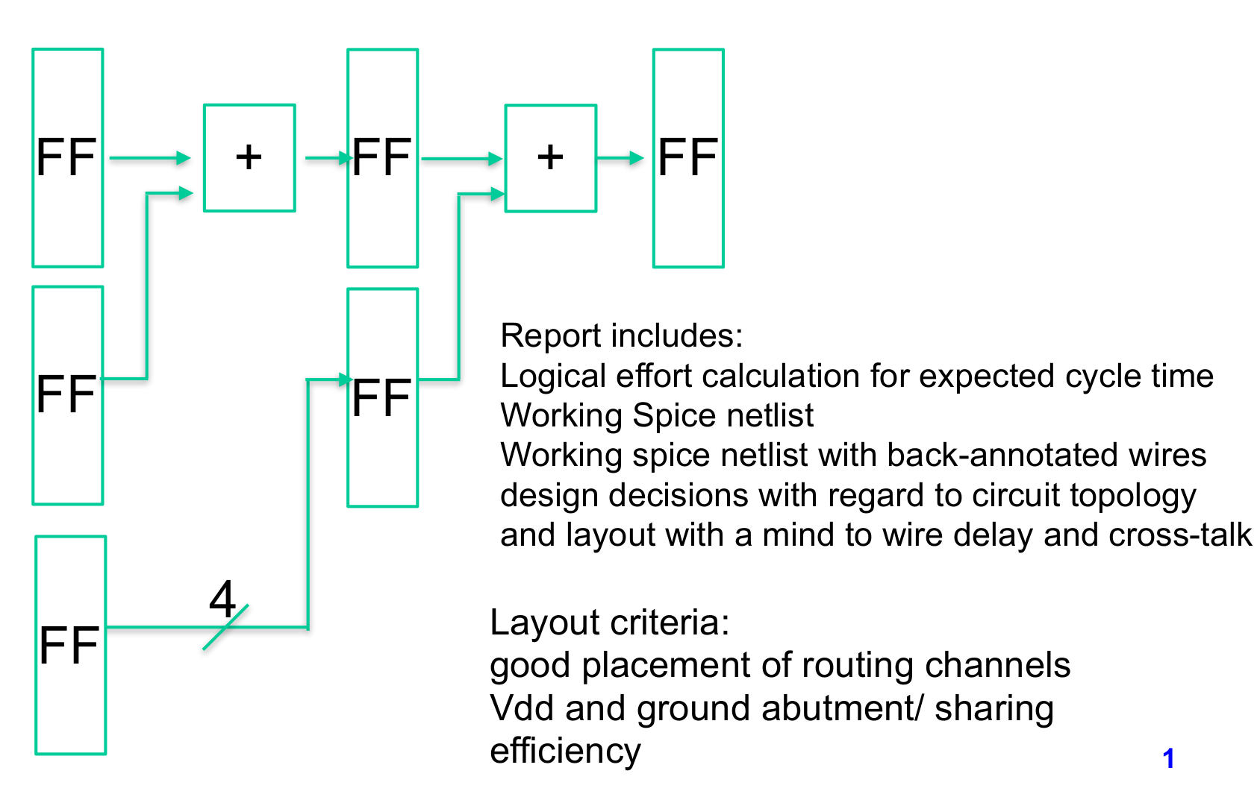

Difficulties and Thoughts:
I was unable to complete the design. Electric VLSI is an incredibly powerful tool, but due to the unexpected learning curve I did not plan for enough time to complete the project. The project could probably be completed in another day or two.

Spice is also fairly new to me, so I was unable to grasp all of the concepts necessary to prove my design adequately. I have provided some output plots of the flip-flop working, but I did not have time to properly find corner constraints of the timing of the full design.

Also, I built several incarnations of the adder. One failed design is shown in the adder section.
It was often hard to resist the temptation to refactor a lower level design.

Results:
As seen in the image below, the project was quite successful despite missing some key elements and modeling. From left to right, the design includes two flip-flops and an adder at the moment. The first flip flop provides bit0 and the second provides bit1 for the addition. Mirrored below that is a copy of the same. Above are three cells that have not been connected to make it more obviouse where the flip-flops and adders are located.

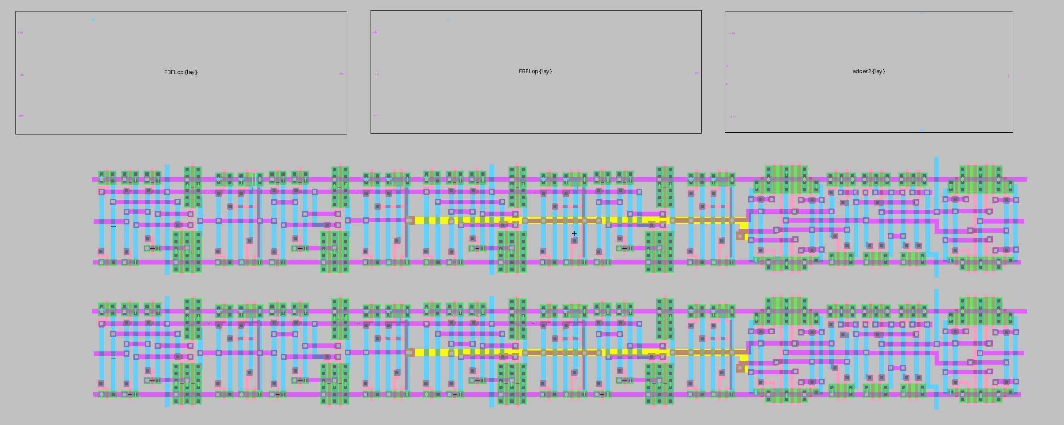
Flip-Flops:
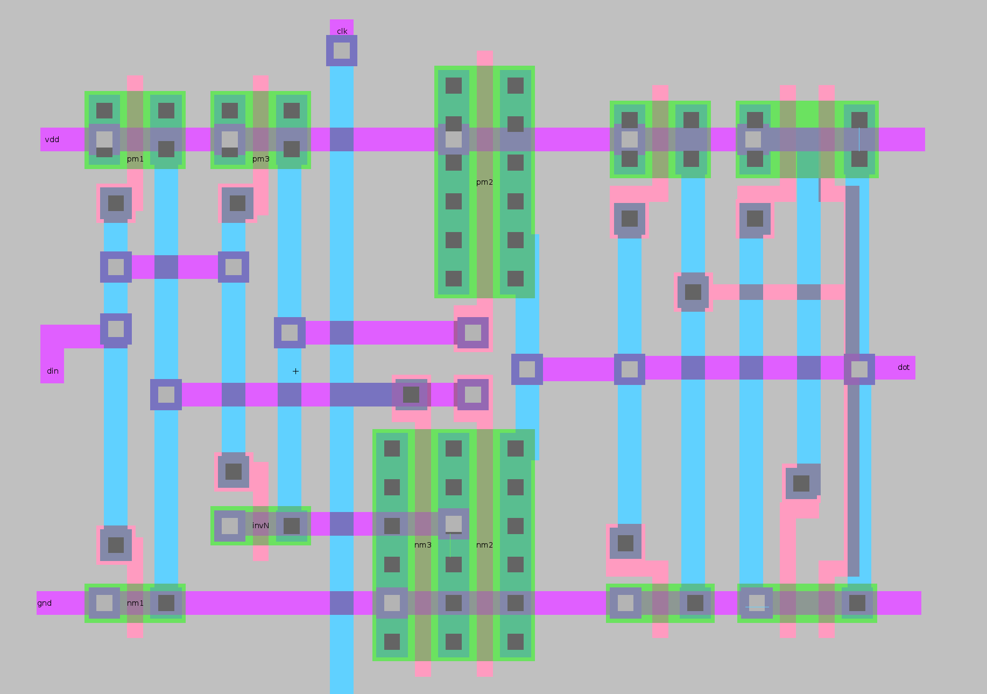
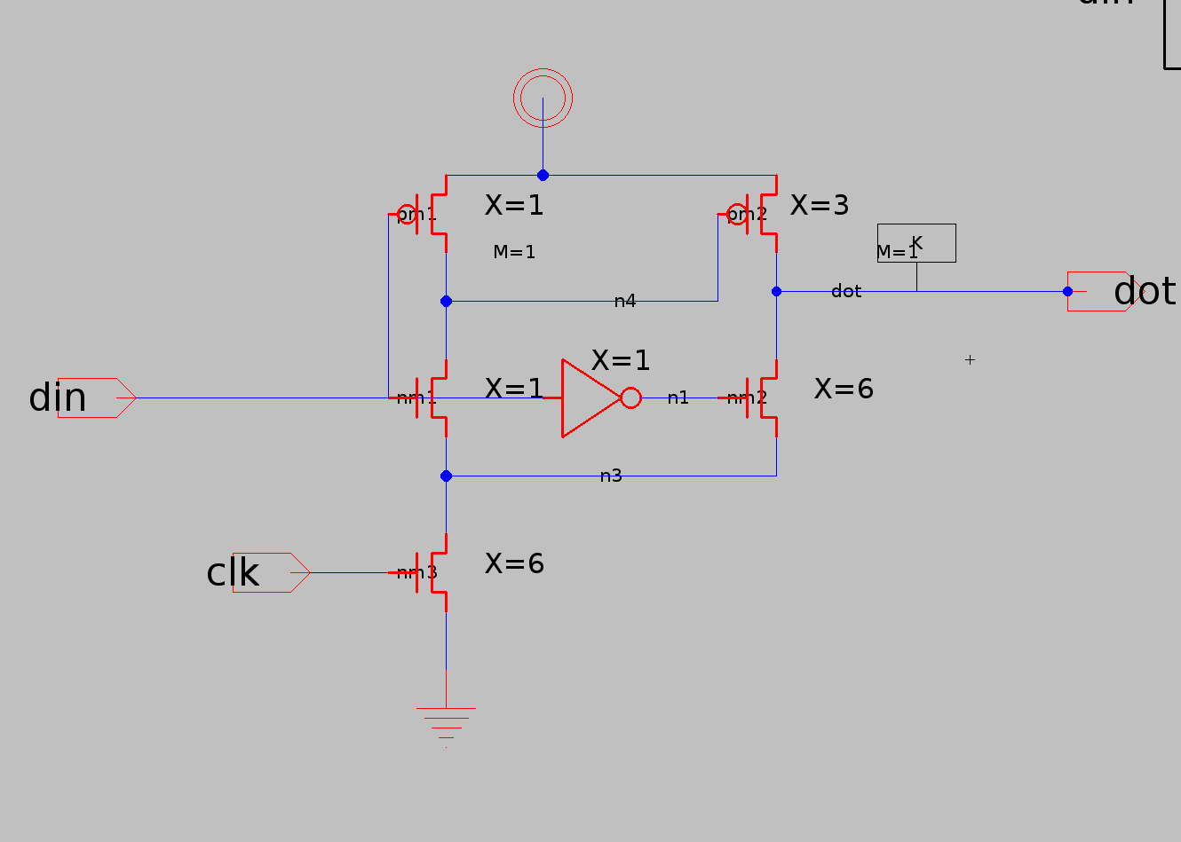
To avoid a two phase clock, the suggested Fairbanks latch was used. An image of its layout and schematic design is shown below.

To design an edge triggered flip-flop, the below design combines two Fairbanks latches and an inverter.
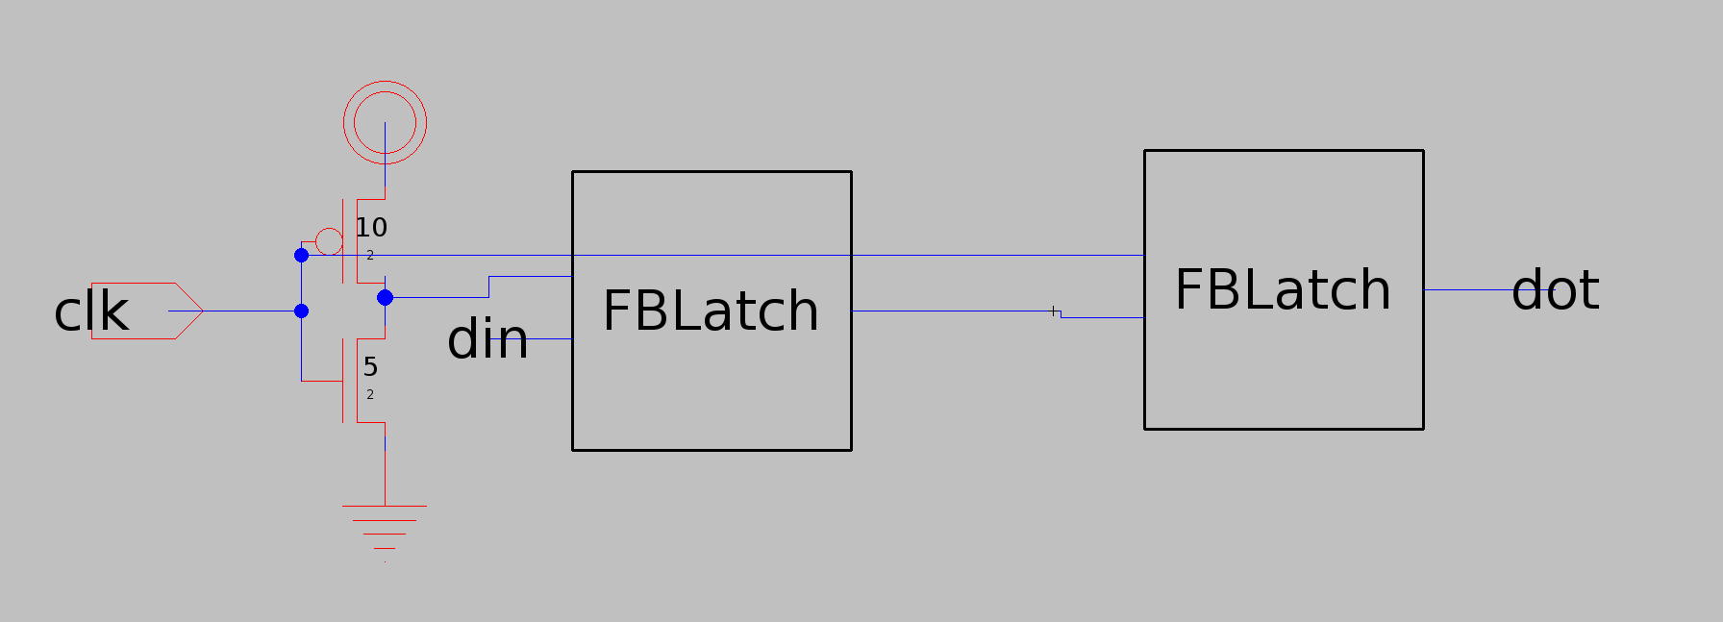
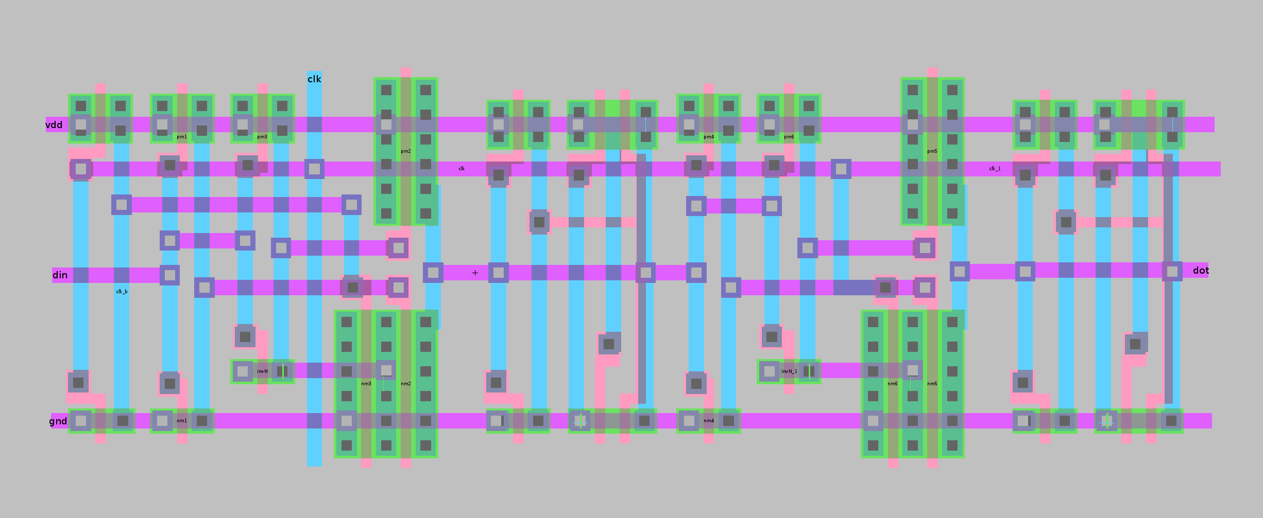

The flop was tested and is shown working in the two spice images below. The first is the flip-flop.
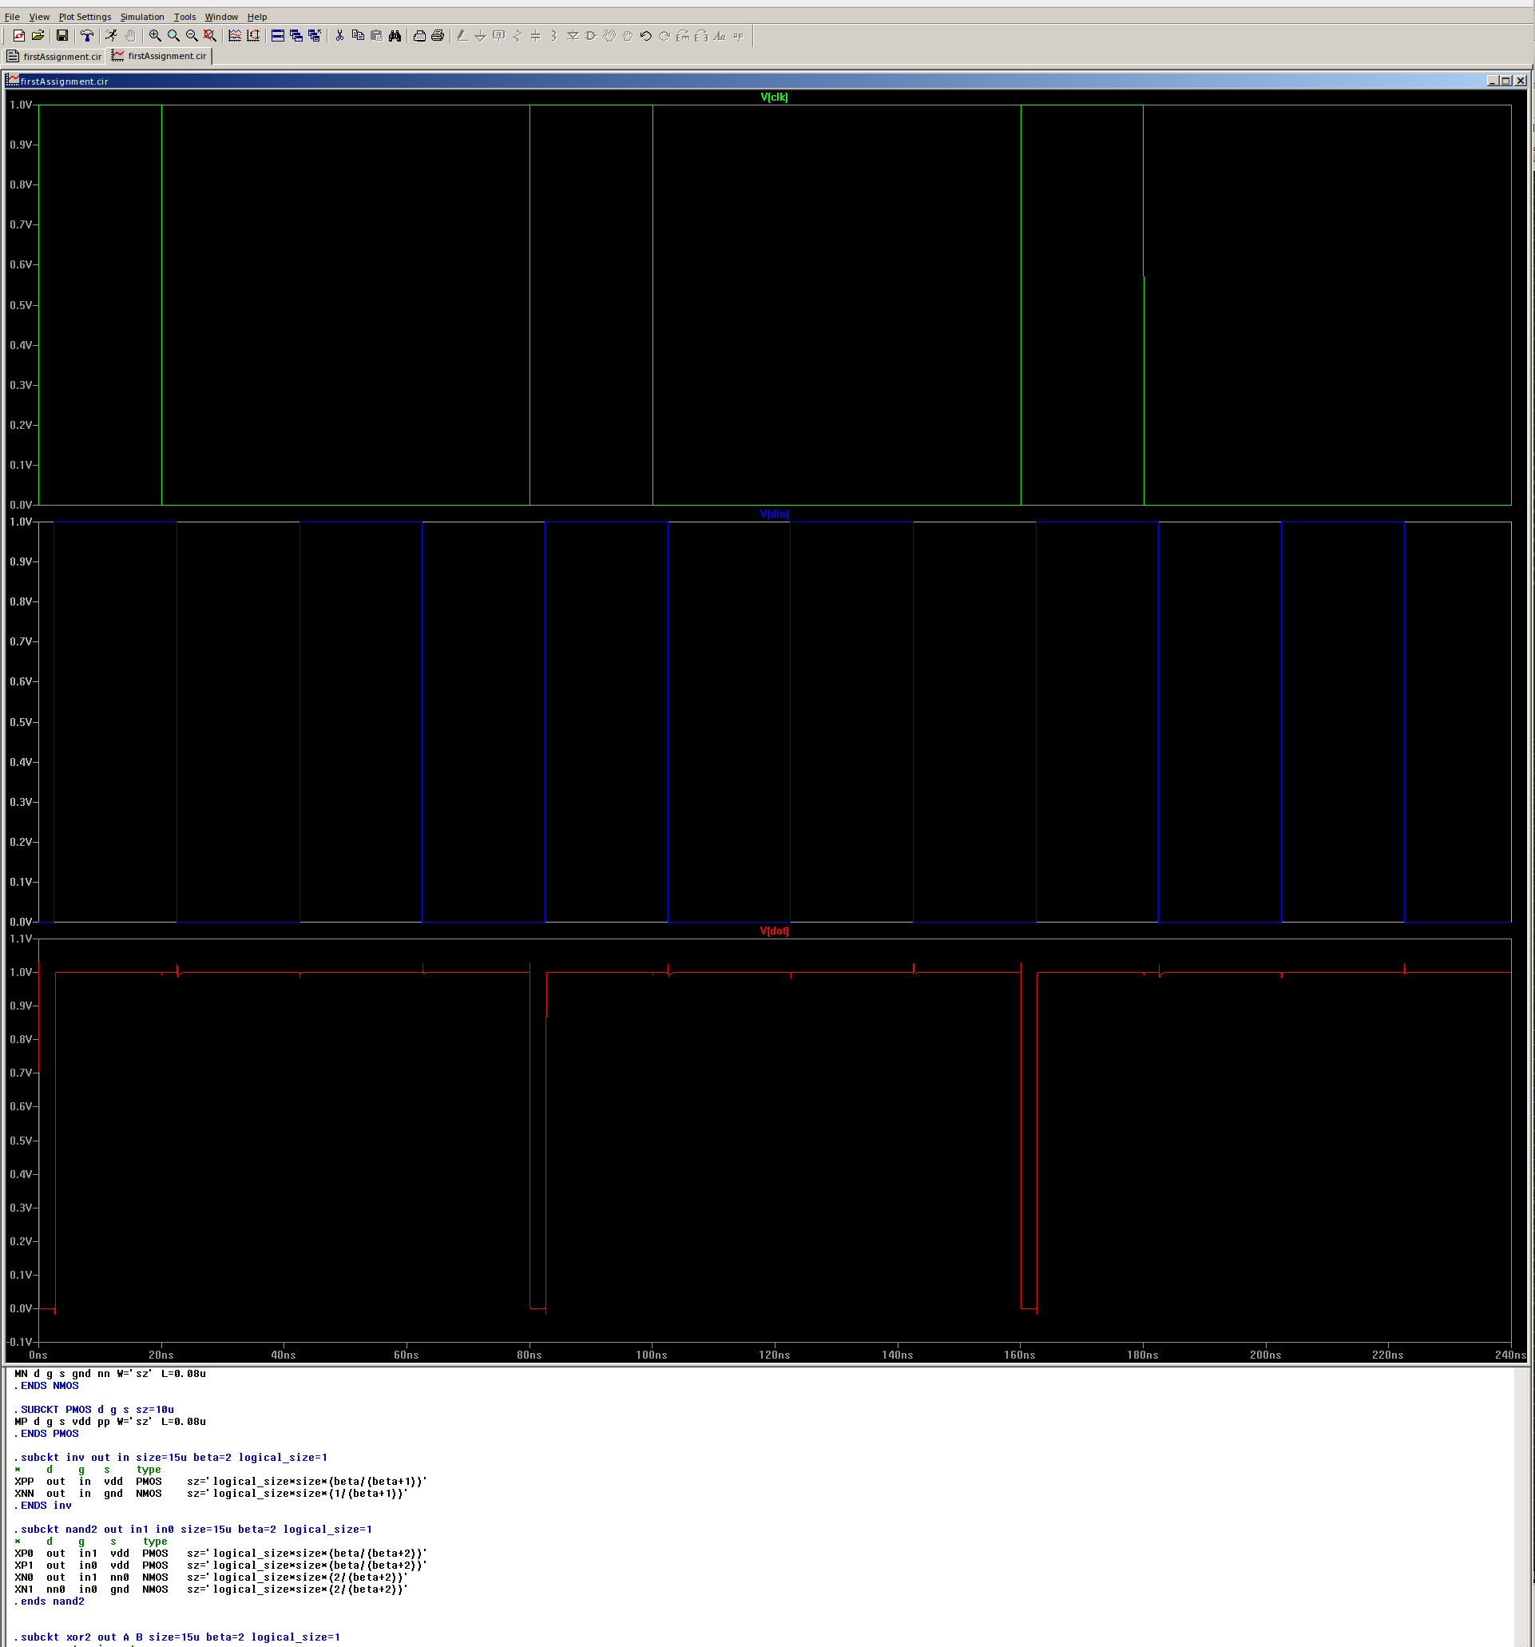

Here the latch operation.
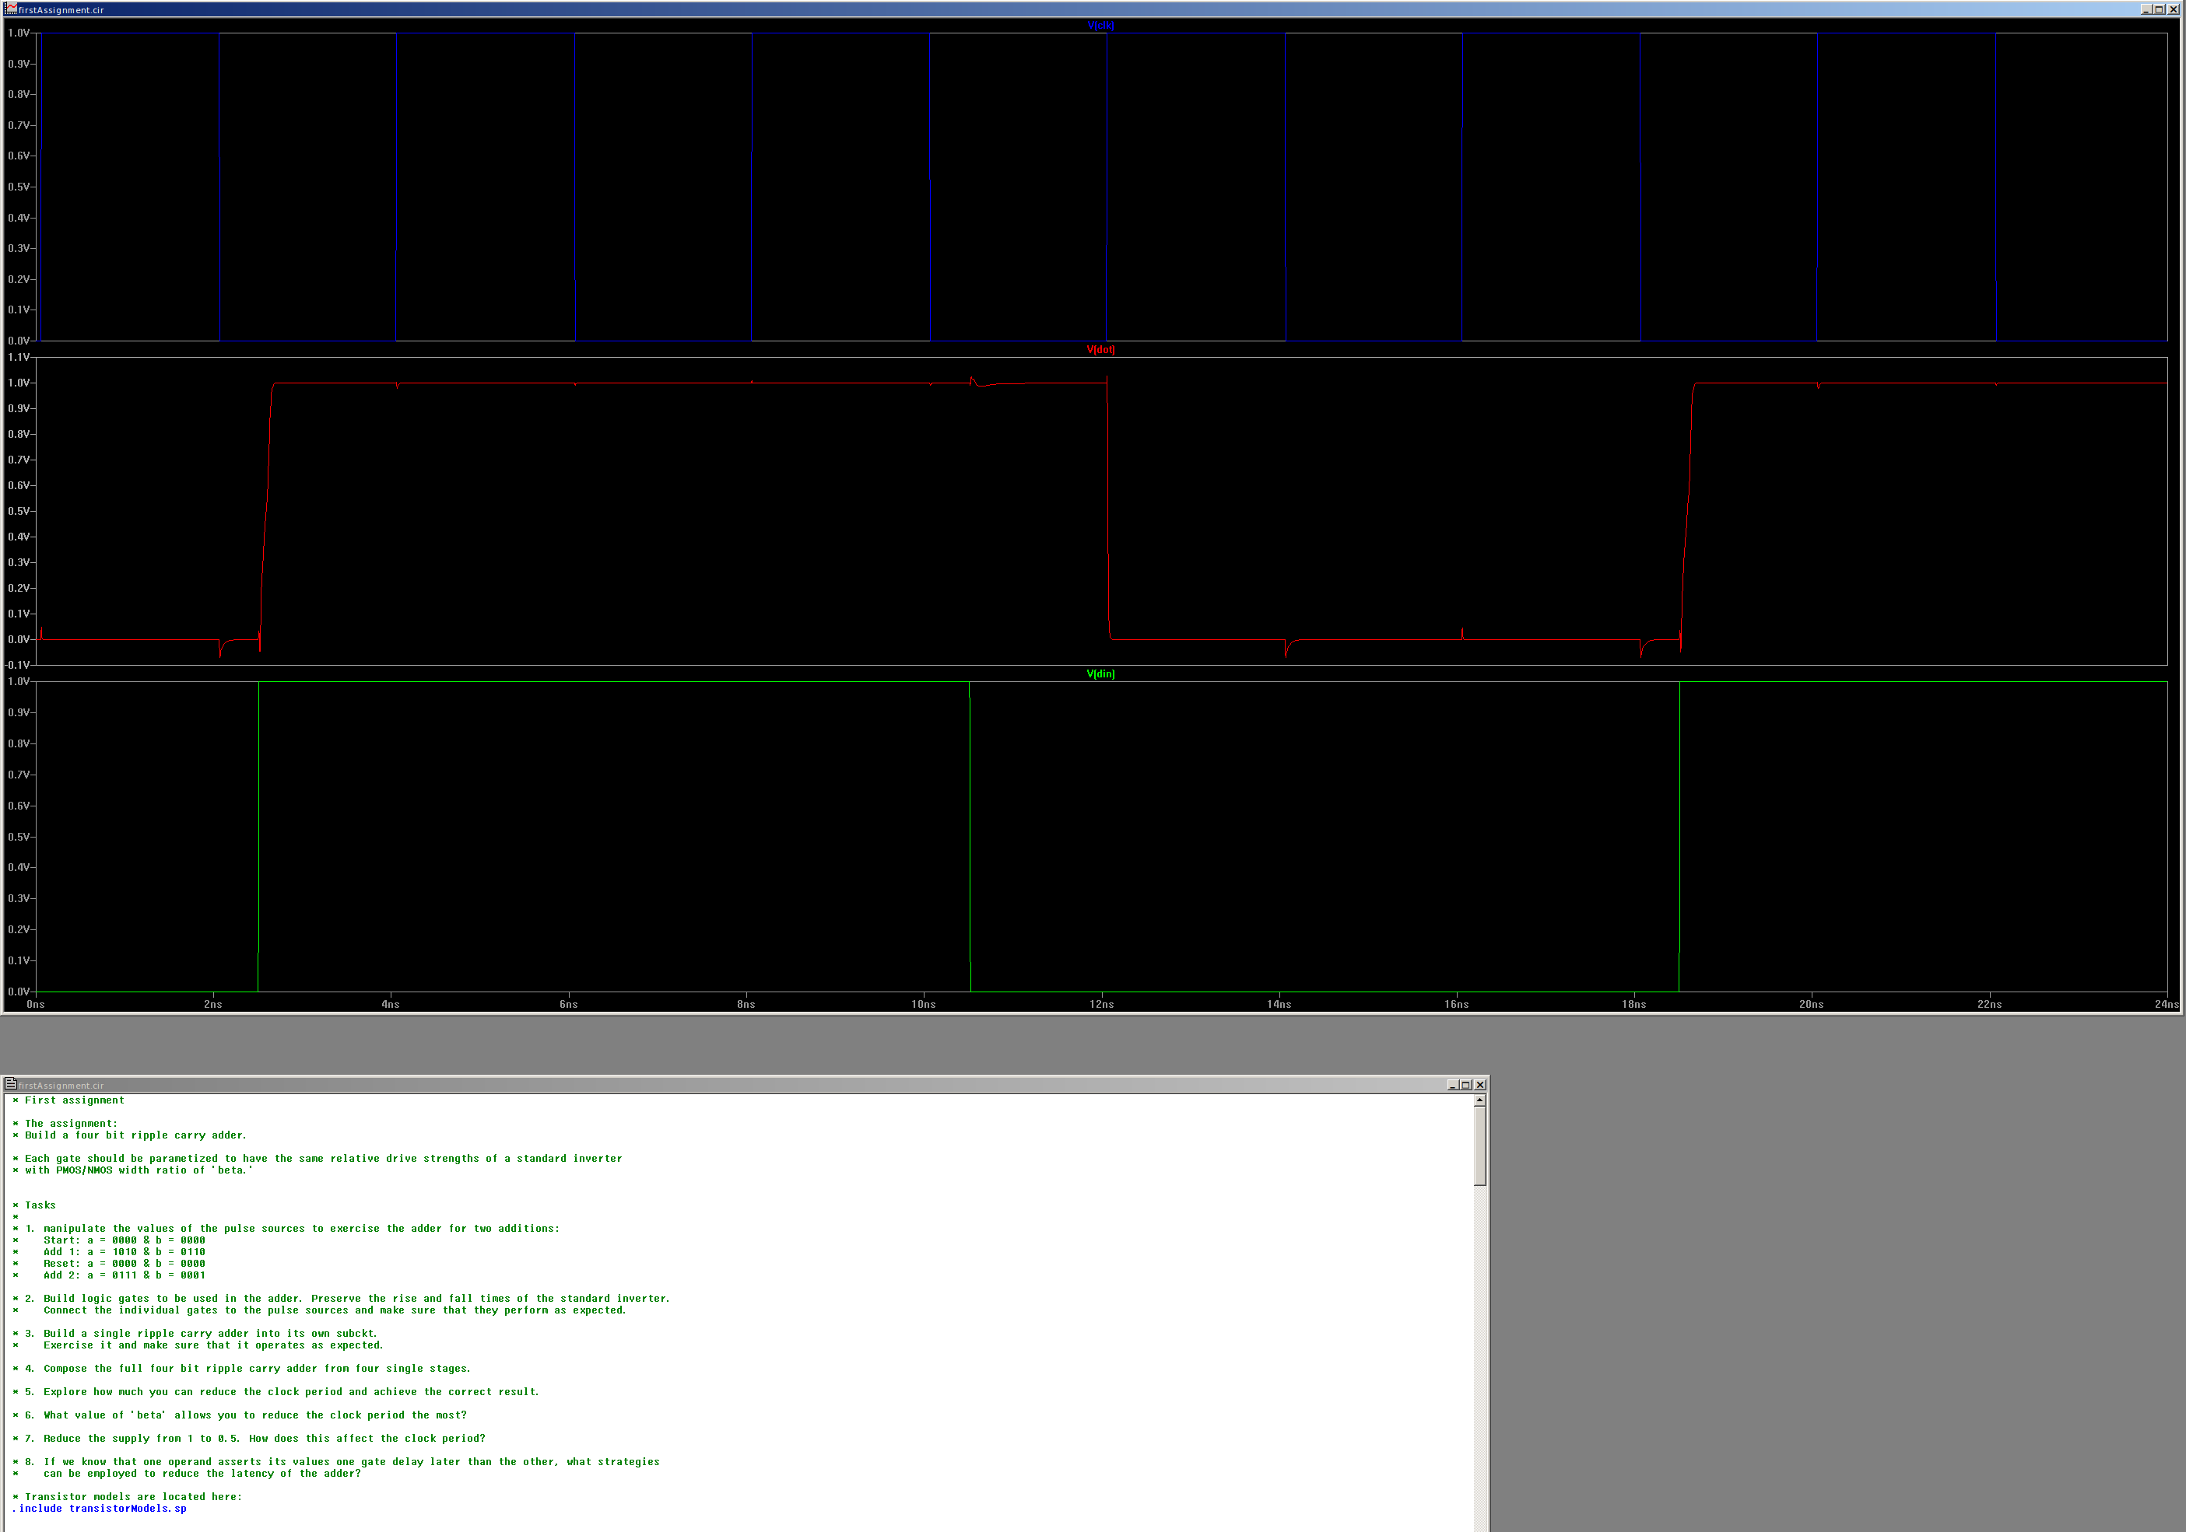

The Adder:
The adder design consists of two Xor gates and three Nand gates (all are 2in). The design for the adder is shown below. Followed by the a failed incarnation.
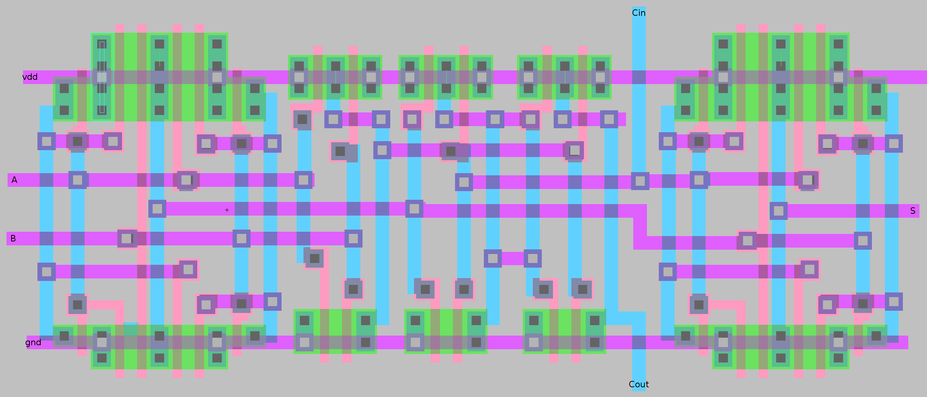
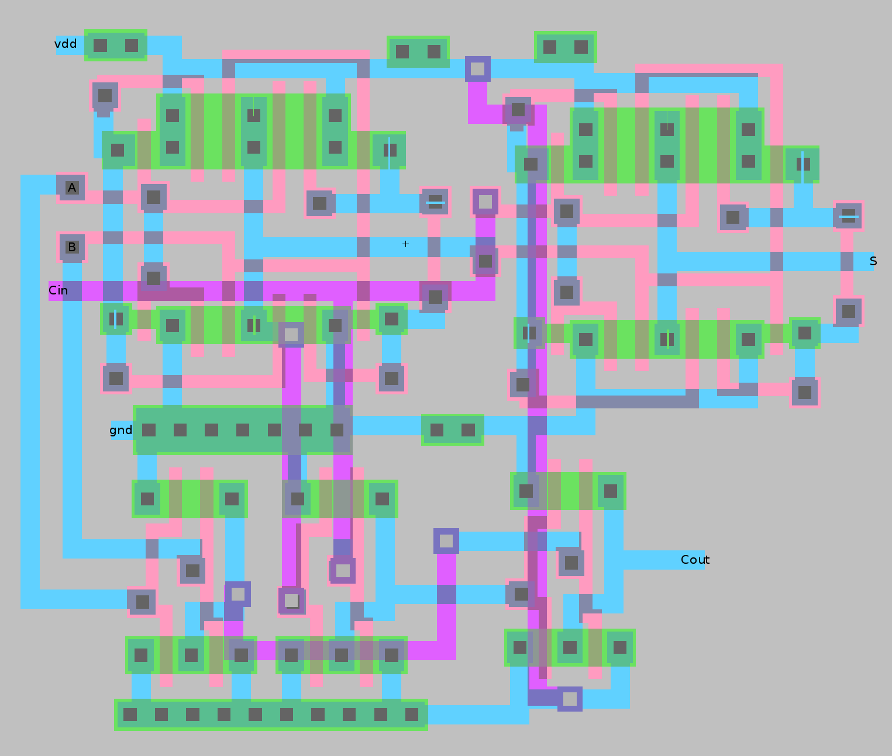
Performance:
I’m not sure what the overal speed of the device should be. I have a similar design as another student, and we used his spice (attached) to model my constraints and it appears that it would run at 50MHz.

And I’m out of time, so that ends the report...

