**Purpose and Description**

Purpose: To understand the switching theories of the light dependent resistor operated relay and to isolate high voltage signals from the circuit to the parallel port using light dependent resistor.

Description: A method of interfacing parallel port with light dependent resistor using java.

**Circuit Diagram**

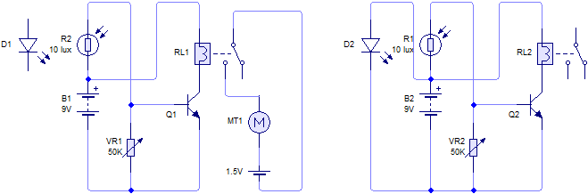

Status Port

Data Port

**Circuit Description**

This circuit is composed of two light activated switch, one for the opto-isolator which is isolating high voltage signals from the motor to the parallel port, and one for the light switch for switching the data switches of the parallel port.

**General Picture**