**APPENDICES**

**APPENDIX A**

**DESIGN PROJECT COMPONENTS**

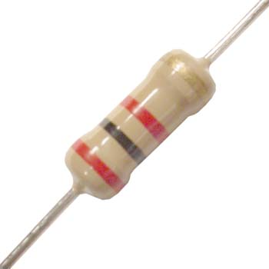

A **resistor** is a [passive](https://en.wikipedia.org/wiki/Passivity_(engineering)) [two-terminal](https://en.wikipedia.org/wiki/Terminal_(electronics)) [electrical component](https://en.wikipedia.org/wiki/Electronic_component) that implements [electrical resistance](https://en.wikipedia.org/wiki/Electrical_resistance) as a circuit element. Resistors act to reduce current flow, and, at the same time, act to lower voltage levels within circuits.

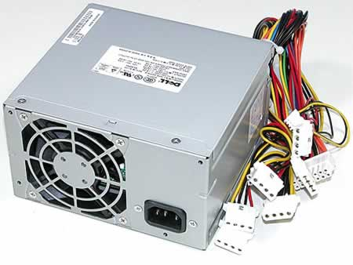

A **power supply** is an electronic device that supplies [electric energy](https://en.wikipedia.org/wiki/Electric_energy) to an [electrical load](https://en.wikipedia.org/wiki/Electrical_load). The primary function of a power supply is to convert one form of electrical energy to another and, as a result, power supplies are sometimes referred to as [electric power converters](https://en.wikipedia.org/wiki/Electric_power_converter).

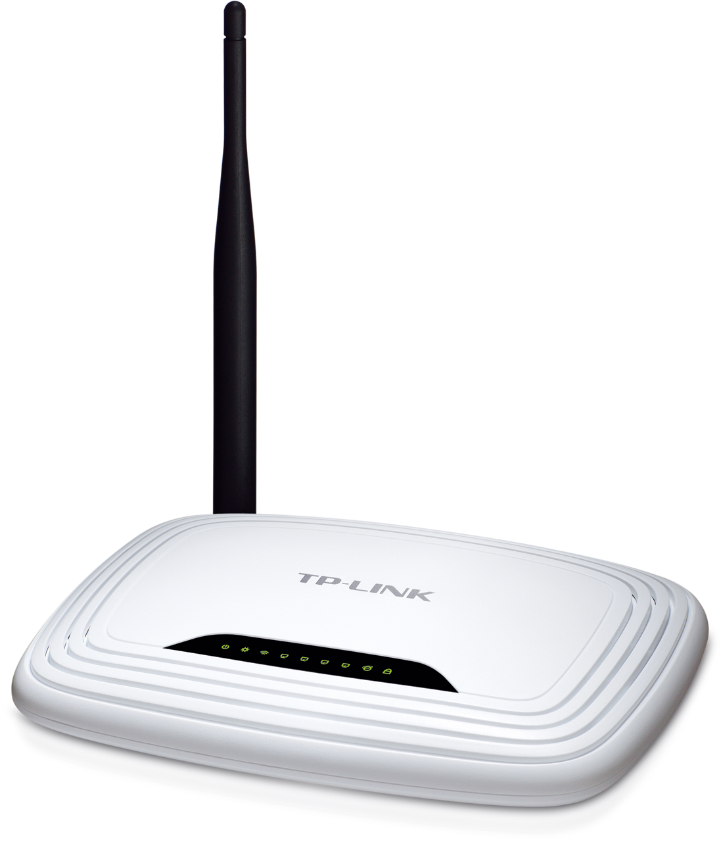

A **router** is a [networking device](https://en.wikipedia.org/wiki/Networking_device) that forwards [data packets](https://en.wikipedia.org/wiki/Data_packet) between [computer networks](https://en.wikipedia.org/wiki/Computer_network). Routers perform the "traffic directing" functions on the [Internet](https://en.wikipedia.org/wiki/Internet). A data packet is typically forwarded from one router to another through the networks that constitute the internetwork until it reaches its destination node.

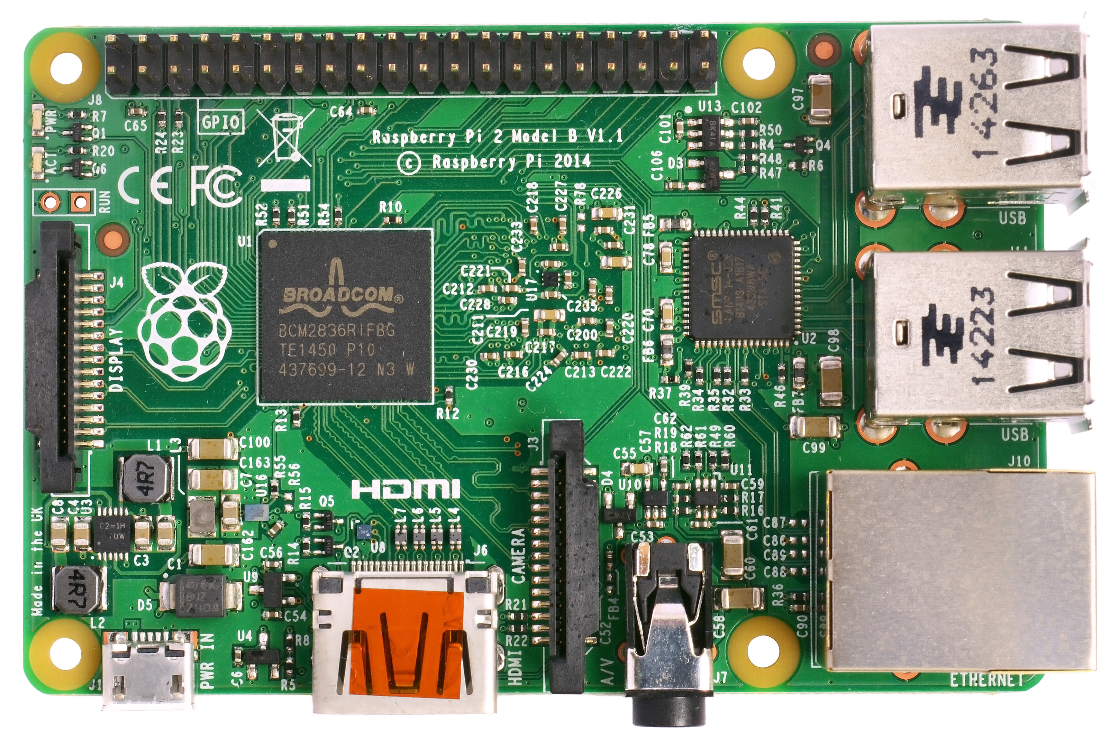

A **Raspberry Pi** is a low cost, **credit-card sized computer** that plugs into a computer monitor or TV, and uses a standard keyboard and mouse. It is a capable little device that enables people of all ages to explore computing, and to learn how to program in languages like Scratch and Python. It’s capable of doing everything you’d expect a desktop computer to do, from browsing the internet and playing high-definition video, to making spreadsheets, word-processing, and playing games.

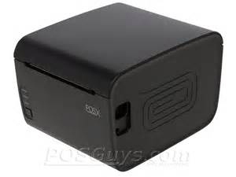

A **thermal impact printer** or **electrothermal printer** is a printer that uses heated pins to "burn" images onto heat-sensitive paper. These printers are commonly used in calculators and fax machines; and although they are inexpensive and print relatively fast, they produce low resolution print jobs.

An **Arduino** is an open-source computer hardware and software company, project and user community that designs and manufactures microcontroller-based kits for building digital devices and interactive objects that can sense and control objects in the physical world.

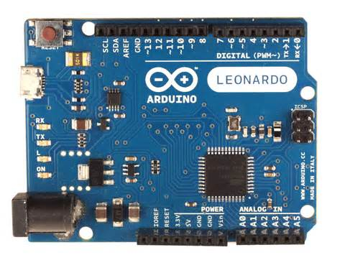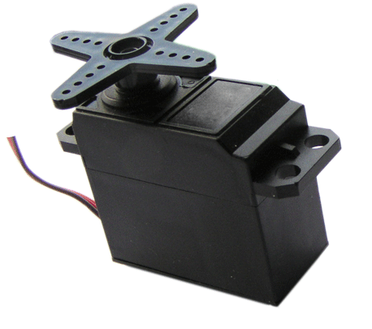

A **Servo** is a small device that has an output shaft. This shaft can be positioned to specific angular positions by sending the servo a coded signal.