**CHAPTER II**

**DESIGN PROJECT MANAGEMENT, ENGINEERING AND FABRICATION**

2.1 METHOD DESIGN AND APPROACH

This chapter accounts for the general method used for the design project.

2.1.1 Methods of Research

The type of research method used by the researchers on their design project is the experimental method. It uses manipulation and controlled testing to understand casual processes. Generally, one or more variables are manipulated to determine their effect on a dependent variable.

The researchers conducted several hardware and software experiments to achieve consistent results. The researchers experimented the performance of class 4 and class 10 SD card to determine the sustained right speed for the card where the operating system will be installed. They tested the Linux operating systems such as NOOBS and Raspbian to determine the suitable system environment for installing LAMP and other third party software that will be used in the development of the software for the designed project. The researchers also conducted several test on the coin slot module in validating the coins including inserting tokens and 25 centavo coins. The thermal printer was also tested on 5v and 9v power supply. The results based on the experiments will be used on the designed project.

2.1.2 Method of Collecting Data

The methods that were used in collecting data are library research, reading documentations and datasheets. Library research was used to provide concepts and understanding on the designed project. The researchers also read about the documentation of the software used and datasheets of the different components and modules.

2.2 PROJECT RESEARCH DESIGN

This part discussed the arrangement of the designed project. It describes the functionalities, the relationships between the said functionalities and the input and output factors. Diagram such as Block Diagram, System Flow, and etc. were also discussed in details in this part.

2.2.1 Block Diagram

Dispenser

Touch Screen

Coin Slot

Arduino Uno

Raspberry Pi

Thermal Printer

Internet

Router

GSM Module

*Figure2.2.1.1 Block Diagram*

Figure 2.2.1.1 shows the relationship of the components / modules of the designed project. The main module uses a master/slave relation. The Raspberry Pi is the master and the Arduino is the slave.

The Raspberry Pi is a single board computer, which runs on Linux, it is where data is being processed. It is the main module of the system where the software for the vending machine and third party software runs.

The software is responsible for displaying items in the touch panel, sending commands to Arduino, receiving commands from Arduino.

Arduino is a microcontroller which is responsible for controlling the other modules. It receives commands from the Raspberry Pi.

The dispenser module will dispense the items. The dispenser module uses servo motor for the dispensing mechanism.

The coin slot module will accept and confirm coins. It will generate pulses and send these signals to the Arduino.

The GSM module will send an SMS and notify the admin.

The thermal printer module will print the official receipt. It is using serial communication with the Arduino.

The network module is composed of a router that connects the whole system through the internet for the back end that can be accessed through mobile, tablet or pc.

2.2.2 Process Diagram

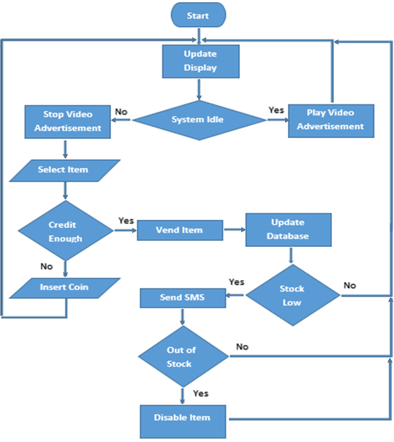

*Figure2.2.2.1 Process Diagram*

Figure 2.2.2.1 shows the process. The system will display the items on the touch screen, and if the system is idle, it will play a video advertisement and wait for user interaction. Once the system detected a user interaction, it will check if the credit is enough to buy the selected item. If it is enough, the item will come out and the database will be updated. The system will also check the available stock and send and SMS once it reached the critical level.

2.3 DESIGN PROJECT MANAGEMENT

This chapter includes developing a project plan, which includes identifying tasks, defining the project goals and when the tasks must be finished, identifying and quantifying the resources needed and determining the budgets for the whole design project.

2.3.1 Design Project Gantt Chart

*Table 2.3.1.1 Gantt Chart*

|  |  |  |  |  |  |  |  |  |  |
| --- | --- | --- | --- | --- | --- | --- | --- | --- | --- |
| **Task** | **Jun** | **Jul** | **Aug** | **Sept** | **Oct** | **Nov** | **Dec** | **Jan** | **Feb** |
| **Title proposal** |  |  |  |  |  |  |  |  |  |
| **Planning** |  |  |  |  |  |  |  |  |  |
| **Research** |  |  |  |  |  |  |  |  |  |
| **Documentation** |  |  |  |  |  |  |  |  |  |
| **Title Defense** |  |  |  |  |  |  |  |  |  |
| **Canvassing** |  |  |  |  |  |  |  |  |  |
| **Purchasing of Materials** |  |  |  |  |  |  |  |  |  |
| **Project Designing** |  |  |  |  |  |  |  |  |  |
| **Circuit Designing** |  |  |  |  |  |  |  |  |  |
| **Programming** |  |  |  |  |  |  |  |  |  |
| **Trouble Shooting and Testing** |  |  |  |  |  |  |  |  |  |
| **Final Documentation** |  |  |  |  |  |  |  |  |  |
| **Project Defense** |  |  |  |  |  |  |  |  |  |

Table 2.3.1.1 This time table in which the researchers will follow in order to organize all the tasks that should be done at a certain period at the same time execute the project well without time pressure. Every task has a specific time in which it must be done. To ensure efficiency and credibility of the chosen design project, the researchers start in planning and researching about the design project.

2.3.2 Design Project Work Breakdown

*Figure 2.3.2.1 Work Breakdown*

Figure 2.3.2.1 This table shows the work breakdown in a ranked and gradual decomposition of the project into deliverable, phases and work packages. It shows the contribution and effort level done in every way of the project objective. The researchers rated each other in a scale of 0 to 10.

2.3.3 Costing and Budgeting

*Table 2.3.3.1 Costing and Budgeting*

|  |  |  |  |
| --- | --- | --- | --- |
| Materials | Quantity/Size | Price/Unit | Total |
| Raspberry Pi 2 Model B | 1 | 2600.00 | 2600.00 |
| Arduino Uno | 1 | 499.00 | 499.00 |
| Coin Slot | 1 | 1510.00 | 1510.00 |
| Thermal Printer | 1 | 2850.00 | 2850.00 |
| Tower Pro Servo Motor | 5 | 175.00 | 875.00 |
| Micro SD Card 16GB | 1 | 333.00 | 333.00 |
| ATX Power Supply | 1 | 800.00 | 800.00 |
| Cooling Fan | 2 | 500.00 | 1000.00 |
| TP-Link Router | 1 | 1400.00 | 1400.00 |
| 2A 5V Power Supply | 1 | 300.00 | 300.00 |
| Micro USB Cable | 1 | 70.00 | 70.00 |
| Misc. |  | 1500.00 | 1500.00 |
| Jumping Wires | 30mtrs | 5.5 | 165 |
|  |  | **Total** | 13902.00 |

Table 2.3.3.1 This table shows the estimated amount that the researchers expended in doing the project in Philippine peso. The components and materials as well as its quantity, units and the total amount are shown in then table.