MuseScore Crash Course
  - A quick intro for students starting A level Music
It will be important to feel confident using MuseScore Studio in September. We use this program to notate music in the classroom and for coursework. It is high quality and also free to download, even for students.
Download MuseScore yourself to use on a home computer: https://musescore.org/en/download. You will need access to a desktop, laptop or chromebook where installing third-party apps is possible. There is no mobile or tablet alternative currently.
Note the musescore.org URL. The musescore.com site is for selling and publishing scores, not downloading free software. You should never be asked to pay money to install MuseScore: it is open-source and free.
If you have used MuseScore before: this is certainly an advantage. Please do not skip this document, however, as I have designed it to be both an easy intro for beginners and also offer advanced users some more techniques and strategies they may not have come across at GCSE or below.

Happy Birthday
It’s almost MuseScore’s 23rd birthday: 2 September 2002.
Open up the MuseScore file that came with this document.
These are the first two and a bit bars from Happy Birthday. Can you complete the song by entering notes into the interface?
Bold words in this document relate to techniques that are explained on the MuseScore handbook website. You should be able to work out a lot of the MuseScore functions on your own, but the handbook will help you both a) work out things when you’re struggling and b) find more advanced and efficient methods to do the things you already know something about.

If you search for entering notes then you come up with a useful article in the handook:

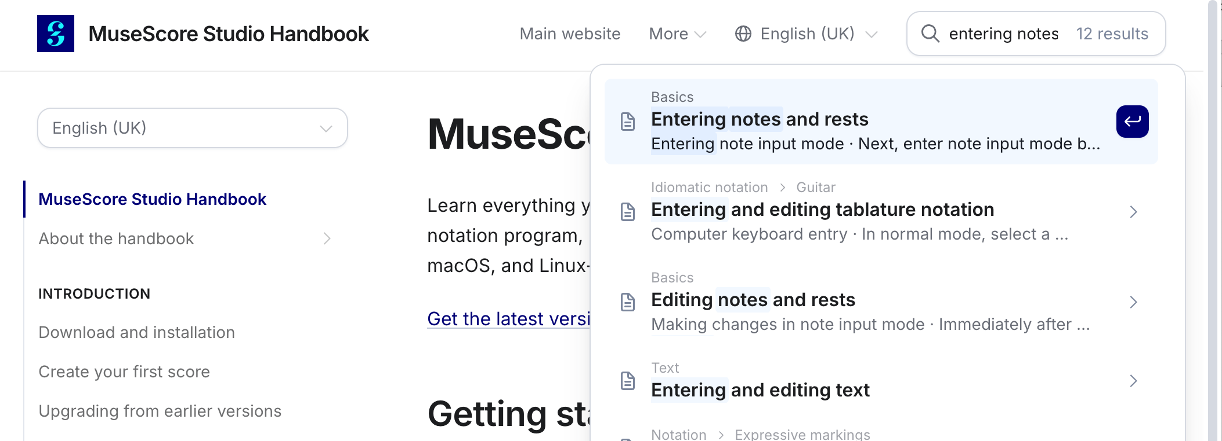

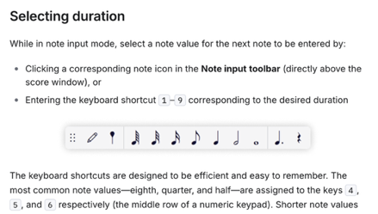
You might know that for note entry you use the pencil icon at the top of MusesScore and choose a note length. Did you also know that you can press a number key on your keyboard to quickly choose a note duration? You would be much faster if you memorised which number corresponds to which note duration.

Use one of the note entry techniques to complete the melody.
Advanced ideas will be in purple in this document.

If you have already used MuseScore, try using another note entry method that you might be less familiar with.

Completing the melody should take 8 or 9 bars.
After these 8 or 9 bars, select the extra 30-odd bars you don't need and delete the bars.
Don’t forget to look up these techniques in bold in the handbook.

Saving your score
The MuseScore studio team have created a cloud service so that you can sync your work across different devices.
I would recommend instead saving on your computer and keeping the file safe in a new folder for A level Music work.
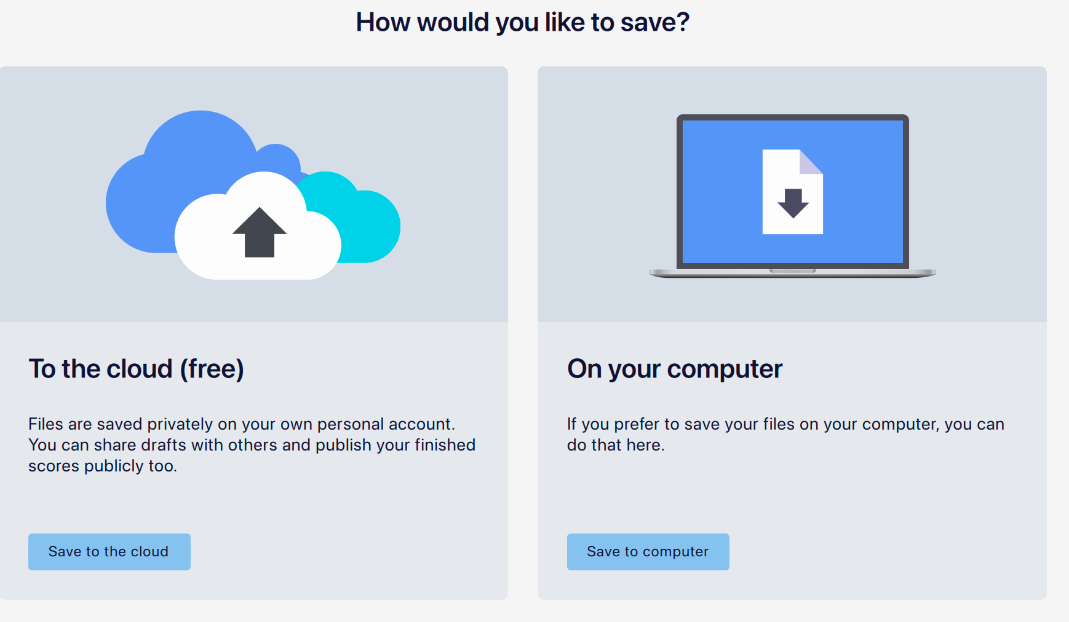

Anacrusis
That first bar shouldn't have rests, it should be an anacrusis.

Instead of…  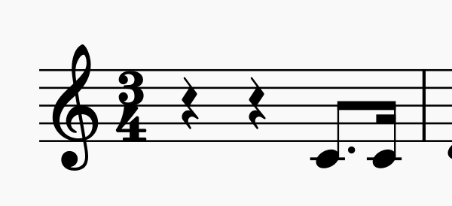 | …it should look something like:  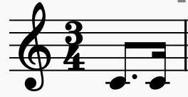

Convert bar 1 to an anacrusis bar.
Make sure you exclude this bar from measure/bar count. This bar should really bar 0, and bar 1 should start on D in the next bar. Anacruses are not counted in bar numbers.

Add a piano accompaniment
Open the Add Instruments dialog. Search for piano. Double-click or click this arrow to move it into the list.
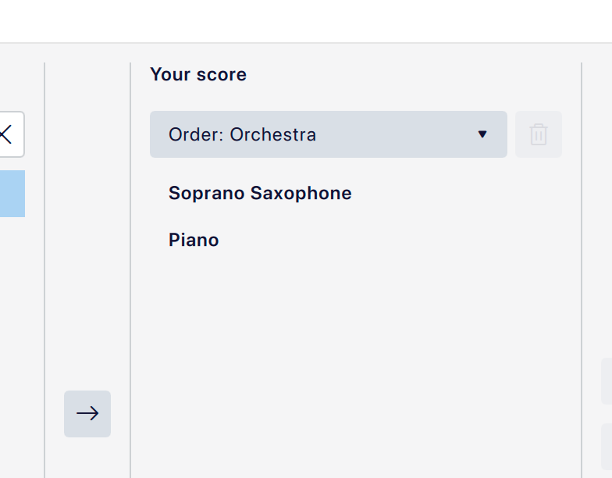

Add these bass notes to the left hand in the first five complete bars.
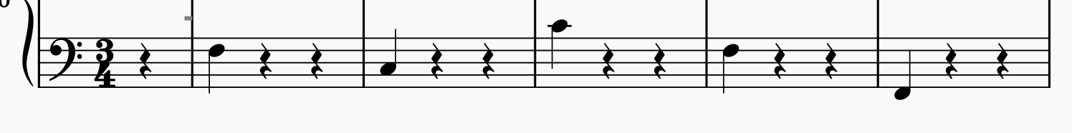

Fill in the final three bars of the left hand, using your ear to help you. What harmony would fit best here?

In the right hand, first bar, leave one rest and add a single F crotchet:
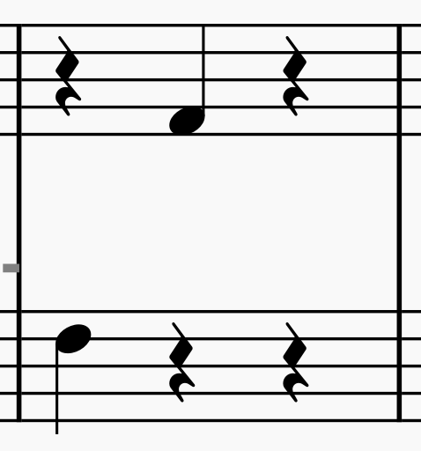

Chords
Enter the F major chord, including this F crotchet.

Try entering notes in this chord without using the mouse. There are two very useful methods, one involving Shift and one Alt.

Copy & paste
Copy and paste this chord so that it appears on both beats 2 and 3 as crotchets.

Using the left-hand bassline you have already entered, complete the right-hand using appropriate chords.

Barlines and rehearsal marks
Let’s pretend that bar five is the start of a new section. Create a double barline at the end of the fourth bar and create a rehearsal mark at the start of the fifth bar: letter A is the default.

Tempo changes
Over the final two bars, slow the tempo using a rit. marking. This will slow down the tempo by 75%. That seems too subtle: can you instead make this 50%? Also, create a pause on the final note, just for extra impact.

Chord symbols
Perhaps the piano player will be replaced by a guitarist? It would be useful for them to have chord symbols instead of the notated piano music:
Go back to bar 1 and create a chord symbol of F. Add one chord symbol per bar to indicate the harmony.
Creating these chord symbols makes a phantom piano play them in the background as you start playback: I often find this distracting, particularly since I already have a real piano part that I have notated. In playback controls you can disable play chord symbols to stop this happening.

Formatting
Format the document so that that the layout is locked with four bars per system. You may have to manually create a system break so that the initial anacrusis bar is not counted, and so that the second system begins with bar 5, not bar 4.
I sometimes find the size of the notation MuseScore produces too large. Reduce the stave size in the page settings to 0.063 inches.

Saving and sharing in September
Save this file (remember on your computer is the best option here) and email it to yourself so that we can review it together in September. When you arrive at the school, you can log in to your private email and download this work to your school account.

Optional extras
Here are some additional (optional) ideas you might like to explore:
- Add lyrics to the saxophone part so that a singer might also take part
- Change the entire saxophone part to a voice so these lyrics make more sense: open the stave/part properties and replace instrument.
- Change the time signature to 3/2, copy and paste the notes with paste as double duration.
- Add a part for drum kit using the slightly cumbersome percussion note entry window. You could try a simple oom-pah-pah or something more original. If you are not a drummer, learn to read basic drum notation.
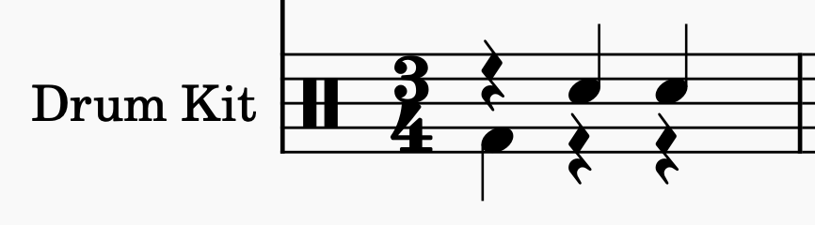

Challenges
Try these two challenges to demonstrate your MuseScore mastery!

#1
Working from scratch, are you able to dictate these four bars for solo piano in MuseScore? Email yourself the file so you are able to open it up the first week in September.
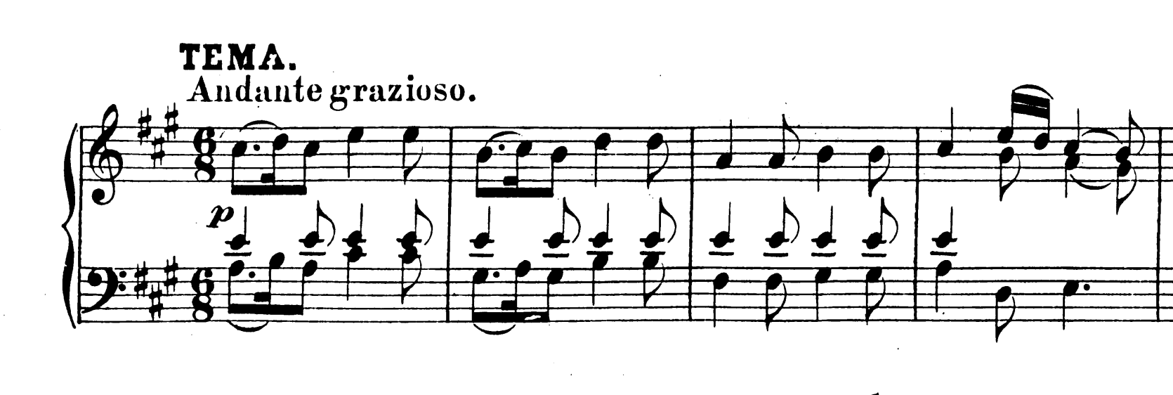
Hints:
- To include ‘Andante grazioso’, you might think of opening the Text palette. You’re better off opening the Tempo palette, adding ‘Andante’ and then editing it.
- Likewise, ‘p’ looks like text but is in fact found in the Dynamics palette, as you’d imagine.
- Two rhythms on one stave at the same time (e.g. in the left hand here) are achieved using Voices.
- Where one voice ends and the other continues (e.g. in the left hand in the final bar) you can delete the rests from one voice or else select the rests and make them invisible (try changing visibility in the Properties panel).

#2
Are you able to compose a short piece or arrange a piece you already know for string quartet? Please try a minimum of eight bars. Again, email this to yourself so we can take a look in September together!

