10 users
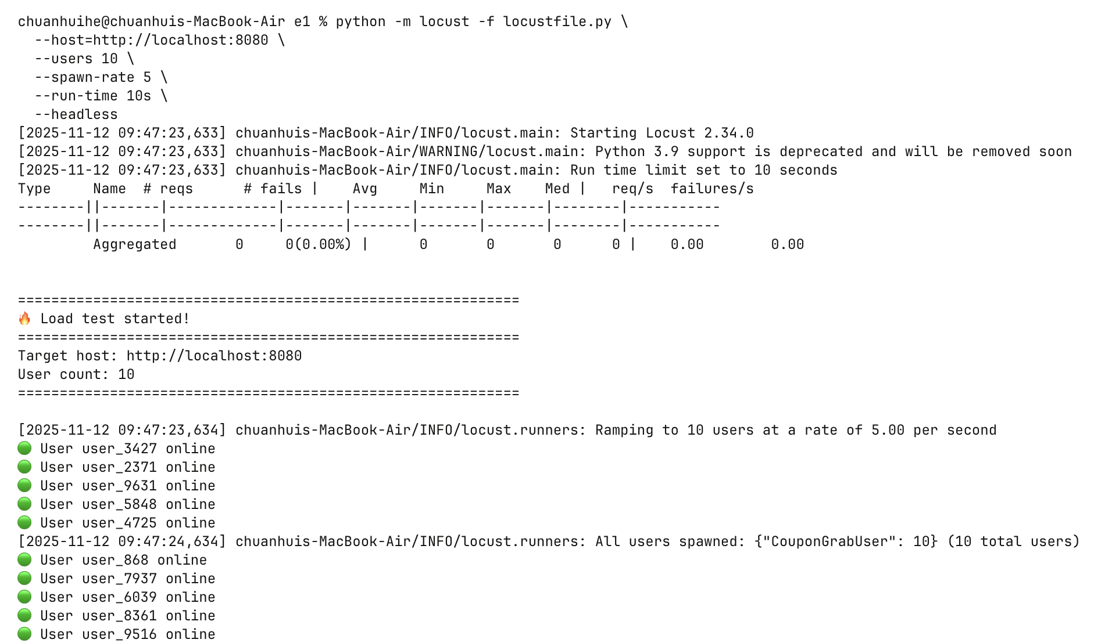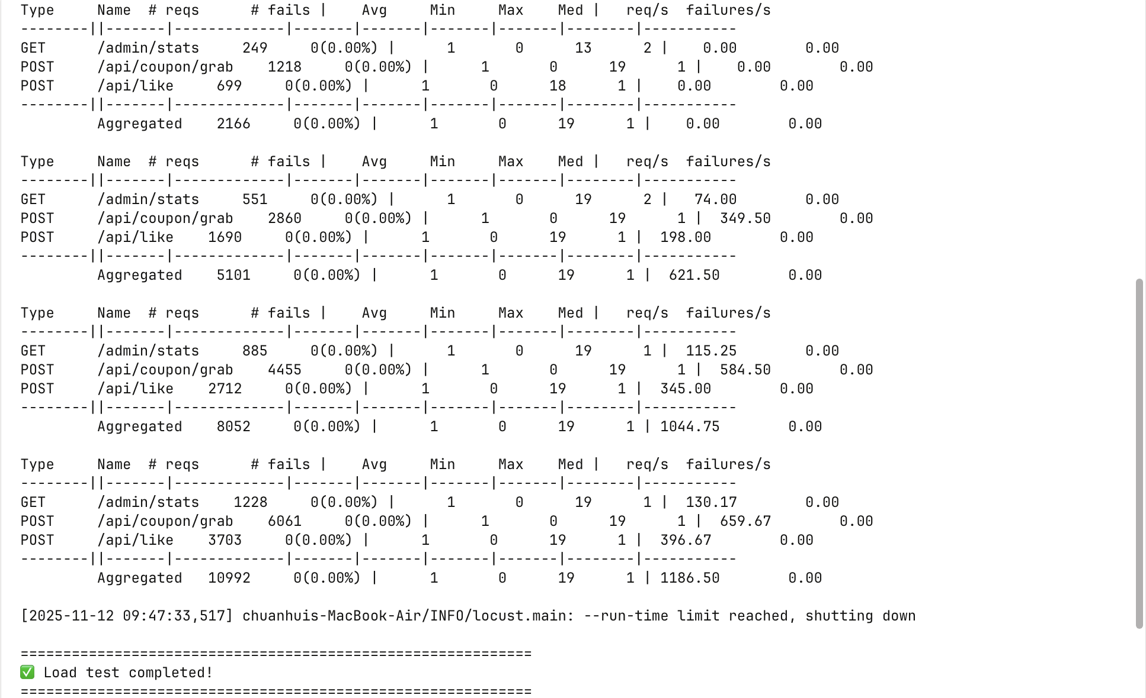
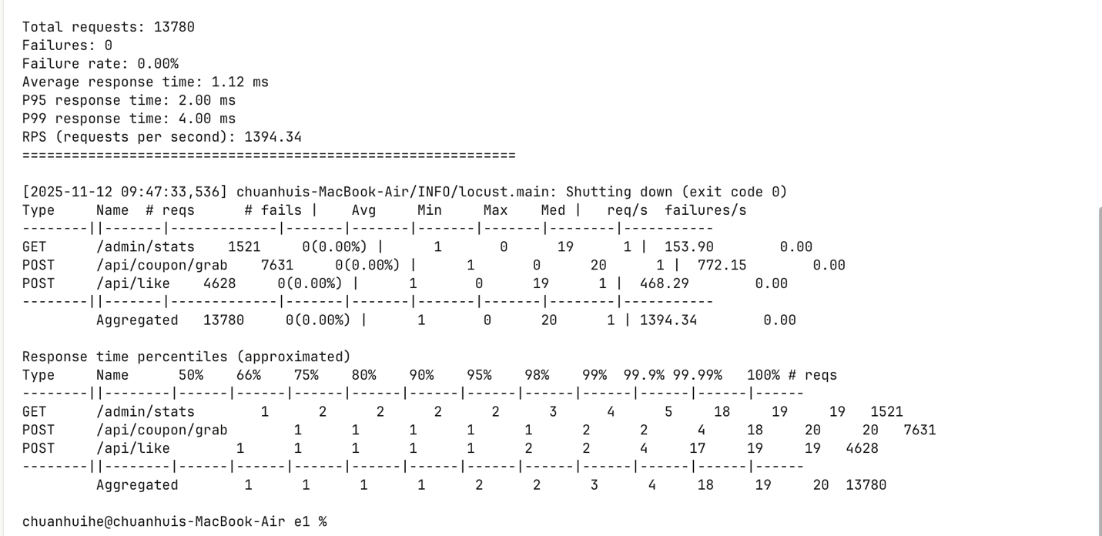

500 users: no filter
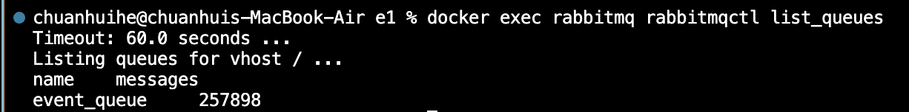============================================================
Total requests: 289952
Failures: 0
Failure rate: 0.00%
Average response time: 171.40 ms
P95 response time: 230.00 ms
P99 response time: 340.00 ms
RPS (requests per second): 2415.04
============================================================
[2025-11-12 16:56:58,553] chuanhuis-MacBook-Air/INFO/locust.main: writing html report to file: report_no_filter.html
[2025-11-12 16:56:58,555] chuanhuis-MacBook-Air/INFO/locust.main: Shutting down (exit code 0)
Type Name # reqs # fails | Avg Min Max Med | req/s failures/s
--------|-|-------|-------------|-------|-------|-------|-------|--------|-----------
GET /admin/stats 32264 0(0.00%) | 171 8 759 170 | 268.73 0.00
POST /api/coupon/grab 161148 0(0.00%) | 171 16 888 170 | 1342.22 0.00
POST /api/like 96540 0(0.00%) | 171 8 887 170 | 804.09 0.00
--------|-|-------|-------------|-------|-------|-------|-------|--------|-----------
Aggregated 289952 0(0.00%) | 171 8 888 170 | 2415.04 0.00

Response time percentiles (approximated)
Type Name 50% 66% 75% 80% 90% 95% 98% 99% 99.9% 99.99% 100% # reqs
--------|-----|--------|------|------|------|------|------|------|------|------|------|------|------
GET /admin/stats 170 180 180 190 200 230 290 350 570 670 760 32264
POST /api/coupon/grab 170 180 180 190 200 230 290 340 560 670 890 161148
POST /api/like 170 180 180 190 200 230 290 350 560 650 890 96540
--------|-----|--------|------|------|------|------|------|------|------|------|------|------|------
Aggregated 170 180 180 190 200 230 290 340 560 670 890 289952

500 users: with filter

============================================================
Total requests: 290257
Failures: 0
Failure rate: 0.00%
Average response time: 171.28 ms
P95 response time: 220.00 ms
P99 response time: 320.00 ms
RPS (requests per second): 2414.19
============================================================
[2025-11-12 17:12:00,666] chuanhuis-MacBook-Air/INFO/locust.main: writing html report to file: report_with_filter.html
[2025-11-12 17:12:00,668] chuanhuis-MacBook-Air/INFO/locust.main: Shutting down (exit code 0)
Type Name # reqs # fails | Avg Min Max Med | req/s failures/s
--------|-|-------|-------------|-------|-------|-------|-------|--------|-----------
GET /admin/stats 32182 0(0.00%) | 171 18 654 170 | 267.67 0.00
POST /api/coupon/grab 161533 0(0.00%) | 171 7 946 170 | 1343.54 0.00
POST /api/like 96542 0(0.00%) | 171 16 945 170 | 802.98 0.00
--------|-|-------|-------------|-------|-------|-------|-------|--------|-----------
Aggregated 290257 0(0.00%) | 171 7 946 170 | 2414.19 0.00

Response time percentiles (approximated)
Type Name 50% 66% 75% 80% 90% 95% 98% 99% 99.9% 99.99% 100% # reqs
--------|-----|--------|------|------|------|------|------|------|------|------|------|------|------
GET /admin/stats 170 180 190 190 210 220 280 320 460 610 650 32182
POST /api/coupon/grab 170 180 190 190 210 220 280 320 460 760 950 161533
POST /api/like 170 180 190 190 210 220 280 320 460 700 950 96542
--------|-----|--------|------|------|------|------|------|------|------|------|------|------|------
Aggregated 170 180 190 190 210 220 280 320 460 700 950 290257

