1. fcc
   1. props
   2. father child communication
2. axios
3. localStorage
4. joi

Destructuring - <https://developer.mozilla.org/en-US/docs/Web/JavaScript/Reference/Operators/Destructuring_assignment>

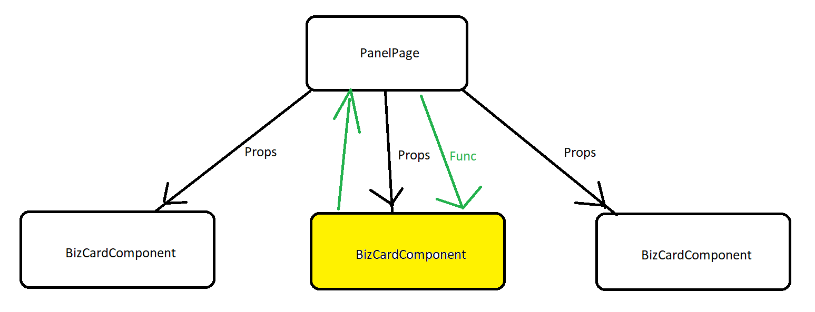

HW:

1. create register and login pages, working with our nodejs project
2. create page to display Rick and Morty characters\*
   1. axios
   2. fcc
   3. add option to delete character