1. joi
2. redux - <https://redux.js.org/introduction/getting-started>
   1. provider – let components to access redux
   2. createSlice – configure sub state
   3. configureStore – configure redux “the big state”
   4. useDispatch – let us update the redux state
   5. useSelector – let us get access to redux substate

like:

const [redux, setRedux] = useState({auth:{logggedIn:false})

redux – useSelector

setRedux – useDispatch

* 1. add value to action

1. better path
2. jwt decode

TK – redux:

1. create page with 2 btns

this page has 2 btns, this btns should update redux state

* 1. btn1: add 1
  2. btn2: sub 1

1. create page to display the value of the redux state

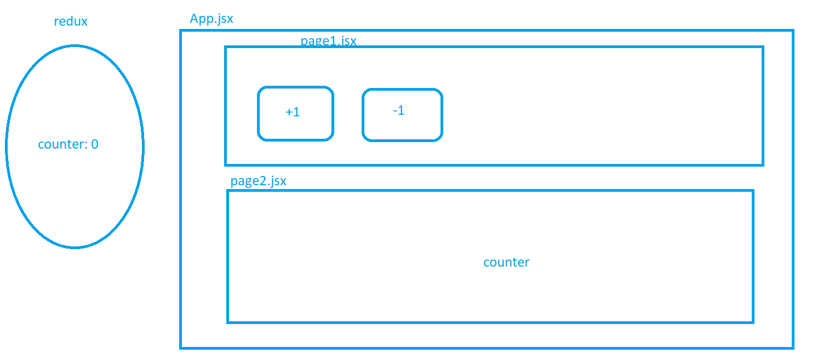

HW:

1. create page with btn that will tell redux generate random number
2. create page that will display this random number
3. \*\*\*optional can display if this number is odd or even
4. \*\*\*\*optional
   1. in register page validate the fields with joi
   2. if the user registered store it in redux and display in toast thank you for register
   3. in navbar:
      1. add register and login - will be displayed if user not logged in
      2. if user registered hide register btn in navbar
      3. if user logged in display welcome and his name and logout btn
      4. when user press on logout it should clear redux and localStorage