**Fake_News_Detection**

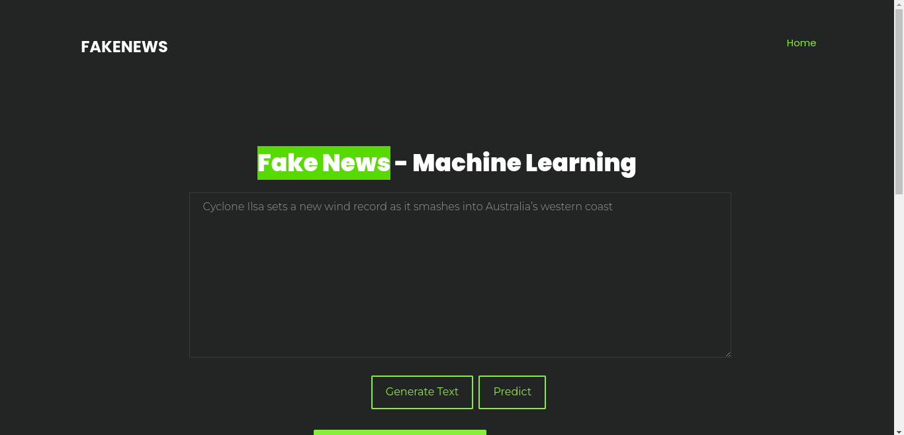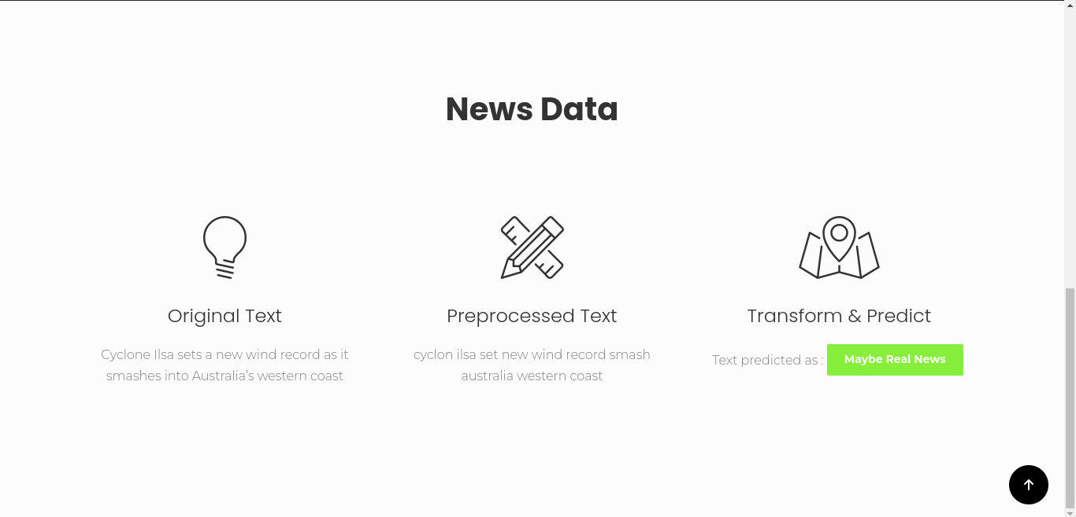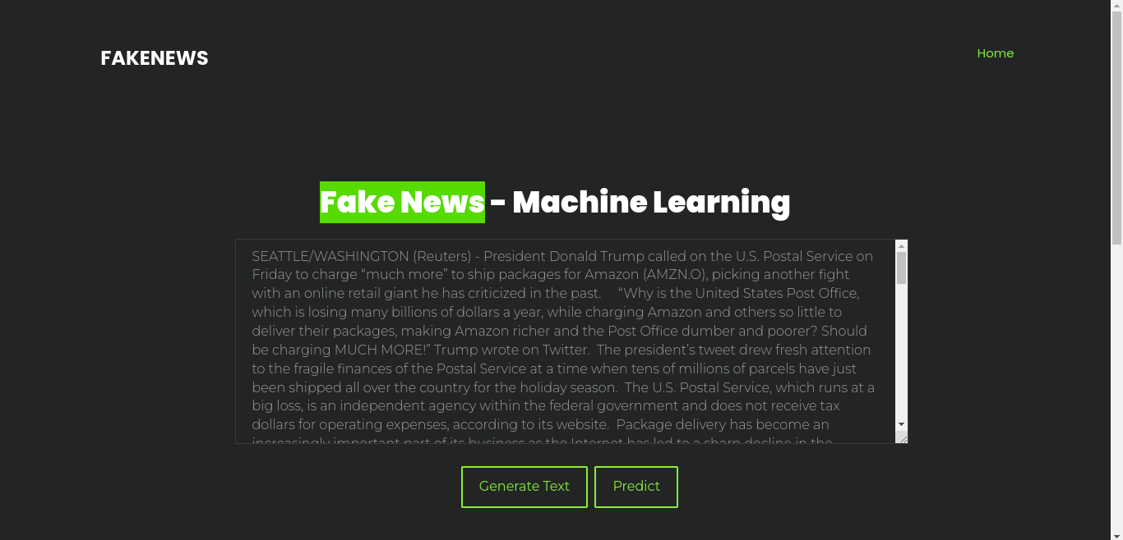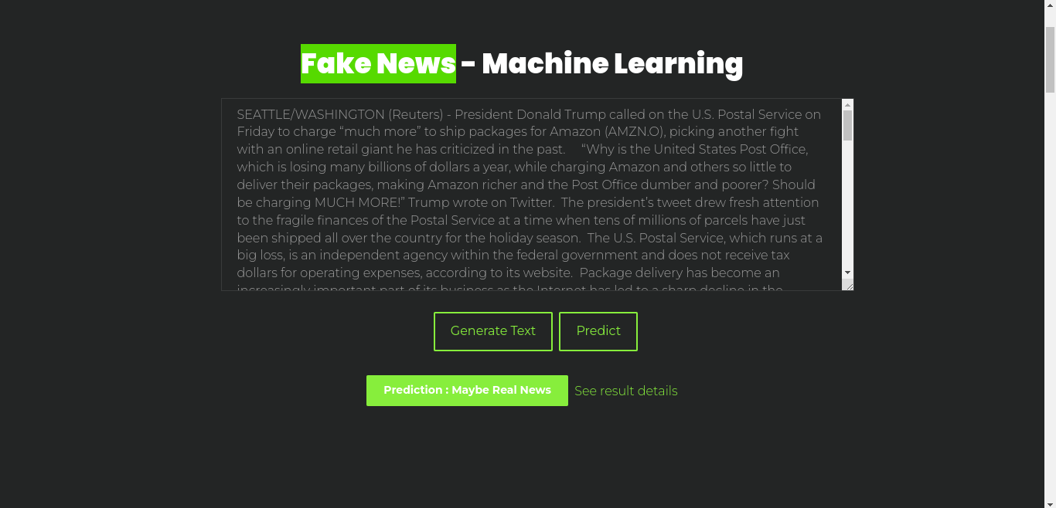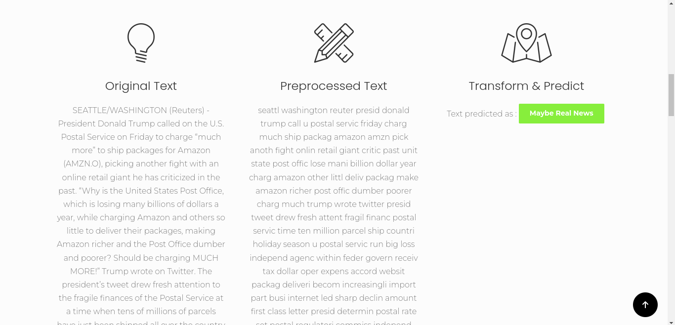

**Coding:**

**App.py**

**from flask import Flask, jsonify, request, render_template, redirect, url_for**

**from prediction_model import PredictionModel**

**import pandas as pd**

**from random import randrange**

**from forms import OriginalTextForm**

**app = Flask(__name__)**

**app.config['SECRET_KEY'] = '4c99e0361905b9f941f17729187afdb9'**

**@app.route("/", methods=['POST', 'GET'])**

**def home():**

**form = OriginalTextForm()**

**if form.generate.data:**

**data = pd.read_csv("random_dataset.csv")**

**index = randrange(0, len(data)-1, 1)**

**original_text = data.loc[index].text**

**form.original_text.data = str(original_text)**

**return render_template('home.html', form=form, output=False)**

**elif form.predict.data:**

**if len(str(form.original_text.data)) > 10:**

**model = PredictionModel(form.original_text.data)**

**return render_template('home.html', form=form, output=model.predict())**

**return render_template('home.html', form=form, output=False)**

**@app.route('/predict/<original_text>')**

**def predict(original_text):**

**#text = 'CAIRO (Reuters) - Three police officers were killed and eight others injured in a shoot-out during a raid on a suspected militant hideout in Giza, southwest of the Egyptian capital, two security sources said on Friday. The sources said authorities were following a lead to an apartment thought to house eight suspected members of Hasm, a group which has claimed several attacks around the capital targeting judges and policemen since last year. The suspected militants fled after the exchange of fire there, the sources said. Egypt accuses Hasm of being a militant wing of the Muslim Brotherhood, an Islamist group it outlawed in 2013. The Muslim Brotherhood denies this. An Islamist insurgency in the Sinai peninsula has grown since the military overthrew President Mohamed Mursi of the Muslim Brotherhood in mid-2013 following mass protests against his rule. The militant group staging the insurgency pledged allegiance to Islamic State in 2014. It is blamed for the killing of hundreds of soldiers and policemen and has started to target other areas, including Egypt s Christian Copts. '**

**model = PredictionModel(original_text)**

**return jsonify(model.predict())**

**@app.route('/random', methods=['GET'])**

**def random():**

**data = pd.read_csv("random_dataset.csv")**

**index = randrange(0, len(data)-1, 1)**

**return jsonify({'title': data.loc[index].title, 'text': data.loc[index].text, 'label': str(data.loc[index].label)})**

**if __name__ == '__main__':**

**app.run()**

**Prediction.py:**

**from nltk.corpus import stopwords**

**import joblib**

**import nltk**

**import re**

**from sklearn.feature_extraction.text import TfidfVectorizer**

**from nltk.stem.porter import PorterStemmer**

**ps = PorterStemmer()**

**nltk.data.path.append('./nltk')**

**model = joblib.load('model2.pkl')**

**print('=> Pickle Loaded : Model ')**

**tfidfvect = joblib.load('tfidfvect2.pkl')**

**print('=> Pickle Loaded : Vectorizer')**

**class PredictionModel:**

**output = {}**

**# constructor**

**def __init__(self, original_text):**

**self.output['original'] = original_text**

**# predict**

**def predict(self):**

**review = self.preprocess()**

**text_vect = tfidfvect.transform([review]).toarray()**

**self.output['prediction'] = 'FAKE' if model.predict(text_vect) == 0 else 'REAL'**

**return self.output**

**# Helper methods**

**def preprocess(self):**

**review = re.sub('[^a-zA-Z]', ' ', self.output['original'])**

**review = review.lower()**

**review = review.split()**

**review = [ps.stem(word) for word in review if not word in stopwords.words('english')]**

**review = ' '.join(review)**

**self.output['preprocessed'] = review**

**return review**

**Index,html:**

**<!DOCTYPE HTML>**

**<html>**

**<head>**

**<meta charset="utf-8">**

**<meta http-equiv="X-UA-Compatible" content="IE=edge">**

**<title>Fake News Prediction</title>**

**<meta name="viewport" content="width=device-width, initial-scale=1">**

**<meta name="description" content="" />**

**<meta name="keywords" content="" />**

**<meta name="author" content="" />**

**<link href="https://fonts.googleapis.com/css?family=Poppins:300,400,700,900" rel="stylesheet">**

**<link href="https://fonts.googleapis.com/css?family=Montserrat:300,400,700" rel="stylesheet">**

**<!-- Animate.css -->**

**<link rel="stylesheet" type="text/css" href="static/css/animate.css">**

**<!-- Icomoon Icon Fonts-->**

**<link rel="stylesheet" type="text/css" href="static/css/icomoon.css">**

**<!-- Bootstrap -->**

**<link rel="stylesheet" type="text/css" href="static/css/bootstrap.css">**

**<!-- Magnific Popup -->**

**<link rel="stylesheet" type="text/css" href="static/css/magnific-popup.css">**

**<!-- Flexslider -->**

**<link rel="stylesheet" type="text/css" href="static/css/flexslider.css">**

**<!-- Owl Carousel -->**

**<link rel="stylesheet" type="text/css" href="static/css/owl.carousel.min.css">**

**<link rel="stylesheet" type="text/css" href="static/css/owl.theme.default.min.css">**

**<!-- Flaticons -->**

**<link rel="stylesheet" type="text/css" href="static/fonts/flaticon/font/flaticon.css">**

**<!-- Theme style -->**

**<link rel="stylesheet" type="text/css" href="static/css/style.css">**

**<!-- Modernizr JS -->**

**<script src="../static/js/modernizr-2.6.2.min.js"></script>**

**<!-- FOR IE9 below -->**

**<!--[if lt IE 9]>**

**<script src="js/respond.min.js"></script>**

**<![endif]-->**

**</head>**

**<body>**

**<div class="colorlib-loader"></div>**

**<div id="page">**

**<nav class="colorlib-nav" role="navigation">**

**<div class="top-menu">**

**<div class="container">**

**<div class="row">**

**<div class="col-md-2 text-center">**

**<div id="colorlib-logo"><a href="/">FAKENEWS</a></div>**

**</div>**

**<div class="col-md-10 text-right menu-1">**

**<ul>**

**<li class="active"><a href="/">Home</a></li>**

**</ul>**

**</div>**

**</div>**

**</div>**

**</div>**

**</nav>**

**<div class="colorlib-intro">**

**<div class="container">**

**<div class="row">**

**<div class="col-md-8 col-md-offset-2 text-center">**

**<div class="intro">**

**<h1><span style="background: #7dc710;">Fake News</span> - Machine Learning</h1>**

**</div>**

**</div>**

**</div>**

**<div class="row" id="colorlib-footer">**

**<div class="display-tc">**

**<form class="form-inline qbstp-header-subscribe" method="POST" action="">**

**{{ form.hidden_tag() }}**

**<!-- <div class="col-three-forth text-center col-md-offset-2">**

**<div class="form-group">**

**<textarea class="form-control" id="email" rows="10">Enter text here...</textarea>**

**<br><br>**

**<p>**

**<a href="#" class="btn btn-primary btn-outline btn-md">Generate Text</a>**

**<a href="#" class="btn btn-primary btn-outline btn-md">Predict</a>**

**</p>**

**</div>**

**</div> -->**

**<div class="col-three-forth text-center col-md-offset-2">**

**<div class="form-group">**

**{% if form.original_text.errors %}**

**{{ form.original_text(class="form-control form-control-lg is-invalid") }}**

**<div class="invalid-feedback">**

**{% for error in form.original_text.errors %}**

**<span>{{ error }}</span>**

**{% endfor %}**

**</div>**

**{% else %}**

**{{ form.original_text(class="form-control", id="email", rows="10") }}**

**{% endif %}**

**</div>**

**</div>**

**<div class="col-three-forth text-center col-md-offset-2">**

**<div class="form-group">**

**<br>**

**{{ form.generate(class="btn btn-primary btn-outline btn-md") }}**

**{{ form.predict(class="btn btn-primary btn-outline btn-md") }}**

**</div>**

**</div>**

**</form>**

**</div>**

**</div>**

**<div class="row" id="colorlib-footer">**

**<div class="col-three-forth text-center">**

**<br>**

**{% if output %}**

**<div class="form-group">**

**<p>**

**<a href="#" class="btn btn-primary"><strong>Prediction : {% if output['prediction']=="REAL" %}Maybe Real News{% else %}Maybe Fake News{% endif %}</strong></a>**

**<a href="#colorlib-services">See result details</a>**

**</p>**

**</div>**

**{% endif %}**

**</div>**

**</div>**

**</div>**

**</div>**

**<div id="colorlib-services">**

**<div class="container">**

**<div class="row">**

**<div class="col-md-8 col-md-offset-2 text-center colorlib-heading animate-box">**

**<h2>News Data</h2>**

**</div>**

**</div>**

**<div class="row">**

**<div class="col-md-4 text-center animate-box">**

**<div class="services">**

**<span class="icon">**

**<i class="icon-lightbulb"></i>**

**</span>**

**<div class="desc">**

**<h3>Original Text</h3>**

**{%if output %}**

**<p>{{ output['original'] }}</p>**

**{% else %}**

**<p>Even the all-powerful Pointing has no control about the blind texts it is an almost unorthographic life One day however a small line</p>**

**{% endif%}**

**</div>**

**</div>**

**</div>**

**<div class="col-md-4 text-center animate-box">**

**<div class="services">**

**<span class="icon">**

**<i class="icon-tools"></i>**

**</span>**

**<div class="desc">**

**<h3>Preprocessed Text</h3>**

**{%if output %}**

**<p>{{ output['preprocessed'] }}</p>**

**{% else %}**

**<p>Even the all-powerful Pointing has no control about the blind texts it is an almost unorthographic life One day however a small line</p>**

**{% endif%}**

**</div>**

**</div>**

**</div>**

**<div class="col-md-4 text-center animate-box">**

**<div class="services">**

**<span class="icon">**

**<i class="icon-map"></i>**

**</span>**

**<div class="desc">**

**<h3>Transform &amp; Predict</h3>**

**{%if output %}**

**<p>Text predicted as : <span class="btn btn-primary"><strong>{% if output['prediction']=="REAL" %}Maybe Real News{% else %}Maybe Fake News{% endif %}</strong></span></p>**

**{% else %}**

**<p>Even the all-powerful Pointing has no control about the blind texts it is an almost unorthographic life One day however a small line</p>**

**{% endif%}**

**</div>**

**</div>**

**</div>**

**</div>**

**</div>**

**</div>**

**</div>**

**<div class="gototop js-top">**

**<a href="#" class="js-gotop"><i class="icon-arrow-up2"></i></a>**

**</div>**

**<!-- jQuery -->**

**<script src="static/js/jquery.min.js"></script>**

**<!-- jQuery Easing -->**

**<script src="static/js/jquery.easing.1.3.js"></script>**

**<!-- Bootstrap -->**

**<script src="static/js/bootstrap.min.js"></script>**

**<!-- Waypoints -->**

**<script src="static/js/jquery.waypoints.min.js"></script>**

**<!-- Stellar Parallax -->**

**<script src="static/js/jquery.stellar.min.js"></script>**

**<!-- Flexslider -->**

**<script src="static/js/jquery.flexslider-min.js"></script>**

**<!-- Owl carousel -->**

**<script src="static/js/owl.carousel.min.js"></script>**

**<!-- Magnific Popup -->**

**<script src="static/js/jquery.magnific-popup.min.js"></script>**

**<script src="static/js/magnific-popup-options.js"></script>**

**<!-- Counters -->**

**<script src="static/js/jquery.countTo.js"></script>**

**<!-- Main -->**

**<script src="static/js/main.js"></script>**

**</body>**

**</html>**

**Dataset.csv:**

**title,text,subject,date,label**

**"As U.S. budget fight looms, Republicans flip their fiscal script","WASHINGTON (Reuters) - The head of a conservative Republican faction in the U.S. Congress, who voted this month for a huge expansion of the national debt to pay for tax cuts, called himself a “fiscal conservative” on Sunday and urged budget restraint in 2018. In keeping with a sharp pivot under way among Republicans, U.S. Representative Mark Meadows, speaking on CBS’ “Face the Nation,” drew a hard line on federal spending, which lawmakers are bracing to do battle over in January. When they return from the holidays on Wednesday, lawmakers will begin trying to pass a federal budget in a fight likely to be linked to other issues, such as immigration policy, even as the November congressional election campaigns approach in which Republicans will seek to keep control of Congress. President Donald Trump and his Republicans want a big budget increase in military spending, while Democrats also want proportional increases for non-defense “discretionary” spending on programs that support education, scientific research, infrastructure, public health and environmental protection. “The (Trump) administration has already been willing to say: ‘We’re going to increase non-defense discretionary spending ... by about 7 percent,’” Meadows, chairman of the small but influential House Freedom Caucus, said on the program. “Now, Democrats are saying that’s not enough, we need to give the government a pay raise of 10 to 11 percent. For a fiscal conservative, I don’t see where the rationale is. ... Eventually you run out of other people’s money,” he said. Meadows was among Republicans who voted in late December for their party’s debt-financed tax overhaul, which is expected to balloon the federal budget deficit and add about $1.5 trillion over 10 years to the $20 trillion national debt. “It’s interesting to hear Mark talk about fiscal responsibility,” Democratic U.S. Representative Joseph Crowley said on CBS. Crowley said the Republican tax bill would require the United States to borrow $1.5 trillion, to be paid off by future generations, to finance tax cuts for corporations and the rich. “This is one of the least ... fiscally responsible bills we’ve ever seen passed in the history of the House of Representatives. I think we’re going to be paying for this for many, many years to come,” Crowley said. Republicans insist the tax package, the biggest U.S. tax overhaul in more than 30 years, will boost the economy and job growth. House Speaker Paul Ryan, who also supported the tax bill, recently went further than Meadows, making clear in a radio interview that welfare or “entitlement reform,” as the party often calls it, would be a top Republican priority in 2018. In Republican parlance, “entitlement” programs mean food stamps, housing assistance, Medicare and Medicaid health insurance for the elderly, poor and disabled, as well as other programs created by Washington to assist the needy. Democrats seized on Ryan’s early December remarks, saying they showed Republicans would try to pay for their tax overhaul by seeking spending cuts for social programs. But the goals of House Republicans may have to take a back seat to the Senate, where the votes of some Democrats will be needed to approve a budget and prevent a government shutdown. Democrats will use their leverage in the Senate, which Republicans narrowly control, to defend both discretionary non-defense programs and social spending, while tackling the issue of the “Dreamers,” people brought illegally to the country as children. Trump in September put a March 2018 expiration date on the Deferred Action for Childhood Arrivals, or DACA, program, which protects the young immigrants from deportation and provides them with work permits. The president has said in recent Twitter messages he wants funding for his proposed Mexican border wall and other immigration law changes in exchange for agreeing to help the Dreamers. Representative Debbie Dingell told CBS she did not favor linking that issue to other policy objectives, such as wall funding. “We need to do DACA clean,” she said. On Wednesday, Trump aides will meet with congressional leaders to discuss those issues. That will be followed by a weekend of strategy sessions for Trump and Republican leaders on Jan. 6 and 7, the White House said. Trump was also scheduled to meet on Sunday with Florida Republican Governor Rick Scott, who wants more emergency aid. The House has passed an $81 billion aid package after hurricanes in Florida, Texas and Puerto Rico, and wildfires in California. The package far exceeded the $44 billion requested by the Trump administration. The Senate has not yet voted on the aid. ",politicsNews,"December 31, 2017 ",1**

**U.S. military to accept transgender recruits on Monday: Pentagon,"WASHINGTON (Reuters) - Transgender people will be allowed for the first time to enlist in the U.S. military starting on Monday as ordered by federal courts, the Pentagon said on Friday, after President Donald Trump’s administration decided not to appeal rulings that blocked his transgender ban. Two federal appeals courts, one in Washington and one in Virginia, last week rejected the administration’s request to put on hold orders by lower court judges requiring the military to begin accepting transgender recruits on Jan. 1. A Justice Department official said the administration will not challenge those rulings. “The Department of Defense has announced that it will be releasing an independent study of these issues in the coming weeks. So rather than litigate this interim appeal before that occurs, the administration has decided to wait for DOD’s study and will continue to defend the president’s lawful authority in District Court in the meantime,” the official said, speaking on condition of anonymity. In September, the Pentagon said it had created a panel of senior officials to study how to implement a directive by Trump to prohibit transgender individuals from serving. The Defense Department has until Feb. 21 to submit a plan to Trump. Lawyers representing currently-serving transgender service members and aspiring recruits said they had expected the administration to appeal the rulings to the conservative-majority Supreme Court, but were hoping that would not happen. Pentagon spokeswoman Heather Babb said in a statement: “As mandated by court order, the Department of Defense is prepared to begin accessing transgender applicants for military service Jan. 1. All applicants must meet all accession standards.” Jennifer Levi, a lawyer with gay, lesbian and transgender advocacy group GLAD, called the decision not to appeal “great news.” “I’m hoping it means the government has come to see that there is no way to justify a ban and that it’s not good for the military or our country,” Levi said. Both GLAD and the American Civil Liberties Union represent plaintiffs in the lawsuits filed against the administration. In a move that appealed to his hard-line conservative supporters, Trump announced in July that he would prohibit transgender people from serving in the military, reversing Democratic President Barack Obama’s policy of accepting them. Trump said on Twitter at the time that the military “cannot be burdened with the tremendous medical costs and disruption that transgender in the military would entail.” Four federal judges - in Baltimore, Washington, D.C., Seattle and Riverside, California - have issued rulings blocking Trump’s ban while legal challenges to the Republican president’s policy proceed. The judges said the ban would likely violate the right under the U.S. Constitution to equal protection under the law. The Pentagon on Dec. 8 issued guidelines to recruitment personnel in order to enlist transgender applicants by Jan. 1. The memo outlined medical requirements and specified how the applicants’ sex would be identified and even which undergarments they would wear. The Trump administration previously said in legal papers that the armed forces were not prepared to train thousands of personnel on the medical standards needed to process transgender applicants and might have to accept “some individuals who are not medically fit for service.” The Obama administration had set a deadline of July 1, 2017, to begin accepting transgender recruits. But Trump’s defense secretary, James Mattis, postponed that date to Jan. 1, 2018, which the president’s ban then put off indefinitely. Trump has taken other steps aimed at rolling back transgender rights. In October, his administration said a federal law banning gender-based workplace discrimination does not protect transgender employees, reversing another Obama-era position. In February, Trump rescinded guidance issued by the Obama administration saying that public schools should allow transgender students to use the restroom that corresponds to their gender identity. ",politicsNews,"December 29, 2017 ",1**

**Senior U.S. Republican senator: 'Let Mr. Mueller do his job',"WASHINGTON (Reuters) - The special counsel investigation of links between Russia and President Trump’s 2016 election campaign should continue without interference in 2018, despite calls from some Trump administration allies and Republican lawmakers to shut it down, a prominent Republican senator said on Sunday. Lindsey Graham, who serves on the Senate armed forces and judiciary committees, said Department of Justice Special Counsel Robert Mueller needs to carry on with his Russia investigation without political interference. “This investigation will go forward. It will be an investigation conducted without political influence,” Graham said on CBS’s Face the Nation news program. “And we all need to let Mr. Mueller do his job. I think he’s the right guy at the right time.” The question of how Russia may have interfered in the election, and how Trump’s campaign may have had links with or co-ordinated any such effort, has loomed over the White House since Trump took office in January. It shows no sign of receding as Trump prepares for his second year in power, despite intensified rhetoric from some Trump allies in recent weeks accusing Mueller’s team of bias against the Republican president. Trump himself seemed to undercut his supporters in an interview last week with the New York Times in which he said he expected Mueller was “going to be fair.” Russia’s role in the election and the question of possible links to the Trump campaign are the focus of multiple inquiries in Washington. Three committees of the Senate and the House of Representatives are investigating, as well as Mueller, whose team in May took over an earlier probe launched by the U.S. Federal Bureau of Investigation (FBI). Several members of the Trump campaign and administration have been convicted or indicted in the investigation. Trump and his allies deny any collusion with Russia during the campaign, and the Kremlin has denied meddling in the election. Graham said he still wants an examination of the FBI’s use of a dossier on links between Trump and Russia that was compiled by a former British spy, Christopher Steele, which prompted Trump allies and some Republicans to question Mueller’s inquiry. On Saturday, the New York Times reported that it was not that dossier that triggered an early FBI probe, but a tip from former Trump campaign foreign policy adviser George Papadopoulos to an Australian diplomat that Russia had damaging information about former Trump rival Hillary Clinton. “I want somebody to look at the way the Department of Justice used this dossier. It bothers me greatly the way they used it, and I want somebody to look at it,” Graham said. But he said the Russia investigation must continue. “As a matter of fact, it would hurt us if we ignored it,” he said. ",politicsNews,"December 31, 2017 ",1**

**FBI Russia probe helped by Australian diplomat tip-off: NYT,"WASHINGTON (Reuters) - Trump campaign adviser George Papadopoulos told an Australian diplomat in May 2016 that Russia had political dirt on Democratic presidential candidate Hillary Clinton, the New York Times reported on Saturday. The conversation between Papadopoulos and the diplomat, Alexander Downer, in London was a driving factor behind the FBI’s decision to open a counter-intelligence investigation of Moscow’s contacts with the Trump campaign, the Times reported. Two months after the meeting, Australian officials passed the information that came from Papadopoulos to their American counterparts when leaked Democratic emails began appearing online, according to the newspaper, which cited four current and former U.S. and foreign officials. Besides the information from the Australians, the probe by the Federal Bureau of Investigation was also propelled by intelligence from other friendly governments, including the British and Dutch, the Times said. Papadopoulos, a Chicago-based international energy lawyer, pleaded guilty on Oct. 30 to lying to FBI agents about contacts with people who claimed to have ties to top Russian officials. It was the first criminal charge alleging links between the Trump campaign and Russia. The White House has played down the former aide’s campaign role, saying it was “extremely limited” and that any actions he took would have been on his own. The New York Times, however, reported that Papadopoulos helped set up a meeting between then-candidate Donald Trump and Egyptian President Abdel Fattah al-Sisi and edited the outline of Trump’s first major foreign policy speech in April 2016. The federal investigation, which is now being led by Special Counsel Robert Mueller, has hung over Trump’s White House since he took office almost a year ago. Some Trump allies have recently accused Mueller’s team of being biased against the Republican president. Lawyers for Papadopoulos did not immediately respond to requests by Reuters for comment. Mueller’s office declined to comment. Trump’s White House attorney, Ty Cobb, declined to comment on the New York Times report. “Out of respect for the special counsel and his process, we are not commenting on matters such as this,” he said in a statement. Mueller has charged four Trump associates, including Papadopoulos, in his investigation. Russia has denied interfering in the U.S. election and Trump has said there was no collusion between his campaign and Moscow. ",politicsNews,"December 30, 2017 ",1**

**Trump wants Postal Service to charge 'much more' for Amazon shipments,"SEATTLE/WASHINGTON (Reuters) - President Donald Trump called on the U.S. Postal Service on Friday to charge “much more” to ship packages for Amazon (AMZN.O), picking another fight with an online retail giant he has criticized in the past. “Why is the United States Post Office, which is losing many billions of dollars a year, while charging Amazon and others so little to deliver their packages, making Amazon richer and the Post Office dumber and poorer? Should be charging MUCH MORE!” Trump wrote on Twitter. The president’s tweet drew fresh attention to the fragile finances of the Postal Service at a time when tens of millions of parcels have just been shipped all over the country for the holiday season. The U.S. Postal Service, which runs at a big loss, is an independent agency within the federal government and does not receive tax dollars for operating expenses, according to its website. Package delivery has become an increasingly important part of its business as the Internet has led to a sharp decline in the amount of first-class letters. The president does not determine postal rates. They are set by the Postal Regulatory Commission, an independent government agency with commissioners selected by the president from both political parties. That panel raised prices on packages by almost 2 percent in November. Amazon was founded by Jeff Bezos, who remains the chief executive officer of the retail company and is the richest person in the world, according to Bloomberg News. Bezos also owns The Washington Post, a newspaper Trump has repeatedly railed against in his criticisms of the news media. In tweets over the past year, Trump has said the “Amazon Washington Post” fabricated stories. He has said Amazon does not pay sales tax, which is not true, and so hurts other retailers, part of a pattern by the former businessman and reality television host of periodically turning his ire on big American companies since he took office in January. Daniel Ives, a research analyst at GBH Insights, said Trump’s comment could be taken as a warning to the retail giant. However, he said he was not concerned for Amazon. “We do not see any price hikes in the future. However, that is a risk that Amazon is clearly aware of and (it) is building out its distribution (system) aggressively,” he said. Amazon has shown interest in the past in shifting into its own delivery service, including testing drones for deliveries. In 2015, the company spent $11.5 billion on shipping, 46 percent of its total operating expenses that year. Amazon shares were down 0.86 percent to $1,175.90 by early afternoon. Overall, U.S. stock prices were down slightly on Friday. Satish Jindel, president of ShipMatrix Inc, which analyzes shipping data, disputed the idea that the Postal Service charges less than United Parcel Service Inc (UPS.N) and FedEx Corp (FDX.N), the other biggest players in the parcel delivery business in the United States. Many customers get lower rates from UPS and FedEx than they would get from the post office for comparable services, he said. The Postal Service delivers about 62 percent of Amazon packages, for about 3.5 to 4 million a day during the current peak year-end holiday shipping season, Jindel said. The Seattle-based company and the post office have an agreement in which mail carriers take Amazon packages on the last leg of their journeys, from post offices to customers’ doorsteps. Amazon’s No. 2 carrier is UPS, at 21 percent, and FedEx is third, with 8 percent or so, according to Jindel. Trump’s comment tapped into a debate over whether Postal Service pricing has kept pace with the rise of e-commerce, which has flooded the mail with small packages.Private companies like UPS have long claimed the current system unfairly undercuts their business. Steve Gaut, a spokesman for UPS, noted that the company values its “productive relationship” with the postal service, but that it has filed with the Postal Regulatory Commission its concerns about the postal service’s methods for covering costs. Representatives for Amazon, the White House, the U.S. Postal Service and FedEx declined comment or were not immediately available for comment on Trump’s tweet. According to its annual report, the Postal Service lost $2.74 billion this year, and its deficit has ballooned to $61.86 billion. While the Postal Service’s revenue for first class mail, marketing mail and periodicals is flat or declining, revenue from package delivery is up 44 percent since 2014 to $19.5 billion in the fiscal year ended Sept. 30, 2017. But it also lost about $2 billion in revenue when a temporary surcharge expired in April 2016. According to a Government Accountability Office report in February, the service is facing growing personnel expenses, particularly $73.4 billion in unfunded pension and benefits liabilities. The Postal Service has not announced any plans to cut costs. By law, the Postal Service has to set prices for package delivery to cover the costs attributable to that service. But the postal service allocates only 5.5 percent of its total costs to its business of shipping packages even though that line of business is 28 percent of its total revenue. ",politicsNews,"December 29, 2017 ",1**

**"White House, Congress prepare for talks on spending, immigration","WEST PALM BEACH, Fla./WASHINGTON (Reuters) - The White House said on Friday it was set to kick off talks next week with Republican and Democratic congressional leaders on immigration policy, government spending and other issues that need to be wrapped up early in the new year. The expected flurry of legislative activity comes as Republicans and Democrats begin to set the stage for midterm congressional elections in November. President Donald Trump’s Republican Party is eager to maintain control of Congress while Democrats look for openings to wrest seats away in the Senate and the House of Representatives. On Wednesday, Trump’s budget chief Mick Mulvaney and legislative affairs director Marc Short will meet with Senate Majority Leader Mitch McConnell and House Speaker Paul Ryan - both Republicans - and their Democratic counterparts, Senator Chuck Schumer and Representative Nancy Pelosi, the White House said. That will be followed up with a weekend of strategy sessions for Trump, McConnell and Ryan on Jan. 6 and 7 at the Camp David presidential retreat in Maryland, according to the White House. The Senate returns to work on Jan. 3 and the House on Jan. 8. Congress passed a short-term government funding bill last week before taking its Christmas break, but needs to come to an agreement on defense spending and various domestic programs by Jan. 19, or the government will shut down. Also on the agenda for lawmakers is disaster aid for people hit by hurricanes in Puerto Rico, Texas and Florida, and by wildfires in California. The House passed an $81 billion package in December, which the Senate did not take up. The White House has asked for a smaller figure, $44 billion. Deadlines also loom for soon-to-expire protections for young adult immigrants who entered the country illegally as children, known as “Dreamers.” In September, Trump ended Democratic former President Barack Obama’s Deferred Action for Childhood Arrivals (DACA) program, which protected Dreamers from deportation and provided work permits, effective in March, giving Congress until then to devise a long-term solution. Democrats, some Republicans and a number of large companies have pushed for DACA protections to continue. Trump and other Republicans have said that will not happen without Congress approving broader immigration policy changes and tougher border security. Democrats oppose funding for a wall promised by Trump along the U.S.-Mexican border. “The Democrats have been told, and fully understand, that there can be no DACA without the desperately needed WALL at the Southern Border and an END to the horrible Chain Migration & ridiculous Lottery System of Immigration etc,” Trump said in a Twitter post on Friday. Trump wants to overhaul immigration rules for extended families and others seeking to live in the United States. Republican U.S. Senator Jeff Flake, a frequent critic of the president, said he would work with Trump to protect Dreamers. “We can fix DACA in a way that beefs up border security, stops chain migration for the DREAMers, and addresses the unfairness of the diversity lottery. If POTUS (Trump) wants to protect these kids, we want to help him keep that promise,” Flake wrote on Twitter. Congress in early 2018 also must raise the U.S. debt ceiling to avoid a government default. The U.S. Treasury would exhaust all of its borrowing options and run dry of cash to pay its bills by late March or early April if Congress does not raise the debt ceiling before then, according to the nonpartisan Congressional Budget Office. Trump, who won his first major legislative victory with the passage of a major tax overhaul this month, has also promised a major infrastructure plan. ",politicsNews,"December 29, 2017 ",1**

**"Trump says Russia probe will be fair, but timeline unclear: NYT","WEST PALM BEACH, Fla (Reuters) - President Donald Trump said on Thursday he believes he will be fairly treated in a special counsel investigation into Russian meddling in the U.S. presidential election, but said he did not know how long the probe would last. The federal investigation has hung over Trump’s White House since he took office almost a year ago, and some Trump allies have in recent weeks accused the team of Justice Department Special Counsel Robert Mueller of being biased against the Republican president. But in an interview with the New York Times, Trump appeared to shrug off concerns about the investigation, which was prompted by U.S. intelligence agencies’ conclusion that Russia tried to help Trump defeat Democrat Hillary Clinton by hacking and releasing embarrassing emails and disseminating propaganda. “There’s been no collusion. But I think he’s going to be fair,” Trump said in what the Times described as a 30-minute impromptu interview at his golf club in West Palm Beach, Florida. Mueller has charged four Trump associates in his investigation. Russia has denied interfering in the U.S. election. U.S. Deputy Attorney General Rod Rosenstein said this month that he was not aware of any impropriety by Mueller’s team. Trump’s lawyers have been saying for weeks that they had expected the Mueller investigation to wrap up quickly, possibly by the end of 2017. Mueller has not commented on how long it will last. Trump told the Times that he did not know how long the investigation would take. “Timing-wise, I can’t tell you. I just don’t know,” he said. Trump said he thought a prolonged probe “makes the country look bad” but said it has energized his core supporters. “What it’s done is, it’s really angered the base and made the base stronger. My base is strong than it’s ever been,” he said. The interview was a rare break in Trump’s Christmas vacation in Florida. He has golfed each day aside from Christmas Day, and mainly kept a low profile, apart from the occasional flurry of tweets. He spent one day golfing with Republican Senator David Perdue from Georgia, who has pushed legislation to cap immigration numbers, and had dinner on Thursday with Commerce Secretary Wilbur Ross, an international trade hawk. Trump told the Times he hoped to work with Democrats in the U.S. Congress on a spending plan to fix roads and other infrastructure, and on protections for a group of undocumented immigrants who were brought to the United States as children. Trump spoke about trade issues, saying he had backed off his hard line on Chinese trade practices in the hope that Beijing would do more to pressure North Korea to end its nuclear and missile testing program. He said he had been disappointed in the results. He also complained about the North American Free Trade Agreement (NAFTA), which his administration is attempting to renegotiate in talks with Mexico and Canada. Trump said Canadian Prime Minister Justin Trudeau had played down the importance of Canadian oil and lumber exports to the United States when looking at the balance of trade between the two countries. “If I don’t make the right deal, I’ll terminate NAFTA in two seconds. But we’re doing pretty good,” Trump said. ",politicsNews,"December 29, 2017 ",1**

**"Factbox: Trump on Twitter (Dec 29) - Approval rating, Amazon","The following statements were posted to the verified Twitter accounts of U.S. President Donald Trump, @realDonaldTrump and @POTUS. The opinions expressed are his own. Reuters has not edited the statements or confirmed their accuracy. @realDonaldTrump : - While the Fake News loves to talk about my so-called low approval rating, @foxandfriends just showed that my rating on Dec. 28, 2017, was approximately the same as President Obama on Dec. 28, 2009, which was 47%...and this despite massive negative Trump coverage & Russia hoax! [0746 EST] - Why is the United States Post Office, which is losing many billions of dollars a year, while charging Amazon and others so little to deliver their packages, making Amazon richer and the Post Office dumber and poorer? Should be charging MUCH MORE! [0804 EST] -- Source link: (bit.ly/2jBh4LU) (bit.ly/2jpEXYR) ",politicsNews,"December 29, 2017 ",1**

**Trump on Twitter (Dec 28) - Global Warming,"The following statements were posted to the verified Twitter accounts of U.S. President Donald Trump, @realDonaldTrump and @POTUS. The opinions expressed are his own. Reuters has not edited the statements or confirmed their accuracy. @realDonaldTrump : - Together, we are MAKING AMERICA GREAT AGAIN! bit.ly/2lnpKaq [1814 EST] - In the East, it could be the COLDEST New Year’s Eve on record. Perhaps we could use a little bit of that good old Global Warming that our Country, but not other countries, was going to pay TRILLIONS OF DOLLARS to protect against. Bundle up! [1901 EST] -- Source link: (bit.ly/2jBh4LU) (bit.ly/2jpEXYR) ",politicsNews,"December 29, 2017 ",1**

**Alabama official to certify Senator-elect Jones today despite challenge: CNN,"WASHINGTON (Reuters) - Alabama Secretary of State John Merrill said he will certify Democratic Senator-elect Doug Jones as winner on Thursday despite opponent Roy Moore’s challenge, in a phone call on CNN. Moore, a conservative who had faced allegations of groping teenage girls when he was in his 30s, filed a court challenge late on Wednesday to the outcome of a U.S. Senate election he unexpectedly lost. ",politicsNews,"December 28, 2017 ",1**

**Jones certified U.S. Senate winner despite Moore challenge,"(Reuters) - Alabama officials on Thursday certified Democrat Doug Jones the winner of the state’s U.S. Senate race, after a state judge denied a challenge by Republican Roy Moore, whose campaign was derailed by accusations of sexual misconduct with teenage girls. Jones won the vacant seat by about 22,000 votes, or 1.6 percentage points, election officials said. That made him the first Democrat in a quarter of a century to win a Senate seat in Alabama. The seat was previously held by Republican Jeff Sessions, who was tapped by U.S. President Donald Trump as attorney general. A state canvassing board composed of Alabama Secretary of State John Merrill, Governor Kay Ivey and Attorney General Steve Marshall certified the election results. Seating Jones will narrow the Republican majority in the Senate to 51 of 100 seats. In a statement, Jones called his victory “a new chapter” and pledged to work with both parties. Moore declined to concede defeat even after Trump urged him to do so. He stood by claims of a fraudulent election in a statement released after the certification and said he had no regrets, media outlets reported. An Alabama judge denied Moore’s request to block certification of the results of the Dec. 12 election in a decision shortly before the canvassing board met. Moore’s challenge alleged there had been potential voter fraud that denied him a chance of victory. His filing on Wednesday in the Montgomery Circuit Court sought to halt the meeting scheduled to ratify Jones’ win on Thursday. Moore could ask for a recount, in addition to possible other court challenges, Merrill said in an interview with Fox News Channel. He would have to complete paperwork “within a timed period” and show he has the money for a challenge, Merrill said. “We’ve not been notified yet of their intention to do that,” Merrill said. Regarding the claim of voter fraud, Merrill told CNN that more than 100 cases had been reported. “We’ve adjudicated more than 60 of those. We will continue to do that,” he said. Republican lawmakers in Washington had distanced themselves from Moore and called for him to drop out of the race after several women accused him of sexual assault or misconduct dating back to when they were teenagers and he was in his early 30s. Moore has denied wrongdoing and Reuters has not been able to independently verify the allegations. ",politicsNews,"December 28, 2017 ",1**

**Donald Trump Sends Out Embarrassing New Year’s Eve Message; This is Disturbing,"Donald Trump just couldn t wish all Americans a Happy New Year and leave it at that. Instead, he had to give a shout out to his enemies, haters and the very dishonest fake news media. The former reality show star had just one job to do and he couldn t do it. As our Country rapidly grows stronger and smarter, I want to wish all of my friends, supporters, enemies, haters, and even the very dishonest Fake News Media, a Happy and Healthy New Year, President Angry Pants tweeted. 2018 will be a great year for America! As our Country rapidly grows stronger and smarter, I want to wish all of my friends, supporters, enemies, haters, and even the very dishonest Fake News Media, a Happy and Healthy New Year. 2018 will be a great year for America! Donald J. Trump (@realDonaldTrump) December 31, 2017Trump s tweet went down about as welll as you d expect.What kind of president sends a New Year s greeting like this despicable, petty, infantile gibberish? Only Trump! His lack of decency won t even allow him to rise above the gutter long enough to wish the American citizens a happy new year! Bishop Talbert Swan (@TalbertSwan) December 31, 2017no one likes you Calvin (@calvinstowell) December 31, 2017Your impeachment would make 2018 a great year for America, but I ll also accept regaining control of Congress. Miranda Yaver (@mirandayaver) December 31, 2017Do you hear yourself talk? When you have to include that many people that hate you you have to wonder? Why do the they all hate me? Alan Sandoval (@AlanSandoval13) December 31, 2017Who uses the word Haters in a New Years wish?? Marlene (@marlene399) December 31, 2017You can t just say happy new year? Koren pollitt (@Korencarpenter) December 31, 2017Here s Trump s New Year s Eve tweet from 2016.Happy New Year to all, including to my many enemies and those who have fought me and lost so badly they just don t know what to do. Love! Donald J. Trump (@realDonaldTrump) December 31, 2016This is nothing new for Trump. He s been doing this for years.Trump has directed messages to his enemies and haters for New Year s, Easter, Thanksgiving, and the anniversary of 9/11. pic.twitter.com/4FPAe2KypA Daniel Dale (@ddale8) December 31, 2017Trump s holiday tweets are clearly not presidential.How long did he work at Hallmark before becoming President? Steven Goodine (@SGoodine) December 31, 2017He s always been like this . . . the only difference is that in the last few years, his filter has been breaking down. Roy Schulze (@thbthttt) December 31, 2017Who, apart from a teenager uses the term haters? Wendy (@WendyWhistles) December 31, 2017he s a fucking 5 year old Who Knows (@rainyday80) December 31, 2017So, to all the people who voted for this a hole thinking he would change once he got into power, you were wrong! 70-year-old men don t change and now he s a year older.Photo by Andrew Burton/Getty Images.",News,"December 31, 2017",0**

**Drunk Bragging Trump Staffer Started Russian Collusion Investigation,"House Intelligence Committee Chairman Devin Nunes is going to have a bad day. He s been under the assumption, like many of us, that the Christopher Steele-dossier was what prompted the Russia investigation so he s been lashing out at the Department of Justice and the FBI in order to protect Trump. As it happens, the dossier is not what started the investigation, according to documents obtained by the New York Times.Former Trump campaign adviser George Papadopoulos was drunk in a wine bar when he revealed knowledge of Russian opposition research on Hillary Clinton.On top of that, Papadopoulos wasn t just a covfefe boy for Trump, as his administration has alleged. He had a much larger role, but none so damning as being a drunken fool in a wine bar. Coffee boys don t help to arrange a New York meeting between Trump and President Abdel Fattah el-Sisi of Egypt two months before the election. It was known before that the former aide set up meetings with world leaders for Trump, but team Trump ran with him being merely a coffee boy.In May 2016, Papadopoulos revealed to Australian diplomat Alexander Downer that Russian officials were shopping around possible dirt on then-Democratic presidential nominee Hillary Clinton. Exactly how much Mr. Papadopoulos said that night at the Kensington Wine Rooms with the Australian, Alexander Downer, is unclear, the report states. But two months later, when leaked Democratic emails began appearing online, Australian officials passed the information about Mr. Papadopoulos to their American counterparts, according to four current and former American and foreign officials with direct knowledge of the Australians role. Papadopoulos pleaded guilty to lying to the F.B.I. and is now a cooperating witness with Special Counsel Robert Mueller s team.This isn t a presidency. It s a badly scripted reality TV show.Photo by Win McNamee/Getty Images.",News,"December 31, 2017",0**

**Sheriff David Clarke Becomes An Internet Joke For Threatening To Poke People ‘In The Eye’,"On Friday, it was revealed that former Milwaukee Sheriff David Clarke, who was being considered for Homeland Security Secretary in Donald Trump s administration, has an email scandal of his own.In January, there was a brief run-in on a plane between Clarke and fellow passenger Dan Black, who he later had detained by the police for no reason whatsoever, except that maybe his feelings were hurt. Clarke messaged the police to stop Black after he deplaned, and now, a search warrant has been executed by the FBI to see the exchanges.Clarke is calling it fake news even though copies of the search warrant are on the Internet. I am UNINTIMIDATED by lib media attempts to smear and discredit me with their FAKE NEWS reports designed to silence me, the former sheriff tweeted. I will continue to poke them in the eye with a sharp stick and bitch slap these scum bags til they get it. I have been attacked by better people than them #MAGA I am UNINTIMIDATED by lib media attempts to smear and discredit me with their FAKE NEWS reports designed to silence me. I will continue to poke them in the eye with a sharp stick and bitch slap these scum bags til they get it. I have been attacked by better people than them #MAGA pic.twitter.com/XtZW5PdU2b David A. Clarke, Jr. (@SheriffClarke) December 30, 2017He didn t stop there.BREAKING NEWS! When LYING LIB MEDIA makes up FAKE NEWS to smear me, the ANTIDOTE is go right at them. Punch them in the nose & MAKE THEM TASTE THEIR OWN BLOOD. Nothing gets a bully like LYING LIB MEDIA S attention better than to give them a taste of their own blood #neverbackdown pic.twitter.com/T2NY2psHCR David A. Clarke, Jr. (@SheriffClarke) December 30, 2017The internet called him out.This is your local newspaper and that search warrant isn t fake, and just because the chose not to file charges at the time doesn t mean they won t! Especially if you continue to lie. Months after decision not to charge Clarke, email search warrant filed https://t.co/zcbyc4Wp5b KeithLeBlanc (@KeithLeBlanc63) December 30, 2017I just hope the rest of the Village People aren t implicated. Kirk Ketchum (@kirkketchum) December 30, 2017Slaw, baked potatoes, or French fries? pic.twitter.com/fWfXsZupxy ALT- Immigration (@ALT_uscis) December 30, 2017pic.twitter.com/ymsOBLjfxU Pendulum Swinger (@PendulumSwngr) December 30, 2017you called your police friends to stand up for you when someone made fun of your hat Chris Jackson (@ChrisCJackson) December 30, 2017Is it me, with this masterful pshop of your hat, which I seem to never tire of. I think it s the steely resolve in your one visible eye pic.twitter.com/dWr5k8ZEZV Chris Mohney (@chrismohney) December 30, 2017Are you indicating with your fingers how many people died in your jail? I think you re a few fingers short, dipshit Ike Barinholtz (@ikebarinholtz) December 30, 2017ROFL. Internet tough guy with fake flair. pic.twitter.com/ulCFddhkdy KellMeCrazy (@Kel_MoonFace) December 30, 2017You re so edgy, buddy. Mrs. SMH (@MRSSMH2) December 30, 2017Is his break over at Applebees? Aaron (@feltrrr2) December 30, 2017Are you trying to earn your still relevant badge? CircusRebel (@CircusDrew) December 30, 2017make sure to hydrate, drink lots of water. It s rumored that prisoners can be denied water by prison officials. Robert Klinc (@RobertKlinc1) December 30, 2017Terrill Thomas, the 38-year-old black man who died of thirst in Clarke s Milwaukee County Jail cell this April, was a victim of homicide. We just thought we should point that out. It can t be repeated enough.Photo by Spencer Platt/Getty Images.",News,"December 30, 2017",0**

**Trump Is So Obsessed He Even Has Obama’s Name Coded Into His Website (IMAGES),"On Christmas day, Donald Trump announced that he would be back to work the following day, but he is golfing for the fourth day in a row. The former reality show star blasted former President Barack Obama for playing golf and now Trump is on track to outpace the number of golf games his predecessor played.Updated my tracker of Trump s appearances at Trump properties.71 rounds of golf including today s. At this pace, he ll pass Obama s first-term total by July 24 next year. https://t.co/Fg7VacxRtJ pic.twitter.com/5gEMcjQTbH Philip Bump (@pbump) December 29, 2017 That makes what a Washington Post reporter discovered on Trump s website really weird, but everything about this administration is bizarre AF. The coding contained a reference to Obama and golf: Unlike Obama, we are working to fix the problem and not on the golf course. However, the coding wasn t done correctly.The website of Donald Trump, who has spent several days in a row at the golf course, is coded to serve up the following message in the event of an internal server error: https://t.co/zrWpyMXRcz pic.twitter.com/wiQSQNNzw0 Christopher Ingraham (@_cingraham) December 28, 2017That snippet of code appears to be on all https://t.co/dkhw0AlHB4 pages, which the footer says is paid for by the RNC? pic.twitter.com/oaZDT126B3 Christopher Ingraham (@_cingraham) December 28, 2017It s also all over https://t.co/ayBlGmk65Z. As others have noted in this thread, this is weird code and it s not clear it would ever actually display, but who knows. Christopher Ingraham (@_cingraham) December 28, 2017After the coding was called out, the reference to Obama was deleted.UPDATE: The golf error message has been removed from the Trump and GOP websites. They also fixed the javascript = vs == problem. Still not clear when these messages would actually display, since the actual 404 (and presumably 500) page displays a different message pic.twitter.com/Z7dmyQ5smy Christopher Ingraham (@_cingraham) December 29, 2017That suggests someone at either RNC or the Trump admin is sensitive enough to Trump s golf problem to make this issue go away quickly once people noticed. You have no idea how much I d love to see the email exchange that led us here. Christopher Ingraham (@_cingraham) December 29, 2017 The code was f-cked up.The best part about this is that they are using the = (assignment) operator which means that bit of code will never get run. If you look a few lines up errorCode will always be 404 (@tw1trsux) December 28, 2017trump s coders can t code. Nobody is surprised. Tim Peterson (@timrpeterson) December 28, 2017Donald Trump is obsessed with Obama that his name was even in the coding of his website while he played golf again.Photo by Joe Raedle/Getty Images.",News,"December 29, 2017",0**

**Pope Francis Just Called Out Donald Trump During His Christmas Speech,"Pope Francis used his annual Christmas Day message to rebuke Donald Trump without even mentioning his name. The Pope delivered his message just days after members of the United Nations condemned Trump s move to recognize Jerusalem as the capital of Israel. The Pontiff prayed on Monday for the peaceful coexistence of two states within mutually agreed and internationally recognized borders. We see Jesus in the children of the Middle East who continue to suffer because of growing tensions between Israelis and Palestinians, Francis said. On this festive day, let us ask the Lord for peace for Jerusalem and for all the Holy Land. Let us pray that the will to resume dialogue may prevail between the parties and that a negotiated solution can finally be reached. The Pope went on to plead for acceptance of refugees who have been forced from their homes, and that is an issue Trump continues to fight against. Francis used Jesus for which there was no place in the inn as an analogy. Today, as the winds of war are blowing in our world and an outdated model of development continues to produce human, societal and environmental decline, Christmas invites us to focus on the sign of the Child and to recognize him in the faces of little children, especially those for whom, like Jesus, there is no place in the inn, he said. Jesus knows well the pain of not being welcomed and how hard it is not to have a place to lay one s head, he added. May our hearts not be closed as they were in the homes of Bethlehem. The Pope said that Mary and Joseph were immigrants who struggled to find a safe place to stay in Bethlehem. They had to leave their people, their home, and their land, Francis said. This was no comfortable or easy journey for a young couple about to have a child. At heart, they were full of hope and expectation because of the child about to be born; yet their steps were weighed down by the uncertainties and dangers that attend those who have to leave their home behind. So many other footsteps are hidden in the footsteps of Joseph and Mary, Francis said Sunday. We see the tracks of entire families forced to set out in our own day. We see the tracks of millions of persons who do not choose to go away, but driven from their land, leave behind their dear ones. Amen to that.Photo by Christopher Furlong/Getty Images.",News,"December 25, 2017",0**

**Racist Alabama Cops Brutalize Black Boy While He Is In Handcuffs (GRAPHIC IMAGES),"The number of cases of cops brutalizing and killing people of color seems to see no end. Now, we have another case that needs to be shared far and wide. An Alabama woman by the name of Angela Williams shared a graphic photo of her son, lying in a hospital bed with a beaten and fractured face, on Facebook. It needs to be shared far and wide, because this is unacceptable.It is unclear why Williams son was in police custody or what sort of altercation resulted in his arrest, but when you see the photo you will realize that these details matter not. Cops are not supposed to beat and brutalize those in their custody. In the post you are about to see, Ms. Williams expresses her hope that the cops had their body cameras on while they were beating her son, but I think we all know that there will be some kind of convenient malfunction to explain away the lack of existence of dash or body camera footage of what was clearly a brutal beating. Hell, it could even be described as attempted murder. Something tells me that this young man will never be the same. Without further ado, here is what Troy, Alabama s finest decided was appropriate treatment of Angela Williams son:No matter what the perceived crime of this young man might be, this is completely unacceptable. The cops who did this need to rot in jail for a long, long time but what you wanna bet they get a paid vacation while the force investigates itself, only to have the officers returned to duty posthaste?This, folks, is why we say BLACK LIVES MATTER. No way in hell would this have happened if Angela Williams son had been white. Please share far and wide, and stay tuned to Addicting Info for further updates.Featured image via David McNew/Stringer/Getty Images",News,"December 25, 2017",0**

**" Fresh Off The Golf Course, Trump Lashes Out At FBI Deputy Director And James Comey","Donald Trump spent a good portion of his day at his golf club, marking the 84th day he s done so since taking the oath of office. It must have been a bad game because just after that, Trump lashed out at FBI Deputy Director Andrew McCabe on Twitter following a report saying McCabe plans to retire in a few months. The report follows McCabe s testimony in front of congressional committees this week, as well as mounting criticism from Republicans regarding the Russia probe.So, naturally, Trump attacked McCabe with a lie. How can FBI Deputy Director Andrew McCabe, the man in charge, along with leakin James Comey, of the Phony Hillary Clinton investigation (including her 33,000 illegally deleted emails) be given $700,000 for wife s campaign by Clinton Puppets during investigation? Trump tweeted.How can FBI Deputy Director Andrew McCabe, the man in charge, along with leakin James Comey, of the Phony Hillary Clinton investigation (including her 33,000 illegally deleted emails) be given $700,000 for wife s campaign by Clinton Puppets during investigation? Donald J. Trump (@realDonaldTrump) December 23, 2017He didn t stop there.FBI Deputy Director Andrew McCabe is racing the clock to retire with full benefits. 90 days to go?!!! Donald J. Trump (@realDonaldTrump) December 23, 2017Wow, FBI lawyer James Baker reassigned, according to @FoxNews. Donald J. Trump (@realDonaldTrump) December 23, 2017With all of the Intel at Trump s disposal, he s getting his information from Fox News. McCabe spent most of his career in the fight against terrorism and now he s being attacked by the so-called president. Trump has been fact-checked before on his claim of his wife receiving $700,000 for her campaign.Politifact noted in late July that Trump s tweet about Andrew McCabe is a significant distortion of the facts. And the implication that McCabe got Clinton off as a political favor doesn t make much sense when we look at the evidence. His July tweet was rated mostly false. But Trump repeats these lies because he knows his supporters will believe them without bothering to Google. It s still a lie, though.Photo by Zach Gibson Pool/Getty Images.",News,"December 23, 2017",0**

**" Trump Said Some INSANELY Racist Stuff Inside The Oval Office, And Witnesses Back It Up","In the wake of yet another court decision that derailed Donald Trump s plan to bar Muslims from entering the United States, the New York Times published a report on Saturday morning detailing the president s frustration at not getting his way and how far back that frustration goes.According to the article, back in June, Trump stomped into the Oval Office, furious about the state of the travel ban, which he thought would be implemented and fully in place by then. Instead, he fumed, visas had already been issued to immigrants at such a rate that his friends were calling to say he looked like a fool after making his broad pronouncements.It was then that Trump began reading from a document that a top advisor, noted white supremacist Stephen Miller, had handed him just before the meeting with his Cabinet. The page listed how many visas had been issued this year, and included 2,500 from Afghanistan (a country not on the travel ban), 15,000 from Haiti (also not included), and 40,000 from Nigeria (sensing a pattern yet?), and Trump expressed his dismay at each.According to witnesses in the room who spoke to the Times on condition of anonymity, and who were interviewed along with three dozen others for the article, Trump called out each country for its faults as he read: Afghanistan was a terrorist haven, the people of Nigeria would never go back to their huts once they saw the glory of America, and immigrants from Haiti all have AIDS. Despite the extensive research done by the newspaper, the White House of course denies that any such language was used.But given Trump s racist history and his advisor Stephen Miller s blatant white nationalism, it would be no surprise if a Freedom of Information Act request turned up that the document in question had the statements printed inline as commentary for the president to punctuate his anger with. It was Miller, after all, who was responsible for the American Carnage speech that Trump delivered at his inauguration.This racist is a menace to America, and he doesn t represent anything that this country stands for. Let s hope that more indictments from Robert Mueller are on their way as we speak.Featured image via Chris Kleponis/Pool/Getty Images",News,"December 23, 2017",0**

**" Former CIA Director Slams Trump Over UN Bullying, Openly Suggests He’s Acting Like A Dictator (TWEET)","Many people have raised the alarm regarding the fact that Donald Trump is dangerously close to becoming an autocrat. The thing is, democracies become autocracies right under the people s noses, because they can often look like democracies in the beginning phases. This was explained by Republican David Frum just a couple of months into Donald Trump s presidency, in a piece in The Atlantic called How to Build an Autocracy. In fact, if you really look critically at what is happening right now the systematic discrediting of vital institutions such as the free press and the Federal Bureau of Investigation as well the direct weaponization of the Department of Justice in order to go after Trump s former political opponent, 2016 Democratic nominee Hillary Clinton, and you have the makings of an autocracy. We are more than well on our way. Further, one chamber of Congress, the House of Representatives, already has a rogue band of Republicans who are running a parallel investigation to the official Russian collusion investigation, with the explicit intent of undermining and discrediting the idea that Trump could have possibly done anything wrong with the Russians in order to swing the 2016 election in his favor.All of that is just for starters, too. Now, we have Trump making United Nations Ambassador Nikki Haley bully and threaten other countries in the United Nations who voted against Trump s decision to change U.S. policy when it comes to recognition of Jerusalem as the capital of the Jewish State. Well, one expert, who is usually quite measured, has had enough of Trump s autocratic antics: Former CIA Director John O. Brennan. The seasoned spy took to Trump s favorite platform, Twitter, and blasted the decision:Trump Admin threat to retaliate against nations that exercise sovereign right in UN to oppose US position on Jerusalem is beyond outrageous. Shows @realDonaldTrump expects blind loyalty and subservience from everyone qualities usually found in narcissistic, vengeful autocrats. John O. Brennan (@JohnBrennan) December 21, 2017Director Brennan is correct, of course. Trump is behaving just like an autocrat, and so many people in the nation are asleep when it comes to this dangerous age, in which the greatest threat to democracy and the very fabric of the republic itself is the American president. Fellow Americans, we know the GOP-led Congress will not be the check on Trump that they are supposed to be. It s time to get out and flip the House and possibly the Senate in 2018, and resist in the meantime, if we want to save our country from devolving into something that looks more like Russia or North Korea than the America we have always know. We re already well on our way.Featured image via BRENDAN SMIALOWSKI/AFP/Getty Images",News,"December 22, 2017",0**

**WATCH: Brand-New Pro-Trump Ad Features So Much A** Kissing It Will Make You Sick,"Just when you might have thought we d get a break from watching people kiss Donald Trump s ass and stroke his ego ad nauseam, a pro-Trump group creates an ad that s nothing but people doing even more of those exact things. America First Policies is set to release this ad, called Thank You, President Trump, on Christmas Day and, well, we threw up a little in our mouths trying to watch this.Basically, the spot is nothing but people fawning all over Trump for all the stuff he hasn t actually done. The ad includes a scene with a little girl thanking Trump for bringing back Merry Christmas, which never went away (there are even videos of President Obama saying Merry Christmas himself). A man thanks him for cutting his taxes. And America First says that everyday Americans everywhere are thanking Trump for being such a great and awesome president.The best president.Nobody s ever done what he s done. He s breaking all kinds of records every day.Believe us.Anyway, the word propaganda comes to mind when watching this. That s what it is literal propaganda promoting someone who shouldn t need this kind of promotion anymore. Watch this ad bullshit below:The way the MAGAs are kowtowing to Orange Hitler is both disgusting and frightening. The man has done nothing, and his policies will harm the very same Americans who are thanking him. Unfortunately, it will take an obscene amount of pain before they ll open their eyes and see they ve been duped by a con man with a bad hairdo.And his ongoing need for this kind of adoration is, at best, unbecoming of his office. This ad is vile.Featured image via Al Drago-Pool/Getty Images",News,"December 21, 2017",0**

**" Papa John’s Founder Retires, Figures Out Racism Is Bad For Business","A centerpiece of Donald Trump s campaign, and now his presidency, has been his white supremacist ways. That is why so many of the public feuds he gets into involve people of color. One of his favorite targets, is, of course, the players in the National Football League who dare to exercise their First Amendment rights by kneeling during the national anthem in protest of racist police brutality. Well, there is one person who has figured out that racism is bad for business, even if it did get the orange overlord elected: The founder of the pizza chain Papa John s.This is a man who has never been on the right side of history on any number of issues, and plus his pizza sucks. But, when he decided to complain about the players protesting, his sales really dropped. Turns out racism doesn t pay, and we all know that corporations are all about the bottom line. Therefore, Papa John Schnatter will no longer be CEO of the hack pizza chain.BREAKING: Papa John's founder John Schnatter to step down as CEO; announcement comes weeks after he criticized NFL over protests. AP Business News (@APBusiness) December 21, 2017The thing is, while people are certainly allowed to have political opinions, they have to realize that those opinions can often come with dire consequences especially if one is in the business of trying to garner sales and support from any and all people, which one would presume is the goal of all CEO s. No one knows whether or not the pressure from his shareholders, the public outcry or boycotts, or even the NFL itself had anything to do with his stepping down. As of right now, all we know is that he will be gone, and perhaps the future CEO will run a company that is inclusive of the diverse fabric that we call America. After all, the guiding symbol of this nation will always be the Statue of Liberty, and bigots like Trump and Schnatter are the past. The rest of us are the future. We just have to survive the present to get there.Featured image via Rob Kim/Getty Images",News,"December 21, 2017",0**

**Forms.py:**

**from flask_wtf import FlaskForm**

**from wtforms import SubmitField, TextAreaField**

**from wtforms.validators import DataRequired, Length**

**class OriginalTextForm(FlaskForm):**

**original_text = TextAreaField('Original Text', validators=[Length(min=20, max=10000)], render_kw={'placeholder': 'Enter text here..'})**

**generate = SubmitField('Generate Text')**

**predict = SubmitField('Predict')**