**Topic: Creation of Website for visitors**

Module Name: Introduction to Web Authoring

Module Code: COM4007

Student’s name:

**Table of Contents**

Task 1 3

Task 2 9

Task 3 30

References 43

Appendices 45

# **Task 1**

**Website Specification**

***Objective/Goals***

The proposed small site's main objectives are to promote visitors' participation in physical exercise and to stimulate their mental activity. The goal is to establish a platform that smoothly integrates numerous activities, catering to varied interests and age groups, by providing a one-stop-shop experience (Hensher et al. 2020).

***Key Audience(s)***

People from a range of generations as well as passions make up the target audience. Both those seeking physical activities and those drawn to cerebral pursuits are targeted by the website. This openness guarantees a wide appeal by accommodating consumers with various tastes (Scholta et al. 2019).

***Provisional Site Structure***

Introduction to the small site and prominent material are on the home page.

Education Hub Page: Providing different courses with intellectually interesting material.

Physical exercises Page: Contains a variety of physical exercises with comprehensive instructions.

Community page: Provide community related information.

Contact and feedback Page: Contain an enquiry form for asking inquiries and writing message and a feedback form for sending feedbacks.

***Functional description***

To enable individualized content suggestions, a user registration system will be put in place. In order to improve user experience, the contact page's form will make use of HTML validation (Tatroe and MacIntyre 2020).

***Competitor Analysis***

Competitor Y places more of an emphasis on content of thought than Competition X does on exercising. With a comprehensive experience that incorporates both elements and a special value proposition, our small site seeks to close this gap (Aversa et al. 2021).

***HTML Document***

<!DOCTYPE html>

<html>

<head>

<h1>Website Specification</h1>

<link rel="stylesheet" href="specification.css">

</head>

<body>

<section>

<h1>Objective/Goals</h1>

<p>The main goal of this mini-site is to provide a colorful and stimulating atmosphere that motivates users to find new interests, take part in physical exercise, and develop their cognitive abilities. The purpose of the mini-site is to encourage wellness and personal development through carefully selected content and engaging features. One of the key goals is that it fosters a belief solidarity as likewise fostering a fulfilling way of life as well as providing helpful material for learning. By promoting a love of study, physical health, and engaged citizenship, its mini-site feels to be interesting to a broad audience. The ultimate goal is to create a "one-stop-shop" that combines recreation, instruction, and exercise to improve the lives of visitors.</p>

</section>

<section>

<h1>Key Audience(s)</h1>

<p>The mini-site is designed for a broad audience that includes people who are discovering new hobbies, fitness lovers, lifelong learners, community searchers, and wellness proponents. It serves users looking for a platform with a wide range of information, including entertaining games and fitness advice as well as instructional materials and social connections. The goal of the mini-site is to create a warm and inclusive online environment by catering to the unique requirements and interests of each audience segment. This calculated strategy makes sure that users find interesting and pertinent material, encouraging a feeling of community and personal development. To engage with a wide range of users on their quest for balanced and fulfilled lifestyles, the mini-site wants to be a useful resource. </p>

</section>

<section>

<h1>Provisional Site Structure</h1>

<p>Then this mini FitLife website will consist of the following sections:</p>

<ul>

<li><strong>Home:</strong> A description of the functions and goals of the website. </li>

<li><strong>Education Corner:</strong> Resources and information for fostering the mind. </li>

<li><strong>Fitness Hub:</strong> Information and manuals For physical exercises. </li>

<li><strong>Community Forum:</strong> A system that allows people to discuss their hobbies and past experiences. </li>

<li><strong>Contact Us:</strong> Customer feedback form. </li>

</ul>

</section>

<section>

<h1>Functional Specification</h1>

<p>The mini-site's functional specs outline a framework that is user-centric and guarantees a flawless and interesting experience for visitors. This roadmap includes user-friendly navigation, interactive content pages, form inclusion for input from customers, mobile-friendly layout for accessibility, and the production of unique content. These requirements emphasize the dedication to producing a distinctive and strategically positioned online platform by prioritizing optimization for usability and applying competition analysis data. By following these rules, the mini-site hopes to accomplish its main objectives of promoting discovery, community participation, and personal growth through a well-designed and intentional digital experience. </p>

<ul>

<li><strong>Interactive Design:</strong> An appealing and simple interface that promote exploration. </li>

<li><strong>Content Management:</strong> Employees may easily change information with minimal effort. </li>

<li><strong>User Registration:</strong> Optional registration for individualized encounters. </li>

<li><strong>Search Function:</strong> A search engine that enables people to identify pertinent stuff rapidly. </li>

<li><strong>Responsive Design:</strong> The ability to work with different devices seamlessly for the user. </li>

</ul>

</section>

<section>

<h1>Competitor Analysis</h1>

<p>By completing a thorough competition study, the mini-site receives important insights into the digital world, enabling strategic positioning and differentiation. The mini-site may adjust its strategy by looking at competitors in the same industry and assessing their strengths, weaknesses, opportunities, and threats. Design, content, and functionality choices are made with the use of competition research. By following this procedure, the mini-site is certain to not only adhere to industry requirements but also to stand out because to its distinctive value offer. Competitor analysis acts as a compass, directing the mini-site towards a distinctive and competitive edge in the online world, promoting creativity, and improving overall user experience. </p>

</section>

</body>

</html>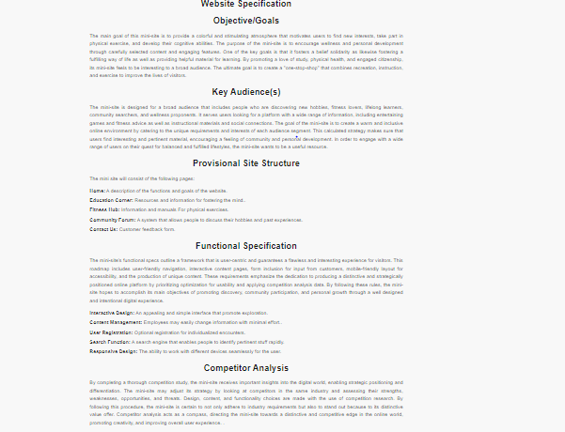

**Image: Website Specification**

# **Task 2**

***First: Home***

<!DOCTYPE html>

<html lang="en">

<head>

<meta charset="UTF-8">

<meta http-equiv="X-UA-Compatible" content="IE=edge">

<meta name="viewport" content="width=device-width, initial-scale=1.0">

<title>Fitlife - Work Hard To Get Better Life</title>

<link rel="shortcut icon" href="./favicon.svg" type="image/svg+xml">

<link rel="stylesheet" href="./assets/css/style.css">

<link rel="preconnect" href="https://fonts.googleapis.com">

<link rel="preconnect" href="https://fonts.gstatic.com" crossorigin>

<link

href="https://fonts.googleapis.com/css2?family=Catamaran:wght@600;700;800;900&family=Rubik:wght@400;500;800&display=swap"

rel="stylesheet">

<link rel="preload" as="image" href="./assets/images/hero-banner.png">

<link rel="preload" as="image" href="./assets/images/hero-circle-one.png">

<link rel="preload" as="image" href="./assets/images/hero-circle-two.png">

<link rel="preload" as="image" href="./assets/images/heart-rate.svg">

<link rel="preload" as="image" href="./assets/images/calories.svg">

<script src="https://kit.fontawesome.com/c32adfdcda.js" crossorigin="anonymous"></script>

</head>

<body id="top">

<header class="header" data-header>

<div class="container">

<a href="#" class="logo">

<ion-icon name="barbell-sharp" aria-hidden="true"></ion-icon>

<span class="span">Fitlife</span>

</a>

<nav class="navbar" data-navbar>

<button class="nav-close-btn" aria-label="close menu" data-nav-toggler>

<ion-icon name="close-sharp" aria-hidden="true"></ion-icon>

</button>

<ul class="navbar-list">

<li>

<a href="#home" class="navbar-link active" data-nav-link>Home</a>

</li>

<li>

<a href="#about" class="navbar-link" data-nav-link>Education Hub </a>

</li>

<li>

<a href="#class" class="navbar-link" data-nav-link>Physical exercises</a>

</li>

<li>

<a href="#blog" class="navbar-link" data-nav-link>Community</a>

</li>

<li>

<a href="#contact" class="navbar-link" data-nav-link>Contact Us</a>

</li>

</ul>

</nav>

<a href="#" class="btn btn-secondary">Join Now</a>

<button class="nav-open-btn" aria-label="open menu" data-nav-toggler>

<span class="line"></span>

<span class="line"></span>

<span class="line"></span>

</button>

</div>

</header>

<main>

<article>

<section class="section hero bg-dark has-after has-bg-image" id="home" aria-label="hero" data-section

style="background-image: url('./assets/images/hero-bg.png')">

<div class="container">

<div class="hero-content">

<p class="hero-subtitle">

<strong class="strong">The Best</strong>Fitness Club

</p>

<h1 class="h1 hero-title">Work Hard To Get Better Life</h1>

<p class="section-text">

At Fitlife, we're dedicated to helping you achieve your fitness goals and lead a healthier life. Our state-of-the-art facilities and expert trainers are here to support you every step of the way.

</p>

<a href="#" class="btn btn-primary">Get Started</a>

</div>

<div class="hero-banner">

<img src="./assets/images/hero-banner.png" width="660" height="753" alt="hero banner" class="w-100">

<img src="./assets/images/hero-circle-one.png" width="666" height="666" aria-hidden="true" alt=""

class="circle circle-1">

<img src="./assets/images/hero-circle-two.png" width="666" height="666" aria-hidden="true" alt=""

class="circle circle-2">

<img src="./assets/images/heart-rate.svg" width="255" height="270" alt="heart rate"

class="abs-img abs-img-1">

<img src="./assets/images/calories.svg" width="348" height="224" alt="calories" class="abs-img abs-img-2">

</div>

</div>

</section>

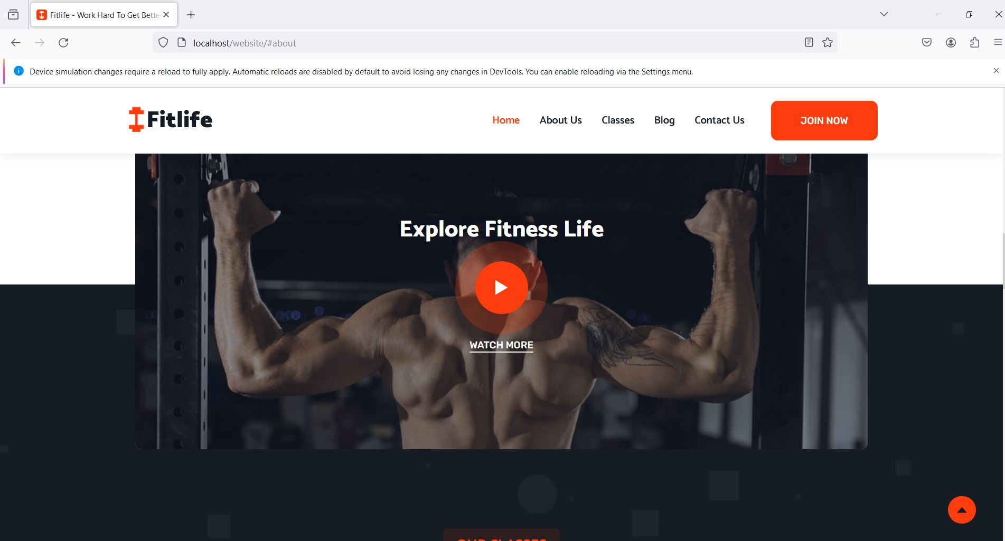

**Home Page Image**

**Second: Education Hub**

<section class="section about" id="about" aria-label="about">

<div class="container">

<div class="about-banner has-after">

<img src="./assets/images/about-banner.png" width="660" height="648" loading="lazy" alt="about banner"

class="w-100">

<img src="./assets/images/about-circle-one.png" width="660" height="534" loading="lazy" aria-hidden="true"

alt="" class="circle circle-1">

<img src="./assets/images/about-circle-two.png" width="660" height="534" loading="lazy" aria-hidden="true"

alt="" class="circle circle-2">

<img src="./assets/images/fitness.png" width="650" height="154" loading="lazy" alt="fitness"

class="abs-img w-100">

</div>

<div class="about-content">

<p class="section-subtitle">About Us</p>

<h2 class="h2 section-title">Welcome To Our Fitness Gym</h2>

<p class="section-text">

At Fitlife, we believe that knowledge is the key to success on your fitness journey. Our education page is packed with insightful articles, videos, and resources that cover a wide range of topics, from nutrition and workout techniques to the science behind fitness. Stay informed and make informed choices for a healthier you.

</p>

<p class="section-text">

Discover effective workout routines and techniques. Explore tips for overall well-being. Learn about balanced diets and meal planning.

</p>

<div class="wrapper">

<div class="about-coach">

<figure class="coach-avatar">

<img src="./assets/images/about-coach.jpg" width="65" height="65" loading="lazy" alt="Trainer">

</figure>

<div>

<h3 class="h3 coach-name">Denis Robinson</h3>

<p class="coach-title">Our Coach</p>

</div>

</div>

<a href="#" class="btn btn-primary">Explore More</a>

</div>

</div>

</div>

</section>

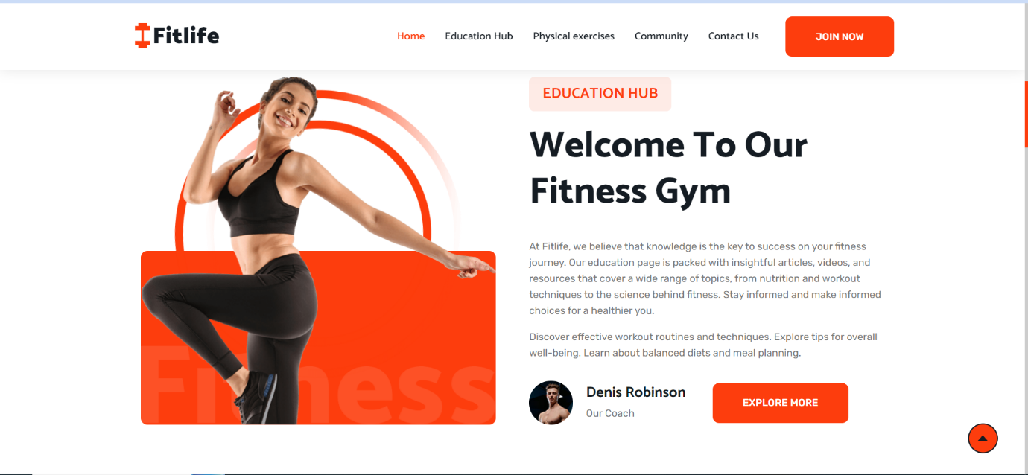

**Education Hub Image**

***Third: Physical Fitness***

<section class="section video" aria-label="video">

<div class="container">

<div class="video-card has-before has-bg-image"

style="background-image: url('./assets/images/video-banner.jpg')">

<h2 class="h2 card-title">Explore Fitness Life</h2>

<button class="play-btn" aria-label="play video">

<ion-icon name="play-sharp" aria-hidden="true"></ion-icon>

</button>

<a href="#" class="btn-link has-before">Watch More</a>

</div>

</div>

</section>

<section class="section class bg-dark has-bg-image" id="class" aria-label="class"

style="background-image: url('./assets/images/classes-bg.png')">

<div class="container">

<p class="section-subtitle">Our Classes</p>

<h2 class="h2 section-title text-center">Fitness Classes For Every Goal</h2>

<ul class="class-list has-scrollbar">

<li class="scrollbar-item">

<div class="class-card">

<figure class="card-banner img-holder" style="--width: 416; --height: 240;">

<img src="./assets/images/class-1.jpg" width="416" height="240" loading="lazy" alt="Weight Lifting"

class="img-cover">

</figure>

<div class="card-content">

<div class="title-wrapper">

<img src="./assets/images/class-icon-1.png" width="52" height="52" aria-hidden="true" alt=""

class="title-icon">

<h3 class="h3">

<a href="#" class="card-title">Weight Lifting</a>

</h3>

</div>

<p class="card-text">

Suspendisse nisi libero, cursus ac magna sit amet, fermentum imperdiet nisi.

</p>

<div class="card-progress">

<div class="progress-wrapper">

<p class="progress-label">Class Full</p>

<span class="progress-value">85%</span>

</div>

<div class="progress-bg">

<div class="progress-bar" style="width: 85%"></div>

</div>

</div>

</div>

</div>

</li>

<li class="scrollbar-item">

<div class="class-card">

<figure class="card-banner img-holder" style="--width: 416; --height: 240;">

<img src="./assets/images/class-2.jpg" width="416" height="240" loading="lazy" alt="Cardio & Strenght"

class="img-cover">

</figure>

<div class="card-content">

<div class="title-wrapper">

<img src="./assets/images/class-icon-2.png" width="52" height="52" aria-hidden="true" alt=""

class="title-icon">

<h3 class="h3">

<a href="#" class="card-title">Cardio & Strenght</a>

</h3>

</div>

<p class="card-text">

Suspendisse nisi libero, cursus ac magna sit amet, fermentum imperdiet nisi.

</p>

<div class="card-progress">

<div class="progress-wrapper">

<p class="progress-label">Class Full</p>

<span class="progress-value">70%</span>

</div>

<div class="progress-bg">

<div class="progress-bar" style="width: 70%"></div>

</div>

</div>

</div>

</div>

</li>

<li class="scrollbar-item">

<div class="class-card">

<figure class="card-banner img-holder" style="--width: 416; --height: 240;">

<img src="./assets/images/class-3.jpg" width="416" height="240" loading="lazy" alt="Power Yoga"

class="img-cover">

</figure>

<div class="card-content">

<div class="title-wrapper">

<img src="./assets/images/class-icon-3.png" width="52" height="52" aria-hidden="true" alt=""

class="title-icon">

<h3 class="h3">

<a href="#" class="card-title">Power Yoga</a>

</h3>

</div>

<p class="card-text">

Suspendisse nisi libero, cursus ac magna sit amet, fermentum imperdiet nisi.

</p>

<div class="card-progress">

<div class="progress-wrapper">

<p class="progress-label">Class Full</p>

<span class="progress-value">90%</span>

</div>

<div class="progress-bg">

<div class="progress-bar" style="width: 90%"></div>

</div>

</div>

</div>

</div>

</li>

<li class="scrollbar-item">

<div class="class-card">

<figure class="card-banner img-holder" style="--width: 416; --height: 240;">

<img src="./assets/images/class-4.jpg" width="416" height="240" loading="lazy" alt="The Fitness Pack"

class="img-cover">

</figure>

<div class="card-content">

<div class="title-wrapper">

<img src="./assets/images/class-icon-4.png" width="52" height="52" aria-hidden="true" alt=""

class="title-icon">

<h3 class="h3">

<a href="#" class="card-title">The Fitness Pack</a>

</h3>

</div>

<p class="card-text">

Suspendisse nisi libero, cursus ac magna sit amet, fermentum imperdiet nisi.

</p>

<div class="card-progress">

<div class="progress-wrapper">

<p class="progress-label">Class Full</p>

<span class="progress-value">60%</span>

</div>

<div class="progress-bg">

<div class="progress-bar" style="width: 60%"></div>

</div>

</div>

</div>

</div>

</li>

</ul>

</div>

</section>

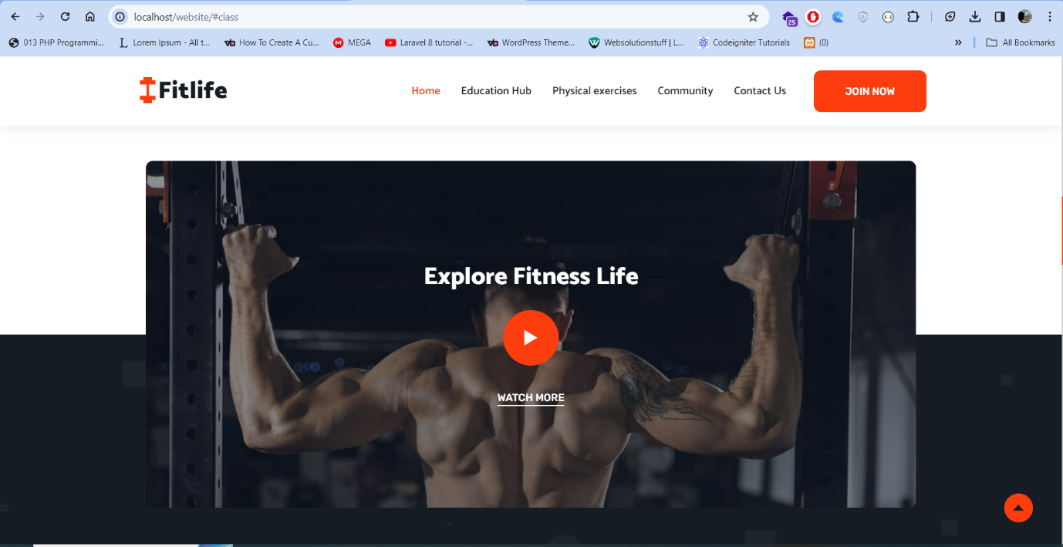

**Fitness page Image**

***Fourth Section: Community***

<section class="section blog" id="blog" aria-label="blog">

        <div class="container">

          <p class="section-subtitle">Our News</p>

          <h2 class="h2 section-title text-center">Latest Blog Feed</h2>

          <ul class="blog-list has-scrollbar">

            <li class="scrollbar-item">

              <div class="blog-card">

                <div class="card-banner img-holder" style="--width: 440; --height: 270;">

                  <img src="./assets/images/blog-1.jpg" width="440" height="270" loading="lazy"

                    alt="Going to the gym for the first time" class="img-cover">

                  <time class="card-meta" datetime="2022-07-07">7 July 2022</time>

                </div>

                <div class="card-content">

                  <h3 class="h3">

                    <a href="#" class="card-title">Going to the gym for the first time</a>

                  </h3>

                  <p class="card-text">

                    Praesent id ipsum pellentesque lectus dapibus condimentum curabitur eget risus quam. In hac

                    habitasse platea dictumst.

                  </p>

                  <a href="#" class="btn-link has-before">Read More</a>

                </div>

              </div>

            </li>

            <li class="scrollbar-item">

              <div class="blog-card">

                <div class="card-banner img-holder" style="--width: 440; --height: 270;">

                  <img src="./assets/images/blog-2.jpg" width="440" height="270" loading="lazy"

                    alt="Parturient accumsan cacus pulvinar magna" class="img-cover">

                  <time class="card-meta" datetime="2022-07-07">7 July 2022</time>

                </div>

                <div class="card-content">

                  <h3 class="h3">

                    <a href="#" class="card-title">Parturient accumsan cacus pulvinar magna</a>

                  </h3>

                  <p class="card-text">

                    Praesent id ipsum pellentesque lectus dapibus condimentum curabitur eget risus quam. In hac

                    habitasse platea dictumst.

                  </p>

                  <a href="#" class="btn-link has-before">Read More</a>

                </div>

              </div>

            </li>

            <li class="scrollbar-item">

              <div class="blog-card">

                <div class="card-banner img-holder" style="--width: 440; --height: 270;">

                  <img src="./assets/images/blog-3.jpg" width="440" height="270" loading="lazy"

                    alt="Risus purus namien parturient accumsan cacus" class="img-cover">

                  <time class="card-meta" datetime="2022-07-07">7 July 2022</time>

                </div>

                <div class="card-content">

                  <h3 class="h3">

                    <a href="#" class="card-title">Risus purus namien parturient accumsan cacus</a>

                  </h3>

                  <p class="card-text">

                    Praesent id ipsum pellentesque lectus dapibus condimentum curabitur eget risus quam. In hac

                    habitasse platea dictumst.

                  </p>

                  <a href="#" class="btn-link has-before">Read More</a>

                </div>

              </div>

            </li>

          </ul>

        </div>

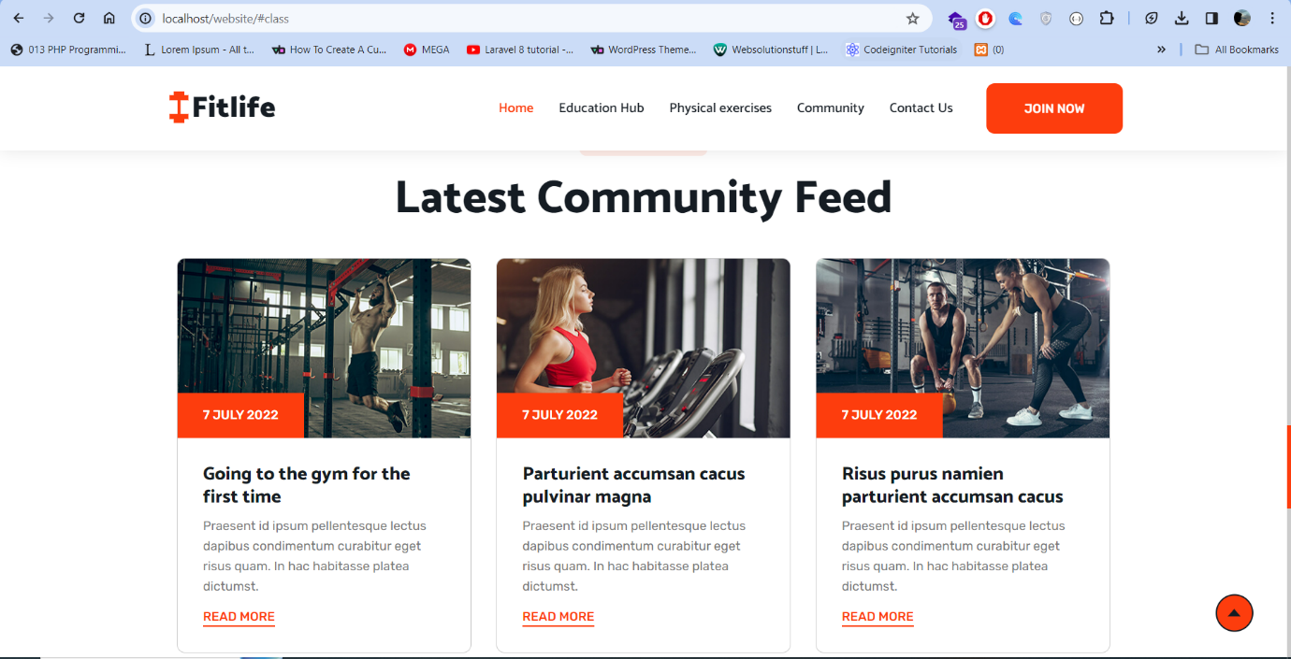

**Community Section image**

***Fifth or Last Section: Contact & Feedback***

<html>

<head>

<link rel="stylesheet" href="styles_contact.css">

</head>

<body>

<header>

<h1 style="text-align: center;">Welcome to Your Mini Site!</h1>

<nav style="text-align: center;">

<ul>

<li><a href="index.html">Home</a></li>

<li><a href="education.html">Education Hub</a></li>

<li><a href="fitness.html">Fitness Care</a></li>

<li><a href="community.html">Community</a></li>

<li><a href="contact.html">Contact & Feedback</a></li>

</ul>

</nav>

</header>

<section>

<h2>Contact Us</h2>

<p>Have a query or wish to get in touch? By using the contact form below, you may get in touch with us.</p>

<form action="submit_contact.php" method="post">

<label for="name">Your Name:</label>

<input type="text" id="name" name="name" placeholder="Please enter your name" required>

<label for="email">Your Email:</label>

<input type="email" id="email" name="email" placeholder="Please enter your email" required>

<label for="message">Your Message:</label>

<textarea id="message" name="message" rows="4" placeholder="Please write your message here" required></textarea>

<button type="submit">Send Message</button>

</form>

<hr>

<h2>Your Feedback</h2>

<p>.</p>

<!-- Feedback Form -->

<form action="submit.php" method="post">

<label for="feedback_name">Your Name:</label>

<input type="text" name="feedback_name" placeholder="Please enter your name" required>

<label for="feedback_email">Your Email:</label>

<input type="email" name="feedback_email" placeholder="Please enter your feedback email" required>

<label for="feedback_message">Your Feedback:</label>

<textarea name="feedback_message" rows="4" required>We value your opinions. Utilize the following feedback form to communicate your ideas with us.</textarea>

<button type="submit">Submit Feedback</button>

</form>

</section>

</body>

</html>

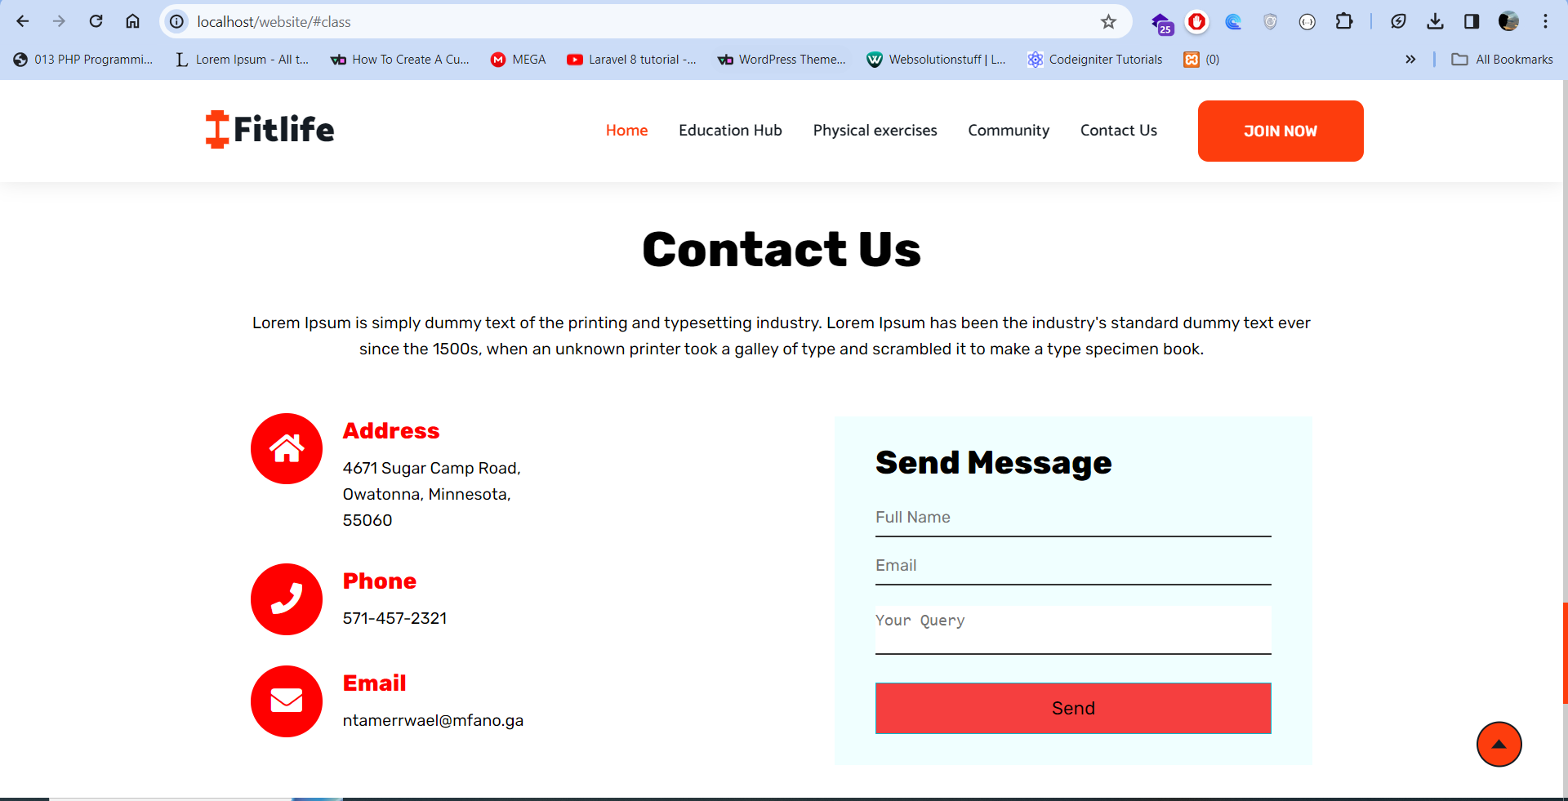 **Contact & Feedback section image**

# **Task 3**

**Implementation across different browsers**

***Mozilla Firefox***

The Gecko rendering engine, used by Mozilla Firefox, is renowned for adhering to web standards (Laperdrix et al. 2020). Testing the micro site on Firefox entails making sure that HTML and CSS components are appropriately read, as well as verifying that the information is shown seamlessly and the desired look is maintained. Any inconsistencies found in the rendering on Firefox has been noted and corrected to improve compatibility.

***Google Chrome***

As one of the widely used browsers with the Blink rendering engine, Google Chrome generally adheres well to web standards (Abi Din et al. 2020). However, subtle variations in the interpretation of HTML and CSS can still occur. Testing on Chrome involves ensuring that the mini site's design and functionality align with the intended user experience. Any fine-tuning required for optimal performance on Chrome has been duly documented.



**Mozilla Firefox browser view**

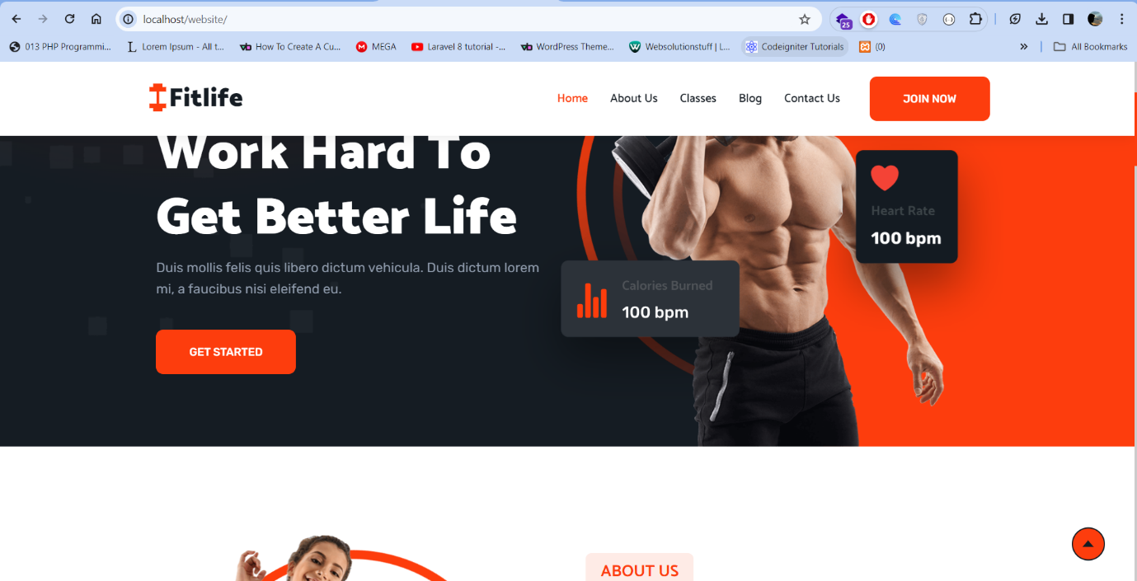

**Google chrome browser view**

**Analyzing HTML and CSS Validation's Effect on Browser Consistency**

***Google Chrome:***

**Expectation:** Given that Firefox conforms closely to web guidelines, consistency in design and functioning is expected.

**Result:** As a result, there are little visual differences and everything works as it should.

***Internet browser***

**Expectation:** Potential discrepancies brought on by prior violations of web standards.

**Result:** As a result, IE-specific problems are addressed using different coding technique to guarantee compatibility.

***Google chrome:***

**Expectation:** Web-compliant rendering that is largely consistent.

**Result:** As a result, there are few deviations from the planned design and user experience.

To reduce errors and give consumers a consistent and dependable experience regardless of the browser being used, HTML and CSS validation is done. To guarantee continued compatibility, all modifications performed after validation has been thoroughly documented.

**Necessary steps adopted for site appearance consistency across browsers**

HTML and CSS validation is necessary to provide an identical client interface amongst browsers. Minor variances in Mozilla Firefox, potential discrepancies in Internet Explorer, and consistent rendering in Google Chrome are the results that may be anticipated. Normalizing styles, feature detection, vendor prefixes, responsive design using media queries, and browser-specific CSS are all crucial stages for maintaining consistency in appearance. These steps help maintain a unified website presentation while improving cross-browser compatibility.

**Html Document**

<!DOCTYPE html>

<html lang="en">

<head>

    <meta charset="UTF-8">

    <meta name="viewport" content="width=device-width, initial-scale=1.0">

    <title>Testing Evidence - STU96645</title>

    <link rel="stylesheet" href="css/styles_education.css">

</head>

<body>

    <header>

        <h1 style="text-align: center;">Evidence Evaluation</h1>

    </header>

    <section class="content">

        <h2>Evaluation of usability and accessibility</h2>

        <h3>Web Browser Support</h3>

        <p>Our website is rigorously tested across a range of web browsers to guarantee flawless user experiences. We put universal accessibility first across the board, in Chrome, Firefox, Safari, and Edge. This careful testing ensures that users of any a web browser can log in and move our web address reliably. Supporting web browsers is important to us since we're committed to giving everyone access to a welcoming and convenient online experience..</p>

        <img src="browser_compatibility_testing.png" alt="Browser Compatibility">

        <h3>validates HTML and CSS</h3>

        <p>Our build methods depend strongly on faithfulness to web norms. Our HTML and CSS code is extensively validated to make sure it complies with industry standards. W3C validator tools are used to conduct thorough validation checks in order to find and fix any mistakes or inconsistencies. This commitment to validation guarantees a strong and error-free website while also enhancing compatibility and accessibility across various devices and browsers. We are dedicated to providing a dependable and flawless online experience, which is why we continuously work to validate HTML and CSS. Below is a screenshot of W3C HTML validation report of our index.html</p>

        <div class="validation">

            <a href="W3C-Validation-Report.html">Check the W3C HTML Validation Report</a>

        </div>

<h3>Assessment of Readability</h3>

<p>We carefully evaluate readability on our website in order to prioritize user-friendly information. This procedure includes assessing the text's readability and simplicity of understanding. We make sure that content is simple to understand for all users by taking into account elements comprised of font size, style, and general presentation. Our focus to readability evaluation is a reflection of our drive for offering inclusive and accessible substances, creating an enjoyable interface for readers with different reading preferences and abilities. </p>

<p>Adaptations were made based on testing outcomes to enhance text legibility. </p>

<img src="readability_enhancement_screenshot.png" alt="Readability Assessment">

</section>

</body>

</html>



**Web browser support testing image**

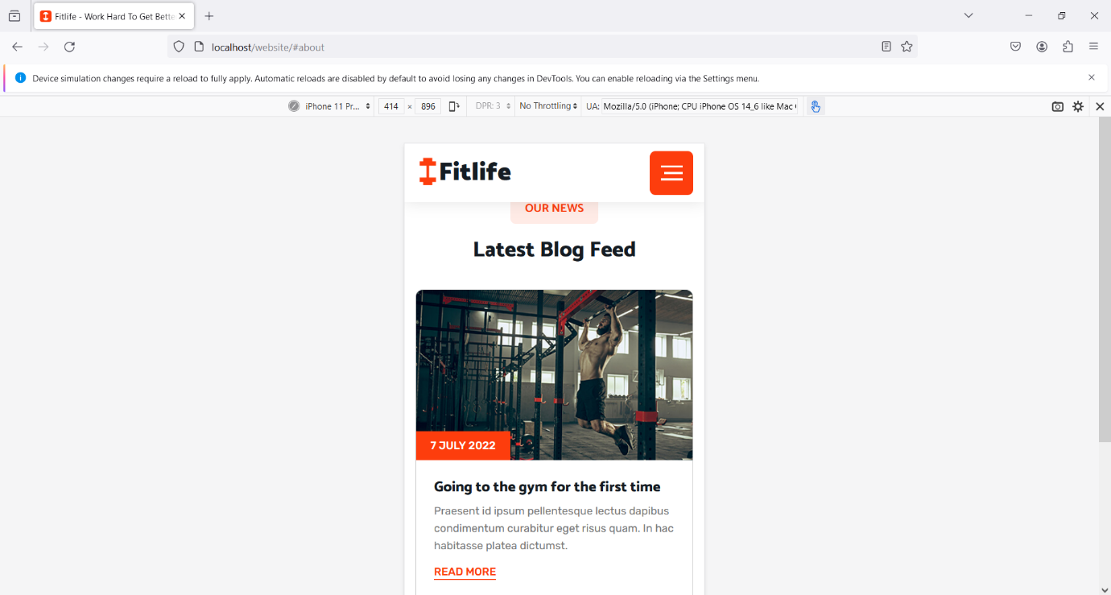

**Readability assessment image**

# 

# **References**

Abi Din, Z., Tigas, P., King, S.T. and Livshits, B., 2020. {PERCIVAL}: Making {In-Browser} Perceptual Ad Blocking Practical with Deep Learning. In *2020 USENIX Annual Technical Conference (USENIX ATC 20)* (pp. 387-400).

Aversa, P., Haefliger, S., Hueller, F. and Reza, D.G., 2021. Customer complementarity in the digital space: Exploring Amazon’s business model diversification. *Long Range Planning*, *54*(5), p.101985.

Dorman, M., 2020. *Introduction to web mapping*. CRC Press.

Hensher, D.A., Mulley, C., Ho, C., Wong, Y., Smith, G. and Nelson, J.D., 2020. Understanding Mobility as a Service (MaaS): Past, present and future. Elsevier.

Laperdrix, P., Bielova, N., Baudry, B. and Avoine, G., 2020. Browser fingerprinting: A survey. *ACM Transactions on the Web (TWEB)*, *14*(2), pp.1-33.

Scholta, H., Mertens, W., Kowalkiewicz, M. and Becker, J., 2019. From one-stop shop to no-stop shop: An e-government stage model. Government Information Quarterly, 36(1), pp.11-26.

Tatroe, K. and MacIntyre, P., 2020. Programming PHP: Creating dynamic web pages. O'Reilly Media.

# 

# **Appendices**

Task 1: Site specification [File Location: 'website/studentno_specification.html']

Task 2 Appendix: Mini Site Development [File Path: 'website/']

Evaluation of usability and accessibility for Task 3 Appendix: [File Location: 'website/studentno_testing.html']