Course Overview 💬
- Levels of Autonomy in LLM applications (Code -> LLM Call -> Chain -> Router -> Agent)
- Understanding Agents & Tools
- Building Agents & Tools from Scratch
- Building Agents From pre-defined LangChain classes
- Graph Structure
– Direct Acyclic Graph (DAG) vs Cyclic Graph
- What is LangGraph?
- Why LangGraph is required?
- Creating LangGraph from scratch
- Creating a LangGraph using in-built classes (Reflection, Reflexion agent)
- Key concepts and terms in LangGraph
– Graph, state, nodes, edges, visualisation, checkpoints, breakpoints, configuration
- Creating a Chatbot with LangGraph
- Common Agentic Patterns
– Human-in-the-loop
– ReAct Agent, and many more.
- Multi-agent systems using LangGraph
- RAGs with LangGraph: CRAG vs ARAG vs self-RAG
- Persistence
- LangGraph ecosystem
– LangGraph Studio
– LangGraph Cloud API, etc
- Agents in Production

Levels of Autonomy in LLM applications
1. Code
Code has zero autonomy and is 100% deterministic.
We all know that everything is hard-coded and it is not even really a cognitive architecture.
Disadvantage:
The problem? You’d need to write rules for every possible scenario – making it impossible to handle real-world complexity.
2. LLM call
A single LLM call means your app basically does one main thing – you give it an input, it processes it, and gives you back an output.
Think of chatbots that just take your message and respond, or apps that translate text.
This was a huge leap from hard-coded rules, even though it’s still pretty simple and is only in the 2nd stage of autonomy.
Output
LLM
User Input

Example User Input:
You are an expert LinkedIn post writer. Write me a post on "AI Agents Taking over Content Creation"
A single LLM call means your app basically does one main thing – you give it an input, it processes it, and gives you back an output.
Think of chatbots that just take your message and respond, or apps that translate text.
This was a huge leap from hard-coded rules, even though it’s still pretty simple and is only in the 2nd stage of autonomy
Disadvantage:
Trying to get everything done in one shot often leads to confused or mixed-up responses – just like how a single person can’t be an expert at everything.

3. Chains
Think of chains like having multiple specialists instead of one generalist. Instead of asking one AI to do everything, we break it down into steps where each AI is really good at one thing.
Imagine a customer service chatbot: The first AI reads your complaint and figures out exactly what product you're talking about.
The second AI finds the right solution from the company's help docs, and the third AI turns that solution into a friendly response.
Each step is simple, but together they create a much smarter system than a single LLM call could.
This is where we first started seeing AI apps that could handle more complex tasks – not just by being smarter, but by breaking big problems into smaller, manageable pieces.
Disadvantage:
The downside? These fixed sequences are like a rigid assembly line – they always follow the same steps defined by the human.
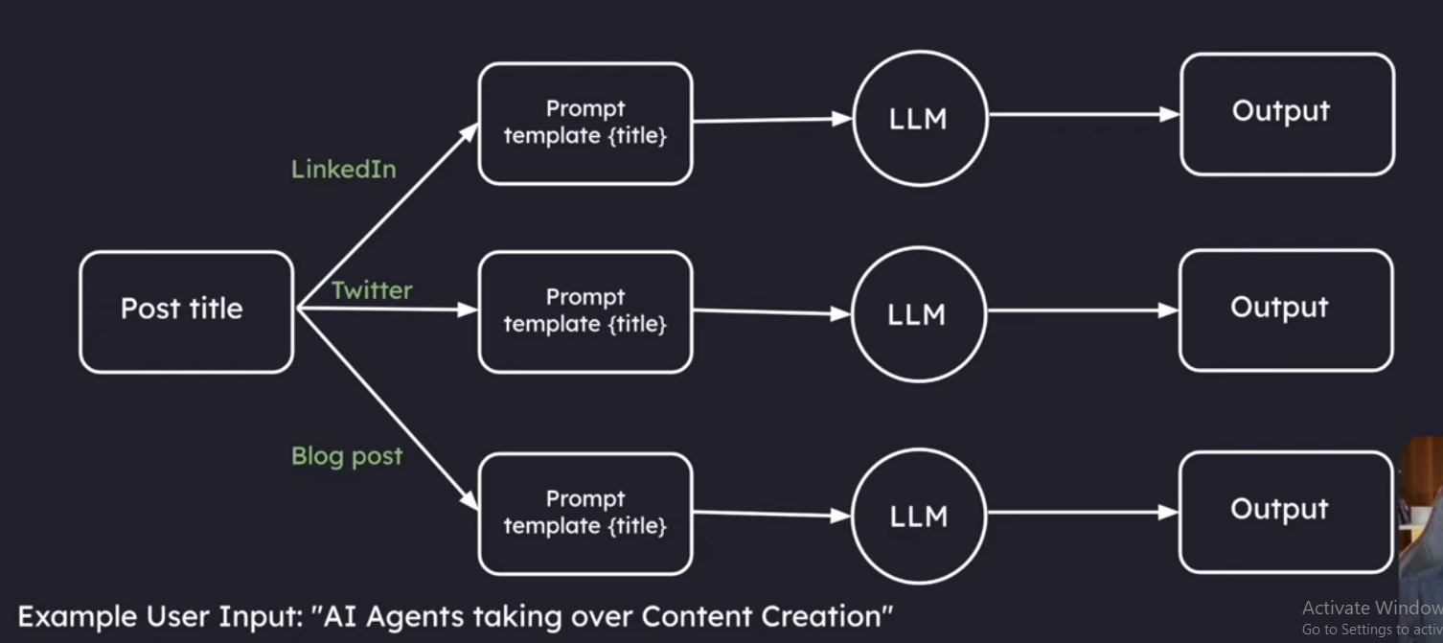

4. Router
Now this is where it gets interesting – routers are like smart traffic cops for your AI. Instead of having a fixed path like in chains, the AI itself decides what steps to take next.
Imagine a personal assistant bot: when you ask it something, it first figures out if you need help with scheduling, research, or calculations, then routes your request to the right tool or chain for the job.
Disadvantage:
While it can choose different paths, it still can’t remember previous conversations or learn from mistakes.
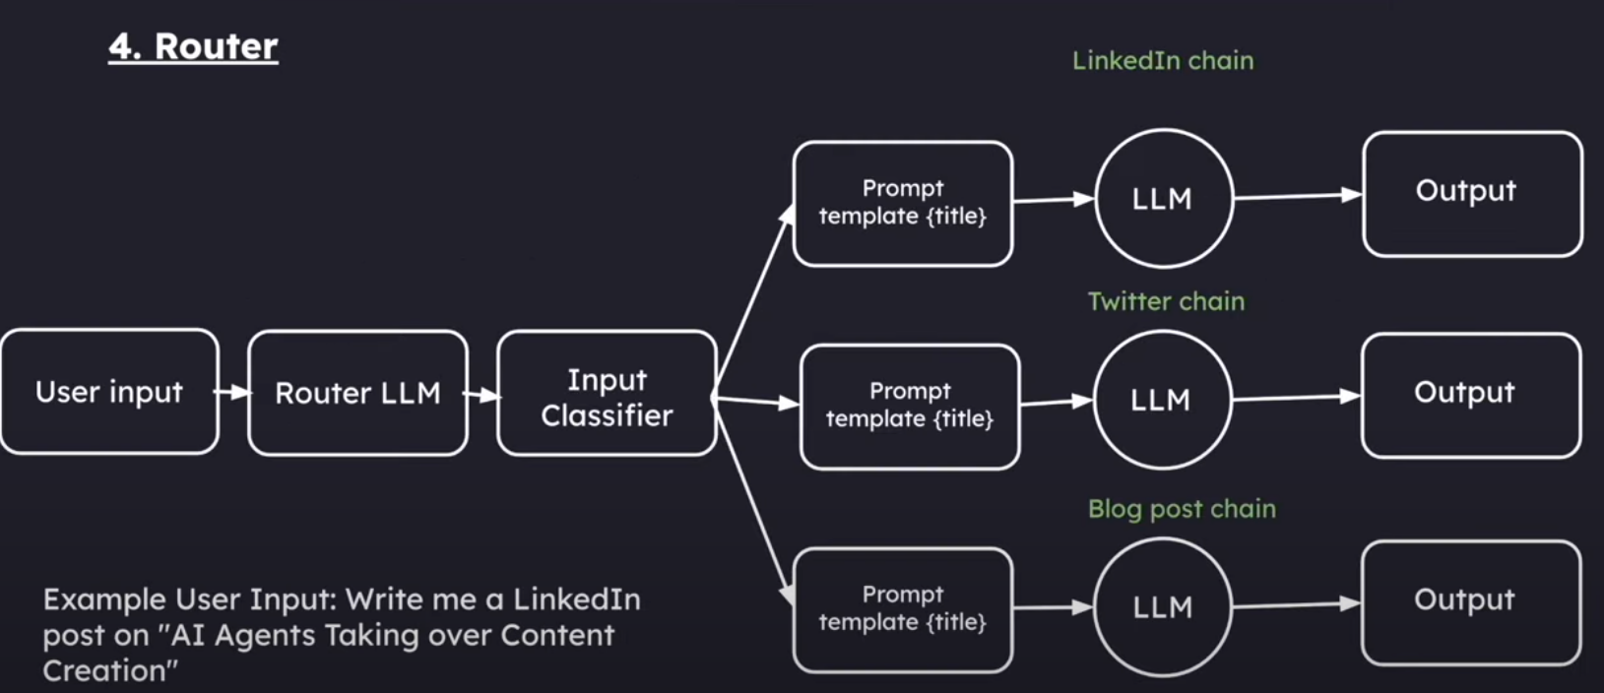

5. State Machine (Agent)
This is combining the previous level (router) but with loops.
Agent ≈ control flow controlled by an LLM
This involves features like:
- Ability to have human-in-loop, ask for approval before moving on
- Multi-agent systems
- Advanced memory management
- Go back in history and explore better alternate paths
- Adaptive Learning
Here is where LangGraph is used
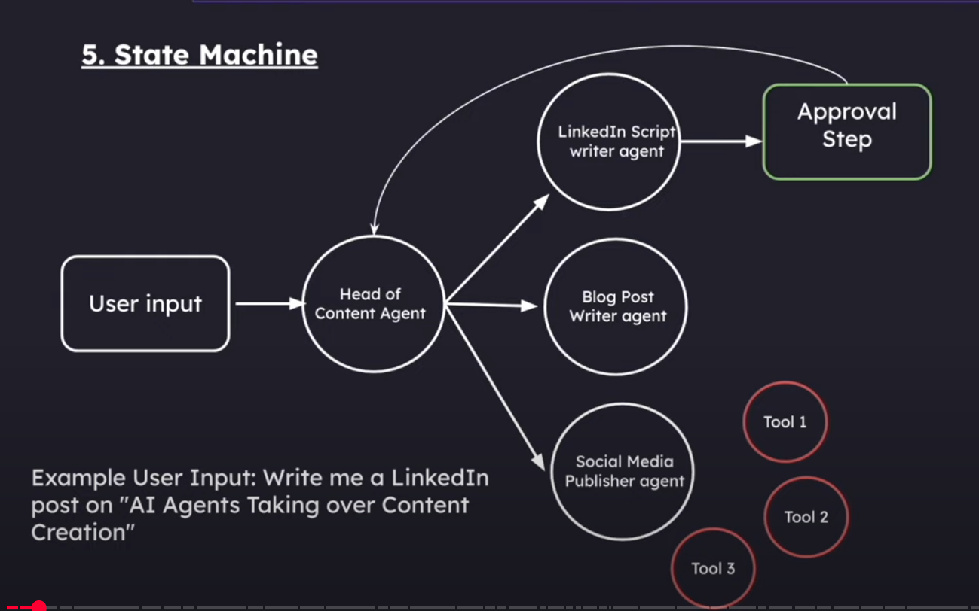

Level of autonomy
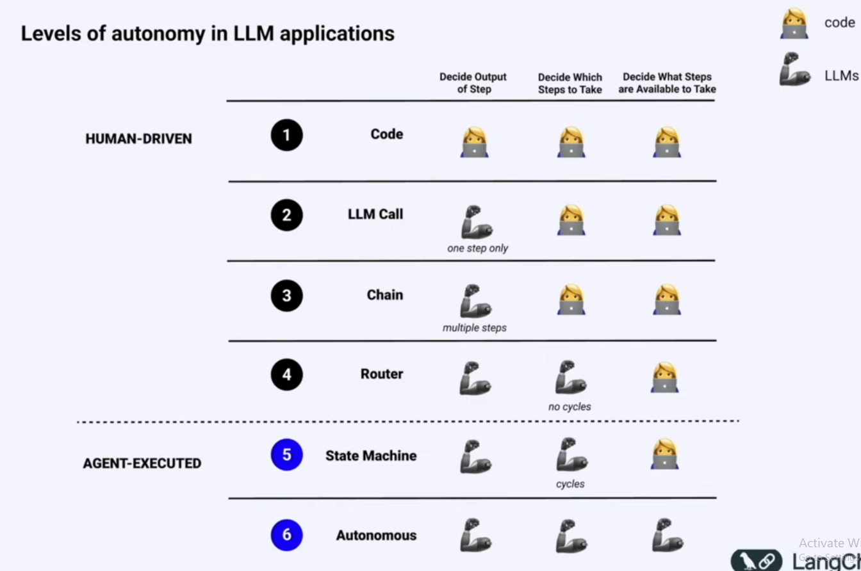
AI Agents & Tools
Think of Agents as the “problem-solvers” of the AI world. Agents are capable of thinking on their own.
In other words, it’s AI that can make autonomous decisions.
In the case of Chains and Router, they follow our specific instruction.
But with agents, they actually take it a step further. They can decide for themselves what steps to take on their own.
What are tools then?
Tools are specific functions that Agents can use to complete tasks.
Just like a chef’s kitchen tools (knife for cutting, oven for baking, blender for mixing), tools are the special abilities we give to AI – like giving it a calculator tool, or a search engine tool, or a calendar tool.
ReACT pattern (Reason and Action)
- Think: LLM first thinks about the user prompt/problem
- Action: LLM decides if it can answer by itself or if it should use a tool
- Action Input: LLM provides the input argument for the tool
Here, LangChain executes the tool and returns the output to the LLM
- Observe: LLM observes the result of the tool
⋮
⋮
⋮
Final Answer: "This is your final answer"

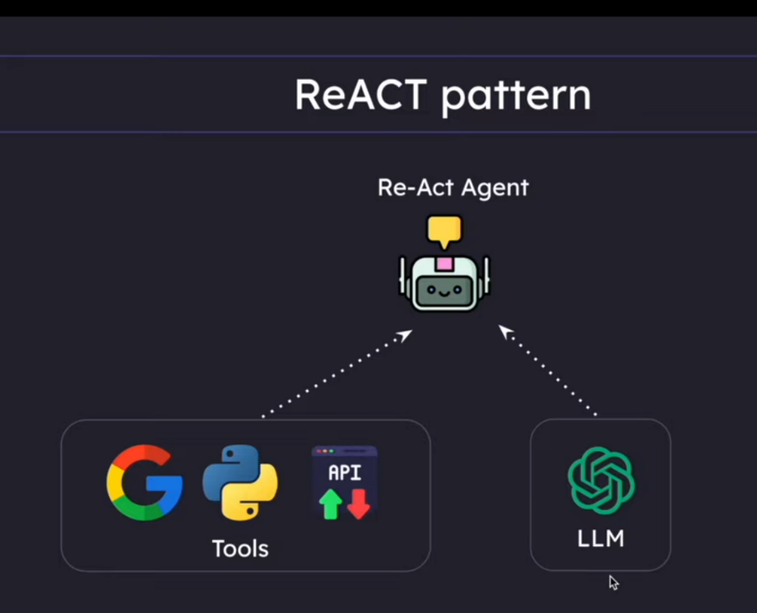

Drawbacks of react agents
Advantage any state is possible
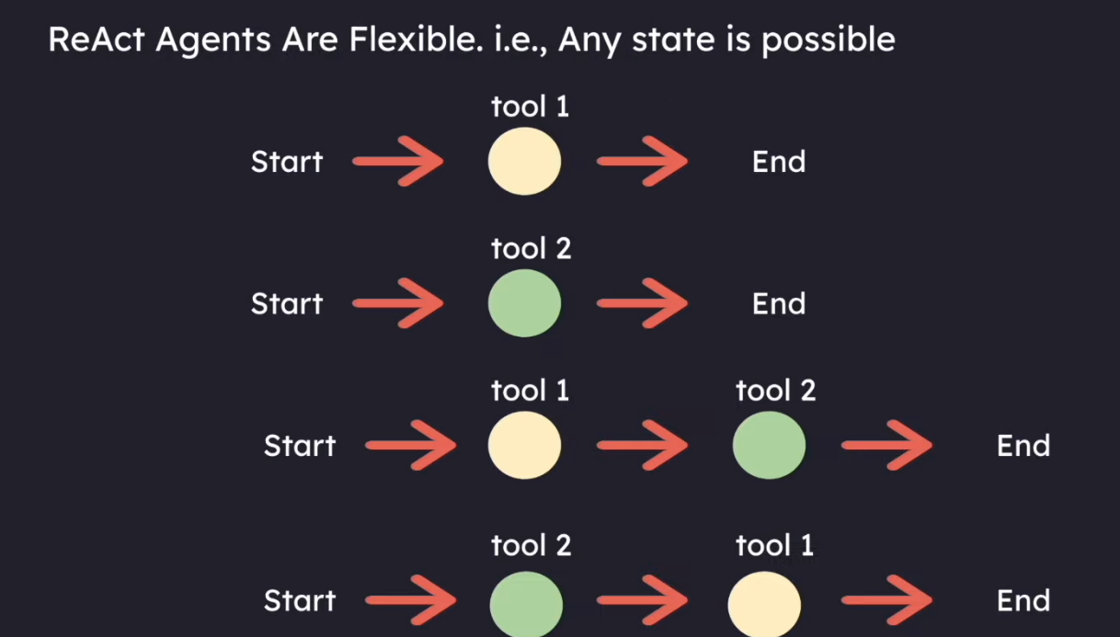

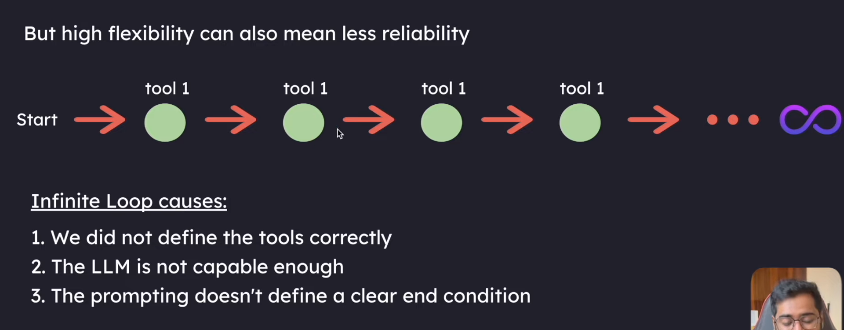

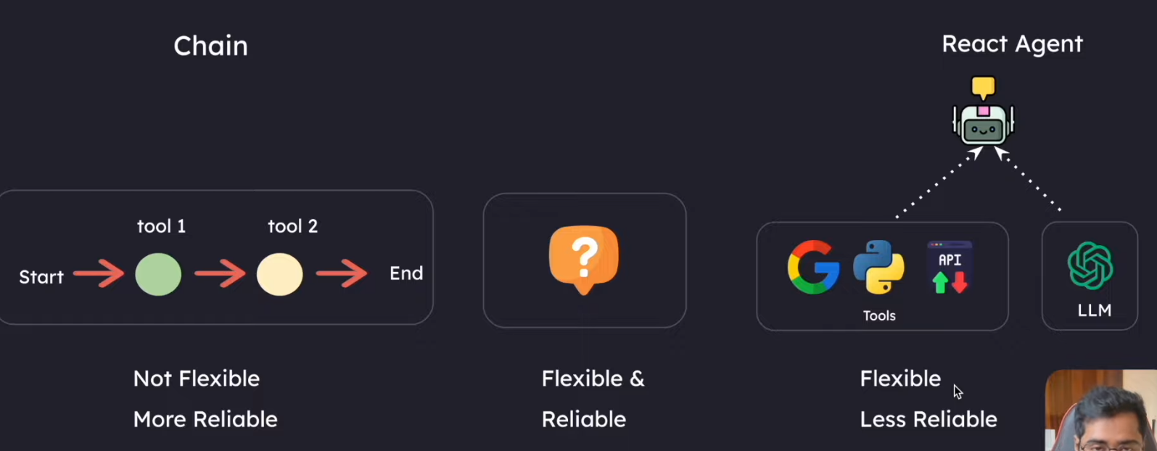

What is LangGraph?
LangGraph is:
- A framework for building controllable, persistent agent workflows.
- It supports:
  - Human interaction
  - Streaming
  - State management
It achieves this by using a Graph Data Structure, where:
- Nodes represent steps or logic (e.g., agent, action).
- Edges define control flow (e.g., continue → action, end → end).
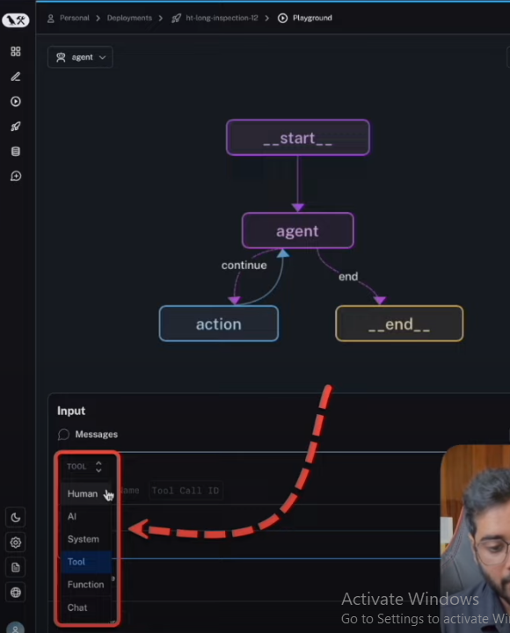
Key Features Of LangGraph
1. Looping and Branching Capabilities:
Supports conditional statements and loop structures, allowing dynamic execution paths based on state.
2. State Persistence:
Automatically saves and manages state, supporting pause and resume for long-running conversations.
3. Human-Machine Interaction Support:
Allows inserting human review during execution, supporting state editing and modification with flexible interaction control mechanisms.
4. Streaming Processing:
Supports streaming output and real-time feedback on execution status to enhance user experience.
5. Seamless Integration with LangChain:
Reuses existing LangChain components, supports LCEL expressions, and offers rich tool and model support.
Ask ChatGPT
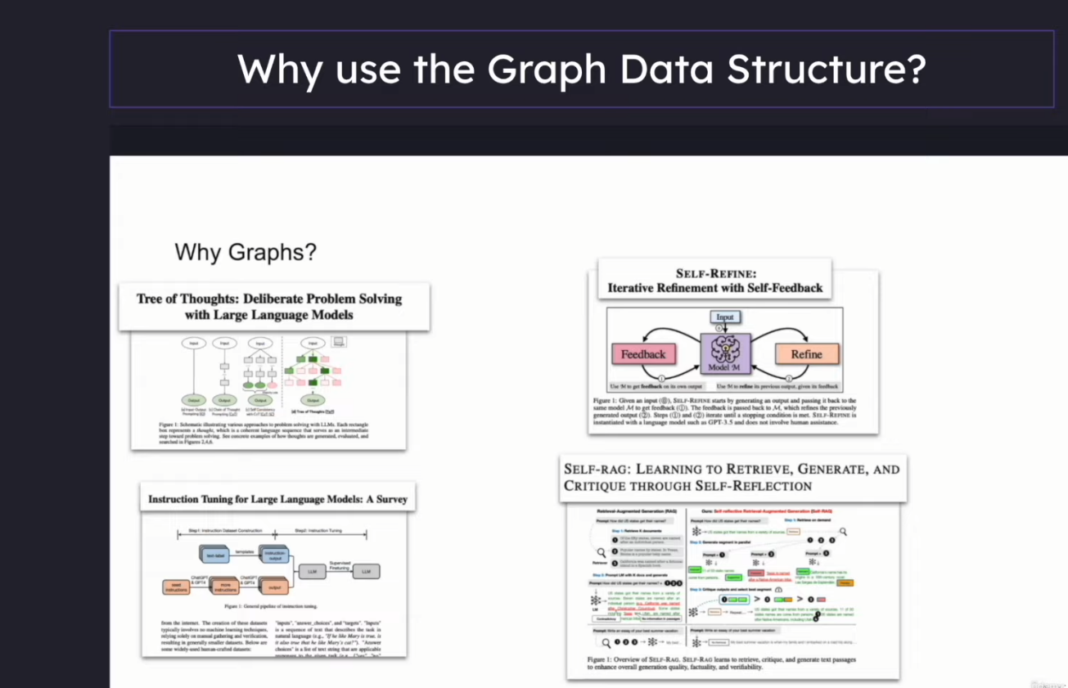

Core Components of LangGraph
- Nodes
- Edges
- Conditional Edges
- State

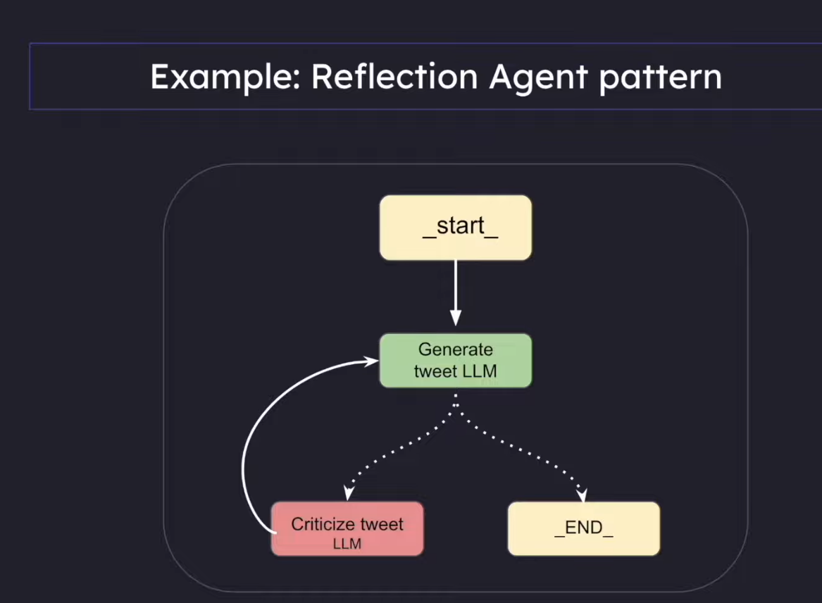

Reflection Agents in LangGraph
- What is a Reflection Agent System?
- Three types of Reflection Agent Systems
- Setup & Installations
- Implement a reflection Agent System
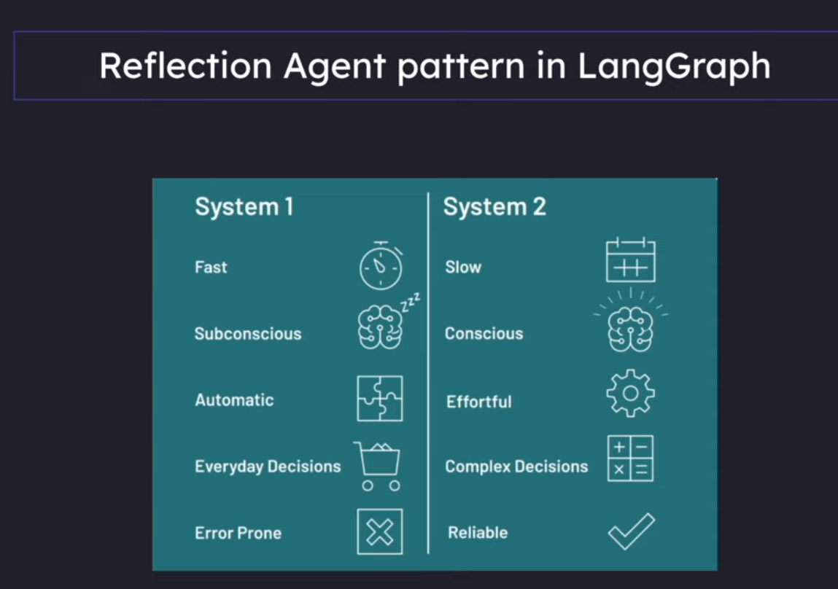
System 2 is a reflection pattern
Types of Reflection Agents in LangGraph
There are 3 types:
- Basic Reflection Agents
- Reflexion Agents
- Language Agent Tree Search (LATS)
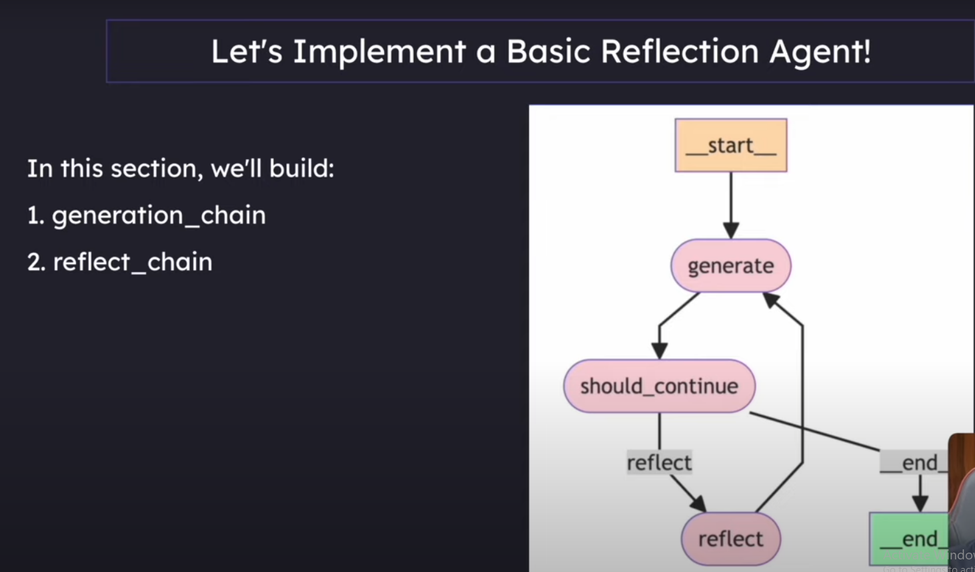

Basic Reflection Agent!
What is a MessageGraph?
- MessageGraph is a class provided by LangGraph used to orchestrate the flow of messages between different nodes.

Example Use Cases:
- Simple routing decisions
- Simple chatbot conversation flows

When to Use:
- If your goal is to just pass messages between nodes, use MessageGraph.
- If your application needs complex state management, use StateGraph instead.
What is a MessageGraph?
To put it simply:
- MessageGraph maintains a list of messages and decides the flow of those messages between nodes.
- Every node in MessageGraph:
  - Receives the full list of previous messages as input.
  - Can append new messages to the list and return it.
- The updated message list is then passed to the next node.

Structured Outputs
It is often useful to have a model return output that matches a specific schema that we define.
"Tell me a joke about cats"
{
'setup': "Why was the cat sitting on the computer?",
'punchline': "Because it wanted to keep an eye on the mouse!",
'rating': 7
}
We have options to get outputs in formats such as JSON, Dictionary, string,YAML.

Pydantic Models for Structured Outputs:
- Pydantic is a Python library that helps define data structures.
- Acts like a "blueprint" for data.
- Uses Python’s type hints (like str, int) to enforce correct data types.

How it works in LangChain / LangGraph:
- Define a class with the fields you need (e.g., name, capital, language).
- Add descriptions to explain what each field means.
- Use .with_structured_output() to tell the LLM to follow your format.
Reflexion Agents in LangGraph
Recap of what we saw previously:
- Reflection Agent System consists of a generator and a reflector component.
- Although iteratively making a post better is significantly better than just prompting ChatGPT, the content generated is still not grounded in live data.
- It could be hallucination or outdated content, and we have no way of knowing.

What is a Reflexion Agent System?
A reflexion agent, like a reflection agent, critiques its own responses.
Additionally, it fact-checks its outputs using external data, such as internet search or API calls.
In the Reflection Agent pattern, we are restricted to the LLM’s training data.
However, in the Reflexion Agent System, we are not limited to that, enabling more grounded and up-to-date responses.
The main component of a Reflexion Agent System is the “actor”.
The actor is the core agent that drives the process: it reflects on its responses and re-executes them.
It can use tools or external sources to ground its self-critique in real data.
It can do this with or without tools to improve based on self-critique that is grounded in external data.(This architecture supports iterative improvement, self-evaluation, and external grounding, making it more robust than traditional reflection systems. )
The main sub-component include
- Tool/tool execution
- Initial Responder: Generate an initial response & self-reflection
Reflexion Agent is thought to have Episodic memory.
Episodic Memory
- In the context of Reflexion agents, episodic memory refers to an agent’s ability to recall specific past interactions, events, or experiences, rather than relying only on generalized knowledge.
- This capability is crucial for making agents feel more context-aware, personalized, and human-like over time.
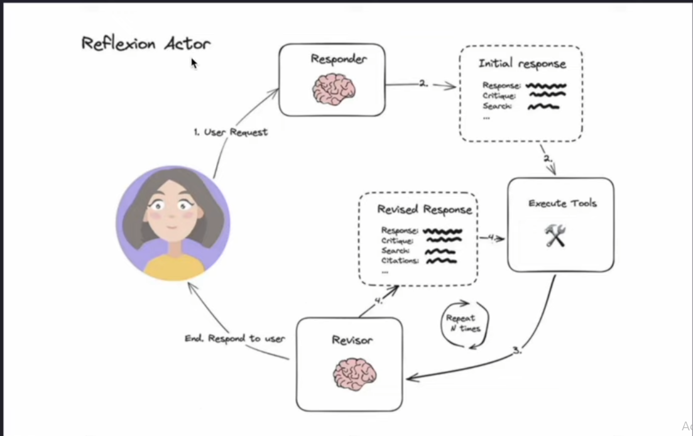

🔄 LLM Response Parser System
This system converts unstructured LLM outputs into structured Python objects through a series of parsing and validation steps to ensure consistency and correctness.
🧩 Key Components
- Chat Prompt Template
  - Helps define the structure and flow of LLM conversations.
  - Ensures the LLM generates responses in a guided format.
- Function Calling with Pydantic Schema
  - Uses schema definitions (via Pydantic) to enforce the structure of LLM responses.
  - Helps validate and constrain data types in outputs.
- Pydantic Parser
  - Parses the raw LLM outputs into structured Python models.
  - Ensures data integrity and type validation.

2. Function Calling with Pydantic Schema
🔧 Function Calling:
- Similar to how we make tools available to the LLM.
- We can send a schema to the LLM and force it to structure its JSON output according to that schema.
🧱 Pydantic:
- A Python library that defines data structures using classes.
- Provides automatic validation of JSON data against these class definitions.
3. Pydantic Parser
- Takes the JSON output from the LLM’s function call.
- Validates it against the defined Pydantic schema (class definition).
- Creates instances of Pydantic classes with the validated data.
- If the LLM’s output does not match the defined schema, it will throw an error.

State in LangGraph - Deep Dive
Concepts we will learn:
- What is StateGraph?
- Basic State Structures
- Complex State Structures
- Manual State Transformation
- Declarative Annotated State Transformation
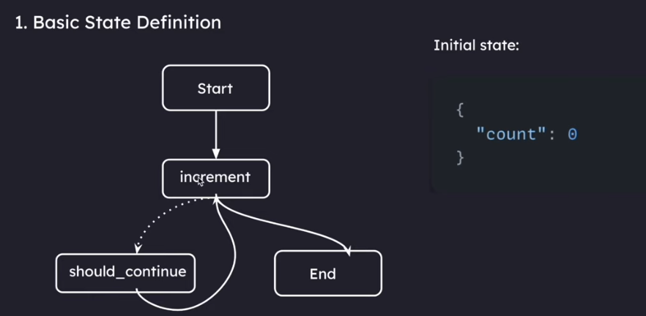

ReAct Agent
LangChain:
In LangChain, we used initialize_agent as an all-in-one solution.
It combines two key components:
- create_react_agent
- AgentExecutor (We will eliminate the need for this in LangGraph)
ReAct Agent
1. create_react_agent: (one that creates the agent)
- Takes each tool’s name and description
- Formats them into a standardized way the LLM can understand
- Inserts them into specific placeholders in the ReAct prompt template
- It makes the LLM call + takes the LLM's response + parses it
Thought: I need to find out when SpaceX's last launch was and calculate days since
Action: search
Action Input: "SpaceX most recent launch date"
Note:- It parses the response of the LLM into one of these two classes: AgentAction and AgentFinish
- create_react_agent
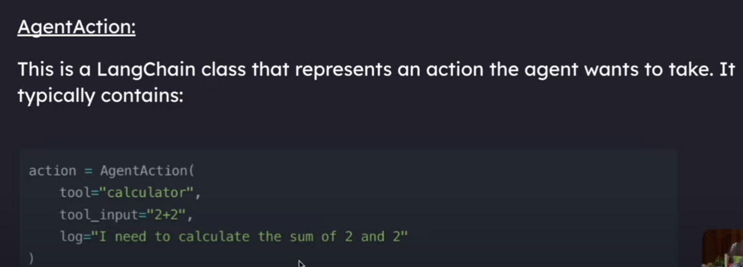
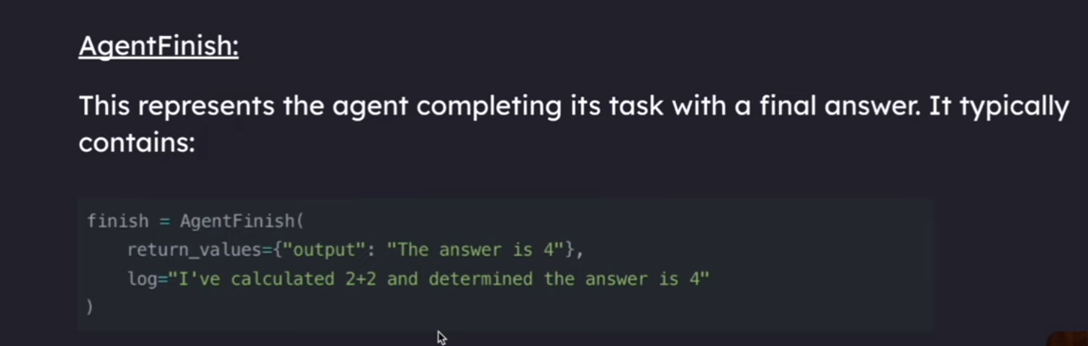
2. AgentExecutor:
- Takes the agent from create_react_agent and manages the execution loop
- Receives the user's question and feeds it to the agent
- Identifies which tool to run based on the agent’s output (AgentAction or no tool if AgentFinish)
- Executes the tool and captures the result
- Feeds the result back to the agent for the next decision
- Continues this loop until the agent produces an AgentFinish
- Returns the final answer to the user
ReAct Agent – LangGraph
Key Advantage:
LangGraph turns the hidden “black box” loop into a visible, editable workflow.
You can now add custom nodes, modify the flow, or insert additional logic.
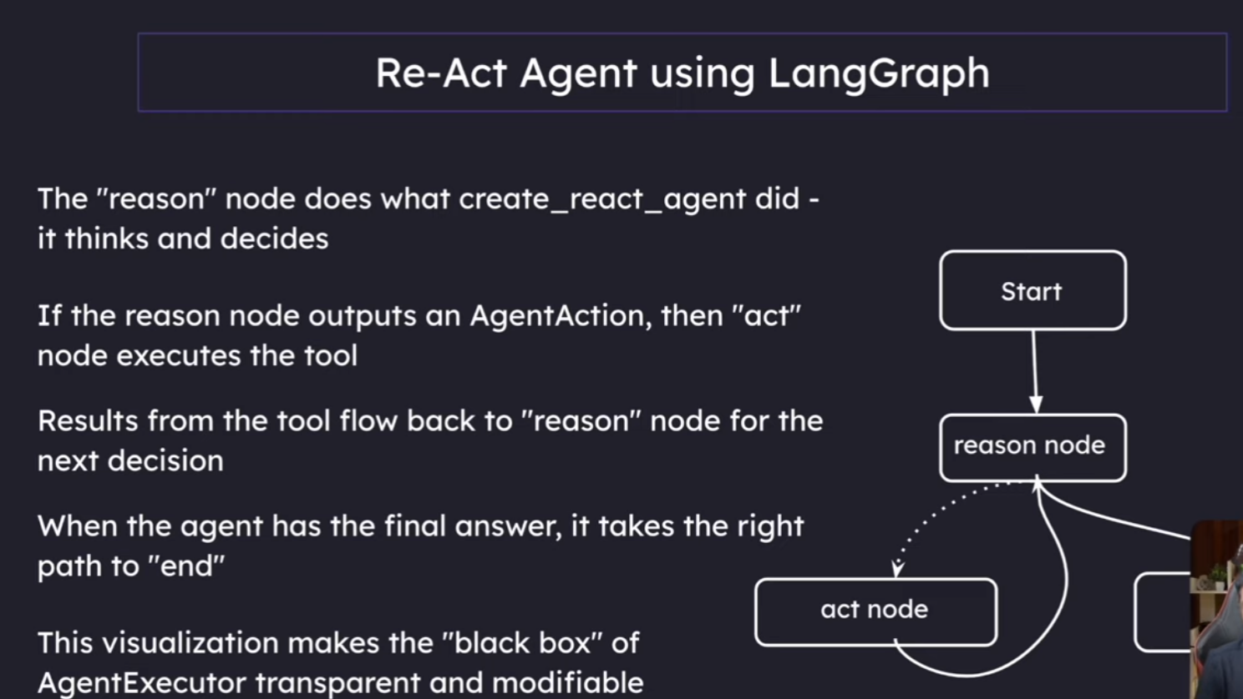
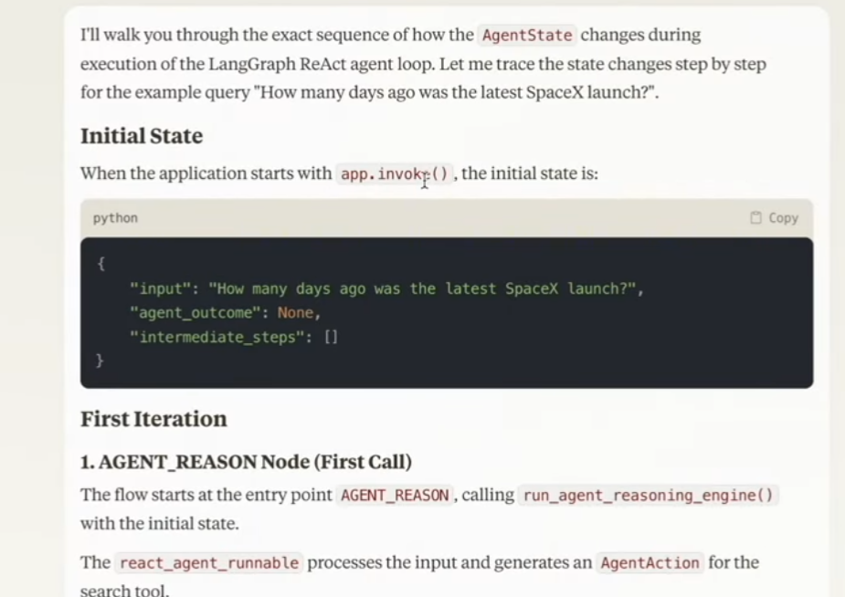

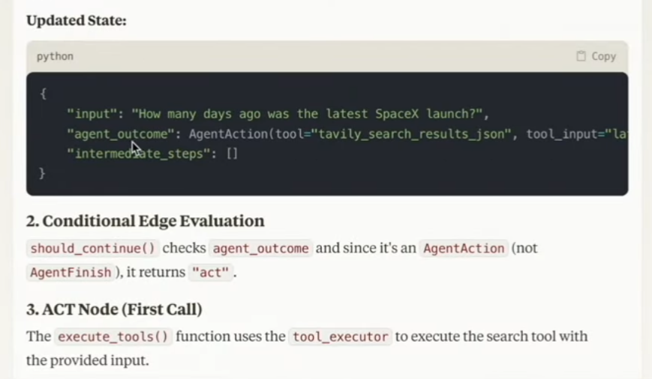
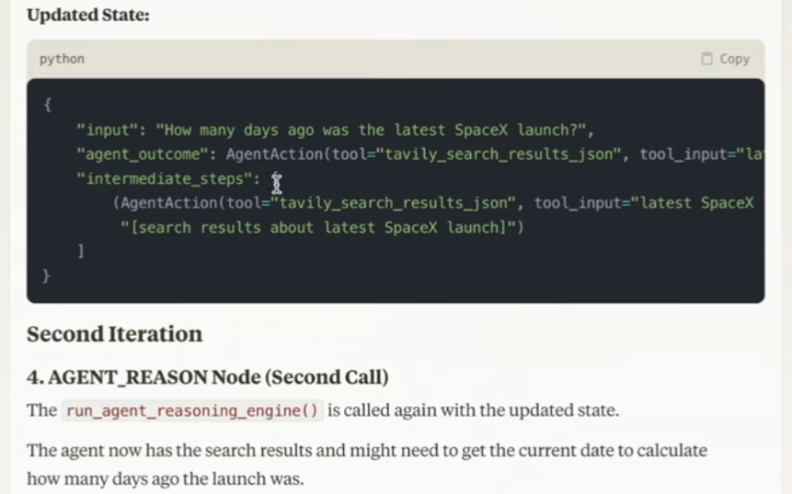
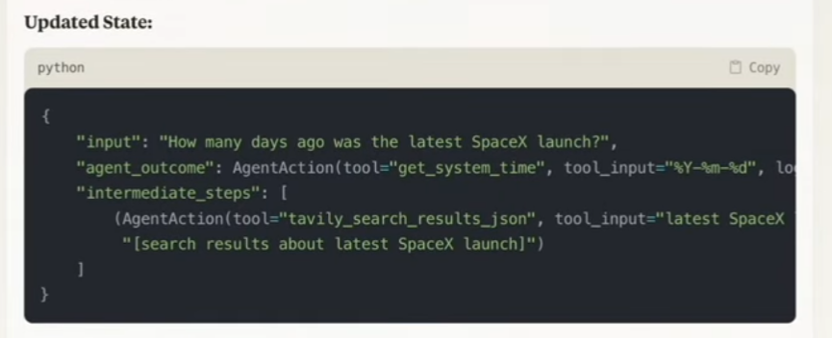
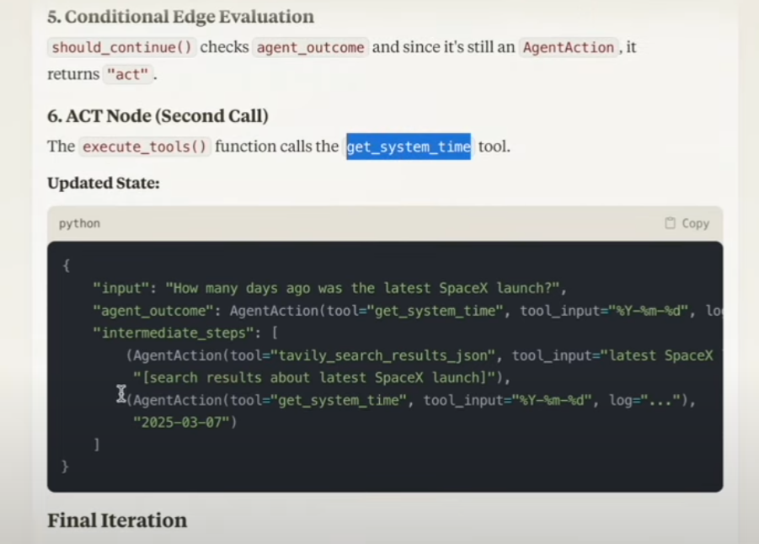
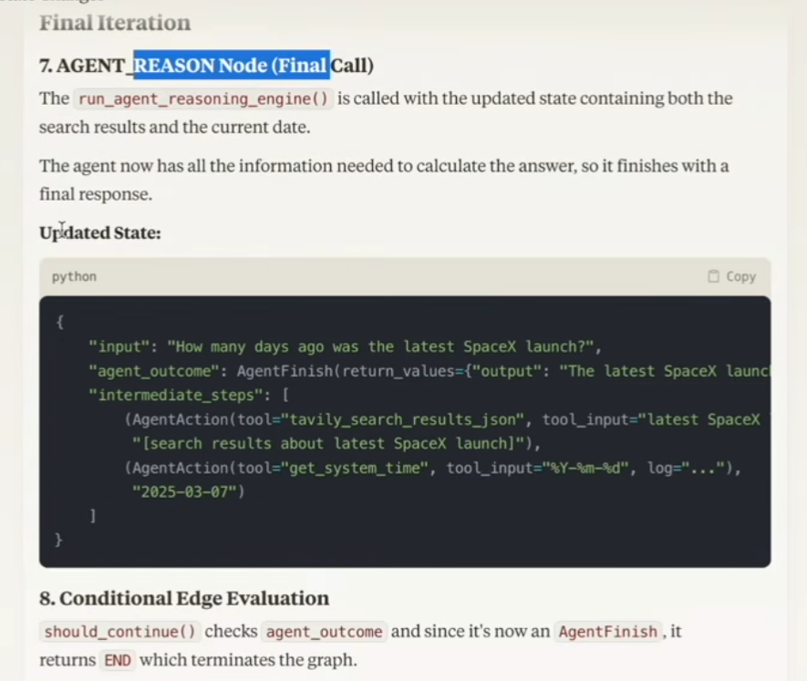
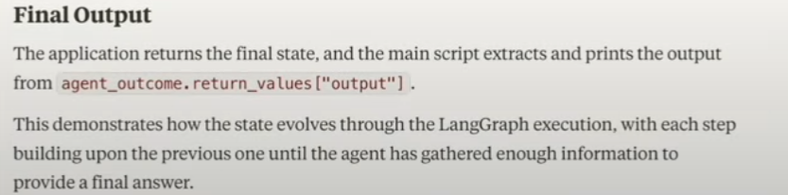
Chatbots using LangGraph
What we’ll cover in the next few sections:
- Basic Chatbot (no memory)
- Chatbot with Tools
- Chatbot with memory
- Chatbot with human-in-loop scenarios
- Chatbot with more complex state
- Understanding Time-travel
- Chat bots using LangGraph
1. Basic Chatbot
No memory
No tools
We’ll learn:
Graph stream method
Chat looping
Use free Llama Model using the Groq interface
(Diagram shows a simple graph: __start__ → chatbot → __end__)
Memory & Checkpointers
- When you build a basic chatbot using LangGraph, you run into an immediate limitation: by default, your chatbot has amnesia.
- Every time a user starts a conversation, the bot has no recollection of previous interactions.
- This happens because without memory management, each invocation of your graph is completely independent.
- This is where the concept of checkpointers in LangGraph come into the picture.
What is a Checkpointer?
A checkpointer in LangGraph is essentially a way to save the state of your agent or workflow at specific points during execution.
Think of it like saving your progress in a video game. When you reach a checkpoint:
- The current state of everything is saved
- If something goes wrong later, you can return to this saved point
- Don’t need to start over from the beginning

In the context of LangGraph nodes and workflows:
- Nodes are the individual steps or components in your workflow
- Checkpoints save the complete state after a node finishes its work
- If an error occurs in a later node, you can resume from the last checkpoint rather than starting the entire workflow again
This is particularly useful for complex workflows where:
- Processing takes significant time or resources
- You want to implement retry mechanisms
- You need persistence across sessions or server restarts
Thread ID:
A thread ID is simply a unique identifier for each specific conversation or workflow execution. Think of it like:
- A unique session ID for a user
- A conversation ID that groups related messages together
The thread ID is necessary because:
- You might have multiple conversations/workflows running simultaneously
- Each needs its own separate saved state
- The thread ID helps the system know which saved state belongs to which conversation
Without thread IDs, all your conversations would share the same state, which would cause confusion and errors.
Human In The Loop
A human-in-the-loop workflow integrates human input into automated processes, allowing for decisions, validation, or corrections at key stages.
This is especially useful in LLM-based applications, where the underlying model may generate occasional inaccuracies.

Use-cases:
- Reviewing tool calls: Humans can review, edit, or approve tool calls requested by the LLM before tool execution.
- Validating LLM outputs: Humans can review, edit, or approve content generated by the LLM.
- Providing context: Enable the LLM to explicitly request human input for clarification or additional details or to support multi-turn conversations.
Human In The Loop (Design Patterns)
- There are typically three different actions that you can do with a human-in-the-loop workflow:
- 1. Approve or Reject:
Pause the graph before a critical step, such as an API call, to review and approve the action.
- If the action is rejected, you can prevent the graph from executing the step, and potentially take an alternative action. This pattern often involves routing the graph based on the human’s input.
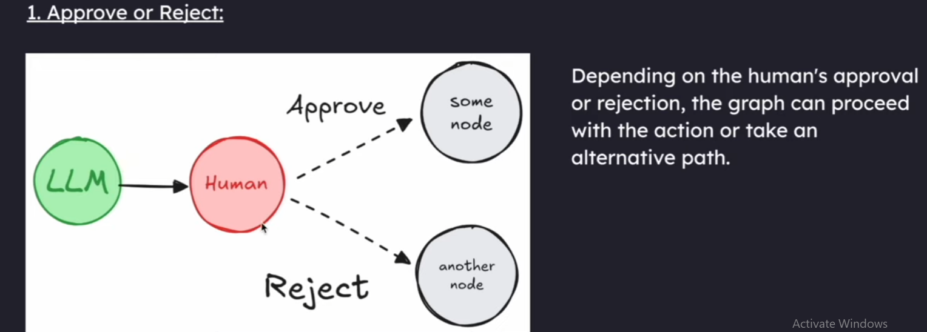
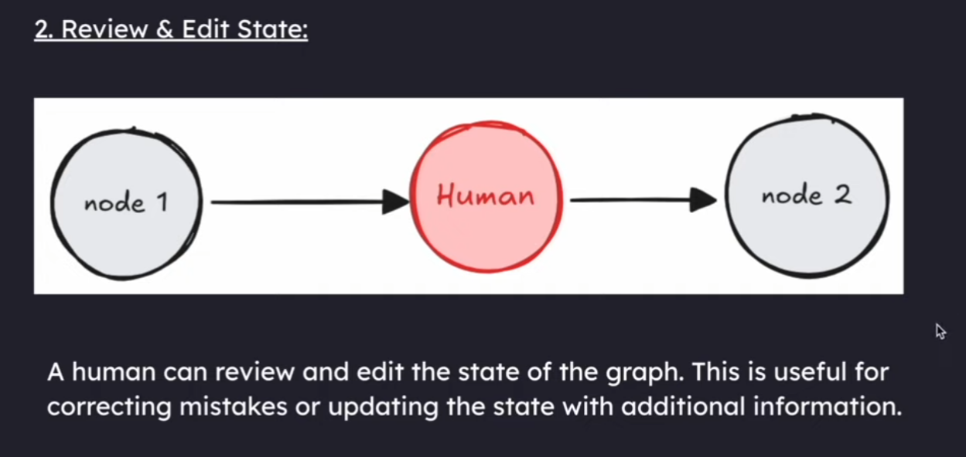
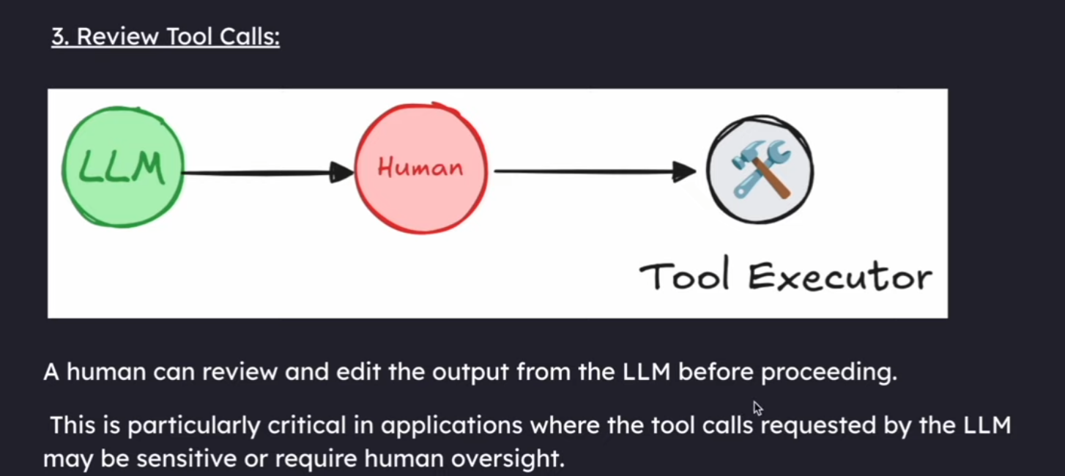
Human In The Loop
Drawbacks of input():
- Freezes your program completely until someone types something
- Only works in terminals – useless for web apps
- If your program crashes, all progress is lost
- Can only handle one user at a time
- Lives only in your terminal session
This is why we use a special method that LangGraph provides called "interrupt".
What is interrupt() & Why Use It?:
- Special LangGraph function that pauses your workflow nicely
- Saves your program’s state so it can continue later
- Works in web apps, APIs, and other interfaces
- Handles multiple users/sessions at once
- Survives program crashes and restarts
- Lets humans take their time to respond
- Required for any serious human-in-the-loop system
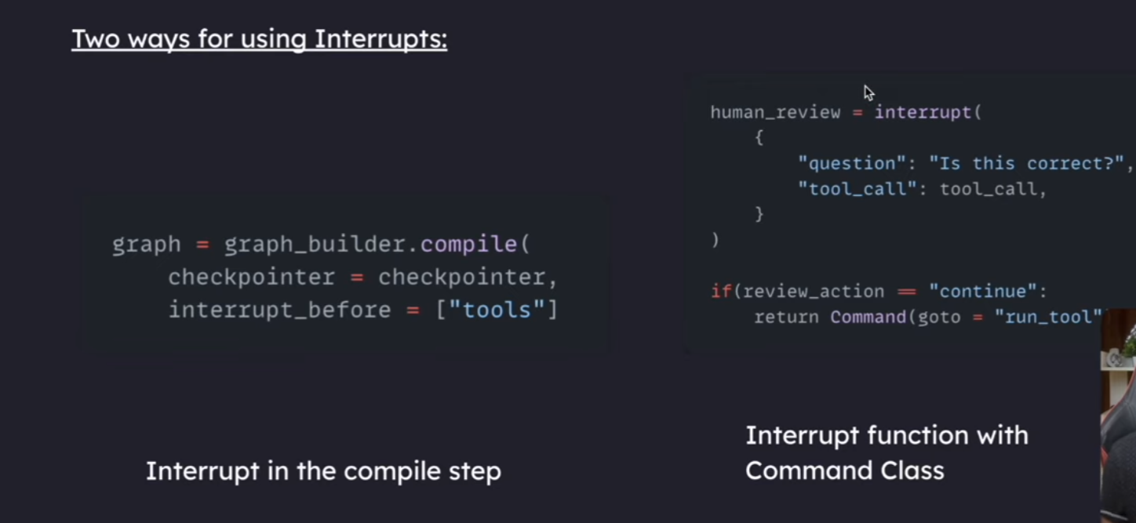

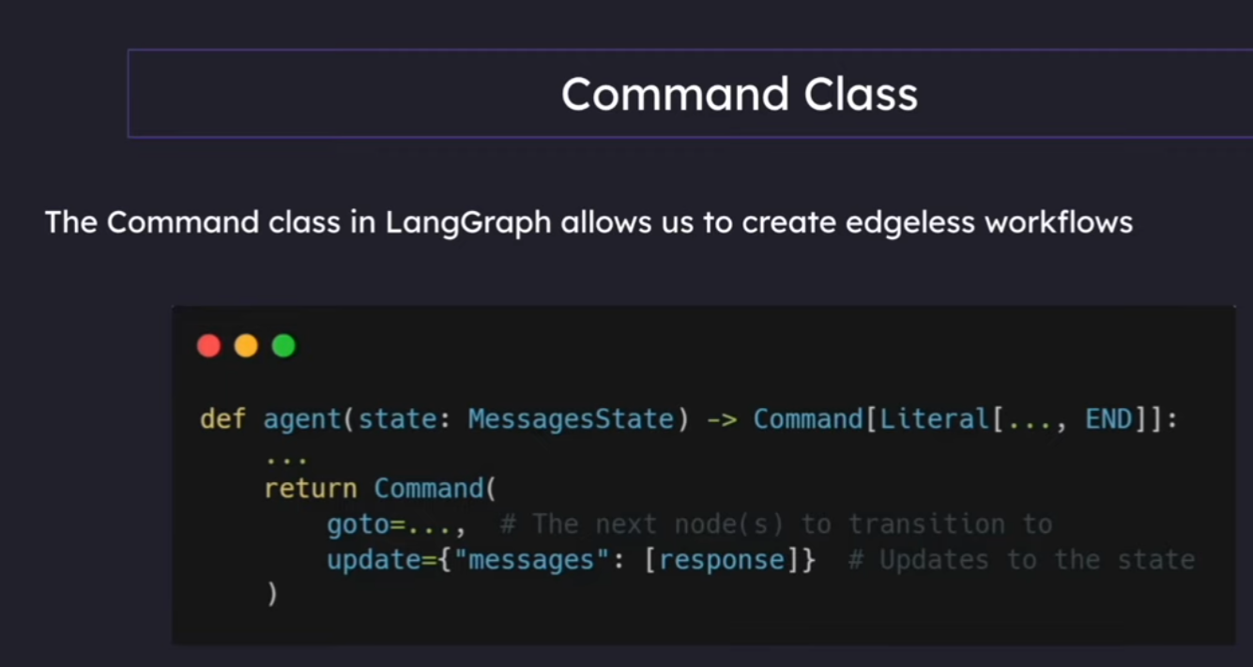
Interrupts
Operations with Interrupts:
- Resume – Continue execution with input from the user without modifying the state
- Update and Resume – Update the state and then continue execution
- Rewind/time Travel – Go back to a previous checkpoint in the execution
- Branch – Create a new branch from the current execution state to explore alternative paths
- Abort – Cancel the current execution entirely
Each of these operations gives you different ways to control the flow of your graph if interrupted.

RAGS in LANGRAPH
