Exam Management System Project Report
Lab 0 project description and rewrite specification. Updated after requirement review; implementation and submission evidence are tracked separately.

1. Description of the problem to be solved

1.1. Purpose of the system
The project automates the creation of a faculty exam timetable: exams are scheduled into sessions, rooms are allocated to cover each course’s enrollment, and invigilators are assigned without time conflicts.
The project reworks an existing exam management system (Node.js/Express, server-rendered pages, SQL Server, scheduling logic in stored procedures) into a Go (Fiber) REST API, PostgreSQL database, and React (Vite, Tailwind CSS) application. Keycloak provides standards-based authentication and token issuance on the same host. Stored-procedure scheduling is replaced by database constraints plus application-level transactions. The rewrite starts with reproducible demo data; the existing SQL Server database and legacy source remain untouched.

1.2. Functional requirements
An unregistered system user (guest) can:
- View the landing page and the published exam schedule (calendar and list views, filterable by date and course);
- Log in through Keycloak using a passkey with user verification or a password with TOTP.
A registered Administrator (administrator role) can:
- View a consolidated dashboard: schedule, courses, sessions, classrooms, personnel, unavailability records, audit log;
- Schedule an exam (course + session);
- Run automatic scheduling for all unplanned courses, optionally filtered by term;
- Assign invigilators automatically or manually, remove assignments, and bulk-assign all unstaffed exam rooms;
- Delete a single exam or clear the entire schedule;
- Change session start/end times (changes are audit-logged automatically);
- Manage personnel unavailability (leave, advisory hours) and approve or reject invigilator requests;
- Review the invigilator availability matrix and per-person workload statistics;
- Export the final schedule to Excel (calendar and list views);
- Trigger an on-demand database backup.
- Publish or unpublish the schedule. Any schedule-affecting edit unpublishes it until an administrator republishes it; guests can only read published schedule data.
Each scheduling action, including an automatic bulk action, runs in one transaction; failure rolls back the whole action. Local uniqueness rules use UNIQUE constraints. Cross-table and aggregate rules are checked in Go while all relevant writes hold the same transaction-scoped schedule lock:
- one exam per course;
- courses of the same term and department never share a session;
- at most two exams per day for each department-and-term cohort, with at least one free session between same-day exams of that cohort;
- one exam per room per session;
- allocated active rooms must cover course enrollment with the fewest rooms; a single floor is preferred when it can achieve that minimum room count;
- an invigilator is never double-booked or assigned during approved unavailability; automatic assignment selects the least-loaded eligible person in the course department, then the shared pool, with stable tie-breaking;

The rewrite preserves the additional legacy limits of four invigilation duties per day and no four consecutive duties. The report takes precedence where the legacy implementation differs: room count is minimized before floor preference, and bulk scheduling is atomic. These rules require acceptance tests rather than an assumption of legacy correctness.
A registered Invigilator (member role with the invigilator permission) can:
- Log in under a restricted, read-mostly role, with narrowly scoped access to their own unavailability requests;
- Submit unavailability requests (date, session, reason) for administrator approval;
- Edit or withdraw their own pending requests; only an administrator can approve or reject a request. Approval rechecks existing duties and rolls back if a conflict would result.
- View assigned duties (date, session, room, course) and personal workload statistics.
A registered Student (member role without the invigilator permission) can:
- Log in under a read-only security role;
- View the exam schedule and download it as an Excel document.

1.3. Non-functional requirements
User interface
- React application (Vite) styled with Tailwind CSS;
- Responsive layout with breakpoints at 640px and 1024px; an expandable keyboard-accessible menu on small screens and a visible navigation bar on large screens; images use max-width: 100% and height: auto;
- Distinct header, content, and footer styles, each containing several elements; SVG icons; a custom or Google font; short CSS animations respecting reduced-motion preferences; aligned layouts with readable content across screen sizes;
- Clear, consistent entry forms using labeled text, number, date, time, checkbox, and select inputs; inline validation; accessible modal windows for conflict information and destructive-action confirmation, with managed focus and keyboard dismissal; visible focus, readable contrast, and unobstructed controls.
API
- REST-compliant resources for eight related, independently managed business entities: departments, courses, sessions, classrooms, personnel, unavailability requests, exams, and invigilator assignments. Exam-room allocations are owned relationships managed atomically through exams; relationships are enforced with foreign keys;
- Each of the eight independently managed business entities exposes create, retrieve-by-ID, update, delete, and list operations. Audit records are append-only technical records with read endpoints, and identity records are managed by Keycloak;
- Combined resource endpoints: the administrator dashboard and duty lists join several entities (e.g. the schedule joins courses, sessions, rooms, and invigilators);
- All list endpoints support pagination and filtering;
- List requests use validated page and page_size parameters, bounded page sizes, stable ordering, and parameterized, allowlisted filters. Successful creates return 201 with Location; retrievals/updates return 200; deletes return 204; invalid, unauthenticated, forbidden, missing, conflicting, or unsupported requests return appropriate 4xx responses rather than 200 or HTML redirects.
- JSON by default, with XML and plain-text representations negotiated through the Accept header; collection reads additionally support valid Atom feeds. OAuth2/OIDC endpoints use their standard protocol formats; Excel exports and backups use their appropriate binary types;
- OpenAPI documentation and a Postman collection cover every application API method and the required authentication flow. Requests demonstrate correct status codes, content types, validation, permissions, pagination, filtering, and returned data.
Security
- Keycloak manages local accounts and hashed passwords. OpenID Connect provides authentication over OAuth2 Authorization Code with PKCE (S256); signed, short-lived JWT access tokens authorize API calls. Strong login uses a passkey with required user verification or a password plus TOTP; administrator access requires the configured MFA assurance level. OAuth2 remains because it is required by the assessment, while passkeys/MFA improve authentication;
- Access categories are guest, member, and administrator; invigilator is an additional member permission linked to a personnel record. Go verifies signature, allowed algorithm, issuer, audience, expiry, and trusted role claims, then enforces role and record ownership. Tokens stay in browser memory. Application database roles are least-privileged: administrators can manage application data without database-owner privileges, guests/students can read permitted views, and invigilators have only the additional grants and row policies needed for their own requests. Schema migration and identity-database owners are separate.
- Use HTTPS, exact redirect-URI allowlists, login throttling, secure provider session cookies, CSRF protection for provider forms, restrictive CORS/CSP, and secret files or environment configuration. Public registration is disabled; an administrator provisions accounts. Recovery and MFA reset require verified identity and an audit trail. No client-supplied role or personnel ID can establish identity.
Database
- PostgreSQL; 3NF schema; primary/foreign keys and CHECK constraints;
- UNIQUE constraints enforce table-local invariants, including one exam per course and one invigilator assignment per exam-room allocation; cross-table room/personnel conflicts and aggregate limits are checked under the shared schedule lock, without denormalizing the 3NF schema;
- Business rules in the Go backend;
- Reporting views (schedule, invigilator workload) queried by the API; audit log (old value, new value, user, timestamp) written in the same transaction;
- On-demand backup (pg_dump) via the administrator interface.
Tooling
- A hosted Git repository contains the source, Lab 0 description, OpenAPI document, Postman collection, tests, and documented quick-start environment. Containerized PostgreSQL and Keycloak, versioned migrations, and idempotent demo seeds support reproducible setup. Upload/submission and repository URLs must be recorded as evidence; this specification alone does not prove delivery.
- Docker Compose runs PostgreSQL and Keycloak for development; Go and Vite run locally with documented commands and a Vite API proxy. Production serves the React build from Go, with PostgreSQL and Keycloak on the same host.
- SonarQube for quality checks.

1.4. System architecture
System components:
- Client side (FrontEnd): React (Vite) with Tailwind CSS;
- Server side (Back-End): Go with the Fiber framework; Keycloak handles authentication and token issuance;
- Database: PostgreSQL, with separate application and Keycloak databases and owners.
Deployment. Go serves the React production build and REST API over HTTPS. PostgreSQL and Keycloak run on the same host with separate credentials and isolated database ownership. React redirects to Keycloak for OpenID Connect login and exchanges the authorization code using PKCE; Keycloak, not Go, issues the JWT. React sends the access JWT in the Authorization header. Go validates it using Keycloak discovery/JWKS, checks role and ownership, selects a fixed application database role, and runs business operations transactionally. Resource responses use the documented negotiated formats. Keycloak also uses HTTPS in production; local loopback development is documented separately.
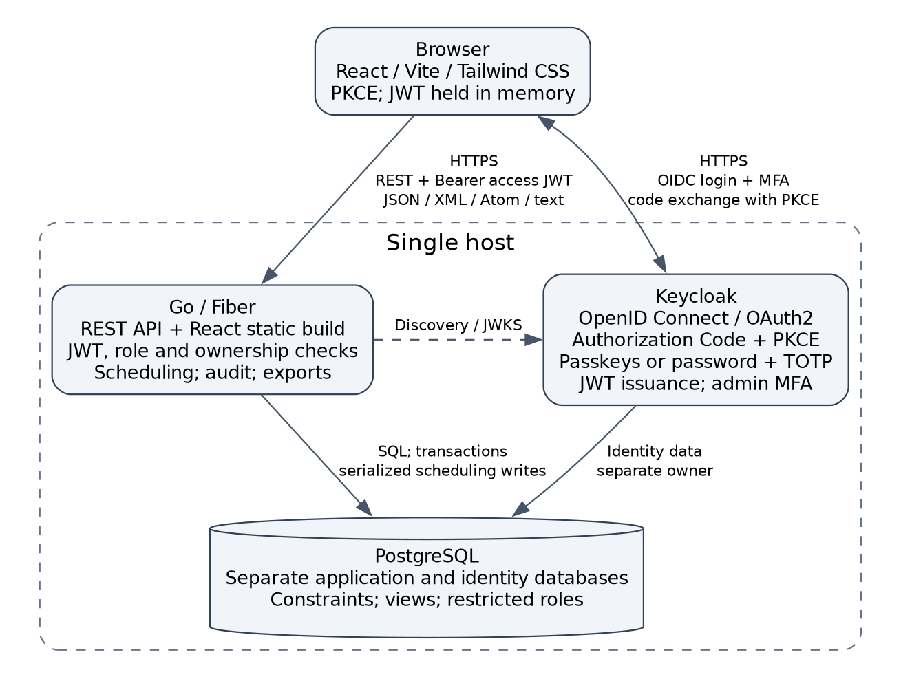
Figure 1. Single-host deployment with a dedicated identity provider. Diagram source: docs/architecture.dot (Graphviz).

1.5. Delivery and acceptance evidence
This report specifies intended behavior; it is not evidence that the rewrite has been implemented. The original report is preserved as MD_exam_management_system_REPORT.original.docx. The requirement audit, implementation sequence, and acceptance conditions are recorded in REWRITE_PLAN.md.
Acceptance requires a clean-checkout quick start; applied migrations and seeded demo accounts/data; passing API and scheduling tests; an executable Postman collection; responsive and accessibility checks at both breakpoints; and a working single-host production-build demonstration.
Record the hosted repository URL, commit used for assessment, Lab 0 upload receipt or submission URL, and API/UI verification results. Do not mark upload, hosting, or runtime correctness complete based on this document.
Retain the legacy source and SQL Server database throughout the rewrite. No live-data import, legacy reset script, database deletion, repository publication, or assessment upload is performed as part of writing this plan.

