Exam Management System Project Report

1. Description of the problem to be solved

1.1. Purpose of the system
The project automates the creation of a faculty exam timetable: exams are scheduled into sessions, rooms are allocated to cover each course’s enrollment, and invigilators are assigned without time conflicts.
The project reworks an existing exam management system (Node.js/Express, server-rendered pages, SQL Server, scheduling logic in stored procedures) onto a decoupled architecture: a Go (Fiber) REST API, PostgreSQL, React (Vite, Tailwind CSS) application. Stored procedures are replaced by declarative constraints plus application-level transactions.

1.2. Functional requirements
An unregistered system user can:
- View the landing page and the published exam schedule (calendar and list views, filterable by date and course);
- Log in to the online application.
A registered Administrator can:
- View a consolidated dashboard: schedule, courses, sessions, classrooms, personnel, unavailability records, audit log;
- Schedule an exam (course + session);
- Run automatic scheduling for all unplanned courses, optionally filtered by term;
- Assign invigilators automatically or manually, remove assignments, and bulk-assign all unstaffed exam rooms;
- Delete a single exam or clear the entire schedule;
- Change session start/end times (changes are audit-logged automatically);
- Manage personnel unavailability (leave, advisory hours) and approve or reject invigilator requests;
- Review the invigilator availability matrix and per-person workload statistics;
- Export the final schedule to Excel (calendar and list views);
- Trigger an on-demand database backup.
All scheduling operations run in a single transaction, any violation rolls back the whole action. Bold constraints are additionally enforced as UNIQUE database constraints:
- one exam per course;
- courses of the same term and department never share a session;
- at most two exams per day for any term, with at least one free session between same-day exams of that term;
- one exam per room per session;
- allocated rooms must cover course enrollment with the fewest rooms, preferring the same floor;
- an invigilator is never double-booked nor assigned during approved unavailability; duty is balanced across the personnel pool.

(Note that these rules are from the original project and I am going to keep them as is and improve upon them since they are already literally implemented.)
A registered Invigilator can:
- Log in under a restricted, read-mostly security role;
- Submit unavailability requests (date, session, reason) for administrator approval;
- View assigned duties (date, session, room, course) and personal workload statistics.
A registered Student can:
- Log in under a read-only security role;
- View the exam schedule and download it as an Excel document.

1.3. Non-functional requirements
User interface
- React application (Vite) styled with Tailwind CSS;
- Navigation menu, tab bar(if needed), images where revelant etc.;
- Standart header, content, and footer trio styling; SVG vector graphics; a non-standart font; CSS animations; alignment across resolutions;
- Entry forms with varied input types (date pickers, combo boxes); modal windows for warnings (e.g. daily exam limit exceeded).
API
- REST-compliant resources for the core entities (courses, sessions, classrooms, personnel, unavailability requests) related via foreign keys;
- Every entity exposes full CRUD plus a list method;
- Combined resource endpoints: the administrator dashboard and duty lists join several entities (e.g. the schedule joins courses, sessions, rooms, and invigilators);
- All list endpoints support pagination and filtering;
- JSON by default; XML, Atom, and plain text via the Accept header;
- Postman collection covering all API methods.
Security
- Local authentication with hashed passwords; OAuth2/JWT authorization; expiring tokens;
- Role-based security at application and database level: administrator sessions use a full-privilege database user; invigilator and student sessions use a read-restricted user.
Database
- PostgreSQL; 3NF schema; primary/foreign keys and CHECK constraints;
- Absolute invariants as UNIQUE constraints;
- Business rules in the Go backend;
- Reporting views (schedule, invigilator workload) queried by the API; audit log (old value, new value, user, timestamp) written in the same transaction;
- On-demand backup (pg_dump) via the administrator interface.
Tooling
- Git repository with a documented development environment (containerized PostgreSQL, seed data).
- Docker for the PostgreSQL server while developing the project.
- SonarQube for quality checks.

1.4. System architecture
System components:
- Client side (FrontEnd): React (Vite) with Tailwind CSS;
- Server side (Back-End): Go with the Fiber framework;
- Database: PostgreSQL.
Deployment. The system runs on a single server: the Go application server exposes the REST API over HTTPS and serves the React production build as static assets; PostgreSQL runs on the same host. After login the browser attaches its JWT to every request; the Go server validates the token, connects under the database user matching the caller’s role, and executes the business logic transactionally, returning results in the negotiated format (JSON/XML/Atom/text).
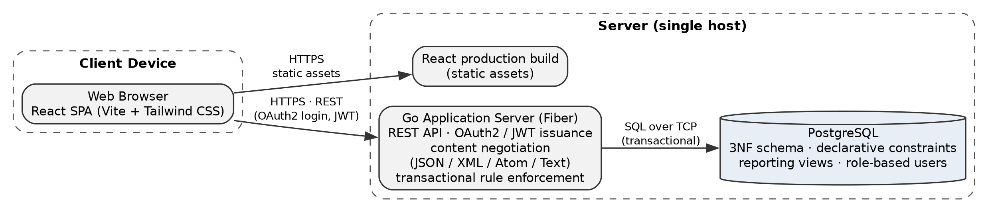
*The diagram is generated using GraphViz as a .dot file so no it is not a AI generated image.

