

ADB phase 1



Team number: 11

Members:

Reem Emad sec.: 1 B.N.: 33

Passant Abd ElGalil sec.1 B.N.: 20

Mariem Nasser sec.: 2 B.N.: 23

Mariem Mohammed sec.:2 B.N.: 22

System description: the system is an online store like OLX, the main entities are:

Customer, deliveryman, order, product

Operating System: Windows

CPU: Intel

Processor: core i7, 10th generation

RAM: 16 GB

Hard Disk: SSD

Data base report:

|  |  |  |  |  |  |  |  |
| --- | --- | --- | --- | --- | --- | --- | --- |
| TABLE_NAME | TABLE_ROWS | AVG_ROW LENGTH | DATA_LENGTH | INDEX_LENGTH | DATA_FREE | FK | AUTO_INCREMENT |
| customer | 1033612(1M) | 225 | 3686400 | 2064384 | 4194304 | 0 | 16419 |
| deliveryman | 16635 | 223 | 3686400 | 2080768 | 4194304 | 0 | 16636 |
| order | 2.5M | 38 | 38338560 | 42041344 | 4194304 | 2 | 1000001 |
| ordercomponents | 3M | 49 | 48840704 | 55705600 | 7340032 | 3 | NULL |
| product | 2M | 243 | 2.36E+08 | 0 | 6291456 | 0 | 1000001 |

Using mysql:



ER diagram:

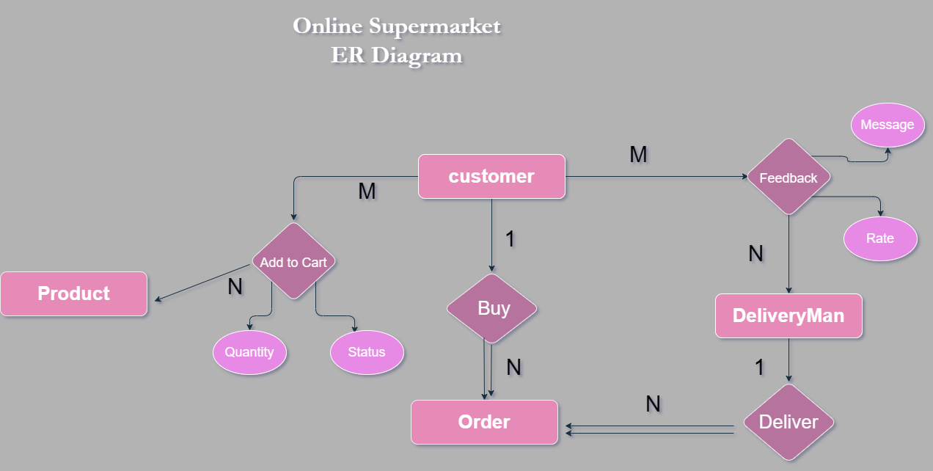

Schema:

