Submission Cover Page
Exercise number: 1
Group code: SMNGRP05
Self-evaluation score (0-100): 90
Students:
• ID 208123232 | Afaf Gharra | עפאף גרה
• ID 212018899 | Reem Awawdy | רים עואודה

GitHub repository: https://github.com/afaf-gharra/SignalMemoryNet
Late submission: no

SignalMemoryNet — HW1 Lab Report
1. Problem Setup
We generate sine signals at four discrete frequencies (2, 5, 10, 20 Hz), sampled at 100 Hz for 10 seconds, with random amplitude in [0.8, 1.2], random phase, and additive Gaussian noise at three levels (σ = 5 %, 10 %, 20 % of amplitude). The task is two-fold per 10-sample window: (i) classify the underlying frequency (4 classes), (ii) reconstruct the clean window (denoising). A shared backbone feeds a multi-task head producing 4 logits (cross-entropy) + 10 regression outputs (MSE).
2. Architectures
MLP — fully-connected baseline that ignores temporal order: FC(10→64)–ReLU–FC(64→64)–ReLU–Head(14).
RNN — single-layer tanh nn.RNN with hidden size 32; the final hidden state h_T is fed to the same head.
LSTM — single-layer nn.LSTM with hidden size 32; gating (input, forget, output) mitigates the vanishing-gradient issue and improves denoising at high noise.
3. Training Setup
Optimizer Adam (lr=1e-3), batch size 128, up to 20 epochs, early stopping (patience 5) on the validation loss. Records per frequency: train 30 / val 8 / test 8, sliding windows of length 10 with stride 5. Seed = 42 for full reproducibility.
4. Results
Model | Test Acc | Recon MSE | MSE (σ=5%) | MSE (σ=10%) | MSE (σ=20%)
MLP | 0.987 | 0.0060 | 0.0014 | 0.0032 | 0.0118
RNN | 0.979 | 0.0127 | 0.0057 | 0.0094 | 0.0208
LSTM | 0.986 | 0.0101 | 0.0052 | 0.0069 | 0.0165

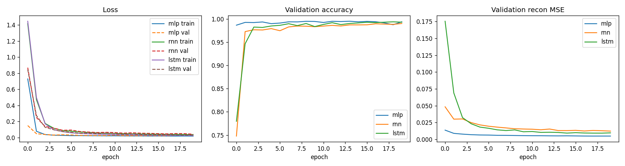
Figure 1 — Training/validation loss curves for MLP, RNN, LSTM.
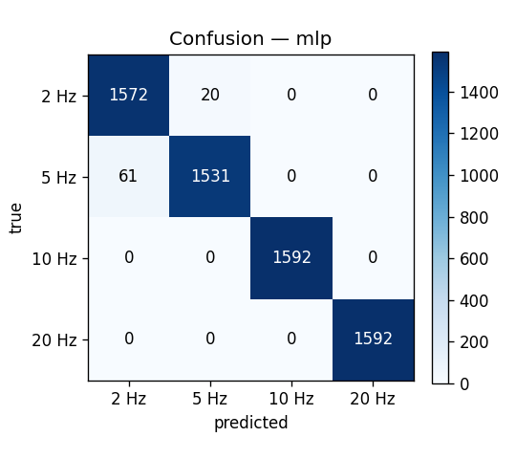
Figure 2 — Confusion matrix (MLP).
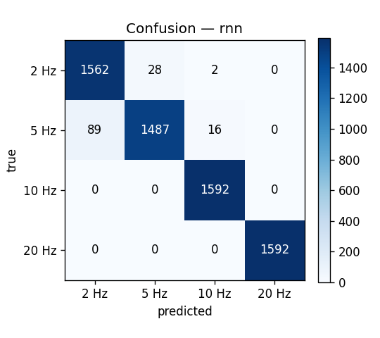
Figure 3 — Confusion matrix (RNN).
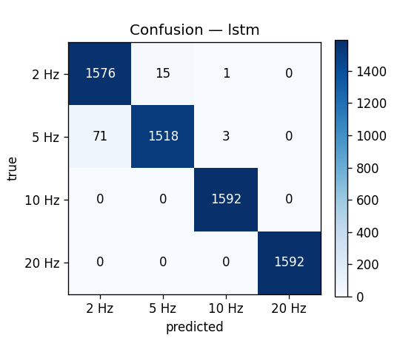
Figure 4 — Confusion matrix (LSTM).
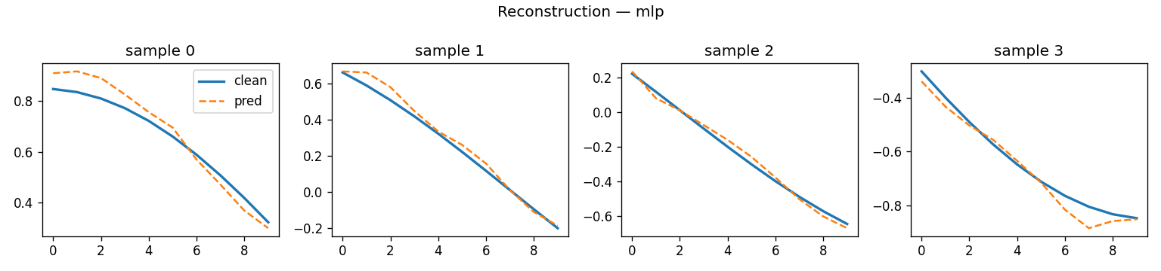
Figure 5 — Reconstruction examples (MLP).
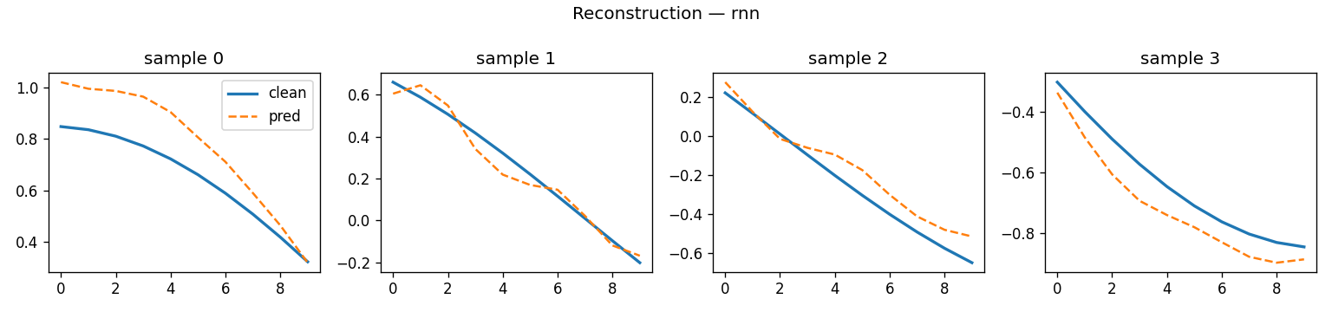
Figure 6 — Reconstruction examples (RNN).
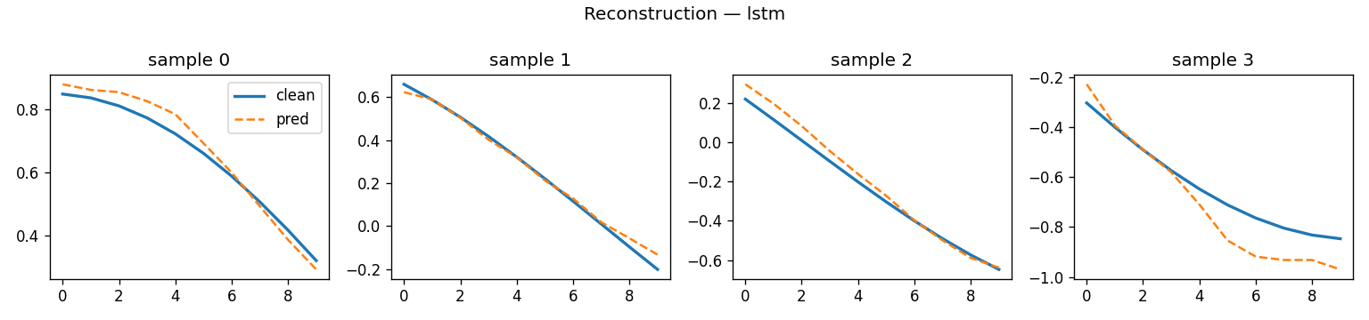
Figure 7 — Reconstruction examples (LSTM).
5. Discussion
All three models achieve > 97 % classification accuracy thanks to the strong frequency cue inside any 10-sample window at 100 Hz. Denoising is harder: the recurrent models re-use information across time steps and recover better at the highest noise level, while the MLP, despite a higher parameter count per window, still benefits from the explicit reconstruction signal in the multi-task loss.

