
CS471 – Web Technologies
Lab 1
(Laboratory)
The Internet Protocols

This lab session covers the usage of the Wireshark application to monitor and capture the outgoing and incoming packets from a network connection (WIFI, ethernet, etc.). Specifically, students should be able to analyze HTTP, HTTPS, TCP/IP, and UDP protocols using Wireshark, a network protocol analyzer, and draw conclusions.
Pre-lab Preparation:
- Review the basics and the structure of HTTP, TCP/IP, and UDP protocols,
- Install Wireshark and ensure it is running on your computer,
- Create an online, publically accessible Git repository to host and upload your work in the labs. We recommend you use GitHub or GitLab.
Lab Activities:
Part 1: Capturing HTTP Traffic.
Task 1: Start Wireshark and capture packets.
Step 1: Open Wireshark.
Step 2: Select the network interface connected to the internet (e.g., Ethernet or Wi-Fi).
Step 3: Click the "Start Capturing Packets" button (the shark fin icon). Step 4: Open your favorite web browser and navigate to (http://neverssl.com/) website.
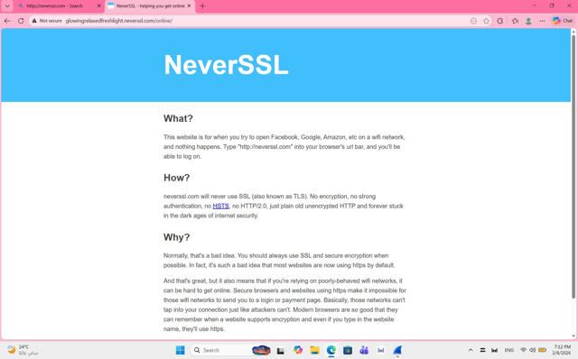
Step 5: After the website has fully loaded, stop capturing packets by clicking the red stop button in Wireshark.
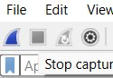
Task 2: Filter HTTP packets and analyze them.
Step 1: In the filter bar, type http and press Enter. This filters out only the HTTP packets from the capture.
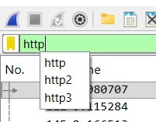
Step 2: Select any HTTP packet to view its details.

Step 3: Observe the HTTP request and response messages. Note the method (GET, POST), URL, response codes (200 OK, 404 Not Found), etc.

Part 2: Analyzing TCP/IP Traffic.
Task 1: Filter TCP packets
Step 1: Clear the previous filter and type TCP to focus on TCP packets.
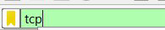
Step 2: Select a TCP packet related to your HTTP request/response.
Step 3: Right-click on the packet and select "Follow" -> "TCP Stream".
Step 4: This shows the entire conversation between the client and server.
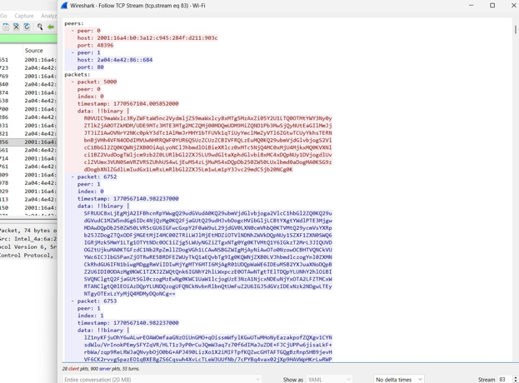
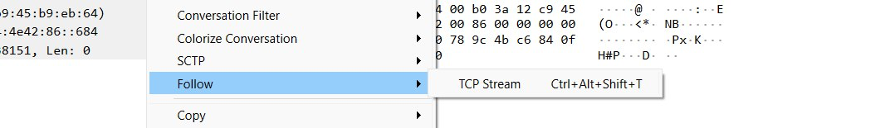
Task 2: Analyze TCP handshake and investigate Data Transfer and Termination

Step 1: Find and select packets related to the TCP three-way handshake:
- SYN: Initiates a connection. o SYN-ACK: Acknowledges and responds to the SYN.
- ACK: Acknowledges the SYN-ACK and establishes the
connection.
Step 2: Note the sequence and acknowledgment numbers. Screenshot and upload your image to your online git repository.
Step 3: Observe the data packets exchanged between the client and server. Take a screenshot and upload it to your online git repo
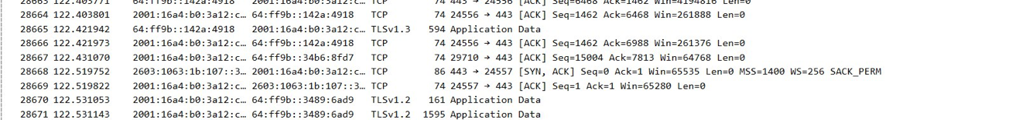
.

Step 4: Look at the TCP termination process (FIN, ACK packets).
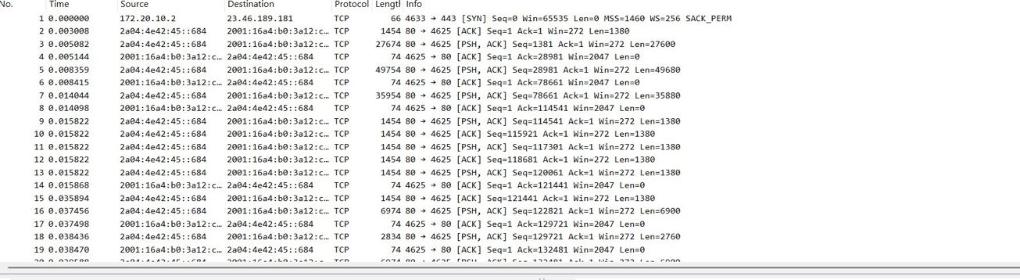

Part 3: Capturing and Analyzing UDP Traffic
Task 1: Generate UDP traffic and capture packets
Step 1: Open a network application that uses UDP (e.g., streaming video, VoIP software, or custom script).
Step 2: Start the application to generate UDP traffic.
Step 3: Start capturing packets in Wireshark while the UDP application is running.
Step 4: After sufficient traffic is generated, stop capturing packets.

Task 2: Filter and analysis UDP Packets
Step 1: In the filter bar, type UDP and press Enter.
Step 2: This filters out only the UDP packets from the capture.
Step 3: Select any UDP packet to view its details.
Step 4: Observe the source and destination ports, length, and data.
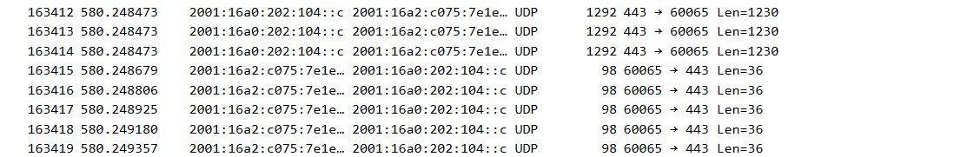
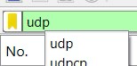
Step 5: Compare the simplicity of UDP headers with TCP headers.

UDP has a simpler header than TCP, which makes it faster but less reliable. TCP uses a more complex header to ensure reliable and ordered data transmission.

Part 4: Comparing TCP and UDP by filling in the following tables. Save your work (e.g., in an MS Word document), and upload it to your online git repo.
Task 1: Fill in the following table and provide reasons.

 | TCP or UDP | Reasons
Reliability and Connection Establishment | Tcp | TCP establishes a connection using the three-way handshake (SYN, SYN-ACK, ACK) and ensures reliable data delivery through acknowledgments and retransmissions.
Data Integrity and Ordering | Tcp | TCP guarantees data integrity and ensures packets are received in the correct order using sequence numbers and acknowledgments.

Task 2: Identify the use Cases and Performance of TCP and UDP.

 | TCP | UDP
Use cases | Web browsing (HTTP/HTTPS), Email, File transfer (FTP)
 |  | Video streaming, VoIP, Online gaming
Performance | Slower than UDP due to connection setup and reliability mechanisms | Faster and lower latency because it has no connection establishment or retransmissions

Page 1 of 3

