
Misr International University
Course Code & Title: SWE320 Software Engineering
Semester: Fall 2025
Lab 3 Task
You have the following tasks to complete in the lab:
- SignUp
- Login
- Menu Change(Sessions)
- View Profile
- Edit
- Delete
- SignOut

- Create php file (index.php), Index.php should contain 2 links to 2 pages (Login.php, SignUp.php)

- Signup page should contain the following form, It should redirect back to index.php after signup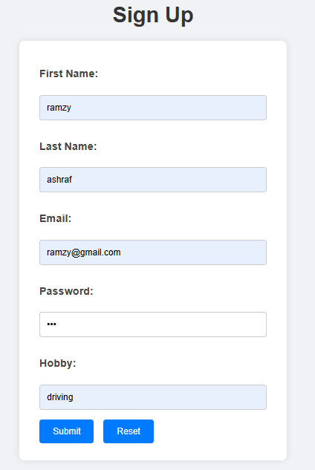
- Login page should contain the following form; it should redirect back to index.php after login
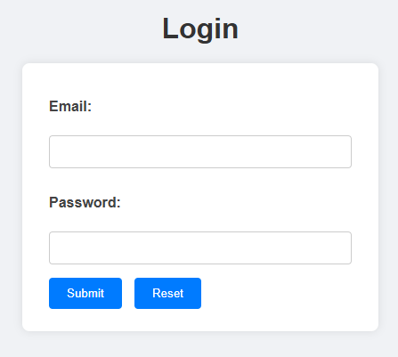

- After login, index.php should change to the following

- View Profile should contain the following

- Edit Profile page should contain the following
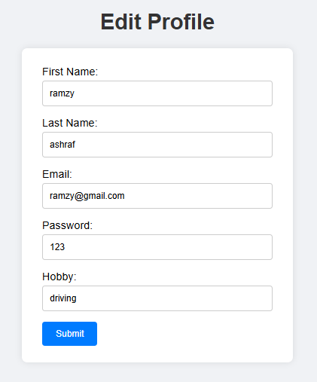
- Delete account will delete the user from the database
- Signout page will signout the user.

