Mock Exam Questions

Mock MCQ Category11

Question 05 (MC)
Specify the type of the image below via its corresponding histogram: (choose one)  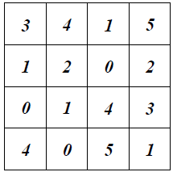 |  |  | MC
Default mark: |  |  | 2
Shuffle the choices? |  |  | Yes
Number the choices? |  |  | A
Penalty for each incorrect try: |  |  | 0
ID number:
# | Answers | Feedback | Grade
 | Low-contrast image. |  | 100
 | High-contrast image. |  | 0
 | - None of these choices. |  | 0
 |  |  | 0
 |  |  | 0
 | General feedback:
 | For any correct response: | Your answer is correct.
 | For any incorrect response: | Your answer is incorrect.
 | Hint 1:
 | Show the number of correct responses (Hint 1): | No
 | Clear incorrect responses (Hint 1): | No
 | Tags:
Allows the selection of a single or multiple responses from a pre-defined list. (MC/MA)

Mock True or False Category

Question 15 (TF)
Imaging in the infrared band is used for satellite imaging. |  |  | TF
Default mark: |  |  | 2
ID number:
 | Answers | Feedback | Grade
 | True |  | 100
 | False |  | 0
 | General feedback:
 | Tags:
Set grade '100' to the correct answer.

Mock True or False Category2

Question 19 (TF)
Image restoration is used to reduce the noise in the image. |  |  | TF
Default mark: |  |  | 2
ID number:
 | Answers | Feedback | Grade
 | True |  | 100
 | False |  | 0
 | General feedback:
 | Tags:
Set grade '100' to the correct answer.

Mock MCQ Category4

Question 71 (MC)
To which category the system s = c r ^{ɣ} belongs: (choose one) |  |  | MC
Default mark: |  |  | 2
Shuffle the choices? |  |  | Yes
Number the choices? |  |  | A
Penalty for each incorrect try: |  |  | 0
ID number:
# | Answers | Feedback | Grade
 | Image negative. |  | 0
 | Gamma correction. |  | 100
 | Contrast stretching. |  | 0
 | None of these choices. |  | 0
 | General feedback:
 | For any correct response: | Your answer is correct.
 | For any incorrect response: | Your answer is incorrect.
 | Hint 1:
 | Show the number of correct responses (Hint 1): | No
 | Clear incorrect responses (Hint 1): | No
 | Tags:
Allows the selection of a single or multiple responses from a pre-defined list. (MC/MA)

Mock MCQ Category5

Question 83 (MC)
To which category s = c r ^{ɣ} belongs: (choose one) |  |  | MC
Default mark: |  |  | 2
Shuffle the choices? |  |  | Yes
Number the choices? |  |  | A
Penalty for each incorrect try: |  |  | 0
ID number:
# | Answers | Feedback | Grade
 | Image acquisition. |  | 0
 | Image enhancement. |  | 100
 | Image restoration. |  | 0
 | None of these choices. |  | 0
 | General feedback:
 | For any correct response: | Your answer is correct.
 | For any incorrect response: | Your answer is incorrect.
 | Hint 1:
 | Show the number of correct responses (Hint 1): | No
 | Clear incorrect responses (Hint 1): | No
 | Tags:
Allows the selection of a single or multiple responses from a pre-defined list. (MC/MA)

Mock Match Category

Question 99 (MAT)
Match: |  |  |  | MAT
Default mark: |  |  |  | 3
Shuffle: |  |  |  | Yes
Show the number of correct responses once the question has finished: |  |  |  | No
Penalty for each incorrect try: |  |  |  | 0
ID number:
# | Question | Answer
 | Image acquisition | can be done using a camera or a scanner.
 | Image enhancement | is used to improve the appearance of an image.
 | Image restoration | is used to reduce the noise in an image.
 |  | is used to compress an image.
 |  | None of these choices.
 | General feedback:
 | For any correct response: | Your answer is correct.
 | For any incorrect response: | Your answer is incorrect.
 | For any partially correct response: | Your answer is partially correct.
 | Hint 1:
 | Show the number of correct responses (Hint 1): | No
 | Clear incorrect responses (Hint 1): | No
 | Tags:
You must provide at least two questions and three answers. You can provide extra wrong answers by giving an answer with a blank question. Entries where both the question and the answer are blank will be ignored.

Mock MCQ Category12 Problem Solving III

Question 115 (MC)
For the following input image with intensities shown, find the missing intensity of the output image indicated as a shaded gray level pixel only.  Hint: Use 3x3 window size.  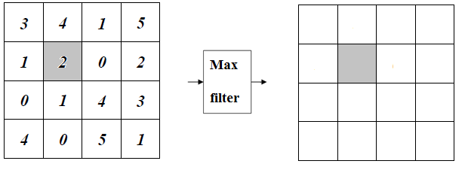 |  |  | MC
Default mark: |  |  | 2
Shuffle the choices? |  |  | Yes
Number the choices? |  |  | A
Penalty for each incorrect try: |  |  | 0
ID number:
# | Answers | Feedback | Grade
 | 1 |  | 0
 | 0 |  | 0
 | 2 |  | 0
 | 4 |  | 100
 | None of these choices. |  | 0
 | General feedback:
 | For any correct response: | Your answer is correct.
 | For any incorrect response: | Your answer is incorrect.
 | Hint 1:
 | Show the number of correct responses (Hint 1): | No
 | Clear incorrect responses (Hint 1): | No
 | Tags:
Allows the selection of a single or multiple responses from a pre-defined list. (MC/MA)

Mock MCQ Category8 Problem Solving III

Question 137 (MC)
For the following input image with intensities shown, find the missing intensity of the output image indicated as a shaded gray level pixel only.  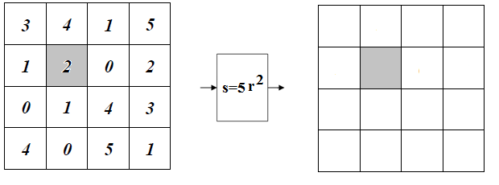 |  |  | MC
Default mark: |  |  | 2
Shuffle the choices? |  |  | Yes
Number the choices? |  |  | A
Penalty for each incorrect try: |  |  | 0
ID number:
# | Answers | Feedback | Grade
 | 20 |  | 100
 | 5 |  | 0
 | 0 |  | 0
 | 255 |  | 0
 | None of these choices. |  | 0
 | General feedback:
 | For any correct response: | Your answer is correct.
 | For any incorrect response: | Your answer is incorrect.
 | Hint 1:
 | Show the number of correct responses (Hint 1): | No
 | Clear incorrect responses (Hint 1): | No
 | Tags:
Allows the selection of a single or multiple responses from a pre-defined list. (MC/MA)

