Addressing Table (first host)

PC-4 |  | 172.20.5.238/28
PC-5 |  | 172.20.5.226/28
PC-6 |  | 172.20.5.62/26
S-MLS interface | G1/1/1 | 172.20.6.41/30
 | VLAN 300 | 172.20.5.225/28
 | VLAN 40 | 172.20.5.1/26

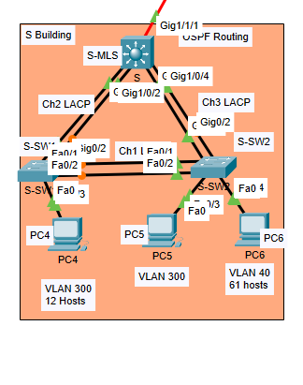
  - switch layer 3 and hosts interfaces:
S-SW1 to S-MLS: g0/2,g0/1
S-SW to S-MLS: g0/2,g0/1
S-MLS to S-SW1:g1/0/1, g1/0/2
S-MLS to S-SW2:g1/0/3, g1/0/4
  - Hosts and pcs interfaces:
S-SW1 to PC4(VLAN 300):F0/3
S-SW2 to PC5(VLAN 300):F0/3
S-SW2 to PC6(VLAN 40):F0/4
  - Hosts between each other interfaces:
S-SW1 TO S-SW2 : F0/1 , F0/2
S-SW1 TO S-SW2 : F0/1

