Networks’ Documentation
Part 1:

- Addressing Scheme:
VLAN 40 will need 61 IP addresses -> 2⁶ -2=62 hosts /26
VLAN 20 will need 31 IP addresses -> 2⁶ -2=62 hosts /26
VLAN 50 will need 30 IP addresses -> 2⁵ -2=30 hosts /27
VLAN 10 will need 25 IP addresses -> 2⁵ -2=30 hosts /27
VLAN 70 will need 20 IP addresses -> 2⁵ -2=30 hosts /27
VLAN 300 will need 12 IP addresses -> 2⁴ -2=14 hosts /28
VLAN 60 will need 12 IP addresses -> 2⁴ -2=14 hosts /28
VLAN 7 will need 7 IP addresses -> 2⁴ -2=14 hosts /28
SW-S toMIU-GW will need 7 IP addresses -> 2⁴ -2=14 hosts /28
Main-MLS to MIU-MIU-GW will need 2 IP addresses -> 2² -2=2 hosts /30
From S-MLS to MIU-MIU-GW will need 2 IP addresses -> 2² -2=2 hosts /30
From S-MLS to MIU-MIU-GW will need 2 IP addresses -> 2² -2=2 hosts /30
From R-MLS to MIU-MIU-GW will need 2 IP addresses -> 2² -2=2 hosts /30

Subnet Table:
Subnet Description | VLAN ID | VLAN Name | Required Number of Hosts | Network Address/CIDR | First Usable Host Address | Last Usable Host Address | Broadcast Address
Main | VLAN 10 | VLAN10 | 25 | 172.20.5.160/27 | 172.20.5.161/27 | 172.20.5.190/27 | 172.20.5.191/27
Main | VLAN 20 | VLAN20 | 31 | 172.20.5.64/26 | 172.20.5.65/26 | 172.20.5.126/26 | 172.20.5.127/26
S | VLAN 300 | VLAN300 | 12 | 172.20.5.224/28 | 172.20.5.225/28 | 172.20.5.238/28 | 172.20.5.239/28
S | VLAN 40 | VLAN400 | 61 | 172.20.5.0/26 | 172.20.5.1/26 | 172.20.5.62/26 | 172.20.5.63/26
N | VLAN 50 | VLAN50 | 30 | 172.20.5.128/27 | 172.20.5.129/27 | 172.20.5.158/27 | 172.20.5.159/27
N | VLAN 60 | VLAN60 | 12 | 172.20.5.240/28 | 172.20.5.241/28 | 172.20.5.254/28 | 172.20.5.255/28
R | VLAN 70 | VLAN70 | 20 | 172.20.5.192/27 | 172.20.5.193/27 | 172.20.5.222/27 | 172.20.5.223/27
R | VLAN 80 | VLAN80 | 7 | 172.20.6.0/28 | 172.20.6.1/28 | 172.20.6.14/28 | 172.20.6.15/28
From Main-MLS to MIU-MIU-GW | - |  | 2 | 172.20.6.32/30 | 172.20.6.33/30 | 172.20.6.34/30 | 172.20.6.35/30
From N-MLS to MIU-MIU-GW | - |  | 2 | 172.20.6.36/30 | 172.20.6.37/30 | 172.20.6.38/30 | 172.20.6.39/30
From S-MLS to MIU-MIU-GW | - |  | 2 | 172.20.6.40/30 | 172.20.6.41/30 | 172.20.6.42/30 | 172.20.6.43/30
From R-MLS to MIU-MIU-GW | - |  | 2 | 172.20.6.44/30 | 172.20.6.45/30 | 172.20.6.46/30 | 172.20.6.47/30
From SW-S to MIU-MIU-GW | - |  | 7 | 172.20.6.16/28 | 172.20.6.17/28 | 172.20.6.30/28 | 172.20.6.31/28

Addressing Table:
Device | Interface | Address | Subnet Mask | Default Gateway | VLAN ID
Main-MLS | G1/1/1 | 172.20.6.33/30 | 255.255.255.252
Main-MLS | VLAN 10 | 172.20.5.161/27 | 255.255.255.224 |  | VLAN 19
Main-MLS | VLAN 20 | 172.20.5.65/26 | 255.255.255.192 |  | VLAN 20
S-MLS | G1/1/1 | 172.20.6.41/30 | 255.255.255.252
S-MLS | VLAN 300 | 172.20.5.225/28 | 255.255.255.240 |  | VLAN 300
S-MLS | VLAN 40 | 172.20.5.1/26 | 255.255.255.192 |  | VLAN 40
N-MLS | G1/1/1 | 172.20.6.37/30 | 255.255.255.252
N-MLS | VLAN 50 | 172.20.5.129/27 | 255.255.255.224 |  | VLAN 50
N-MLS | VLAN 60 | 172.20.5.241/28 | 255.255.255.240 |  | VLAN 60
R-MLS | G1/0/5 | 172.20.6.45/30 | 255.255.255.252
R-MLS | VLAN 70 | 172.20.5.193/27 | 255.255.255.224 |  | VLAN 70
R-MLS | VLAN 80 | 172.20.6.1/28 | 255.255.255.240 |  | VLAN 80
MIU-MIU-GW | Gig0/0 | 209.165.200.226 | 255.255.255.240
MIU-MIU-GW | Gig0/1 | 64.100.1.2/27 | 255.255.255.224
MIU-MIU-GW | Gig0/0/0 | 172.20.6.30/28 | 255.255.255.240
MIU-MIU-GW | Gig0/1/0 | 172.20.6.34/30 | 255.255.255.252
MIU-MIU-GW | Gig0/2/0 | 172.20.6.42/30 | 255.255.255.252
MIU-MIU-GW | Gig0/3/0 | 172.20.6.46/30 | 255.255.255.252
ISP | Gig 0/0 | 209.165.200.225 | 255.255.255.240
ISP | Gig 0/1 | 64.100.1.1 | 255.255.255.224
ISP | Gig 0/2 | 64.100.2.1 | 255.255.255.224
Branch-GW | Gig 0/0.2 | 192.168.2.1 | 255.255.255.0
Branch-GW | Gig 0/0.3 | 192.168.3.1 | 255.255.255.0
Branch-GW | Gig 0/1 | 64.100.1.2 | 255.255.255.224
Wireless Home Router | G0/1 | 64.100.2.2 | 255.255.255.224
Wireless Home Router | Router IP | 192.168.10.1 | 255.255.255.128
Hosts Address:
PC-number | VLAN ID | IP Address | Subnet Mask | Default Gateway
MIU
PC-1 |  | 172.20.5.190/27 | From DHCP Server | 172.20.5.161/27
PC-2 |  | 172.20.5.162/27 | From DHCP Server | 172.20.5.161/27
PC-3 |  | 172.20.5.126/26 | From DHCP Server | 172.20.5.65/26
PC-4 |  | 172.20.5.238/28 | From DHCP Server | 172.20.5.225/28
PC-5 |  | 172.20.5.226/28 | From DHCP Server | 172.20.5.225/28
PC-6 |  | 172.20.5.62/26 | From DHCP Server | 172.20.5.1/26
PC-7 |  | 172.20.5.158/27 | 255.255.255.224 | 172.20.5.129/27
PC-8 |  | 172.20.5.254/28 | 255.255.255.240 | 172.20.5.241/28
PC-9 |  | 172.20.5.222/27 | 255.255.255.224 | 172.20.5.193/27
PC-10 |  | 172.20.6.14/28 | 255.255.255.240 | 172.20.6.1/28
MIU_ Branch 1
PC-11 |  | From DHCP Server | From DHCP Server | From DHCP Server
PC-12 |  | From DHCP Server | From DHCP Server | From DHCP Server
Wireless Home Network
Laptop |  | 64.100.2.3/27 | 255.255.255.224 | 64.100.2.2
Tablet |  | 64.100.2.4/27 | 255.255.255.224 | 64.100.2.2
Smartphone |  | 64.100.2.5/27 | 255.255.255.224 | 64.100.2.2
Servers
DHCP Server |  | 172.20.6.18/28 | 255.255.255.240 | 172.20.6.30/28
Email Server |  | 172.20.6.19/28 | 255.255.255.240 | 172.20.6.30/28
Web server |  | 172.20.6.20/28 | 255.255.255.240 | 172.20.6.30/28
DNS server |  | 172.20.6.21/28 | 255.255.255.240 | 172.20.6.30/28
NTP and Syslog server |  | 172.20.6.22/28 | 255.255.255.240 | 172.20.6.30/28

Final Implementation Documentation for Network Project

Part 2: Build the Network and Configure Basic Device Settings and Interface Addressing (10%)
What we did:
- Assigned full IPv4 addresses to all PCs manually based on the Addressing Table.
- Configured hostnames, passwords, console security, MOTD banners, and SSH for all routers and switches.
- Ensured domain lookup was disabled to prevent accidental DNS lookups.

Commands used:
hostname [NAME] // Set device hostname
no ip domain-lookup // Prevent incorrect DNS lookups
enable secret MIU1234567 // Set enable password
line console 0
password CSC1234567 // Console access password
login
banner motd #Unauthorized access# // MOTD banner
ip domain-name miu.edu.eg // Define domain for SSH
crypto key generate rsa // Generate RSA key for SSH
ios dhcp excluded-address ... // Reserve Ips
Problems encountered:
- None, this step was completed smoothly.

Part 3: Network Infrastructure Settings (10%)
What we did:
- Created VLANs across switches.
- Verified VLANs with show vlan brief.
- Created access mode links between switches and pcs
- Created trunk links using switchport trunk , switchport mode trunk.
- Used interface range and channel-group commands for EtherChannel setup.
- Set up Inter-VLAN routing:
  - L3 switches: Configured routed ports and SVI interfaces.
  - Branch-GW: Used subinterfaces on GigabitEthernet0/0 with encapsulation dot1Q for VLAN2 and VLAN3.
Commands used:
vlan [x] // Create VLANs
interface range f0/1 – [x]
switchport access vlan [x] // Assign ports to VLAN
interface range g0/1 – [x]
channel-group 1 mode active // EtherChannel
interface port-channel 1
switchport mode trunk // Trunk
interface g[x]/[x]
no switchport
ip address 172.20.x.x ... // Routed interface

Problems encountered:
- EtherChannel initially didn’t work due to missing mode active/passive.

Part 4: Configure Routing Protocols (10%)
What we did:
- OSPF (Process ID 100) configured on MIU-GW, Main-MLS, S-MLS.
  - Included default route propagation.
- EIGRP (AS 10) configured on MIU-GW, N-MLS, R-MLS.
  - Default route and directly connected network advertisement.
- Route Redistribution between OSPF and EIGRP on MIU-GW.
- Configured static routes on MIU-GW and Branch-GW pointing to ISP.
Commands used:

router ospf 100 //start ospf proccess
router-id 1.1.1.1 //giving router its unique id
network 172.20.0.0 0.0.63.255 area 0 //puts the network in ospf area 0
no passive-interface g0/0 interfaces except G0/0
default-information originates // Propagates the default route through
OSPF to other routers.

router eigrp 10 // Enables the EIGRP process using
Autonomous System (AS) number 10.
network 172.20.0.0 //puts networks in branch to eigrp
no passive-interface g0/1 interfaces that don’t need it.
redistribute ospf 100 metric 10000 1 255 1 1500 //tells EIGRP to accept routes learned
from OSPF.
redistribute eigrp 10 subnets into ospf 100 // Tells OSPF to accept routes
learned from EIGRP.
ip route 0.0.0.0 0.0.0.0 64.100.1.1 // Static default route

Problems encountered:
- Default routes weren’t advertised initially. Redistribution commands fixed it.

Part 5: Configure DHCP Server (5%)
What we did:
- Configured DHCP pools on Main Branch and Branch-GW.
- Used ip dhcp excluded-address to reserve static IPs.
- Branch-GW used DHCP pools B-LAN2 and B-LAN3.
Commands used( doing the same in both MIU-GW and BRANCH-GW):
ip dhcp excluded-address [172.20.5.0 ] [0.0.3.255]x3 // Prevents DHCP fromassigning
critical addresses like gateway/router/SVI.
ip dhcp pool VLAN[x] // Creates a DHCP pool for VLAN[x]
network 192.168.2.0 255.255.255.0
default-router 192.168.2.1 // gateway IP
dns-server 172.20.5.10 // internal DNS
domain-name miu.edu.eg // sets internal domain suffix

Problems encountered:
- Incorrect mask on one pool. Fixed by rechecking the config.

Part 6: NAT Configuration (5%)
What we did:
- Configured Dynamic NAT with PAT and Static NAT for the web server.
Commands used:
- access-list 1 permit 172.20.0.0 0.0.63.255// Allows inside LAN addresses
- ip nat inside source list 1 interface g0/0 overload
// Enables PAT (Port Address Translation) using the G0/0 interface’s public IP. All internal users share one public IP with different port numbers.
- ip nat inside source static 172.20.5.10 209.165.200.227
// Maps the internal IP of the Web Server (or DNS, Email, etc.) to the public IP so it can be accessed from the outside.
- interface g0/0 // The interface connected to the ISP
- ip nat outside
- interface g0/1 // The interface facing the internal network (LAN).
- ip nat inside
Problems encountered:
- NAT didn’t work until ACL 1 was corrected.

Part 7: Network Management Configuration (10%)
What we did:
- Set up NTP, Syslog, DNS, Email, and Web Servers.
Commands used:
ntp server 172.20.5.8 // Synchronizes time with an internal NTP server
logging 172.20.5.7 // Sends log messages to the Syslog Server.
ip name-server 172.20.5.6 // Maps names (like www.miu.edu.eg) to IPs.
Problems encountered:
- DNS initially not resolving until zone file was updated.

Part 8: IPsec VPN (10%)
What we did:
- Site-to-site IPsec VPN between MIU-GW and Branch-GW.
Commands used (Branch-GW and MIU-GW):

access-list 130 permit ip 192.168.2.0 0.0.0.255 172.20.5.0 0.0.63.255
// Tells the router which traffic to encrypt (from MIU to Branch).
- crypto isakmp policy 10 //Defines IKE Phase 1 policy
- encryption aes 256 // AES encryption
- authentication pre-share // pre-shared key
- group 5 // Diffie-Hellman group 5
- crypto isakmp key cisco45 address 209.165.200.225 //shares passkey
- crypto ipsec transform-set VPN-SET esp-aes esp-sha-hmac
// Defines IPsec transform set (encryption and authentication for the VPN tunnel)
- crypto map VPN-MAP 10 ipsec-isakmp
// Defines the full VPN config and binds it to access-list 130,
- set peer 209.165.200.225 // Defines the full VPN config and binds it to
access-list 130, the peer, and transform-set
- set transform-set VPN-SET
- match address 130

- interface g0/1 // Activates the VPN on the outbound interface.
- crypto map VPN-MAP

Problems encountered:
- ACL direction issues and wildcard mismatch blocked traffic.
- Crypto map didn’t apply due to misnaming.
- It works just one way not both ways

Part 9: Wireless Configuration (10%)
What we did:
- Configured the SSID and WPA2 key on Wireless Router.
SSID: MIU-CSC230 Passphrase: miu_csc230

Problems encountered:
- Device didn’t connect due to SSID case mismatch.

Part 10: Verify Connectivity (10%)
What we did:
- Verified with ping, traceroute, show arp ,show ip route, show crypto isakmp sa, show crypto ipsec sa
Commands used:
Show run
ping [IP]
traceroute [IP]
show ip route
show arp
show ip interface brief
show crypto isakmp sa
show crypto ipsec sa
Problems encountered:
- VPN didn't initiate until real traffic (e.g. ping) passed.

Part 11: Documentation and Handover (10%)
What we did:
- Connectivity check:
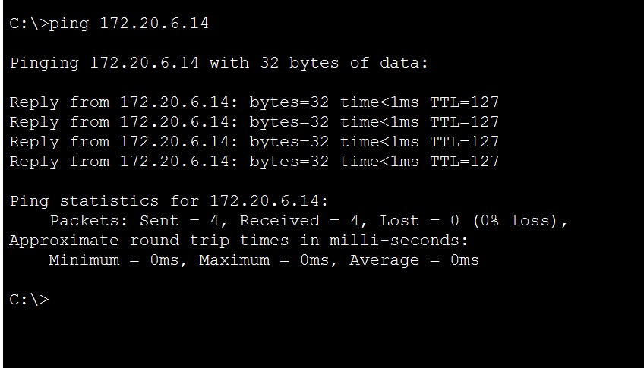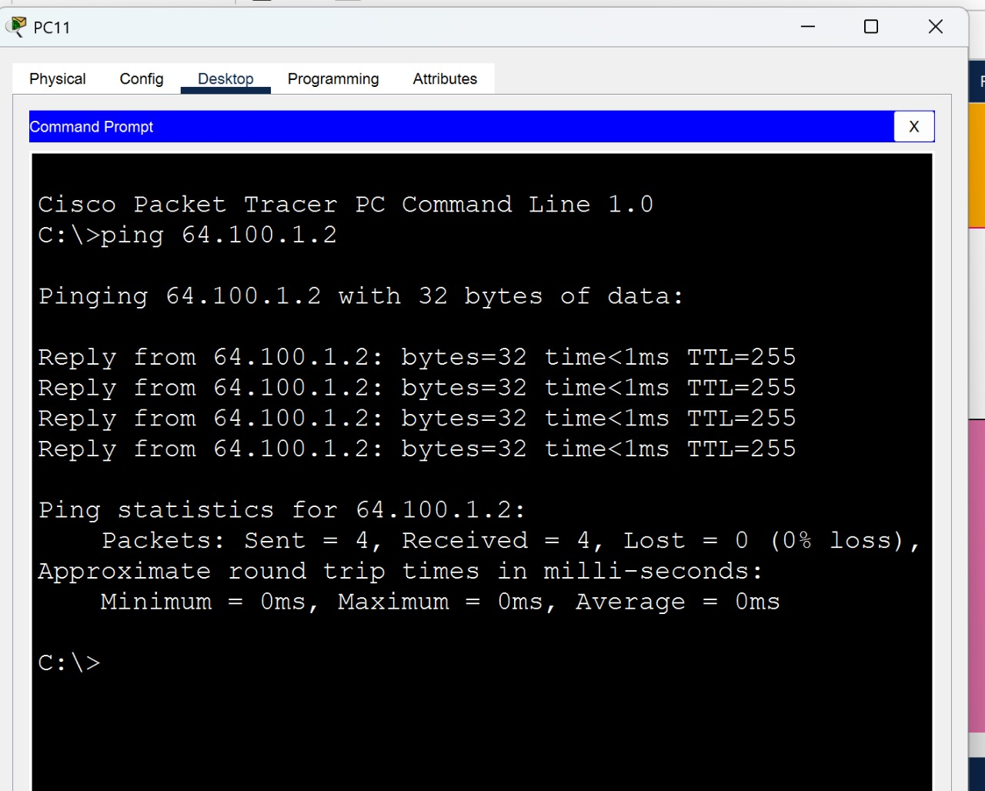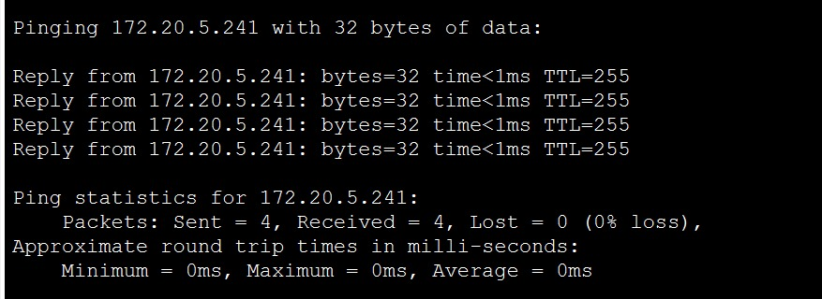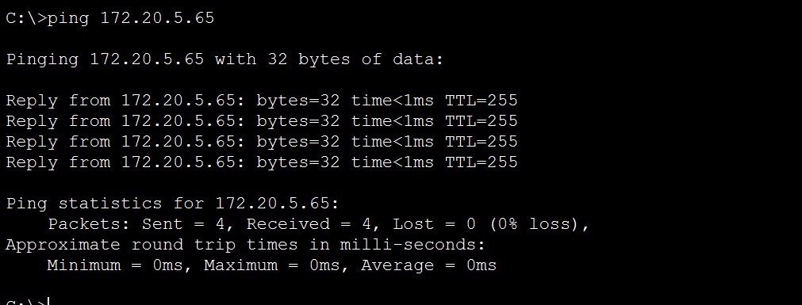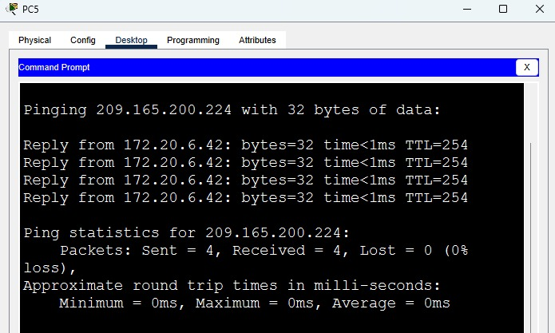
- Routing table confirmed.
Commands used:
show run
show ip route
show crypto isakmp sa
show crypto ipsec sa
Final Note: All functionalities work after debugging VPN ACLs and crypto map mismatches. The entire topology is fully functional and secure.

